PHYSICAL PHARMACEUTICS-II BP403T
UNIT-I(COLLOIDS)
Class 3
Topic : Effect of electrolytes, coacervation, peptization& protective action Stability of colloidal systems
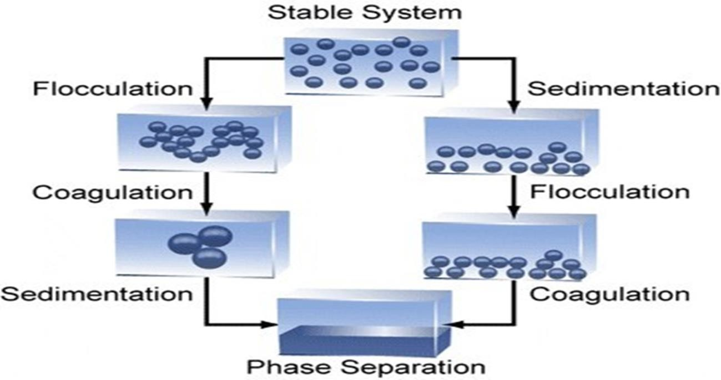

- The presence and magnitude, or absence, of a charge on a colloidal particle is an important factor in the stability of colloidal systems.
- Stabilization is accomplished essentially by two means:
- providing the dispersed particles with an electric charge, and
- surrounding each particle with a protective solvent sheath that prevents mutual adherence when the particles collide as a result of Brownian movement.
- second effect is significant only in the case of lyophilic sols
- A lyophobic sol is thermodynamically unstable.
- The particles in lyophobic sols are stabilized only by the presence of electric charges on their surfaces.

- The like charges produce a repulsion that prevents coagulation of the particles.
- If the last traces of ions are removed from the system by dialysis, the particles can agglomerate and reduce the total surface area, and, owing to their increased size, they may settle rapidly from suspension.
- Hence, addition of a small amount of electrolyte to a lyophobic sol tends to stabilize the system by imparting a charge to the particles.
- Addition of electrolyte beyond that necessary for maximum adsorption on the particles, results in the accumulation of opposite ions and reduces the zeta potential below its critical value.
- The critical potential for finely dispersed oil droplets in water (oil hydrosol) is about 40 milli volts, this high value signifying relatively great instability.
- The critical zeta potential of a gold sol, on the other hand, is nearly zero, which suggests that the particles require only a minute charge for stabilization; hence, they exhibit marked stability against added electrolytes.
- The valence of the ions having a charge opposite to that of the particles appears to determine the effectiveness of the electrolyte in coagulating the colloid.
- The precipitating power increases rapidly with the valence or charge of the ions, and a statement of this fact is known as the Schulze–Hardy rule.
- Will give order of capacity to coagulate hydrophobic colloids
- Precipitating power increases rapidly with the valence of charge of ions
- Cations: Al⁺³>Ba⁺²>Na⁺
- Anions: [Fe(CN)6]⁻³>PO4-2>Cl⁻¹
- Coagulation is a process where the colloidal particles aggregate together and ultimately dispersion breaks upbecomes unstable

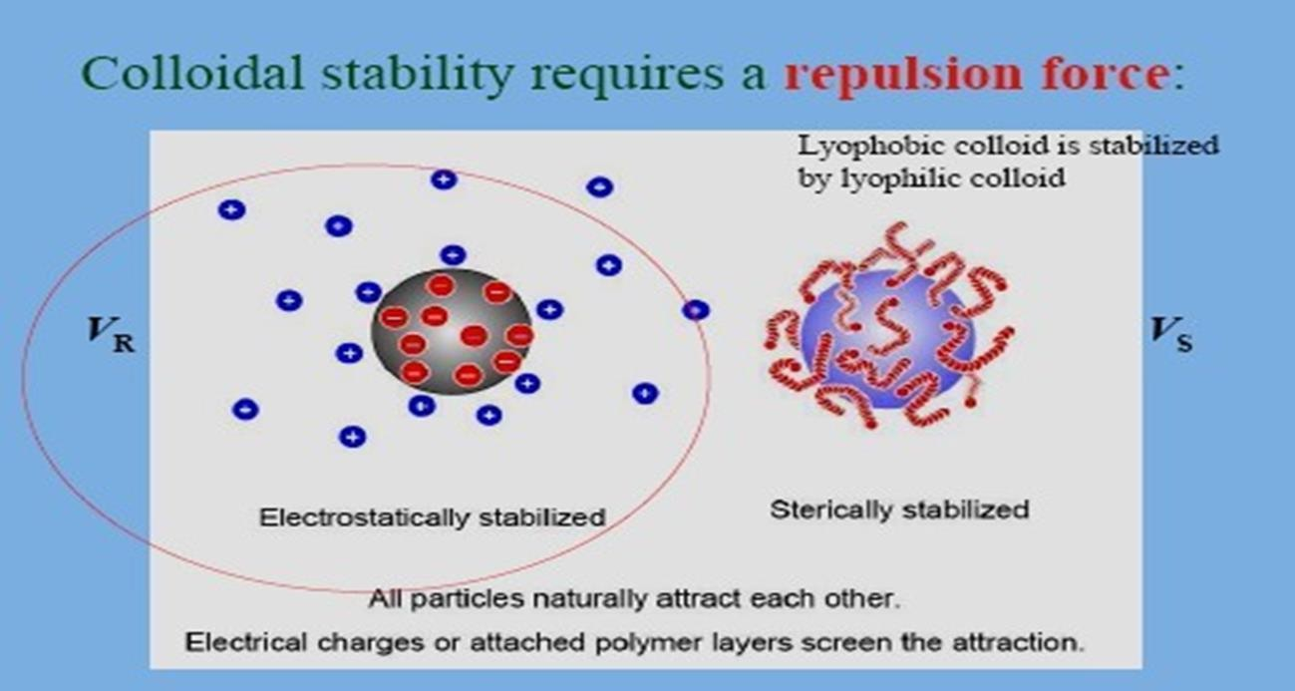

DLVO Theory
- Describes stability of lyophobic colloids
- The forces operating on colloidal particles in a dipersion are the repulsive and attractive forces
- Repusive are due to overlapping of electrical double layer
- Attractive are due to vanderwall and london type dispersion forces
- Forces result in potential energies of repulsion VR and attraction VA between the particles and composite potential energy represents interaction curve VT
- There is a deep potential well of attraction near the origin and a high potential barrier of repulsion at moderate distances
- As two particles approach each other in the medium a weak attractive force exist beyond the range of electrical double layer repulsive forces
- Attractive region is called as secondary minimum
- Responsible for flocculation of suspended particles in coarse dispersions
- Following this principle the amount of electrolyte of a particular valence type required to precipitate a colloid can be determined

- 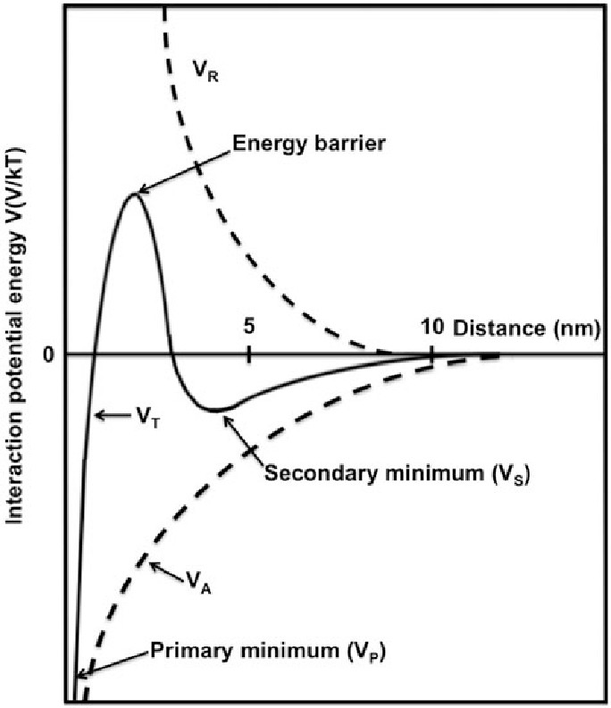
- The precipitation power is directly related to the hydration of the ion and its ability to separate water molecules from colloidal particles.
- Alcohol and acetone can also decrease the solubility of hydrophilic colloids so that the addition of a small amount of electrolytes may then bring about coagulation
addition of less polar solvent
- e.g. alcohol, acetone
- The addition of less polar solvent renders the solvent mixture unfavourable for the colloids solubility decreases
Stability of colloids
Lyophilic sols and association colloids:
- Thermodynamically Stable
- Present as true solution
- Addition of moderate amounts of electrolytes not cause coagulation (opposite lyophobic)

- If sufficient salt is added, agglomeration and sedimentation of the particles may result. This phenomenon, is called as salting out.
- The Hofmeister or lyotropic series ranks cations and anions in order of coagulation of hydrophilic sols.
- Several anions of the Hofmeister series in decreasing order of precipitating power are
- citrate, tartrate, sulfate, acetate, chloride, nitrate, bromide, and iodide.
- Flocculation on the addition of alcohol, followed by salts, as a gradual transformation from a sol of a lyophilic nature to one of a more lyophobic character
Coacervation
- When negatively and positively charged hydrophilic colloids are mixed,
- the particles may separate from the dispersion to form a layer rich in the colloidal aggregates.
- The colloid-rich layer is known as a coacervate, and the phenomenon in which macromolecular solutions separate into two liquid layers is referred to as coacervation
- Example:the mixing of gelatin and acacia.
- Gelatin at a pH below 4.7 (its isoelectric point) is positively charged;
- Acacia carries a negative charge that is relatively unaffected by pH in the acid range.
- When solutions of these colloids are mixed in a certain proportion, coacervation results.
- The viscosity of the upper layer, now poor in colloid, is markedly decreased below that of the coacervate, and in pharmacy this is considered to represent a physical incompatibility.
- Coacervation need not involve the interaction of charged particles;
- the coacervation of gelatin may also be brought about by the addition of alcohol, sodium sulfate, or a macromolecular substance such as starch
- If the coacervate is formed in a stirred suspension of insoluble drug particles the coacervate will surround the drug particles
- The particles thus coated can be seperated and dried
- Forms basic of one of the method of encapsulation
- Microencapsulated Sulfamethoxazole in gelatin-acacia coacervate

- Dissolution rate of sulfathiazole can be enhanced by coacaervation Applications
- Sulfonamide treated with
- Acid or base in aqueous solution
- Alcoholic solution of drug is diluted with water
- Addition of resorcinol a coacervating agent for povidone to aqueous solution of drug and povidone
Results in amorphous precipitate having increased solubility and dissolution rate
Sensitization and Protective Colloidal Action
- The addition of a small amount of hydrophilic or hydrophobic colloid to a hydrophobic colloid of opposite charge tends to sensitize or even coagulate the particles. This is considered due to a reduction of the zeta potential below the critical value (usually about 20–50 millivolts).
- The instability of the hydrophobic particles to a reduction in the thickness of the ionic layer surrounding the particles and a decrease in the coulombic repulsion between the particles.
- The addition of large amounts of the hydrophile (hydrophilic colloid), stabilizes the system, the hydrophile being adsorbed on the hydrophobic particles
- This phenomenon is known as protection, and the added hydrophilic sol is known as a protective colloid.
- The protective property is expressed most frequently in terms of the gold number.
- The gold number is the minimum weight in milligrams of the protective colloid (dry weight of dispersed phase) required to prevent a color change from red to violet in 10 mL of a gold sol on the addition of 1 mL of a 10% solution of sodium chloride.
- A pharmaceutical example of sensitization and protective action is provided when bismuth sub nitrate is suspended in a tragacanth dispersion;
- the mixture forms a gel that sets to a hard mass in the bottom of the container.
- Bismuth sub carbonate, a compound that does not dissociate sufficiently to liberate the bismuth ions, is compatible with tragacanth.

- These phenomena probably involve a sensitization and coagulation of the gum by the Bi3+ ions.
- The flocculated gum then aggregates with the bismuth subnitrate particles to form a gel or a hard cake.
- If phosphate, citrate, or tartarate is added, it protects the gums from the coagulating influence of the Bi3+ ions, and,
- by reducing the zeta potential on the bismuth particles, partially flocculates the insoluble material.
- Partially flocculated systems tend to cake considerably less than deflocculated system
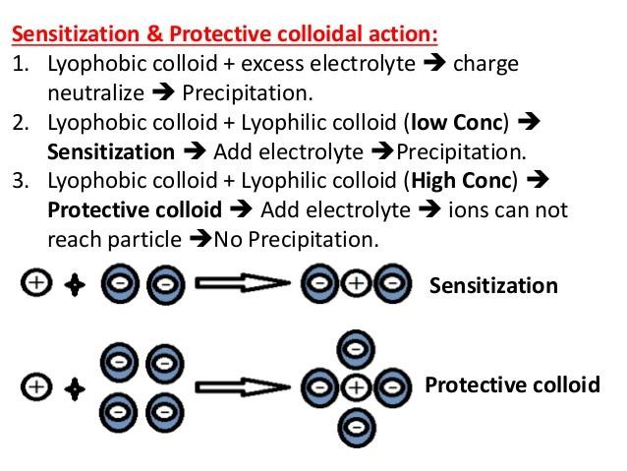

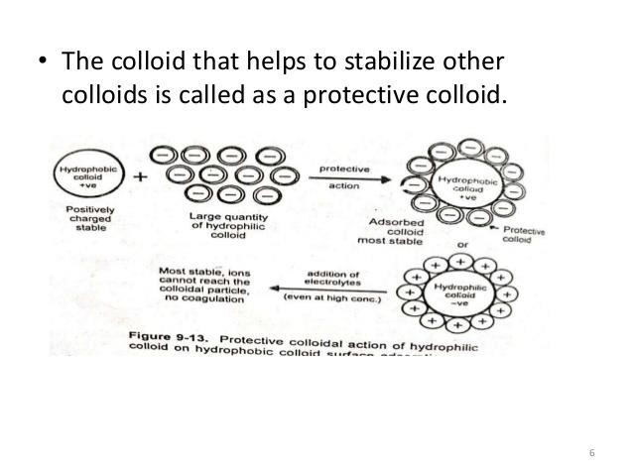
The gold number of protective colloids

Protective colloid | Gold number
Gelatin | 0.005-0.01
Albumin | 0.1
Acacia | 0.1-0.2
Sodium alginate | 1-5
Tragacanth | 2

Peptization
- Process responsible for the formation of stable dispersion of colloidal particles in dispersion medium

- Process of converting a precipitate into colloidal sol by shaking it with dispersion medium in the presence of small amount of electrolyte
- Electrolytes used are called as peptizing agents
- Particularly important in colloidal chemistry
- Freshly prepared Al or Fe hydroxide is difficult to filter very fine colloidal particles pass through filter paper
- To facilitate filtration flocculation done by adding salt
- Electrical charges present on surface of particles neutralizaed and disappear by adding electrolyte(electrical double layer compress by the added electrolyte and collapses at high ionic strength)
- electricl repulsion no longer hinders the aggregation-flocculation precipitate easy to filter
- ppt is washed with excess volume of water
- Electrical double layer reappears and electrical repulsion reappears The precipitate peptizes and the particle pass again through filter
- Addition of surfactants ,water soluble polymer or ions which are adsorbed at the particle surface prevent aggregation and keep the particles in colloidal dimensions
- Ex:Ferric hydroxide solution peptizing into colloidal solution by adding ferric chloride(Fe+3)
- Continuous washing of gelatinous precipitate of Al(OH)3 with water brings about peptization
- Powdered activated charcoal added to water with stirring aggregated grains cannot be completely broken up and the resulting suspension is gray and translucent. The addition of ≤0.1%SLS or octoxynol9 deflocculates the grains into finely dispersed particles and results in a deep black and opaque dispersion.
Kraft point:
- KRAFFT POINT, Kt :
- The solubility of a surface active agent depends on the temperature of the system. But
adequateconcentration of surface active agent is required to form micelles. This relationship is stated by Krafft point.
- Kraft point is defined as the temperature at which solubility of a surfactant equals to CMC
- At kraft point the concentration of surfactant is sufficient to form micelles

- Infact micelles are more soluble in water than monomers thus the solubility show a sudden increase in several folds. this type of behavior exhibited by several non ionic surfactants.
- One has to verify the Krafft point and attempts to prepare colloids above this
temperature.

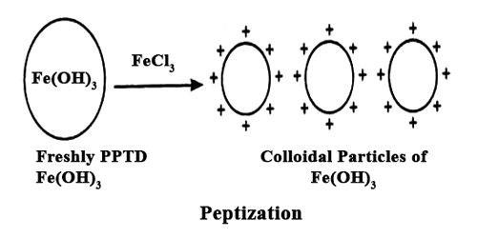

At low temperature the surfactant is a normal molecule with some sort of solubility curve that would tend to increase as shown in above figure. But surfactants have CMCs which also change with
The point where the two curves crosses is the kraft point temperature, as shown.
as you have micelles then the “solubility” of the surfactant is defined by micelle formation and, roughly
below the kraft point the solubility of a surfactant is too low for micellization so solubility alone determines surfactant monomer concentration . As temperature increase the solubility increases until at Krafft Point the CMC is reached. At this temperature a relatively large amount of surfactant can be dispersed in micelles and solubility increases greatly
A cloud point refers to the temperature at which a solution of a surfactant begins to agglomerate on a molecular level, generating a cloudy physical appearance. Cloud point temperatures are important for liquid fuels and other petroleum-based substances.

Nonionic surfactants are the most likely to display cloud point occurrences due to their solubility at lower temperatures. Shale inhibitors are produced from glycols that present cloud point behavior. The applicable use of cloud points is within the temperature range of 0°C to 100°C (32°F to 212°F), correlating to the physical state boundaries of water. It is measured using 1% aqueous surfactant solutions. Other components present in a solution may decrease or increase the solution's cloud point.

