PHYSICAL PHARMACEUTICS-II BP403T

Class3
Topic name :Optical Properties of Colloids The Faraday-Tyndall effect
- When a strong beam of light is passed through a colloidal sol, a visible cone, resulting
from the scattering of light by the colloidal particles, is formed. This is the Faraday Tyndall effect.
- An intense light beam is passed through the sol against a dark background at right angles to the plane of observation, and, although the particles cannot be seen directly, the bright spots corresponding to particles can be observed and counted.
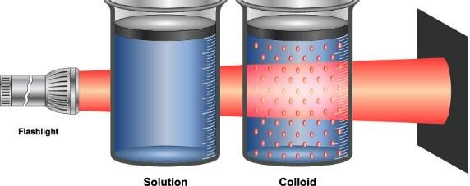

Electron microscope
- electron microscope widely used to observe the size, shape, and structure of colloidal particles.
- The success of the electron microscope is due to its high resolving power, which can be defined in terms of d, the smallest distance by which two objects are separated and yet remain distinguishable.

- The smaller the wavelength of the radiation used, the smaller is d and the greater is the resolving power.
- The optical microscope uses visible light as its radiation source and is able to resolve only two particles separated by about 20 nm (200 Å).
The radiation source of the electron microscope is a beam of highenergy electrons having wavelengths in the region of 0.01 nm (0.1 Å). With current instrumentation, this results in d being approximately 0.5 nm (5 Å), a much-increased power of resolution over the optical microscope
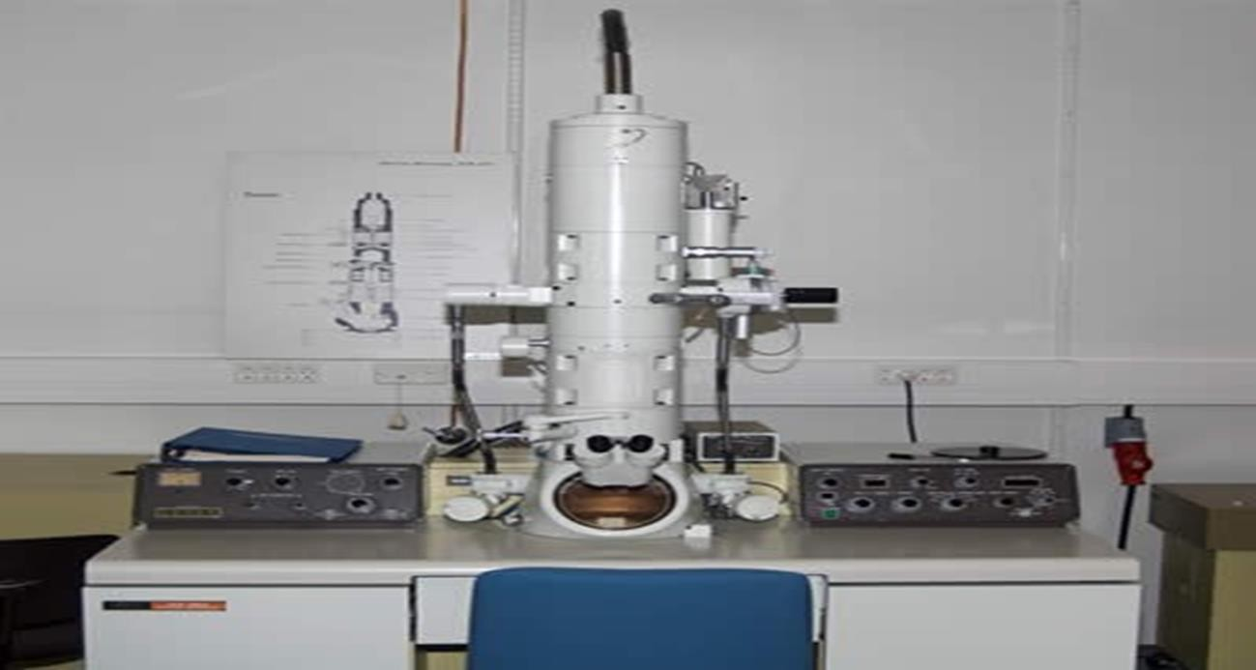

Optical Properties of Colloids Light Scattering
This property depends on the Faraday Tyndall effect and is widely used for determining the molecular weight of colloids.
can also be used to obtain information on the shape and size of these particles.
Scattering can be described in terms of the turbidity, τ, the fractional decrease in intensity due to scattering as the incident light passes through 1 cm of solution.
- can be expressed as the intensity of light scattered in all directions, Is, divided by the intensity of the incident light, I.

- At a given concentration of dispersed phase, the turbidity is proportional to the molecular weight of the lyophilic colloid.
- Because of the low turbidities of most lyophilic colloids, more convenient to measure the scattered light rather than the transmitted light.
- The turbidity can be calculated from the intensity of the scattered light, provided that the dimensions of the particle are small compared with the wavelength of the light used.
- The molecular weight of the colloid can be obtained from the following equation:
Hc / τ = 1/M + 2Bc τ : turbidity in cm⁻¹
C: conc of solute in gm / cc of solution M: molecular weight in Daltons
B: interaction constant
H: constant for a particular system H=32π³n²(dn/dc)²/3λ⁴ N
n =refractive index λ=wavelength in cm⁻¹
dn/dc=change in refractive index with concentration

- A plot of Hc/τ against concentration results in a straight line with a slope of 2B.
- The intercept on the Hc/τ axis is 1/M, the reciprocal of which yields the molecular weight of the colloid.
- When the molecule is asymmetric, the intensity of the scattered light varies with the angle of observation.

APPLICATIONS
- estimation of the shape and size of the particles.
- to study proteins, synthetic polymers, association colloids, and lyophobic sols.

