PHYSICAL PHARMACEUTICS II BP(403T) UNIT I-(COLLOIDAL DISPERSIONS)
Class 2
Topic : Purification of colloids, Classification of colloids
DIALYSIS
- Uses a semipermeable membrane of collodion or cellophane, the pore size of which will prevent the passage of colloidal particles,
- permit small molecules and ions, such as urea, glucose, and sodium chloride, to pass through, which shows that, at equilibrium, the colloidal material is retained in compartment A,
- whereas the sub colloidal material is distributed equally on both sides of the membrane.
- By continually removing the liquid in compartment B, it is possible to obtain colloidal material in A that is free from subcolloidal contaminants.
Dialysis can also be used to obtain subcolloidal material that is free from colloidal contamination in this case, one simply collects the effluent

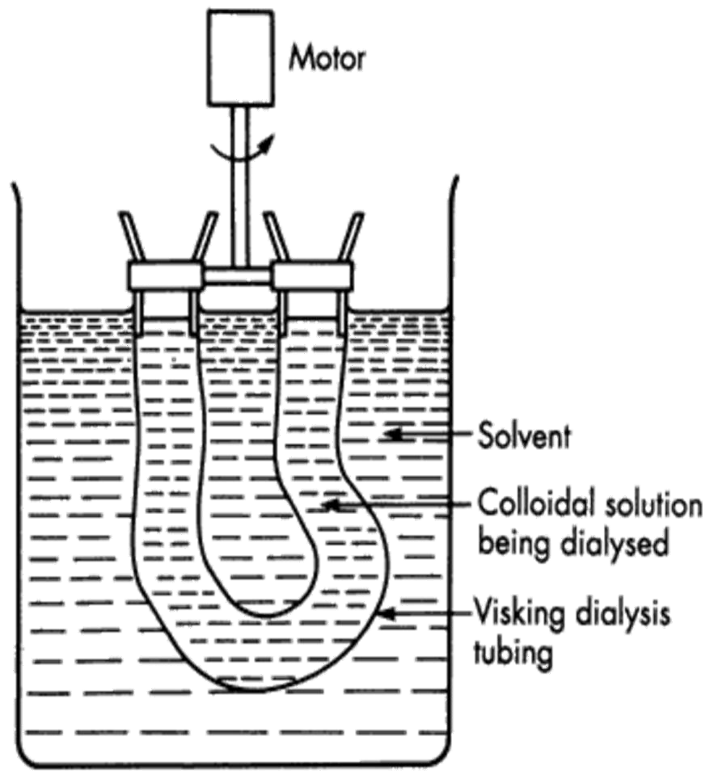

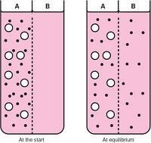

The principle of dialysis is utilized in the artificial kidney, which removes low molecular weight impurities from the body by passage through a semi permeable membrane.
- When dialysis and ultra filtration are used to remove charged impurities such as ionic contaminants, the process can be hastened by the use of an electric potential across the membrane. This process is called electro dialysis,
- An electrodialysis cell consists of three compartments two outer and one centre compartment
- The centre compartment is separated from outer two compartments by two dialyzing membranes supported by screens
- The two outer compartments contain water and central compartment contain colloidal solution
- When the electrical potential is applied the anions move from the sol into the anode compartment while cations move from the sol into the cathode compartment
- The colloidal particles in the centre compartment move to one of the membranes based on their charge
- Non electrolyte impurities diffuse into both the outer compartments
- As the density increase due to accumulation of colloidal particles ,settle to the bottom of the compartment
- The supernatant liquid changed be decantation and thus the purified colloidal sol is prepared by electrodialysis and decantation this process is called electrodecantation

Ultra filtration
- Used to separate and purify colloidal material. Filtration is conducted under negative pressure (suction) through a dialysis membrane supported in a Buchner funnel.

- As the process uses high pressure the membrane is usually supported by wire screen
- In order to avoid the increase in concentration of colloidal particles and to remove the dissolved impurities completely the water is replaced continuously
- To maintain uniform concentration throughout the colloidal sol,the sol is stirred
- An ultrafilter maybe an ordinary filter paper impregnated with collodion(cellulose tetranitrate dissolved in amixture of ether and alcohol in the ratio of 3:1)or cellophane(a regenerated cellulose in swollen gel sheet)or cellulose acetate.

Types of Colloidal Systems Lyophilic Colloids:
- Systems containing colloidal particles that interact to an appreciable extent
with the dispersion medium are referred to as lyophilic(solvent-loving) colloids.
- Owing to their affinity for the dispersion medium-materials form colloidal dispersions, or sols, with relative ease.
- lyophilic colloidal sols are usually obtained simply by dissolving the material in the solvent being used.
- For example, the dissolution of acacia or gelatin in water or celluloid in amyl acetate leads to the formation of a sol.
- The various properties of this class of colloids are due to the attraction between the dispersed phase and the dispersion medium, which leads to solvation, the attachment of solvent molecules to the molecules of the dispersed phase.
- In the case of hydrophilic colloids, in which water is the dispersion medium, this is termed hydration.

- Most lyophilic colloids are organic molecules, for example, gelatin, acacia, insulin, albumin, produce lyophilic colloids in aqueous dispersion media (hydrophilic sols).
- Rubber and polystyrene form lyophilic colloids in nonaqueous, organic solvents.
- These materials accordingly are referred to as lipophilic colloids.
- A material that forms a lyophilic colloidal system in one liquid (e.g., water) may not do so in another liquid (e.g., benzene).
Hydrophilic colloids further subdivided as follows:
  - True solutions: Acacia and Povidone form molecular dispersion in water

Gelled solutions:
solutions of polymers at higher concentration
    - also formed at higher temperatures at which their solubility is low
    - solutions of gelatin and starch set to gels on cooling
    - methyl cellulose sets to gel on heating c)Pariculate dispersion:
do not form molecular dispersion but present as minute particles of colloidal dimension
ex:Bentonite
- Lipophilic colloids exhibit affinity towards oils and called oleophilic
- Polystyrene ,Gum rubber form colloidal solutions with benzene
- Activated charcoal forms particulate dispersion in all oils Lyophilic colloid dispersions are thermodynamically stable
Form colloiadal dispersions spontaneously with dispersion medium

They are also reversible i.e they can be formed after the dispersion medium has been removed the residue obtained after the removal of dispersion medium forms again a colloidal dispersion on adding to the dispersion medium.

Lyophobic Colloids
- have little attraction, if any, for the dispersion medium.
- These are the lyophobic (solvent-hating) colloids and, predictably, their properties differ from those of the lyophilic colloids.
- primarily due to the absence of a solvent sheath around the particle.
- Lyophobic colloids are generally composed of inorganic particles dispersed in water.
- Examples : gold, silver, sulfur, Arsenous sulfide, and silver iodide In contrast to lyophilic colloids
- Dispersion method: in which coarse particles are reduced in size, and through comminution or peptization
- Condensation methods: in which materials of sub colloidal dimensions are caused to aggregate into particles within the colloidal size range.
- Colloid mills and ball mills and micronizers reduce the size of the particles to colloidal range
- In colloid mill the coarse material is sheared in a narrow gap between a static cone and a rapidly rotating cone

Bredig ‘s method
- In electrical dispersion method the dispersions of metals are prepared by producing an electric arc by keeping close together two electrodes made of the metal immersed in water containing traces of KOH as stabilizer in a container cooled by ice externally
- The intense heat vaporises some the metal and the vapor condenses into colloidal particles in water eg: silver,gold,platinum,hydrosols

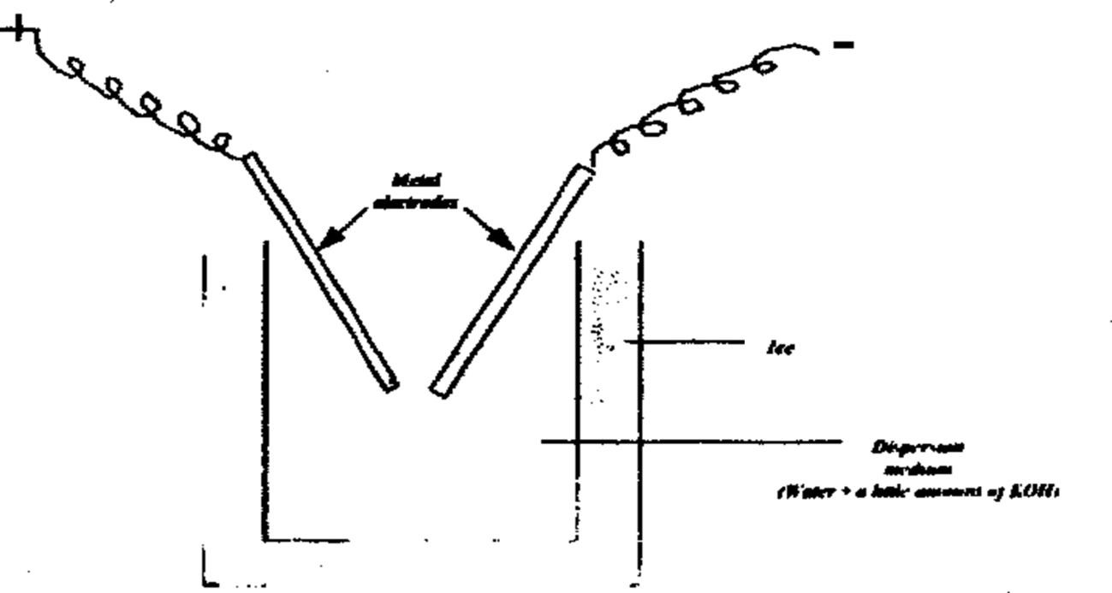
Dispersion can be achieved by the use of high intensity ultrasonic generators operating at frequencies in excess of 20,000 cycles per second.
Ex:preparation of soyabean oil for intravenous injection
Peptization process of dispersion of a precipitated material (flocculated or aggregated) into smaller aggregates of colloidal dimension
- Effected by addition of deflocculating agents or peptizing agents
- Peptizing agents: surfactants, water soluble polymers or ions that adsorb onto particle surface and do not allow aggregation and keep the particles in colloidal dimension
- Peptization –by removal of flocculating agents results in disintegration of floccules into smaller particles
- Ex: ferric hydroxide yields sol when ferric chloride is added to it
- Washing of Gelatinous precipitate of aluminium hydroxide with water brings peptization

- The required conditions for the formation of lyophobic colloids by condensation or aggregation involve a high degree of initial supersaturation followed by the formation and growth of nuclei.
- Supersaturation can be brought about by change in solvent or reduction in temperature.
- ex: Sulfur is dissolved in alcohol and the concentrated solution is then poured into an excess of water, many small nuclei form in the supersaturated solution, grow rapidly to form a colloidal sol.
- Other condensation methods depend on a chemical reaction, such as reduction, oxidation, hydrolysis, and double decomposition.

Reduction
- Thus, neutral or slightly alkaline solutions of the noble metal salts, when treated with a reducing agent such as formaldehyde or pyrogallol, form atoms that combine to form charged aggregates.

Oxidation
- The oxidation of hydrogen sulfide leads to the formation of sulfur atoms and the production of a sulfur sol.
- Br₂ + H₂S S + 2 HBr

Hydrolysis
- If a solution of ferric chloride is added to a large volume of water, hydrolysis occurs with the formation of a red sol of hydrated ferric oxide.
- Chromium and aluminum salts also hydrolyze in this manner.
Double decomposition between hydrogen sulfide and arsenous acid results in an arsenous sulfide sol.
- If an excess of hydrogen sulfide is used, HS- ions are adsorbed onto the particles. This creates a large negative charge on the particles, leading to the formation of a stable sol

Association Colloids: Micelles and the Critical Micelle Concentration
- Association or amphiphilic colloids form the third group in this classification.
- Molecules or ions, termed amphiphiles or surface-active agents, are characterized by having two distinct regions of opposing solution affinities within the same molecule or ion.
- When present in a liquid medium at low concentrations, the amphiphiles exist separately and are of such a size as to be sub colloidal.
- As the concentration is increased, aggregation occurs over a narrow concentration range.
- These aggregates, which may contain 50 or more monomers, are called micelles. Because the diameter of each micelle is of the order of 50 Å, micelles lie within the size range have designated as colloidal.
- The concentration of monomer at which micelles form is termed the critical micelle concentration(CMC).
- The number of monomers that aggregate to form a micelle is known as the aggregation number of the micelle.
- Below the CMC, the concentration of amphiphile undergoing adsorption at the air water interface increases as the total concentration of amphiphile is raised.
- Eventually, a point is reached at which both the interface and the bulk phase become saturated with monomers.

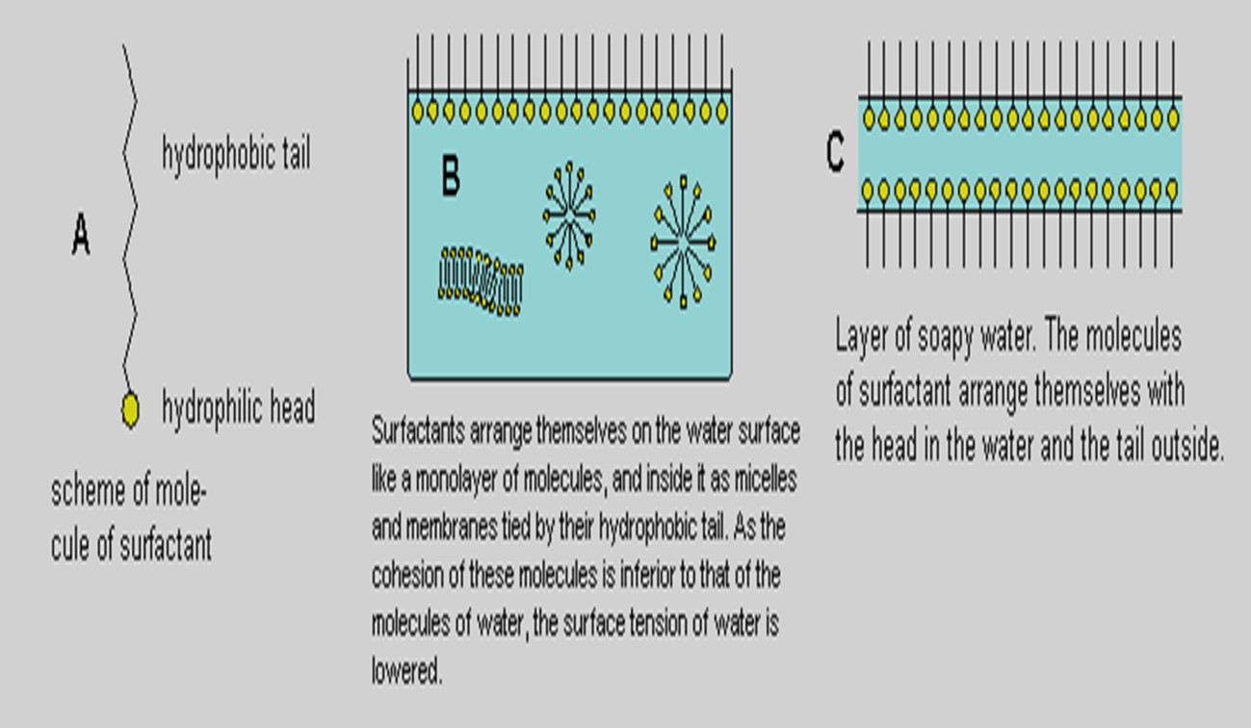

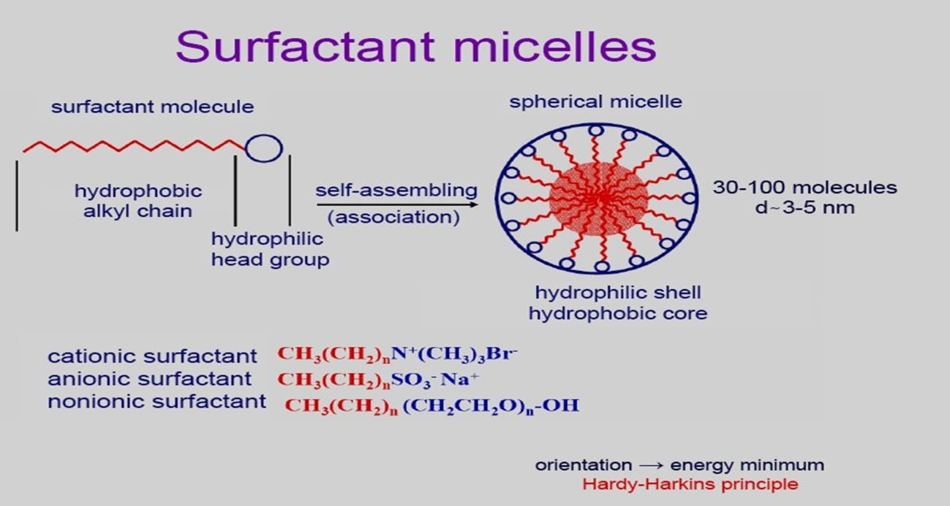
- further amphiphile added in excess of this concentration aggregates to form micelles in the bulk phase, and, in this manner, the free energy of the system is reduced.

- increasing interfacial adsorption, above the CMC, the surface tension remains essentially constant, showing that the interface is saturated and micelle formation has taken place in the bulk phase.
- In the case of amphiphiles in water, the hydrocarbon chains face inward into the micelle to form, in effect, their own hydrocarbon environment.
- Aggregation also occurs in nonpolar liquids. The orientation of the molecules is now reversed, however, with the polar heads facing inward while the hydrocarbon chains are associated with the continuous nonpolar phase.
- It seems likely that spherical micelles exist at concentrations relatively close to the CMC.
- At higher concentrations, laminar micelles have an increasing tendency to form and exist in equilibrium with spherical micelles.
- As with lyophilic sols, formation of association colloids is spontaneous, provided that the concentration of the amphiphile in solution exceeds the CMC.
- Amphiphiles may be anionic, cationic, nonionic, or ampholytic (zwitterionic), and this provides a convenient means of classifying association colloids.
- A certain number of the sodium ions are attracted to the surface of the micelle, reducing the overall negative charge somewhat. These bound ions are termed counter ions or gegenions.
- Mixtures of two or more amphiphiles are usual in pharmaceutical formulations.
- Assuming an ideal mixture, to predict the CMC of the mixture from the CMC values of the pure amphiphiles and their mole fractions, x, in the mixture, according to the expression
- 1/CMC=x₁/CMC₁+x₂/CMC₂ where x=molefraction

