PHYSICAL PHARMACEUTICS II BP(403T) UNIT V (DRUG STABILITY)

Class 45:
Topic:Accelerated stability and stress testing
Accelerated stability analysis is designed to predict stability and hence shelf life of formulations under normal or recommended storage conditions by carrying out the study under accelerated conditions of temperature, moisture and light.
The federal food and drug cosmetics act (FDA) requires that all manufacturer should establish controls for ensuring quality, safety and purity, strength and efficacy of a drug product.
These controls are called Cgmp (current good manufacturing practices) are given by the FDA (food and drug administration).
Stability testing also one of the cGMP practice and includes testing of drug substances or drug products that are susceptible to change during storage which influences quality, safety, purity and strength, efficacy of the product.
The nature of the stress testing will depend on individual drug substance and type of drug product involves.
The method of accelerated stability testing of pharmaceutical products based on principles of chemical kinetics was demonistrated by Garret & Carper.

Objective:
To serve as a rapid means of selecting the best formulation from amongst a series of similar formulations of the product.
To predict shelf-life of the product, shelf life is the time period for which the product will remain satisfactory under normal or recommended storage conditions.
To serve as a rapid means of quality control.

Stress used during stability testing: Temperature, humidity, light:

Increase in temperature, humidity and light causes degradation, so preparations are subjected to different temp, humidity and light conditions and samples collected and analysed at regular intervals.
Accelerated stability studies are experimental design used in manufactures in industries.

Accelerated stability studies-prediction of shelf life:
Shelf-life: is the time period during which the dosage form is supposed to retain its original qualities.
The prediction of shelf life is based on applying the following equation
- Garrett and Carper
- Arrhenius method
- Free and Blythe method.
An important consideration during accelerated stability testing is to determine the stability of products in a container in which they are marketed.
Generally in stability of any active component in a pharmaceutical preparation can be evaluated by some properties of degradation, eg decrease in concentration of API / drug.
If then function is made to know the order of reaction by using graphical method which was linear, and form the graphs, the temperature dependency of degradation is obtained by the help of Garrett Carper, Arrhenius and Free blythe equations.
Then shelf life of active ingredient is measured at normal storage conditions.

Various steps in prediction of shelf-life:
Procedure of accelerated stability testing:
Steps:
Preparation for which the stability is determined is divided into different portions and each portion is stored at different elevated temp such as 40, 50, 60 and 70⁰C inorder to accelerate the degradation
Samples from each portion are withdrawn at various intervals of time and remaining amount of drug is calculated.

Then by using the graphical / substitution / half life method the order of the decomposition is estimated
Eg: graphical method a plot of concentration terms on y-axis (a, log a, a/a-x) and time on x-axis which gives straight line accordingly zero, first and second order is determined.
After that from slope of lines, the rate constant K values for the reactions is obtained at each elevated temperature.

Arrhenius plot:
Employing the Arrhenius equation, the rate constant for degradation at room temperature i.e 25⁰C is determined.

Method 1:
A plot of logarithm of K vs 1/temperature is drawn and a straight line is obtained, then the straight line is extrapolated to 25⁰C and reading of K value at 25⁰C.
Then by using the K value, the shelf life of the product is estimated based on the order the equation is used, shelf life is determined and time period during which the product will retain its potency is determined.
Calculations are carried out to determine the amount of drug to be added in excess (overages) to compensate the loss in during the shelf life period to assure 100% concentration in the product during use within the shelf life.

Method 2: Free and Blythe equation
In this method the determination of shelf life is done by using a graph in which log% of drug remaining vs time (in days)
From the graph a straight line is obtained and the time period required to fall 90% concentration is noted at all temperatures.
Then the log time to 90% is plotted against the reciprocal of temperature (either ⁰C or K), straight line obtained is extrapolated to lower temperature (25⁰C) and from this no of days required for the potency to fall to 90% of its original value (i.e shelf life) is read directly at 25⁰C.

Method1:
Garrett and carper graph/plot:

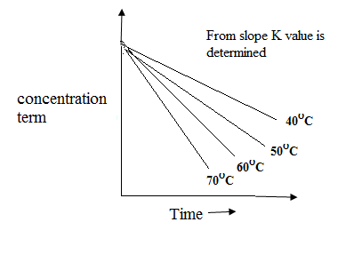

Accelerated breakdown of drug at elevated temp

Arrhenius plot log k vs 1/temp
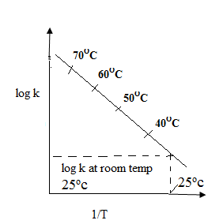
Arrhenius plot for predicting the rate constant at room temperature(25ºc)

Method 2:

Free and Blythe method
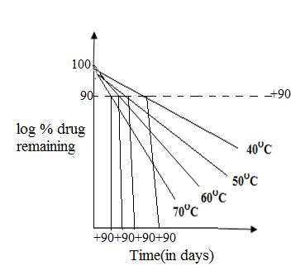
Time in days for drug potency to fall to 90% original value
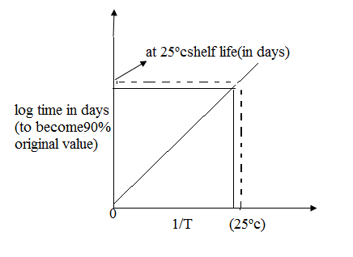
Plot of +90 against 1/T to find predicted shelf life at 25ºc

Limitations to accelerated stability studies:

Arrhenius plot is applicable to only those thermal reaction with activation energy 10-30 k cal/mol, some reactions which do not takes place under normal conditions may take place at elevated temperature, so actual information may not be obtained.
The order of reaction may be also different in real and accelerated conditions, accelerated study can be used if decomposition is due to freezing, contamination by micro-organisms, excessive agitation during transport (breaking of tablets).
Products containing substances like proteins and methyl cellulose may decompose at elevated temperatures and also products like ointments and suppositories may melt at high temperature which is not suitable for accelerated testing.
Products like emulsions may appear to be more stable at elevated temperature which may not be stable at normal storage conditions.

International regulatory guidelines for stability:
The stability studies of drug substances and drug products has long been a concern for both the pharmaceutical industry as well as the regulatory agencies worldwide.

ICH:
First effort towards harmonization of technical requirements for registration of pharmaceuticals including stability requirements started with the inception of the international conference on harmonization (ICH) in 1990.
Birth of ICH took place at a meeting in april 1990, hosted by European federation of pharmaceutical industries and associations in Brussels.
ICH steering committee also established at that meeting has since been meeting regularly at least twice a year.
Harmonization of stability requirement was the first topic taken by ICH which resulted in issuance of first ICH tripartite guideline on stability testing of new drug substances and products (Q1A) in 1993.
The WHO, mean while being an observer to the ICH process felt the ICH parent guideline Q1A is not only enough and given a separate stability testing of pharmaceutical products containing well established drug substance in conventional dosage forms.

ICH and WHO guidelines for stability studies:
ICH so far given 6 guidelines for stability studies

Q1A parent guidelines has been revised twice and the current version Q1A (R2) lays down the requirements pertaining to registration application within 3 regions of Europe, Japan and United states and all other 5 has been given in table.
ICH guidelines on stability studies

ICH guideline | Title
Q1A | Stability testing of new drug substances and  products (second revision).
Q1B | Stability testing: photo stability testing of new drug substances and products.
Q1C | Stability testing for new dosage form.
Q1D | Bracketting and matrixing designs for stability  testing of drug substances and products.
Q1E | Evaluation of stability data.

