PHYSICAL PHARMACEUTICS II BP(403T)
UNIT V (DRUG STABILITY)
CLASS 41

Topic41:Factors affecting rate of reaction
Number of factors effect the reaction velocity other that concentration are

Temperature
- Light
- Solvents
- Ionic strength
- Dielectric constant of solvent
- Catalysis
- Surfactants

1.Temperature:
Collison theory:
- reaction rates are expected to be proportional to the number of collisions per unit time, because the no of collisions increases as the temp increases, the reaction rate is also expected to increase.
- In fact the speed of many reactions can be increased 2 to 3 times with each 10⁰c rise in temperature.
- As a reaction proceeds from reactants to products, the system must pass through prevents reactants from immediately becoming products. The activation energy Ea is measure of this barrier.
- The effect of temperature on reaction rate is given by Arrhenius, which is in exponential form

WHERE,
𝐾 = 𝐴𝑒−𝐸𝑎/𝑅𝑇

K is specific reaction rate constant
A is frequency factor or Arrhenius factor Ea is activation energy
R is gas constant = 1.987 cal deg mol

T absolute temperature
The frequency factor A referred to above is a measure of frequency of collisions that may be expected between the reacting molecules.
The activation energy Ea is the energy required for effective collision to cause a reaction between molecules.
Convert Arrhenius equation into log form

ln 𝐾 =
𝐸_{𝑎}
𝑅𝑇 + 𝑙𝑛𝐴
𝐸_{𝑎}

log 𝐾 = log 𝐴 − 2.303 𝑅𝑇
Where log A→ is a constant
The values of constants A and Ea can be determined by determining K at various temperatures.
A plot of log K versus 1/T gives a straight line with slope equal to –Ea/2.303R and intercept at Y- axis equal to log A.

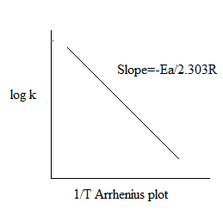
Ea can also be obtained by plotting log t1/2 against 1/T which yields a straight line with slope equal to Ea/2.303R.
The half life of 1st order reaction is related to K by t1/2 = 0.693/K
convert into log form

log t1/2 = log 0.693-log K Substituting log K = log 0.693 – log t1/2 in equation
Log 𝑘 = log A- ^{Ea} ¹
2.303 RT
Log 0.693- log t1/2 = log A – Ea
2.303RT
Log t1/2 = Ea +constant
2.303RT

A plot log t1/2 versus 1/T gives the slope equal to Ea/2.303
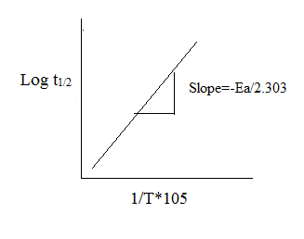

(Higuchi also used this plot)
Ea can also be obtained by determining K1 at T1 and K2 at T2 and using the formula

log 𝐾₁₌ log 𝐾₂₌
Substract log K2 from log K1
log 𝐴 − 𝐸𝑎 1
2.303𝑅 𝑇1

log 𝐴 − 𝐸𝑎 1
2.303𝑅 𝑇2

log 𝐾₂
− 𝑙𝑜𝑔𝐾₁
= Ea (T2-T1/T2T1)
2.303R

Log K2 = Ea (T2-T1/T1T2)
K1 2.303R

Limitations to Arrhenius equation:

- Arrhenius equation is useful when the energy of activation is in the range of 10 to 30 k cal/mol.
- If Ea is only 2 to 3 kcal/mol as in case of photolytic reaction, little advantage is gained from the equation
- Similarly if Ea is more as in case of pyrolysis the rate of degradation is so fast and it becomes difficult to make use of this relation.

