PHYSICAL PHARMACEITICS-IIBP403T UNIT-IV(MICRO MERITICS )
Class35:

Topic:Derived Properties of Powders
- Size distribution and surface area are the fundamental properties of any collection of particles
- Derived properties that are based on fundamental properties
- Porosity
- Packing arrangments
- Densities of particles
- Bulkiness
- Flow properties

Densities of Particles
- . Density is defined as weight per unit volume
- The true density of the material itself, exclusive of the voids and intraparticle pores larger than molecular or atomic dimensions in the crystal lattices,
- The granule density =mass/granular volume determined by the displacement of mercury, which does not penetrate At ordinary pressures into pores smaller than about 10 μm,
- The bulk density as determined from the bulk volume and the weight of a dry powder in a graduated cylinder

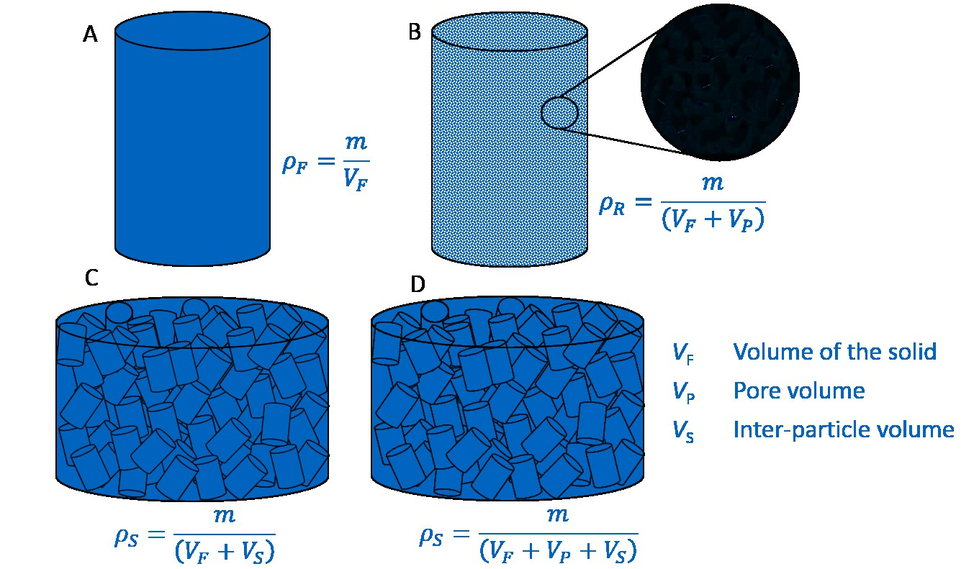

Determination of Densities True Density:
- True density, ρ, is the density of the actual solid material.
- Methods for determining the density of nonporous solids by displacement in liquids.
- If the material is porous, as is the case with most powders, the true density can be determined by use of a helium densitometer

Gas displacement method
- the volume of the empty apparatus (dead space) is first determined by introducing a known quantity of helium.
- A weighed amount of powder is then introduced into the sample tube, adsorbed gases are removed from the powder by an out gassing procedure, and helium, which is not adsorbed by the material, is again introduced.
- The pressure is read on a mercury manometer, and by application of the gas laws, the volume of helium surrounding the particles and penetrating into the small cracks and pores is calculated.

- The difference between the volume of helium filling the empty apparatus and the volume of helium in the presence of the powder sample yields the volume occupied by the powder. Knowing the weight of the powder, calculate the true density.
- The procedure is equivalent to the first step in the BET method for determining the specific surface area of particles

Liquid displacement method
- A 25ml standard flask may be used for the determination of true volume
- A liquid in which powder is insoluble is added to the standard flask and weight is determined
- Some amount of powder whose true density to be found out is added into the flask and the weight is found out
- Now the liquid is added to the powder to fill the voids within the powder until the powder and liquid together occupy the volume 25cc
- Again it is weighed
- Weight of empty bottle=a
- Weight of empty bottle+liquid=b
- Weight of empty bottle+powder=c
- Weight of empty bottle+liquid+powder=d
- The weight of powder =c-a
- Density of liquid=b-a/25
- True denity=weight of powder/true volume
• =c-a/(b-a/ρ)-(d-c/ ρ)
- A pycnometer can be used for better results
- By using water and alcohol gives density slightly less than true density since these liquids cannot enter into the smallest void space

Granule density
- ρg, can be determined by a method similar to the liquid displacement method.

- Mercury is used because it fills the void spaces but fails to penetrate into the internal pores of the particles.
- The volume of the particles together with their intraparticle spaces then gives the granule volume, and from the powder weight, the granule density is determined by pycnometer.
- A measure of true density was obtained by highly compressing the powders. The samples were compressed to 100,000 lb/in2, and the resulting tablets were weighed.
- The volumes of the tablets were computed after measuring the tablet dimensions with calipers.
- The weight of the tablet divided by the volume then gave the true or high-compression density

Bulk density
- ρb, is defined as the mass of a powder divided by the bulk volume.
- A standard procedure for obtaining bulk density or its reciprocal, bulk specific volume,
- A sample of about 50 cm3 of powder that has previously been passed through a U. S. Standard No. 20 sieve is carefully introduced into a 100 mL graduated cylinder
- The cylinder is dropped at 2 sec intervals onto a hard wood surface three times from a height of 1 in.
The bulk density is then obtained by dividing the weight of the sample in grams by the final volume in cm³ of the sample contained in the cylinder
- The term light as applied to pharmaceutical powders means low bulk density or large bulk volume, whereas heavy signifies a powder of high bulk density or small volume.
- It should be noted that these terms have no relationship to granular or true densities
- the bulk density of a powder depends primarily on particle size distribution, particle shape, and the tendency of the particles to adhere to one another.
- The particles may pack in such a way as to leave large gaps between their surfaces, resulting in a light powder or powder of low bulk density.
- On the other hand, the smaller particles may shift between the larger ones to form a heavy powder or one of high bulk density

