PHYSICAL PHARMACEUTICS II BP(403T) UNIT IV (MICROMERITICS)
CLASS 34

Topic: Air Permeability Method
- The principal resistance to the flow of a fluid such as air through a plug of compacted powder is the surface area of the powder.
- The greater is the surface area per gram of powder, Sw, the greater is the resistance to flow.
- Hence, for a given pressure drop across the plug, permeability is inversely proportional to specific surface.
- From equations Sw = αs/ƿ αvdvs it is then possible to compute dvs.
- A plug of powder can be regarded as a series of capillaries whose diameter is related to the average particle size.
- The internal surface of the capillaries is a function of the surface area of the particles. According to Poiseuille equation
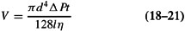
- Where V is the volume of air flowing through a capillary of internal diameter d and length l in t seconds under a pressure difference of ΔP. The viscosity of the fluid air is η poise.
- The Kozeny Carman equation, derived from the Poiseuille equation, is the basis of most air permeability methods. Stated in one form, it is
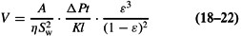
- Where A is the cross-sectional area of the plug, K is a constant (usually 5.0 ± 0.5) that takes account of the irregular capillaries, and ε is the porosity, instrument is the Fisher sub sieve sizer
- In practice, the flow rate through the plug, or bed, is also affected by
- The degree of compression of the particles

  - The more compact the plug, the lower is the porosity, which is the ratio of the total space between the particles to the total volume of the plug.
- The irregularity of the capillaries.
  - The irregularity of the capillaries means that they are longer than the length of the plug and are not circular
  - From the values of A ,k, ε,ΔP(value obtained from manometer) η is the (viscosity of the fluid air) and v(the volume of the air that flowed in time t ,the specific surface can be calculated
  - The Kozney carman equation gives the effect of porosity on sw and dvs and dvs decreases with decrease of porosity

Fisher sub sieve sizer
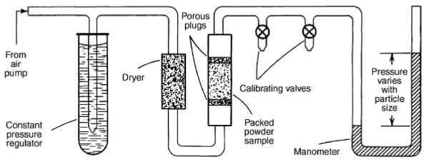

Applications and advantages of Fisher sub sieve sizer
  - Simple instrumentation and speed of determination made it possible to control batch to batch variations
  - For standardization of powder drugs
  - Ex: Bephenium hydroxy napthoate(antihelmenthic drug) is stndardised by means of air permeability method.The drug is administered as suspension should posess a specific surface of 7000cm²/g as the specific surface reduced the activity of the drug also falls
  - For the determination of specific surface of Griseofulvin

