PHYSICAL PHARMACEUTICS II BP(403T) UNIT IV (MICROMERITICS)
CLASS 30

Topic:Methods for Determining Particle Size
- Many methods are available for determining particle size are Microscopy, sieving, sedimentation, and the determination of particle volume these measurements are truly direct methods.
- The microscope allows to view the actual particles, the results obtained are probably no more direct than those resulting from other methods because only two of the three particle dimensions are ordinarily seen.
- The sedimentation methods yield a particle size relative to the rate at which particles settle through a suspending medium, a measurement important in the development of emulsions and suspensions.
- The measurement of particle volume, using an apparatus called the Coulter counter, allows one to calculate an equivalent volume diameter.
- The technique gives no information as to the shape of the particles. Thus, in all these cases, the size may or may not compare with that obtained by the microscope or by other methods.

Optical Microscopy
- It should be possible to use the ordinary microscope for particle-size measurement in the range of 0.2 to about 100 μm.
- According to the microscopic method, an emulsion or suspension, diluted or undiluted, is mounted on a slide or ruled cell and placed on a mechanical stage.
- The microscope eyepiece is fitted with a micrometer by which the size of the particles can be estimated.
- The field can be projected onto a screen where the particles are measured more easily, or a photograph can be taken from which a slide is prepared and projected on a screen for measurement.

- The particles are measured along an arbitrarily chosen fixed line, generally made horizontally across the center of the particle, measurements are the Feret diameter, the Martin diameter, and the projected area diameter.
- Martin's diameter is the length of a line that bisects the particle image. The line can be drawn in any direction but must be in the same direction for all particles measured.
- Feret's diameter, is the distance between two tangents on opposite sides of the particle parallel to some fixed direction, the y direction
- Projected area diameter, It is the diameter of a circle with the same area as that of the particle observed perpendicular to the surface on which the particle rests.
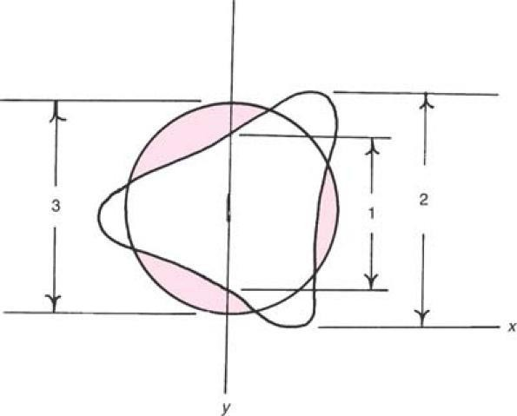
- A size frequency distribution curve can be plotted for the determination of the statistical diameters of the distribution.
- Electronic scanners have been developed to remove the necessity of measuring the particles by visual observation.

Applications:
- Useful for the size range of 0.2-100µm
- Video recording technique is used for the particle size determination of tablet excipients ex:Sodium starch glycolate, Sodium carboxymethylcellulose

Disadvantages
- A disadvantage of the micr-scopic method is that the diameter is obtained from only two dimensions of the particle: length and breadth. No estimation of the depth (thickness) of the particle is ordinarily available.
- In addition, the number of particles that must be counted are 625 if particle size distribution is wide and 100-200 if it is narrow to obtain a good estimation of the distribution makes the method somewhat slow and tedious.

Advantages:
Nonetheless, microscopic examination of a sample should be undertaken even when other methods of particle-size analysis are being used, because the presence of agglomerates and particles of more than one component may often be detected

Size range | Mean size range | Number of particles in each size range | Percent n | Cumulative frequency under size | nd | nd² | nd³ | Percent nd³ | Cumulative % frequency undersize

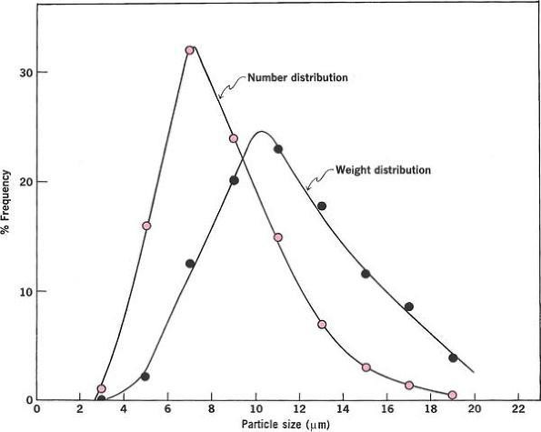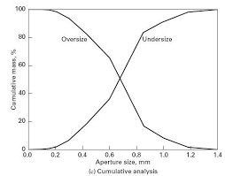
Frequency distribution curves
Frequency distribution curves

Sieving
- This method uses a series of standard sieves calibrated by the National Bureau of Standards.

- Sieves are generally used for grading coarser particles; however, sieves can be employed for screening material as fine as 44 μm (No. 325 sieve).
- Sieves produced by photoetching and electroforming techniques are available with apertures from 90 μm to as low as 5 μm.
- According to the method of the U. S. Pharmacopeia for testing powder fineness, a mass of sample is placed on the proper sieve in a mechanical shaker.
- The powder is shaken for a definite period of time, and the material that passes through one sieve and is retained on the next finer sieve is collected and weighed
- Another approach is to assign the particles on the lower sieve with the arithmetic or geometric mean size of the two screens. This method is used for size classification in analysis of the average weight of compressed tablets.
- Frequently the powder is assigned the mesh number of the screen through which it passes or on which it is retained.
- The size ranges of calamine samples were measured in this way.
- When detailed analysis required The sieves can be arranged in a nest of about five with the coarsest at the top.
- A carefully weighed sample of the powder is placed on the top sieve, and after the sieves are shaken for a predetermined period of time, the powder retained on each sieve is weighed.

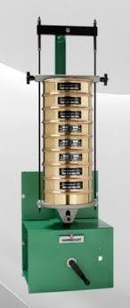
Sieve Shaker
- Sieving can be influenced by vibratory motion, Side tap motion ,bottom tap motion
,rotary tap motion and finally rotary tap motion.
- Assuming a log-normal distribution, one plots the cumulative percent by weight of powder retained on the sieves on the probability scale against the logarithm of the arithmetic mean size of the openings of each of two successive screens.
- The geometric mean weight diameter, d′g, and the geometric standard deviation, σg, can be obtained directly from the straight line.

Disadvantages
- Sieving errors can arise from
- Sieve loading
- Duration and intensity of agitation
- Sieving may result in attrition

Sieve number | Size range | Mean size | wt retained on each sieve | %wt retained | Cumulative%weight under

