PHYSICAL PHARMACEUTICS II BP(403T) UNIT IV (MICROMERITICS)
CLASS 29

TOPIC: Number and Weight Distributions Number and Weight Distributions
- Number distribution, implying that they were collected by a counting technique such as microscopy.
- Frequently, interested in obtaining data based on a weight, rather than a number, distribution.
- Although this can be achieved by using a technique such as sedimentation or sieving, it will be more convenient, if the number data are already at hand, to convert the number distribution to a weight distribution and vice versa.
- Two approaches are available. Provided the general shape and density of the particles are independent of the size range present in the sample, an estimate of the weight distribution of the data can be obtained by calculating the values. These are based on nd . These data have been plotted alongside the number distribution data.
- The significant differences in the two distributions are apparent, even though they relate to the same sample. For example, only 12% of the sample by number is greater than 11 μm, yet these same particles account for 42% of the total weight of the particles. For this reason, it is important to distinguish carefully between size distributions on a weight and a number basis.

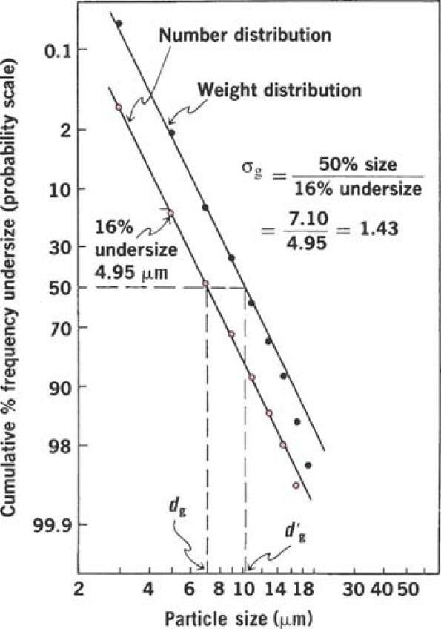
- Weight distributions can also be plotted in the same manner as the number distribution data, the slope of the line for the weight distribution is identical with that for the number distribution.
- Thus, the geometric standard deviation on a weight basis, σ′g, also equals, the prime is dropped because the value is independent of the type of distribution.
- The geometric mean diameter (the particle size at the 50% probability level) on a weight basis, d′g, μm, whereas dg, provided the distribution is log-normal.
- The second approach is to use one of the equations developed by Hatch and Choate. By this means, it is possible to convert number distributions to weight distributions with a minimum of calculation. In addition, a particular average can be readily computed by use of the relevant equation.

Particle Number
- Particle Number A significant expression in particle technology is the number of particles per unit weight, N, which is expressed in terms of dvn.

- The number of particles per unit weight is obtained as follows.
- Assume that the particles are spheres,
- the volume of a single spherical particle is Volume=4/3πr³ as r=d/2 v= Volume=(4/3)πd³/8
- Volume=πd vn3/6
- and the mass= (volume × density)
- (πd vn3 ρ )/6g / per particle=1g/N
- The number of particles per gram is then obtained from the proportion
