PHYSICAL PHARMACEITICS-IIBP403T
UNIT-III(COARSE DISPERSIONS) CLASS 26
Topic: STABILITY OF EMULSION
Creaming
- Factors of strokes equation can be altered to reduce rate of creaming
- The viscosity of external phase can be increased without exceeding the limits of acceptable consistency
- By adding viscosity improver or thickening agents such as methyl cellulose , tragcanth or sodium alginate
- The particle size of globules is reduced by homogenization(milk stability)
- If the particle size is reduced from 5micrometers to 1 micrometer the rate of creaming is reduced to 0.014cm/day
- When the particle size reduced to 2 to5 micrometers brownian motion exerts sufficient influence so that particle settles at a slower rate than predicted by strokes law
- Adjustment of densities of two phases
- Theoretically Adjusting densities of two phases to a same values should eliminate the tendency to cream
- This condition is seldom realized altering temperatures alter densities
Coalescence and breaking
- Creaming reversible process where as breaking is irreversible
- The cream floccules can be redispersed easily and a uniform mixture is reconstitued from a creamed emulsion by agitation because the oil globules surrounded by protective sheath of emulsifying agent
- When breaking occurs simple mixing fails to resuspend the globules in a stable emulsified form because film surrounding the particles has been destroyed and the oil tends to coalesce
- Aggregation : Dispersed particles come together but do not fuse.

- Coalescence is the process by which emulsified particles merge with each to form large particles.
- This type of closed packing induces greater cohesion which leads to coalescence.
- In this process, the emulsifier film around the globules is destroyed to a certain extent.
- This step can be recognized by increased globule size and reduced number of globules.
- Coalescence is observed due to:
- Insufficient amount of the emulsifying agent.
- Altered partitioning of the emulsifying agent.
- Incompatibilities between emulsifying agents.
- Particle size: reduction of particle size does not necessarily lead to increased stability
- An optimum degree of dispersion for each particular system exists for maximum stability
- As in the case of solid particles if the dispersion is non uniform the small particles wedge between larger ones permitting stronger cohesion so that the internal phase coalesce readily
- Viscosity :viscosity alone may not produce stable emulsions
- Viscous emulsions maybe more stable than mobile ones as by virtue of the retardation of flocculation and coalescence
- Probably an optimum rather than high viscosity is needed to promote stability
- Phase volume ratio of an emulsion has a secondary influence on the stability of the product and represents the relative volume of water to oil in emulsion. •
- The major factor to prevent coalescence is the mechanical strength of the interfacial film.
- If o/w emulsion having more than about 74%oil the oil globules often coalesce and the emulsion breaks
- This value is known as critical point is defined as the concentration of internal phase above which the emulsifying agent cannot produce a stable emulsion of the desired type
- In some emulsions the value may be higher than 74% owing to irregular shape and size of globules

- The phase volume ratio of 50:50 (with approximate loose packing) results in most stable emulsion
- Emulsions can be stabilized by electrostatic repulsion between the droplets by increasing zeta potential
- Lecithin is a mixture of phospholipids having negative charge at physiological pH
- The stabilizing effect is due to adsorption of at the droplet surface
- Creates negative charge and consequently electrostatic repulsion
- Ex: perfluoro carbon emulsions stabilized by lecithin-blood substitute Triglyceride acids in water for i.v administration stabilized by lecithin
- However the stability of emulsion is poor because in clinical practice they are mixed with electrolytes ,amino compounds and for total parenteral nutrition
- The addition of positively charged species such as sodium and calcium ions or cationic amino acids the charge on the latter depends on pH and reduces zeta potential cause flocculation
- Heparin an anticoagulant is a negatively charged polyelectrolyte that causes rapid flocculation in emulsions containing calcium and lecithin
- The critical flocculation concentration occurs at a specific zeta potential
- The value of zeta potential can be determined by plotting the flocculation rate against surface potential and extrapolating to zero flocculation rate
- Divalent electrolytes strongly bound to the surface of droplets stabilized by lecithin to form 1:2 ion-lipid complex
- Cause a charge reversal on the droplets leading to positively charged particles
- The droplets are then flocculated by bridging of the negatively charged heparin molecules across the positively charged particles

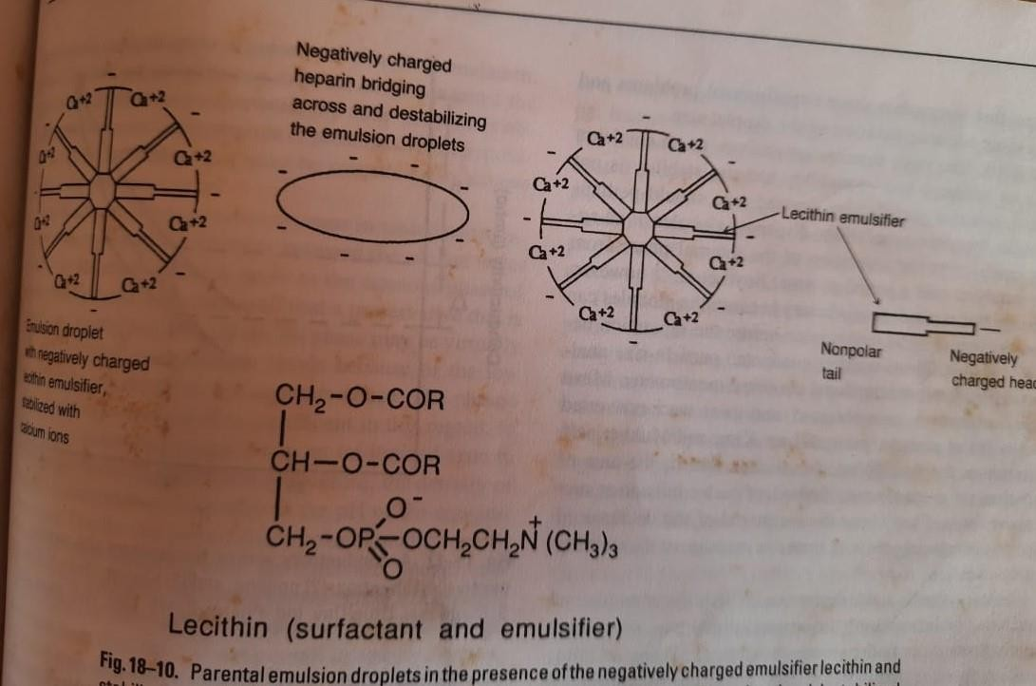

- When oil phase which usually carries negative charge are surrounded by film of emulsifier non ionic agent the electrokinetic effects are less significant in maintaining stability
- To be effective an emulsifier film must be tough and elastic and should form rapidly during manufacture
- A good emulsifier or combination of emulsifiers brings about a preliminary lowering of interfacial tension to produce small uniform globules and form rapidly to protect the globules from reaggregation during manufacture
- The film then slowly increase in strength over a period of days or weeks
Breaking:
Breaking is the destroying of the film surrounding the particles.
- Separation of the internal phase from the external phase is called breaking of the emulsion.
- This is indicated by complete separation of oil and aqueous phases, is an irreversible process, i.e., simple mixing fails.
- It is to re-suspend the globules into an uniform emulsion.

- In breaking, the protective sheath around the globules is completely destroyed and oil tends to coalesce.
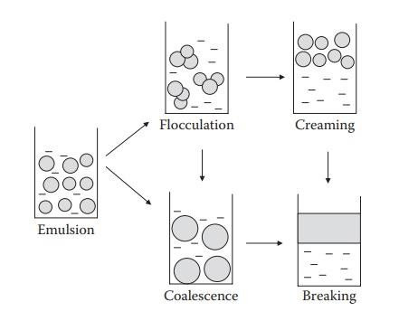
Phase Inversion
- This involves the change of emulsion type from o/w to w/o or vice versa.
- When intend to prepare one type of emulsion say o/w, and if the final emulsion turns out to be w/o, it can be termed as a sign of instability.
- An o/w emulsion stabilized with sodium chloride inverted to w/o type by adding calcium chloride to form calcium stearate
- Can also produced by alterations in phase volume ratio
- In the manufacture of an emulsion one can mix o/w emulsifier with oil and then add small amount of water
- Because the volume of water is small compared with that of oil the water is dispersed by agitation in the oil eventhough emulsifier forms an oil in water system
- As more water is slowly added invertion point gradually reached and emulsifier envelop the oil globules results in o/w emulsion

- Used in preparation of commercial emulsions and is the principle of continental method used in compound practice

