PHYSICAL PHARMACEITICS-IIBP403T UNIT-III(COARSE DISPERSIONS)
Class25:

Topic: Multiple emulsions
- Multiple emulsion are complex system which consist of both w/o and o/w at the same time.
- There are potential matrices for the encapsulation of biactive compounds and for the controlled release compounds
- w/o/w multiple emulsion are system where small water droplets are entrapped within larger oil droplets and they are disperse continous water phase
- Because of presense of reservoir phase that can be use to prolong release of active ingredients.
- This is made possible by double emulsification hence the systems are also called as “Double emulsions”.
- These are also called as “Liquid membrane systems” as the liquid film which separates the liquid phases acts as a thin semipermeable film through which solute must diffuse in order to transverse from one phase to another.
- Multiple emulsions are thermodynamically unstable.
- They are often stabilized by using a combination of hydrophilic & hydrophobic surfactants.
The ratio of these surfactants is important in achieving stable multiple emulsions
- Multiple emulsion w/o/w contain two emulsifiers:
- Low HLB surfactant (Hydrophobic in nature)
- High HLB surfactant (Hydrophilic in nature)
- Low HLB surfactant use in disperse phase High HLB surfactant use in continuous phase

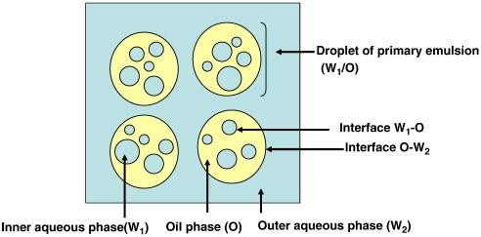
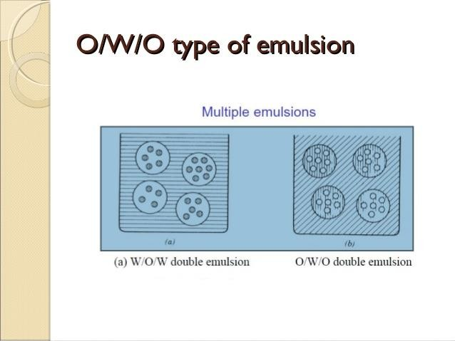
- Ex: o/w/o emulsions are formed better by lipophilic non ionic surfactant using gum acacia emulsified system

- w/o/w emulsions may be prepared first by forming w/o emulsion from isopropylmyristate (oil), sorbitan oleate(emulgent) and distilled water this emulsion is added to polyoxyethylene sorbitan mono oleate solution in water to produce finally w/o/w emulsion

Multiple emulsions-Applications
- Prolonged action
- Taste masking
- More effective dosage forms
- Parenteral preparations
- Protection of drug from external environment and enzyme entrapment

Selection of Emulsifier
- Depend on the use to which emulsion is required
- Weather emulsion meant for external, internal or parenteral

First method
- Selection based on HLB
- To produce emulsions of o/w type emulsifiers in the HLB range of 8-18 are used
- For W/O type emulsifiers in the range of HLB 3-6 are tried

Second method
- Alligation method:HLB values are algebrically additive
- By taking emulsifiers with low HLB values and High HLB values proportions of the emulsifiers required to produce the required HLB value maybe worked out
- Two emulsifiers of HLB values 3 and 18 to get a HLB value 10 the required proportions can be obtained as follows
3(lower value) 8(higher desired value) 10
18(higher value) 7(lower desired value)

- The selection of emulsifiers from the knowledge of their hydrophilic and lipophilic behaviour of the type of emulsion produced with a given lipid or aqueous phase
- This approach is most readily illustrated with non ionic surfactants but the principles involved can be extrapolated to any type of emulsifier or combination of emulsifiers
- The HLB value of the surfactants based on polyhydric alcohol fatty acid esters may be estimated by
- HLB=20(1-S/A)
- S= saponification number of the ester
- A= acid number of the acid
- If saponification number is not known(ex:beesax and lanolin derivatives) their HLB values can be calculated by HLB=(E+P/5)
- E=weight percent of oxyethylene chains
- P= weight percent of the polyhydric alcohol groups(glycerolor sorbitol)
- If the hydrophilic region is polyoxyethylene the HLB value is calculated by HLB=E/5
- Another useful means of finding of HLB of an emulsifiers is that proposed by Davies which permits calculation of the HLB value by algebrically adding the values assigned to a particular atomic grouping within the molecule of the emulsifier
- HLB of surfactant=∑(hydrophilic groups)- ∑(hydrophobic groups)+7
- Occasionally it will be found that a single emulsifier can yield the desired viscosity
- In case of o/w emulsions stable emulsions can be prepared readily by utilizing a combination of a lipophilic and hydrophilic surfactant
- Such combinations appear to produce mixed interfacial phase of high surface coverage as well as of sufficient viscosity to prevent creaming and promote stability
- The HLB value of the mixture of surfactants A and B calculated by
- HLBmixture=faxHLBA+(1-fA)XHLBB
- fA is the weight fraction of surfactant A in the mixture

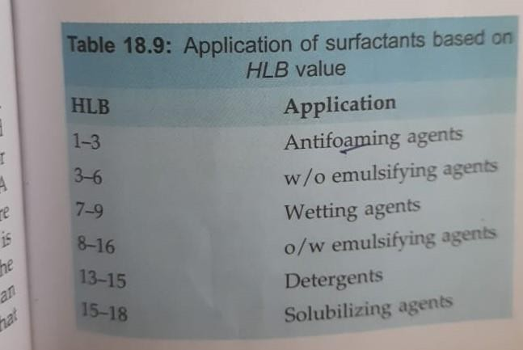

Required HLB value
- Hlb values of combinations may be determined by taking weighted averages of the individual surfactant HLB values
- Any HLB value can be obtained by a blend of emulsifiers with the additional advantage in most cases or greater efficiency at lower concentration
- The blending of two emulsifiers of very low HLB value and very high HLB value can result in an unstable emulsion unless an emulsifier of medium HLB is included
- w/o emulsion of lanolin requires an HLB of about 8 a 68:32 mixture of sorbitan monostearate (HLB4.7) and polyoxyethylene(20)sorbitan monooleate(HLB 15.0) could be used to yield an emulsifier exhibiting an average HLB value of 8

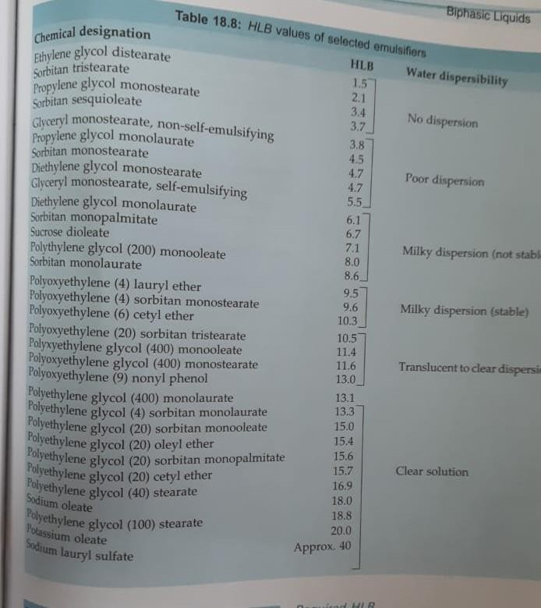

Phase inversion temperature
- As a rule maximum particle size reduction occurs at or near PIT
- At PIT surfactant that are normally water soluble may actually become soluble in oil phase
- As the emulsion cools emulsifier migrates
- Ex: by changing their location from internal to the external phase of the emulsions
- However the emulsification will be successful regardless of the location of the emulsifier as long as the temperatures exceeds the PIT during emulsification

Determination of Surfactant amount
- The surfactant mixture of which the least amount is required for optimal stability of an emulsion
- This goal can be achieved by determining the amount of water that can be solubilized in a given oil-plus-surfactants mixture under carefully controlled temperature and agitating conditions

- For this purpose 10g of the lipid/surfactant mixture is weighed into a 68ml capacity square glass vial
- After equilibration at a temperature at which this system is fluid water is added in 0.1ml increments
- The mixture is shaken and allowed to stand at equilibration temperature until all air bubbles have escaped
- The addition of water is continued until the system remains permanently turbid
- If the initial lipid/surfactant mixture is not clear it usually become clear upon the addition of water and then become cloudy again upon continued addition of water
- This second cloud point is the end of titration
- As a rule the most stable o/w emulsion with the finest particle size results at the surfactant/oil ratio that can tolerate the largest quantity of water and still remain clear

HLB system shortcomings
- There is no assurance that a stable emulsion prepared from one class of emulsifiers at a particular HLB can be duplicated by another class of emulsifiers exhibiting same HLB
- Marked difference in emulsion type, viscosity and time for phase separation were noted when polyoxyethylene ether derivatives when compared to polyoxyethylene ester type surfactants having same HLB and concentration
- Additional complications arise from the observation that HLB required for a particular emulsion depends on salt content and on phase ratio
- Improvement in the classical HLB is the phenol index –possible to determine the effective HLB of non-ionics as a function of concentration and in the presence of additives such as alcohols, and glycols
- Stable mineral oil –in-water emulsions have been obtained with a combination of non ionic ethers having an HLB value as low as 1.9

