PHYSICAL PHARMACEUTICS II BP(403T) UNIT III (COARSE DISPERSION)
CLASS 21
TOPIC: CONTROLLED FLOCCULATION

Surfactants:
- Both ionic and non-ionic surfactants are capable of doing flocculation of the suspended particles.
- At a particular concentration, the surfactants trim down the surface free energy by reducing the interfacial tension between the liquid medium and solid drug particles. This may lead to form closely packed agglomerates.
- However, at a particular surfactant concentration, when the particles possess less surface free energy, they are attracted towards each other by Van der Waal’s force and form a loose agglomerate.
- Ionic surfactants cause flocculation by neutralizing the charge on each particle, resulting into a flocculated suspension.
- When the surfactants reduce the interfacial tension, the liquid becomes capable of displacing the adsorbed film of air from the surface of solid drug particle and facilitating wetting.
Hence, the concentration of surfactant needs to be adjusted very carefully as it facilitates the wetting and also functions as a deflocculating agent to achieve dispersion
POLYMERS
- Addition of xanthan gum resulted in increased sedimentation volume presumably by a polymer bridging phenomenon
- Hydrophilic polymers also act as protective colloids and particles coated in this manner are less prone to cake than are uncoated particles

- Polymers exhibit pseudo plastic flow in solution and serves to promote physical stability within the suspension
- Gelatin a poly electrolytic polymer exhibit flocculation that depends on pH and ionic strength of the dispersion medium
- Sodium sulfathiazole, precipitated from acid solution in the presence of gelatin ,to be free flowing in the dry state and not to cake when suspended
- Sulfathiazole carries negative charge in aqueous vehicles
- The coated material precipitated from acid solution in the presence of gelatin carries positive charge
- Because gelatin being positively charged at the pH at which precipitation occurs
- Improved properties result from the positively charged gelatin coated particles being partially flocculated in suspension
- Positively charged liposomes has been used as flocculating agents for negatively charged particles
- Liposomes are vesicles of phospholipids having no toxicity that can be prepared in various particle sizes
- Adsorbed on the negatively charged particles
- Polymers are high molecular weight compounds with long-chain in their structure. They play an important role as a flocculating agent.
- The mechanism of polymer induced flocculation is less well understood than the inorganic electrolytes.
- The function of a polymer in place depends on its affinity for the particle surface as well as charge, size and orientation of it in the continuous medium.
- Many polymers have polar functional groups in its hydrocarbon backbone. As a result of this, the polymer molecule may adsorb on the particle surface and maintain a degree of interaction with the liquid continuous medium.

- Polymers can produce both flocculated and deflocculated suspensions.
- An ionic polymer has the potential to affect the zeta potential of a particle in a manner similar to inorganic electrolytes.
- The flocculating role of a polymer is due to the bridging of the polymer between the surfaces of different particles.
- At a higher concentration, sufficient binding sites are available on the particles, permitting additional inter-particle attachments to form. At the intermediate concentration, optimum flocculation and sedimentation volume takes place.
- At high concentration, complete coverage of the particle surface with polymer occurs and insufficient binding sites remains to permit interparticle bridging which results into a low degree of flocculation.
- This high concentration of polymer also prevents the close association of individual particles by a phenomenon known as steric stabilization.
- Steric stabilization is the ability of adsorbed polymers to prevent close approach and cohesion of dispersed particles due to the energetically unfavourable conditions.
- Suspension formulated with a relatively high concentration of polymer would be deflocculated with small sedimentation volume
- The conformation of the polymer in the continuous phase may also have an effect on the degree of flocculation.
- At concentration where flocculation occurs, polymers having a linear conformation in the continuous phase will be more effective flocculants than the polymers that are coiled.
- In many cases, a combination of polymer and inorganic electrolyte are used to achieve flocculation.
- Generally, the sensitivity of the dispersed solid particles for flocculation is enhanced by electrolytes when used in presence polymers.


Controlled Flocculation
Polymer concentration | Low | Medium | High
Sedimentation volume | Similar to drug | High | low
 | 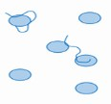 | 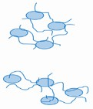 | 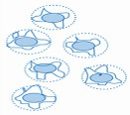

Controlled flocculation of Structured vehicle
- Structured vehicles are aqueous dispersions of natural and synthetic gums.
- When the gums are dispersed homogeneously in the aqueous medium, its viscosity increases. That is why they are also known as thickening agents.
- This thickness of the continuous medium retards the settling of the individual particles of a suspension. Hence the structured vehicles are also known as suspending agents.
- It is important to note that too high viscosity may cause causes difficulty in pouring and administration.
- It may also affect the absorption of the drug since the polymeric counterparts are adsorbed onto the surface of the particle and thus suppress the rate of dissolution.
- From the stability point of view, suspensions that contain discrete solid particles may be regarded as stable. But in practice, the sedimentation of the solid particles occurs on long standing due to its size.

- Smaller the particle size, more the surface free energy. These highly energetic finer particles tend to release the energy associated with them.
- As a result, the particles approach each other and form a closely packed structure. This structure is heavier and sediment at the bottom and the smaller particles fills within the voids of larger particles leaving a cloudy supernatant liquid due to colloidal particles.
- The particles of the lowest layer are pressed by the weights of the particles above them thus overcoming the electric repulsive barrier. This leads to the formation of hard cake which is very difficult to redisperse upon shaking.
- The construction of structured vehicle ensures the formation of deflocculated suspension.
- Under such formation, if the principle of flocculation is applied, it may produce floccules that will settle rapidly but the dispersion of it could be achieved with ease.
For successful flocculation in the structured vehicle, need an appropriately charged flocculating agent or flocculent and a hydrocolloid as a protective colloid
- Although the controlled flocculation approach is capable of fulfilling the desired physical chemical requisites of a pharmaceutical suspension, the product can look unsightly if F, the sedimentation volume, is not close or equal to 1.
- Consequently, in practice, a suspending agent is frequently added to retard sedimentation of the flocs
- Such agents as carboxymethylcellulose, Carbopol 934, Veegum, tragacanth, and bentonite have been employed, either alone or in combination.
- This can lead to incompatibilities, depending on the initial particle charge and the charge carried by the flocculating agent and the suspending agent.

- For example, a dispersion of positively charged particles is prepared then flocculated by the addition of the correct concentration of an anionic electrolyte such as monobasic potassium phosphate.
- the physical stability of this system can be improved by adding a minimal amount of one of the hydrocolloids .
- No physical incompatibility will be observed because the majority of hydrophilic colloids are themselves negatively charged and are thus compatible with anionic flocculating agents.
- If, a flocculated suspension of negatively charged particles with a cationic electrolyte (aluminum chloride), the subsequent addition of a hydrocolloid may result in an incompatible product, as evidenced by the formation of an unsightly stringy mass that has little or no suspending action and itself settles rapidly.
- Under these circumstances, it becomes necessary to use a protective colloid to change the sign on the particle from negative to positive
- This is achieved by the adsorption onto the particle surface of a fatty acid amine (which has been checked to ensure its nontoxicity) or a material such as gelatin, which is positively charged below its isoelectric point.
- It is able to use an anionic electrolyte to produce flocs that are compatible with the negatively charged suspending agent.

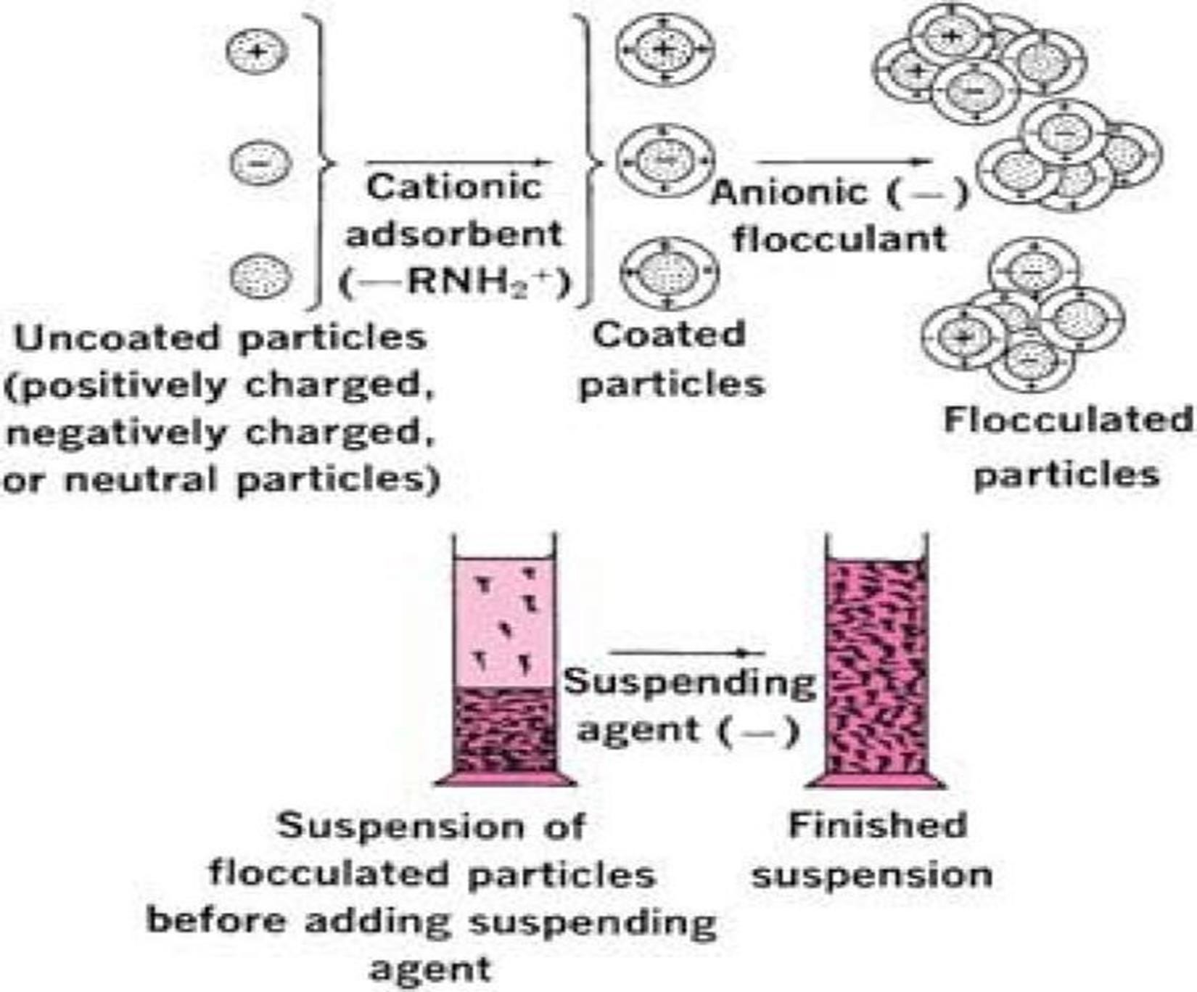

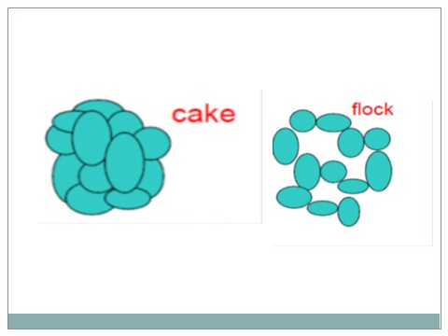

Flow chart focusing the approaches for formulation of suspension
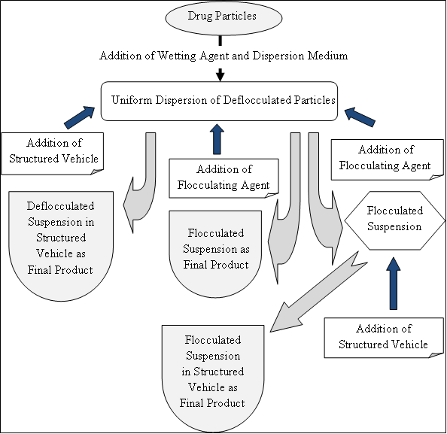

- There is another approach which may produce a stable suspension.

- In this approach irrespective to the charge of drug particles whether positive, negative or neutral, it will be coated first with a positively charged protective colloid.
- This will transform all types of charged particles coated with a colloid of positive charge.
- At this moment if negatively charged flocculant is used, it will produce a stable suspension

Rheological considerations
- Rheology can be applied to study the following factors:
- The viscosity of a suspension –as it effects the settling of dispersed particles
- Change in flow properties of the suspension when the container is shaken and when the product is poured from the bottle
- Spreading qualities of a lotion when it is applied to the effected area
- The only shear that occurs in a suspension in storage is due to settling of suspended particles , this force is negligible
- When the container is shaken and the product is poured from the bottle a high shearing rate is manifested
- An ideal suspending agent should have high viscosity at negligible shear that is during shelf storage
- It should have a low viscosity at high shearing rate that it should be free flowing during agitation, pouring and spreading
- Ex: pseudoplatic materials like tragacanth, sodium carboxy methyl cellulose shows these desirable properties
- A suspending agent that is thixotropic as well as pseudoplastic should prove to be useful because it forms a gel on standing and becomes fluid when disturbed

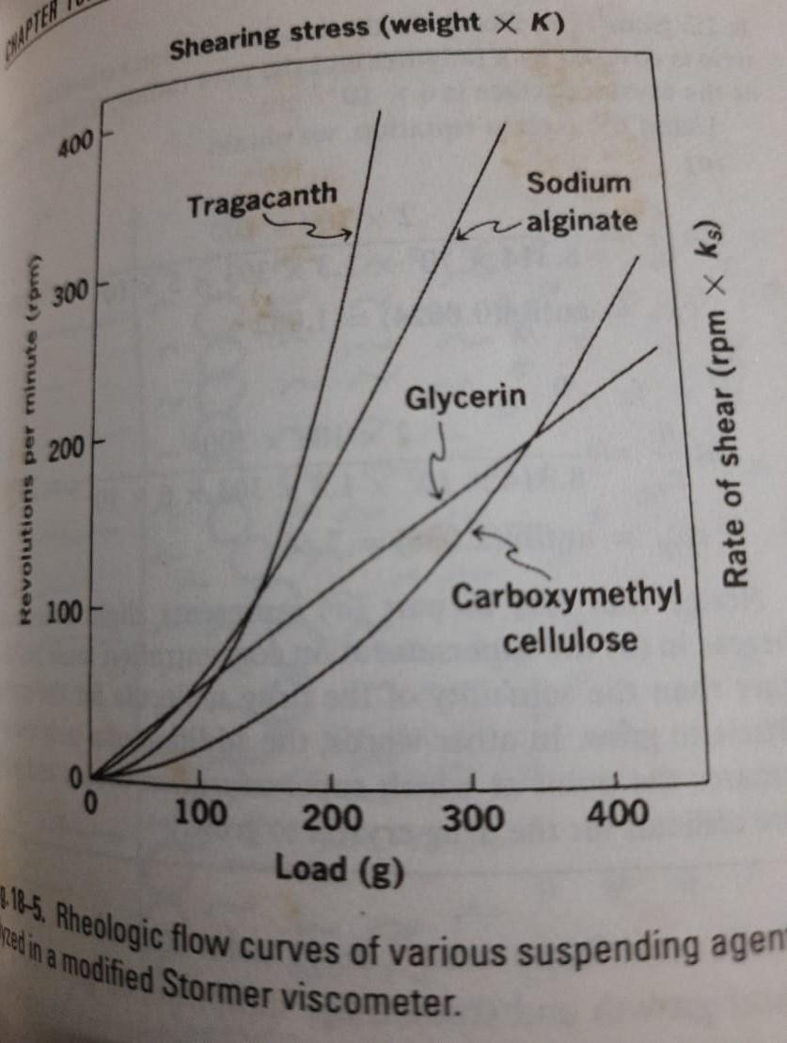
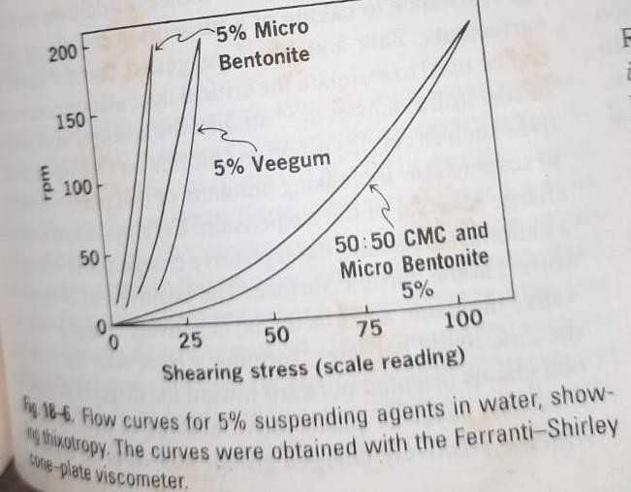

- Hysteresis loop of bentonite is quite marked
- Veegum shows considerable thixotropy
- The combination of bentonite and carboxymethyl cellulose dispersion shows both pseudoplastic and thixotropic characteristics should produce an excellent suspending medium
PHYSICAL STABILITY OF SUSPENSIONS
- Raising temperature often leads to flocculation of sterically stabilized suspensions
- Repulsion due to steric interaction depending on the nature thickness and completeness of the surfactant-adsorbed layers on the particles
- When suspension is heated the energy of repulsion between the particles can be reduced owing to dehydration of polyoxy ethylene groups of surfactant
- The attractive energy increased and particles flocculate

Freeze-thaw cycles :
- During freezing particles overcome the repulsive barrier caused by ice formation which forces the particles close enough to experience strong attractive forces present in the primary minimum and form aggregates according to DLVO theory
- When ice melts the particles remain as aggregates unless work is applied to overcome the energy peak
- Aggregate size was found to be inversely related to freezing rate
- The higher the freezing rate the smaller is the size of ice crystal formed
- Small ice crystals do not result in the aggregation of many suspension particles as do large ice crystal

Particle Growth:
- Resulting from temperature fluctuation or ostwald ripening during storage

- temperature fluctuation can change particle size distribution and polymorphic form of a drug, altering absorption rate and bioavialability
- Particle growth rate is particularly important when solubility of the drug is dependent on temperature
- When temperature raised crystals of drug may dissolve and form supersaturated solution which favor crystal growth can be avoided by adding polymers and surfactants
- ex: inhibition of sulfathiazole crystal growth by adding PVP
- Polymer forms a non condensed net like film over the sulfathiazole crystal allowing crystal grow out only through the openings of the net
- Growth is controlled by the pore size of the polymer network at the surface smaller the pore size higher is the super saturation of the solution required for the crystals to growth
- Ex: inhibition of crystal growth by PVP in acetaminophen suspension
- PVP attach to the free space on the drug crystal lattice and the polymer is surrounded by hydration shell
- The adsorbed segments of the polymer inhibits crystal growth of acetaminophen because they form a barrier that impeds the approach of the drug molecules from the solution to the crystal surface
- High molecular weight polymers of PVP are more effective than low molecular weight polymers because adsorption becomes more irreversible as the chain lenghth increases

- 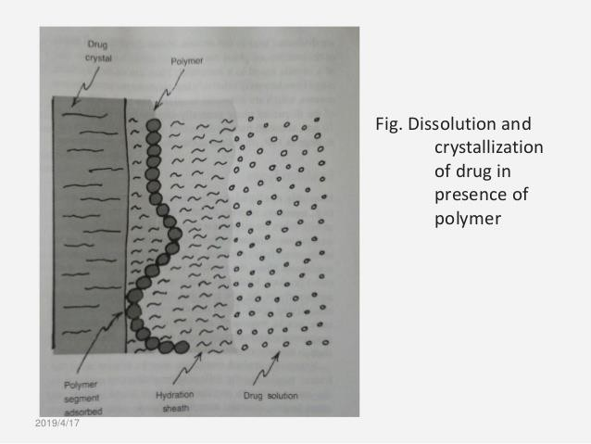

Interaction with excipients
- Ex: flocculation by sorbitol in sulfamerazine suspension containing non ionic surfactants as wetting agents
- Flocculation depends on cloud point of surfactant
- The lower the cloud point the less sorbitol was needed to induce flocculation
- Cloud point can be lowered by preservative such as methyl paraben
- Adsorption of preservative cetylpyridinium chloride a cationic surfact has a positive charge is strongly adsorbed at the particle surface
- The positive end of the preservative molecule adsorbs on negatively charged surface of zinc oxide particles forming a layer with hydrocarbon chain orientsd towards the dispersion medium
- A second layer of preservative adsorbs at this monolayer with positively charged groups now directs towards the dispersion medium

- Physical stability of suspension enhanced owing to the repulsion of likely charged particles however strong adsorption of the preservative on the zinc oxide particles reduces the biologically active free fraction of preservative in the dispersion medium and the microbiological activity is diminished

