PHYSICAL PHARMACEUTICS II BP(403T) UNIT III(COARSE DISPERSIONS)
CLASS 20

TOPIC: Formulation of flocculated and deflocculated suspensions.
- When sedimentation is studied in flocculated systems, it is observed that the flocs tend to fall together, producing a distinct boundary between the sediment and the supernatant liquid.
- The liquid above the sediment is clear because even the small particles present in the system are associated with the flocs.
- It is not the case in deflocculated suspensions having a range of particle sizes, in which, in accordance with Stokes's law, the larger particles settle more rapidly than the smaller particles
- No clear boundary is formed (unless only one size of particle is present), and the supernatant remains turbid for a considerably longer period of time.
- Whether the supernatant liquid is clear or turbid during the initial stages of settling is a good indication of whether the system is flocculated or deflocculated, respectively.
- The initial rate of settling of flocculated particles is determined by the floc size and the porosity of the aggregated mass.
- Subsequently, the rate depends on compaction and rearrangement processes within the sediment.
- The term subsidence is sometimes used to describe settling in flocculated systems

SEDIMENTATION PARAMETERS
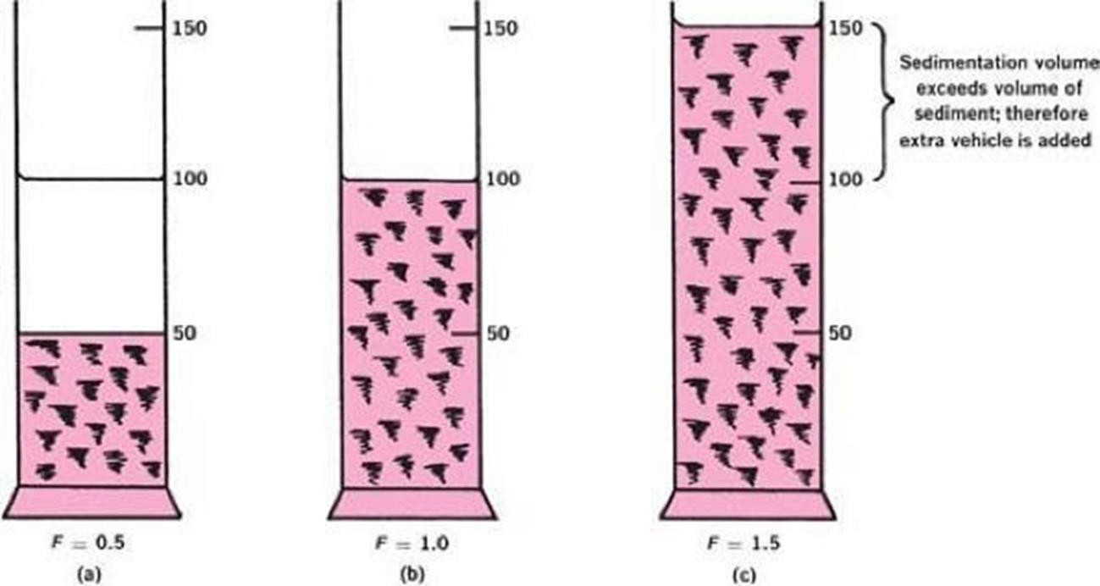
- Two useful parameters that can be derived from sedimentation (or, more correctly, subsidence) studies are sedimentation volume, V, or height, H, and degree of flocculation.
- The sedimentation volume, F, is defined as the ratio of the final, or ultimate, volume of the sediment, Vu, to the original volume of the suspension, Vo, before settling. Thus,
- F = Vu/ Vo
- The sedimentation volume can have values ranging from less than 1 to greater than 1.

- F is normally less than 1, and in this case, the ultimate volume of sediment is smaller than the original volume of suspension. Figure a, in which F = 0.5.
- If the volume of sediment in a flocculated suspension equals the original volume of suspension, then F = 1 Figure b.
- Such a product is said to be in flocculation equilibrium and shows no clear supernatant on standing.
It is therefore pharmaceutically acceptable
- It is possible for F to have values greater than 1, meaning that the final volume of sediment is greater than the original suspension volume.
- This comes about because the network of flocs formed in the suspension is so loose and fluffy that the volume they are able to encompass is greater than the original volume of suspension.
- This situation is illustrated in Figure c, in which sufficient extra vehicles have been added to contain the sediment(F = 1.5).
- The sedimentation volume gives only a qualitative account of flocculation .
- A more useful parameter for flocculation is β, the

degree of flocculation.
- consider a suspension that is completely deflocculated, the ultimate volume of the sediment will be relatively small.
- Writing this volume as V∞, based on equation
- F ∞ = V∞/V o
- Where
- F ∞ = sedimentation volume of the deflocculated, or peptized, suspension.
- The degree of flocculation, β, is therefore defined as
- the ratio of F to F∞,

- β = F/ F∞
- Substituting equations
- β = Vu/V o
- V∞/V o
- β = Vu/ V∞
- The degree of flocculation is a more fundamental parameter than F because it relates the volume of flocculated sediment to that in a deflocculated system.
- Hence β can be written as
- β= ultimate sediment volume of flocculated suspension / ultimate sediment volume of deflocculated suspension


Differences between deflocculated and
flocculated suspensions

- Deflocculated Suspension
1. Pleasant appearance as particle are uniformly dispersed.
2. Supernatant is clear.
3. Particle experience repulsive force.
4. Rate of sedimentation is slow.
5. Particle settle independently
- and separately.
6. Sediment is closely packed and form
hard cake.
7. The re-dispersion of a sediment formed in a deflocculated suspension is difficult by agitation.
8. In potential energy curve it
represent primary minimum.
9. Bioavailability is relatively high.
- Flocculated Suspension
1. Unpleasant in appearance.

2. Supernatant is cloudy.
3. Particle experience attractive force.
4. Rate of sedimentation is fast.
5. Particle settle as floccs.
6. Sediment are loosely pack net
  - work.
7. The re-dispersion of a sediment formed in a flocculated
suspension can easily be
done by agitation
8.In potential energy curve it represent secondary minimum.
7. Bioavailability is comparatively less

FORMULATION OF SUSPENSIONS
- The approaches commonly used in the preparation of physically stable suspensions fall into two categories
  - The use of a structured vehicle to maintain deflocculated particles in suspension
  - The application of the principles of flocculation to produce flocs that, although they settle rapidly, are easily re-suspended with a minimum of agitation.
- Structured vehicles are pseudo plastic or plastic in nature, thixotropy associated with these type of flow
- Act by entrapping particles (generally deflocculating) so that ideally no settling occurs
- In reality usually some degree of sedimentation takes place
- The shear thinning property of vehicles facilitate the reformation of a uniform dispersion when shear is applied
- A disadvantage of deflocculated systems is that formation of a compact cake when the particles eventually settle.
- It is for this reason that the formulation of flocculated suspensions has been advocated.
- Optimum physical stability and appearance will be obtained when the suspension is formulated with flocculated particles in a structured vehicle of the hydrophilic colloid type.
- Whatever approach is used, the product must

flow readily from the container
- possess a uniform distribution of particles in each dose. WETTING OF PARTICLES

  - The initial dispersion of an insoluble powder in a vehicle is an important step in the manufacturing process and requires further consideration.
- Powders sometimes are added to the vehicle, particularly in large-scale operations, by dusting on the surface of the liquid.
- It is frequently difficult to disperse the powder owing to an adsorbed layer of air, minute quantities of grease, and other contaminants.
- The powder is not readily wetted, and although it may have a high density, it floats on the surface of the liquid.
- Finely powdered substances are particularly susceptible to this effect because of entrained air, and they fail to become wetted even when forced below the surface of the suspending medium.
- The wettability of a powder can be ascertained easily by observing the contact angle that powder makes with the surface of the liquid.
- The angle is approximately 90° when the particles are floating well out of the liquid.
- A powder that floats low in the liquid has a lesser angle, and one that sinks obviously shows no contact angle
- Powders that are not easily wetted by water and accordingly show a large contact angle, such as sulfur, charcoal, and magnesium stearate, are said to be hydrophobic.
- Powders that are readily wetted by water when free of adsorbed contaminants are called hydrophilic. Zinc oxide, talc, and magnesium carbonate belong to the latter class.
- Surfactants are quite useful in the preparation of a suspension in reducing the interfacial tension between solid particles and a vehicle.
- As a result of the lowered interfacial tension, the advancing contact angle is lowered, air is displaced from the surface of particles, and wetting and deflocculation are promoted

- Ex: deflocculating effect of octoxynol a nonionic surfactant enhances the dissolution rate of prednisolone from tablets
- The tablet breakup into fine granules that are deflocculated in suspension
- Deflocculating effect is proportional to surfactant concentration Glycerin is useful in levigating the insoluble material
  - Glycerin flows into voids between the particles to displace the air and during
the mixing operation coats and separates the material so that water can penetrate and wet the individual particles
  - The dispersion of particles of colloidal gums by alcohol, glycerin and propylene glycol allowing water to subsequently penetrate into interstices is a well known practice in pharmacy
  - Flocculation is a process of making loose contact or adhesion of the particles dispersed in a liquid medium.
  - This phenomenon is materialized by a precise balance of attractive and repulsive forces between the dispersed particles of the liquid medium.
  - This flocculation may be controlled by the optimum elevation of the force of attraction over the force of repulsion, resulting into a larger size cluster or a network like structure.
.
  - The term flocculation may carry a negative connotation but in many cases, by controlling this flocculation , may actually produce a more desirable featured suspension than the de-flocculated one.
  - An uncontrolled flocculation, on the other hand, may cause too much precipitate, reduce gloss and increase the viscosity.
  - Thus it is very important to control the flocculation to make a stable and therapeutically effective dosage form

  - Assuming that the powder is properly wetted and dispersed, now consider the various means by which controlled flocculation can be produced so as to prevent formation of a compact sediment that is difficult to redisperse.
  - Materials used to produce flocculation in suspensions is electrolytes, surfactants and polymers
Electrolytes act as flocculating agents by reducing the electric barrier between the particles, as evidenced by a decrease in the zeta potential and the formation of a bridge between adjacent particles so as to link them together in a loosely arranged structure
  - The electrolytes act by altering the zeta potential of the dispersed particles of the suspension.
  - The zeta potential is the difference in potential between the surface of the tightly bound layer (shear plane) of the dispersed particle and the electro-neutral region of the bulk.
  - When the electrolytes lower the zeta potential to a particular value, the electrical barrier between the dispersed particles reduces and the particles approach each other. This results into flocculation in place.
  - The flocculation ability of an electrolyte depends on its valency. The divalent ions are ten times more effective then the monovalent ions while trivalent ones are thousand times more effective.
  - Being more efficient, the application of trivalent ions is limited because of their toxicity.
  - The most widely used electrolytes as flocculating agent include sodium salts of chlorides, acetates, phosphates and citrates.
The concentration of the electrolytes must be optimum to achieve flocculation otherwise, any excess quantity may cause a reversal of this and may lead to deflocculation
- If particles of bismuth subnitrate dispersed in water, it was find that, they possess a large positive charge, or zeta potential.

- Because of the strong forces of repulsion between adjacent particles, the system is deflocculated.
- By preparing a series of bismuth subnitrate suspensions containing increasing concentrations of monobasic potassium phosphate, it gives a correlation between apparent zeta potential and sedimentation volume, caking, and flocculation
- The addition of monobasic potassium phosphate to the suspended bismuth subnitrate particles causes the positive zeta potential to decrease owing to the adsorption of the negatively charged phosphate anion.
- With the continued addition of the electrolyte, the zeta potential eventually falls to zero and then increases in the negative direction, as shown in Figure.
- At a particular concentration range of monobasic potassium phosphate, the deflocculated bismuth subnitrate suspension becomes flocculated. This conversion is evident by the absence of caking with a concomitant increase in sedimentation volume.
- Microscopic examination of the various suspensions shows that at a certain positive zeta potential, maximum flocculation occurs and will persist until the zeta potential has become sufficiently negative for deflocculation to occur once again.
- The onset of flocculation coincides with the maximum sedimentation volume determined.
- When the zeta potential becomes sufficiently negative, all the bismuth subnitrate particles behave like a negatively charged species and the repulsive force again dominate
- F remains reasonably constant while flocculation persists and only when zeta potential becomes sufficiently negative to effect repeptization does the sedimentation volume starts to fall
- Finally the absence of caking in the suspension correlated with the maximum sedimentation volume

- Similar correlation Aluminium chloride was added to a suspension of sulfamerazine in water
- Initial zeta potential is negative when sufficient electrolyte is added the zeta potential reaches zero and increases in positive direction
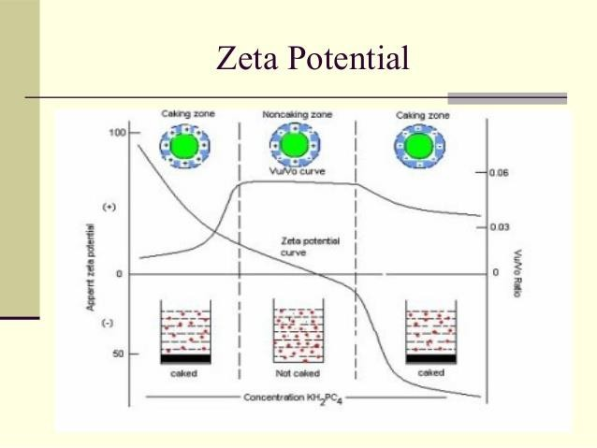
  - Colloidal and coarse dispersed particles can posess surface charge depend on pH of the system
  - Zero point of charge is the pH at which the net surface charge is zero
  - Desired charge can be achieved through adjusting the pH by the addition of HCl or NaOH to produce a positive,zero or negative surface charge
  - The negative zeta potential of nitrofurantoin decreases considerably when the pH values changes from basic to acidic

