PHYSICAL PHARMACEUTICS-II BP403T

CLASS 8
TOPIC: Rheology Introduction Newtons law Non Newtonian systems
- rheo – to flow
- logos – science
- Rheology is the study of the flow and deformation of matter under stress.
- Viscosity :is an expression of the resistance of a fluid to flow Higher the viscosity greater the resistance
Importance in pharmacy
- Formulation of medicinal and cosmetic creams, pastes and lotions.
- Formulation of emulsions, suspensions, suppositories, and tablet coating.
- Fluidity of solutions for injection.
- In mixing and flow of materials, their packaging into the containers,
- their removal prior to use, the pouring from the bottle.
- Extrusion of a paste from a tube .
- Passage of the liquid to a syringe needle
- Spreading lotion on the skin
- Spraying liquids from aerosols and atomizers
- Drug release from dosage forms and delivery systems is often controlled by rheological properties
- Viscosity has been shown to affect absorption from GI tract
- Influence the choice of processing equipments in the pharmaceutical system
- Passage of ointments in colloidal mill

- Use of roller mills for compacting powders or processing ointments
- Mechanical properties of glass or plastic and rubber polymeric closures
- Manufacturing of dosage forms: Materials undergo process such as mixing, flowing through pipes, filling into the containers etc. Flow related changes influence the selection of mixing equipment.
- Handling of drugs for administration: The syringibility of the medicines, the pouring of the liquids from containers, extrusion of ointment from tubes, all depend on the changes in flow behavior of dosage forms.
NEWTONS law of flow
- consider a block of liquid consisting of parallel layer of molecules, similar to a deck of cards, when pressure is applied horizontally on the top layer ‘A’ The liquid begin to flow velocity since force is applied on the top layer (A),
- it moves at greater velocity while moving ahead, the first layer (A) induces flow in the second layer (B).
- The velocity of second layer (B) is somewhat less than that off the first layer (A), because of the viscous drag offered by the third layer (C).

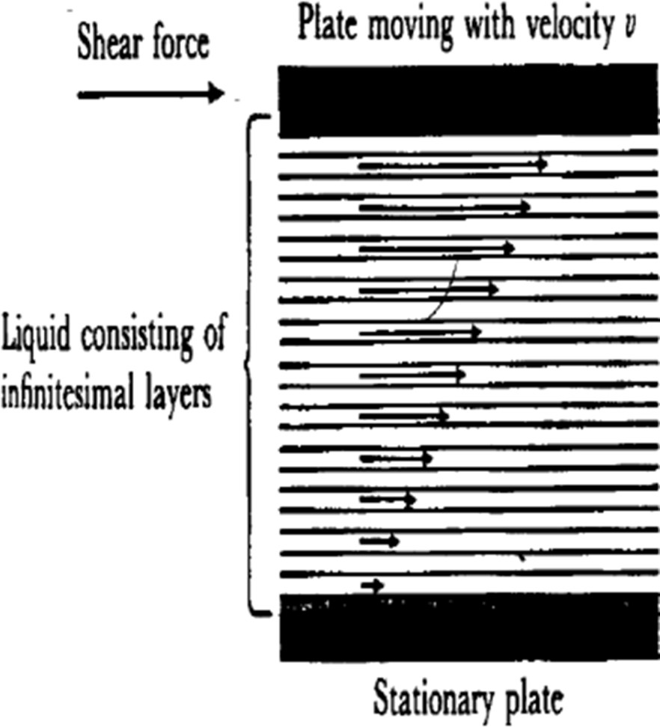
- Similarly the velocity of the third layer (C) is less than that of the second layer (B) but higher than that of the fourth layer (D).
- This phenomena continues and the bottom layer (N) remains stationary, thus liquids resist flow when force is applied
- Eg: water, glycerin chloroform, very dilute colloidal solutions.
- Coefficient of viscosity is defined as the force per unit area required to maintain unit difference is velocity between two parallel layers is the liquid, one centimeter apart
Mathematic treatment of viscosity
- Shear stress is defined as the force per unit area , which is applied to bring about the flow.

- Shear stress, F = F¹/A
- Rate of shear is defined as the change in the velocity, dv, with an change in distance dr
- Rate of shear G=dv/dr
- If velocity is high then greater is the force required per unit area to produce a certain rate of shear
- Relationship between shear stress and rate of shear is as follows:
- Shear stress α rate of shear
- F¹/A α dv/dr
- F¹/A =n dv/dr
- F =nG
- η =F/G
- η = coefficient of velocity
- F =shear stress
- G=rate of shear

Shear stress-shear rate relationship is normally represented in the form of a curve namely “Rheogram or Consistency curve”
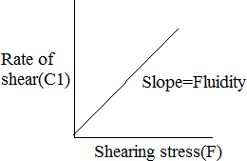

Mathematic treatment of viscosity
- Units: ISO system – poise
- Centi poise=0.01 poise
- CGS system - dy sec/cm² or g.cm⁻¹.sec²
- SI system - 0.1N.sm⁻²
- Poise is defined as the shearing force required to produce a velocity of 1 cm/sec between two parallel planes of a liquid each 1 cm² is area separated by a distance of 1 cm
- Fluidity: the term fluidity is used to denote the reciprocal of viscosity
- Fluidity = 1/η
- Kinematic viscosity: it is defined as the viscosity divided by the density of liquid
- Kinematic viscosity =η/p
- Units: stokes or centistokes
- Relative viscosity: it is defined as the ratio of viscosity of the dispersion to that of the solvent (η₀)
- Relative viscosity (η₁) =η/η₀
- Specific viscosity: the term is defined the relative increase in the viscosity of the dispersion over that of the solvent
- Specific viscosity η_{sp} = η-η₀/η₀
- Reduced viscosity: it is defined as the ratio of specific viscosity to the concentration
Reduced viscosity = η_{sp/}/c Effect of temperature on viscosity

- As temperature increases, the system acquires thermal energy which facilitates the breaking of cohesive forces. The viscosity of liquid decreases.
- In case of gases, an increase in temperature increases the viscosity owing to the increased molecular collisions and interactions, the relationship between viscosity and temperature is
- η= AeEV/RT

- A is constant depends on molecular weight & molar volume.
- E_{v} is activation energy.
- Energy of vaporization of a liquid is energy required to remove a molecule from a liquid leaving a hole have same size as that of the molecule departed
- A hole must also be made avialable if one molecule is move past one another
- Activation energy is about one third of energy of vaporization
- Free space needed to flow is one third of volume of a particle
- More energy is required to break the liquid molecules associated with hydrogen bonds
- Bonds are broken at higher temperatures by thermal movement and energy decreases

NON NEWTONIAN FLOW
- A non newtonian flow is defined as one for which the relation between F and S is not linear.
- Rheological properties of heterogeneous dispersions such as emulsions, suspensions and semisolids are more complex and do not obey Newton’s equations of flow.
- Based on the pattern of consistency curves, Non Newtonian fluids are categorized as

- Plastic flow
- Pseudoplastic flow
- Dilatant flow Plastic Flow
- The consistency curve for the plastic flow is given in the figure, the curve does not pass through the origin.
- The substance initially behaves like an elastic body and fails to flow when less amount of stress is applied.
Further increase in the stress leads to non-linear increase in the shear rate which progressively get linearised, the linear portion when extrapolated intersects the x-axis called yield value

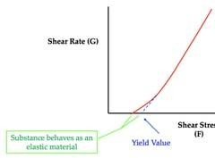

- plastic flow resembles Newtonian flow above the yield value; plastic flow can be adequately expressed as yield value and plastic viscosity.

- Plastic flow is associated with the presence of flocculated particles in concentrated suspensions, butter, certain ointment pastes and gels.
- Floccules are the aggregation of particles with inter particle contacts, this structure is maintained when the system is at rest.
- Yield value represents the stress required to break the inter-particle contacts so that particles behave individually, therefore yield value is an indicative of forces of flocculation.
- Plasticity exhibited by concentrated flocculated suspension where particles attracted by vander wall forces giving structure to the system.
- The shear force required to break the force of flocculation between the particles contribute to the yield value
- Apparent viscosity drops with increasing shear
- As the yield value is exceeded the shearing stress and rate os shear become directly proportional
- Frictional forces between the moving particles also contribute to the yield value, once the yield value exceeds, further increase in shearing stress will bring about a proportional increase in rate of shear.
- Materials that exhibit plastic flow are often called as Bingham bodies in honor of Bingham.
- U = F-f/G
- F is shear stress
- f is yield value
- G is rate of shear
- Yield value (f) is the intercept on the shear stress axis and has the units dyne/cm²
Plastic flow explained by flocculated particles in concentrated suspensions, ointments, pastes and gels.



