PHYSICAL PHARMACEITICS-IIBP403T UNIT-I(COLLOIDAL DISPERSIONS)
CLASS 7
TOPIC :Pharmaceutical applications of colloids
- Certain medicinal have been found to possess unusual or increased therapeutic properties with reduced side effects when formulated in the colloidal state.
- Colloidal silver chloride, silver iodide, and silver protein are effective germicides and do not cause the irritation that is characteristic of ionic silver salts.
- Coarsely powdered sulfur is poorly absorbed when administered orally, yet the same dose of colloidal sulfur may be absorbed so completely as to cause a toxic reaction and even death
- Colloidal copper - treatment of cancer,
- colloidal gold(radioactive colloids) - diagnostic agent for paresis, and colloidal mercury for syphilis.
- natural and synthetic polymers are important in contemporary pharmaceutical practice
- Polymers are macromolecules formed by the polymerization or condensation of smaller, noncolloidal molecules.
- Proteins are important natural colloids and are found in the body as components of muscle, bone, and skin
- The plasma proteins are responsible for binding certain drug molecules to such an extent that the pharmacologic activity of the drug is affected.
- Naturally occurring plant macromolecules such as starch and cellulose that are used as pharmaceutical adjuncts are capable of existing in the colloidal state.

- Hydroxyethyl starch is a macromolecule used as a plasma substitute.
- synthetic polymers are applied as coatings to solid dosage forms to protect drugs that are susceptible to atmospheric moisture or degradation under the acid conditions of the stomach.(enteric coating)
- Colloidal electrolytes (surface-active agents) are used to increase the solubility, stability, and taste of certain compounds in aqueous and oily pharmaceutical preparations.
- by using the compounds in colloidal state
- Adsorption of toxins from the gastrointestinal tract by kaolin and
- the rate of neutralization of excess acidity in the stomach by aluminium hydroxide
may be increased
- Hydrophilic colloids are used as suspending agents and as protective colloids for hydrophobic colloids
- Association colloids are used to increase the solubility, stability, absorption of the drugs and to improve the taste of certain compounds in pharmaceutical preparations
- Colloids are used as drug delivery system for therapeutics
- Hydrogels,microparticles,emulsions and micro emulsions,liposomes,micelles,nanoparticles and nanocrystals
Hydrogels
- Whereas a gel is a colloid with a liquid as dispersion medium and a solid as a dispersed phase a hydrogel is a colloidal gel in which water is the dispersion medium.
- Natural and synthetic hydrogels are now used for wound healing, as scaffolds in tissue engineering, and as sustained-release delivery systems.

- Wound gels are excellent for helping create or maintain a moist environment.
- hydrogels provide absorption, desloughing, and debriding capacities to necrotic and fibrotic tissue.
- When used as scaffolds for tissue engineering, hydrogels may contain human cells to stimulate tissue repair
- are loaded with pharmaceutical ingredients, hydrogels provide a sustained release of drugs.
- environmentally sensitive hydrogels have the ability to sense changes in pH, temperature, or the concentration of a specific metabolite and release their load as a result of such a change
- can be used as site-specific controlled drug delivery systems.
- Hydrogels that are responsive to specific molecules, such as glucose or antigens, can be used as biosensors as well as drug delivery systems.
- Light-sensitive, pressure-responsive, and electrosensitive hydrogels also have the potential to be used in drug delivery.
- The most important challenges that should be addressed in designing useful environmentally sensitive hydrogels include slow response time, limited biocompatibility, and biodegradability.

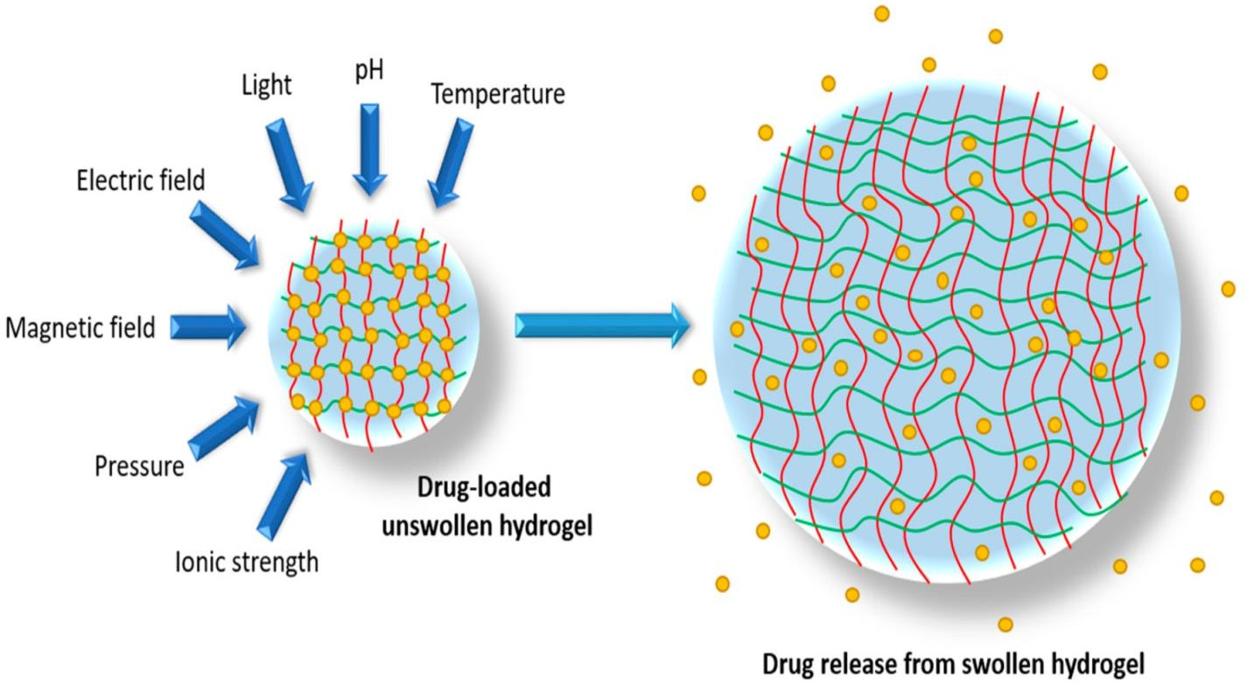
Microparticles
- Microparticles are small (0.2–5 μm), loaded microspheres of natural or synthetic polymers.
- Microparticles were initially developed as carriers for vaccines and anticancer drugs.
- novel properties of microparticles have been developed to increase the efficiency of drug delivery and improve release profiles and drug targeting.
- functional surface coatings of nonbiodegradable carboxylated polystyrene or biodegradable poly(D,L-lactide-co-glycolide) microspheres with poly(L-lysine)-g-poly(ethylene glycol) (PLL-g-PEG) were investigated in attempts to shield them from nonspecific phagocytosis and to allow ligand-specific interactions via molecular recognition.
- coatings of PLL-g-PEG-ligand conjugates provided for the specific targeting of microspheres to human blood–derived macrophages and dendritic cells while reducing nonspecific phagocytosis.
- Microparticles can also be used to facilitate nontraditional routes of drug administration.

- For example, it was found that microparticles can be used to improve immunization using the mucosal route of administration of therapeutics.
- It was found in this study that after mucosal delivery, microparticles can translocate to tissues in the systemic compartment of the immune system and provoke immunologic reactions
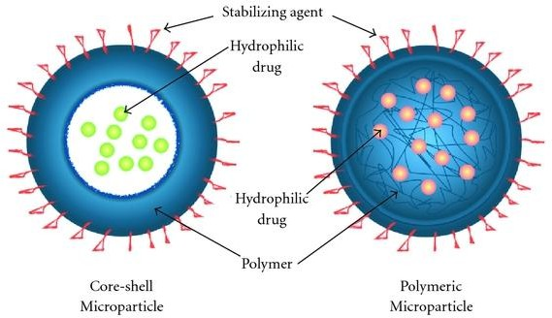

Emulsions and Microemulsions
- excellent candidates as potential drug delivery systems
- because of their improved drug solubilization,
- long shelf life, and
- ease of preparation and administration.

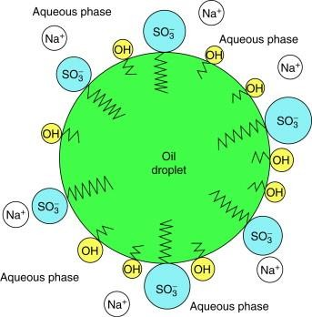
- Three distinct microemulsions—oil external, water external, and middle phase can be used for drug delivery, depending upon the type of drug and the site of action.
- used for controlled release and targeted delivery of different pharmaceutical agents.
- For instance, micro-emulsions were used to deliver oligo nucleotides (small fragments of DNA) specifically to ovarian cancer cells.
- In contrast to microemulsions, nanoemulsions consist in very fine oil-in-water dispersions, having droplet diameter smaller than 100 nm.
- Compared to microemulsions, they are in a metastable state, and their structure depends on the history of the system.
- Nanoemulsions are very fragile systems.
- The nanoemulsions can find an application in skin care due to their

- good sensorial properties (rapid penetration, merging textures) and their biophysical properties (especially their hydrating power).
Liposomes
- Liposomes consist of an outer uni- or multilaminar membrane and an inner liquid core.
- liposomes are formed with natural or synthetic phospholipids similar to those in cellular plasma membrane.
- Because of this similarity, liposomes are easily utilized by cells.
- Liposomes can be loaded by pharmaceutical or other ingredients by two principal ways:

- lipophilic compounds can be associated with liposomal membrane, and hydrophilic substances can be dissolved in the inner liquid core of liposomes.
- To decrease uptake by the cells of the reticuloendothelial system and/or enhance their uptake by the targeted cells, the membrane of liposomes can be modified by polymeric chains and/or targeting moieties or antibodies specific to the targeted cells.
- Because they are relatively easy to prepare, biodegradable, and nontoxic, liposomes have found numerous applications as drug delivery systems.

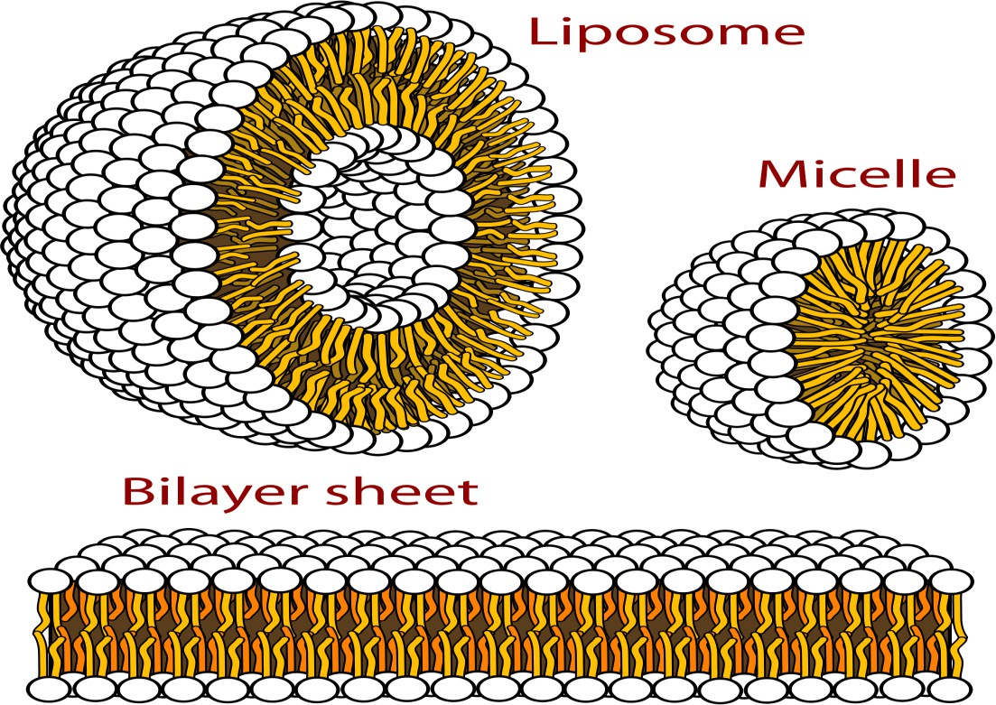

- Micelles are structures similar to liposomes but do not have an inner liquid compartment.
- Therefore, they can be used as water-soluble biocompatible microcontainers for the delivery of poorly soluble hydrophobic pharmaceuticals.
- Pluronic block copolymers, are recognized pharmaceutical excipients listed in the US and British Pharmacopoeia.
- used extensively in a variety of pharmaceutical formulations including delivery of low molecular mass drugs, polypeptides, and DNA.
- Pluronic block copolymers are versatile molecules that can be used as structural elements of polycation-based gene delivery systems (polyplexes).
Nanoparticles
- Nanocapsules are submicroscopic colloidal drug carrier systems composed of an oily or an aqueous core surrounded by a thin polymer membrane

- A novel nanoparticle-based drug carrier for photodynamic therapy, Nanoparticles have also found applications as nonviral gene delivery systems.
Nano crystals
- Inorganic nanostructures that interface with biologic systems
- in vivo targeting by using semiconductor quantum dots (qdots), which are small (<10 nm) inorganic nanocrystals that possess unique luminescent properties;
- their fluorescence emission is stable and tuned by varying the particle size or composition.
- By adding a targeting moiety, one can direct these qdots specifically to the targeted organs and tissues.
- In particular, it was found that ZnS-capped CdSe qdots coated with a lung-targeting peptide accumulate in the lungs of mice after intravenous injection, whereas two other peptides specifically direct qdots to blood vessels or lymphatic vessels in tumors.

