PHYSICAL PHARMACEUTICS-II BP403T
UNIT –I(COLLOIDAL DISPERSIONS)
Class 4
Topic : Kinetic properties of colloids
- Related to motion of the particles with respect to the dispersion medium Motion of the particles may be
- Thermally induced-Brownian movement,diffusion and osmosis
- Gravitationally induced ---sedimentation
- Applied externally--- viscosity
- Brownian Motion
- describes the random movement of colloidal particles, which may be observed with particles as large as about 5 μm, due to the bombardment of the particles by the molecules of the dispersion medium.
- The motion of the molecules cannot be observed, of course, because the molecules are too small to see.
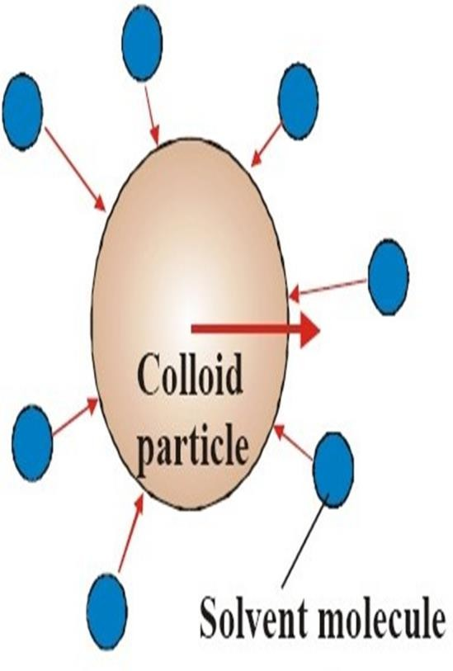

Diffusion
- Particles diffuse spontaneously from a region of higher concentration to one of lower concentration until the concentration of the system is uniform throughout. Diffusion is a direct result of Brownian movement.
- According to Fick's first law, the amount, dq, of substance diffusing in time, dt, across a plane of area, A, is directly proportional to the change of concentration, dc, with distance traveled, dx.
- Fick's law is written as
- dq = - DA ( dc/dx)dt
- D is the diffusion coefficient, the amount of material diffusing per unit time across a unit area when dc/dx, called the concentration gradient, is unity.
- D thus has the dimensions of area per unit time.
- The coefficient can be obtained in colloidal chemistry by diffusion experiments in which the material is allowed to pass through a porous disk, and samples are removed and analyzed periodically.
- Another method involves measuring the change in the concentration or refractive index gradient of the free boundary that is formed when the solvent and colloidal solution are brought together and allowed to diffuse.
- D=Kt/6Πƞr (1)
- D=Rt/6ΠƞrN (2)
where D is the diffusion coefficient obtained from Fick's law as already explained, k is the Boltzmann constant,
R is the molar gas constant, T is the absolute temperature,
η is the viscosity of the solvent,
r is the radius of the spherical particle, and N is Avogadro's number.
- Equation (2) is called the Sutherland–Einstein or the Stokes–Einstein equation

- The measured diffusion coefficient can be used to obtain the molecular weight of approximately spherical molecules, such as egg albumin and hemoglobin, by use of the equation
- D=RT/6³√4ΠN/3Mv
- where M is molecular weight and
- v is the partial specific volume Analysis of equations and allows to formulate the following three main rules of diffusion:
- the velocity of the molecules increases with decreasing particle size;
- the velocity of the molecules increases with increasing temperature; and
- the velocity of the molecules decreases with increasing viscosity of the medium
Osmotic Pressure
- The osmotic pressure, π, of a dilute colloidal solution is described by the van't Hoff equation
- π = cRT
- where c is molar concentration of solute. This equation can be used to calculate the molecular weight of a colloid in a dilute solution.
- Replacing c with cg/M in equation, in which cg is the grams of solute per liter of solution and M is the molecular weight, p/ cg =RT/M applies in a very dilute solution .
- The quantity of p/ cg of a polymer having molecular weight 50000 is a linear function of the concentration and equation can be written as
- π / cg =RT (1/M+Bcg)
- B is a constant for any particular solvent /solute system
- With linear lyophilic molecules deviations occur because solute molecules gets solvated free solvent concentration decreases apparent concentration of solute increases
- A plot of p/ cg Vs cg generally results one of three lines
- Ideal line I real line II and III intercept is RT/M if temperature at which experiment is carried out known molecular weight of polymer can be calculated

- 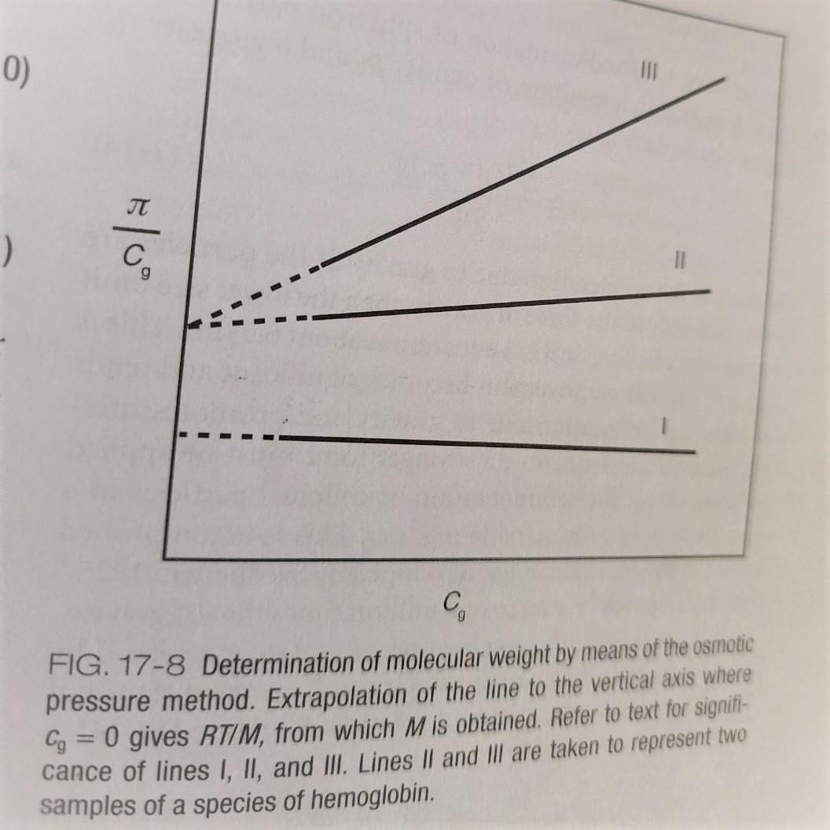
- Slope is B interaction constant
- For line I B value is zero
- Line III --- typical for linear colloid in a solvent having high affinity for the dispersed particles good solvent for the given polymer
- Line II depicts colloid in a solvent having poor affinity with dispersed material
- Calculated molecular weight is independent of the solvent used
Sedimentation
- The velocity, v, of sedimentation of spherical particles having a density ρ in a medium of density ρ0 and a viscosity η0 is given by Stokes's law:
- v =2r²(ρ-ρ0)g/9ƞ0
- Where g is the acceleration due to gravity.
- If the particles are subjected only to the force of gravity, then the lower size limit of particles obeying Stoke's equation is about 0.5 μm.
- because Brownian movement becomes significant and tends to offset sedimentation due to gravity and promotes mixing instead.

- Consequently, a stronger force must be applied to bring about the sedimentation of colloidal particles in a quantitative and measurable manner. This is accomplished by use of the ultracentrifuge.
- In a centrifuge acceleration due to gravity is replaced by ω²x where ω is angular velocity and x is the distance of the particle from the centre of rotation
- v =dx/dt=2r²(ρ-ρ0) ω²x /9ƞ0
- The instant velocity v=dx/dt of a particle in aunit centrifugal field is expressed in terms of swedberg sedimentation coeffecient s=(dx/dt)/ ω²x
- Owing to the centrifugal force particles having a high molecular weight from position x1 at time t1 to position x2 at time t2 and sedimentation coeffecient can be obtained by s=ln (x2/x1)/ω² (t2-t1)
- Boundary located by the change of refractive index can be attained at any time during the run and translated into a peak on photographic plate called schlieren pattern
- Component of definite molecular weight-single peak –insulin monodisperse protein the two chains attached to each other by disulfide bridges
- Gelatin polydisperse protein having different fractions of molecular weight –give different peaks(particle with greater weight disperse first)

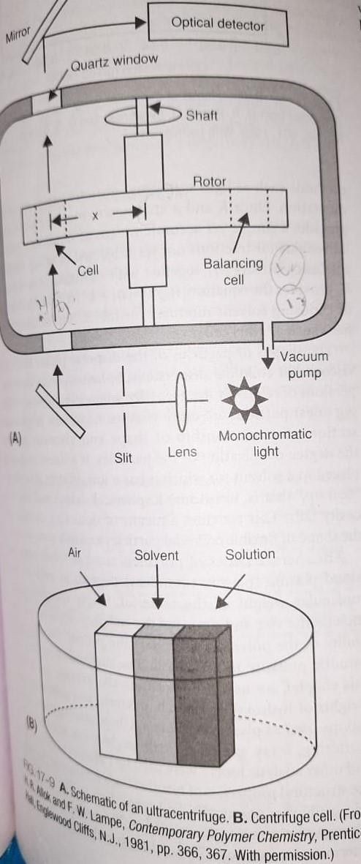

- The sedimentation coefficient s computed after the two distances x1 and x2 measured from scherlien photograph obtained at times t1 and t2
- Diffusion coefficientD from diffusion data
- ω the angular velocity is equal to 2 p times of the speed of the rotor in revolutions per second
- The molecular weight of a polymer can be obtained by use of equation M=RTs/D(1-vρ0)
- R is molar gas constant
- T is absolute temperature
- v bar is partial specific volume of the protein
- ρ0 is density of the solvent
- Sedimentation equilibrium method: equilibrium is established when the sedimentation force is just balanced by counter diffusional force and boundary is stationary

- Diffusion coeffecient need not be determined
- But centrifuge has to be run for several weeks to attain equilibrium throughout the cell
Viscosity
- Is the resistance to the flow of a system under an applied stress
- Einstein equation of flow applicable to dilute colloidal dispersions of spherical particles namely
- Ƞ= Ƞ0(1+2.5ɸ)
- Ƞ= viscosity of dispersion
- Ƞ0=viscosity of dispersion medium
- ɸ=volume fraction of colloidal particles defined as volume of the particles divided by the total volume of the dispersion equal to concentration term
- Ƞ and Ƞ0 can be obtained from capillary viscometer
- Several viscosity coefficients can be obtained
- Ƞrel =Ƞ /Ƞ0 =(1+2.5ɸ) and
- Ƞsp = Ƞ /Ƞ0 -1 =2.5ɸ
- Ƞsp /ɸ=2.5
- Because volume fraction is directly related to concentration
- Ƞsp /c=k where c is expressed in no of grams of colloidal particles in 100ml of total dispersion
- For highly polymeric materials dispersed in the medium at moderate concentrations equation is expressed as
- Ƞsp /c=k 1+K2c+k3c2
- Graph between Ƞsp /c vs c and line extrapolated to infinite dilution the intercept is k1 is known as intrinsic viscosity used to calculate molecular weight of colloids by Mark-Houwnik equation [Ƞ]=KMª
- K and a are constants characteristics of the particular polymer –solvent system

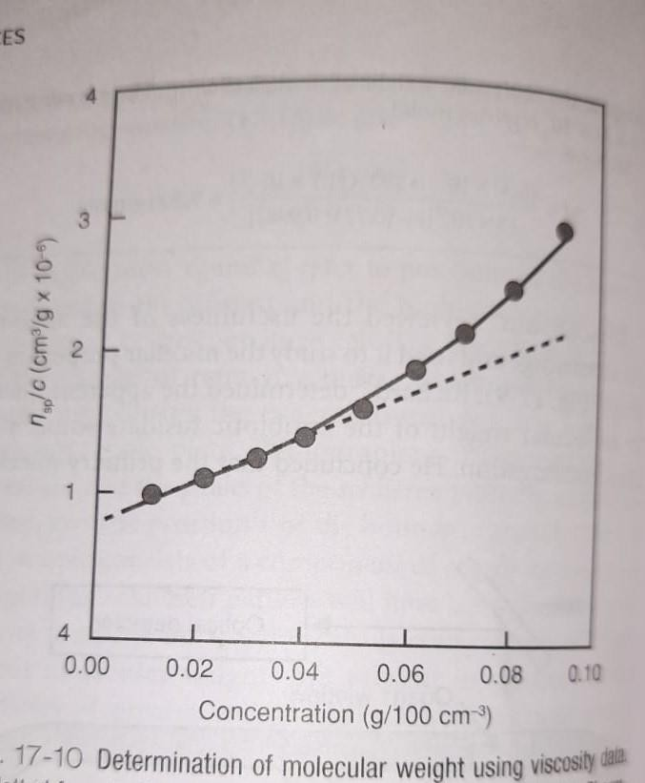

- Shape of the dispersed phase particles affect the viscosity of the colloidal dispersion
- Spherocolloids form dispersion of relatively low viscosity whereas linear particles are more viscous
- If a linear particle is placed in a solvent having low affinity it tends to ball up to assume spherical shape and the viscosity falls
- Detects change in the shape
- Plasma extenders like dextran properties like imparting viscosity and osmotic pressure to blood depends on molecular weight

