PHYSICAL PHARMACEITICS-IIBP403T UNIT-III(COARSE DISPERSIONS)

Class22:
Topic:Emulsions and theories of emulsification
EMULSIONS
- Emulsions are thermodynamically unstable system consisting of at least two immiscible liquid phases one of which is dispersed as globules (the dispersed phase) in the other liquid (continuous phase) stabilized by presence of an emulsifying agent
- either the dispersed phase or continuous phase consistency ranges from mobile liquid to a semisolid
- The particle diameter of the dispersed phase generally extends from about 0.1 to 10µm Types of emulsions

Based on dispersed phase
- Oil in Water (O/W): Oil droplets dispersed in water.
- Water in Oil (W/O): Water droplets dispersed in oil.
- Multiple emulsions (e.g. w/o/w emulsions).
- Single Emulsion Multiple Emulsion

Based on size of liquid droplets
- 0.2 – 50 mm Macroemulsions
- 0.01 – 0.2 mm Microemulsions
- 50 – 1000 nm Nanoemulsions Types of emulsions

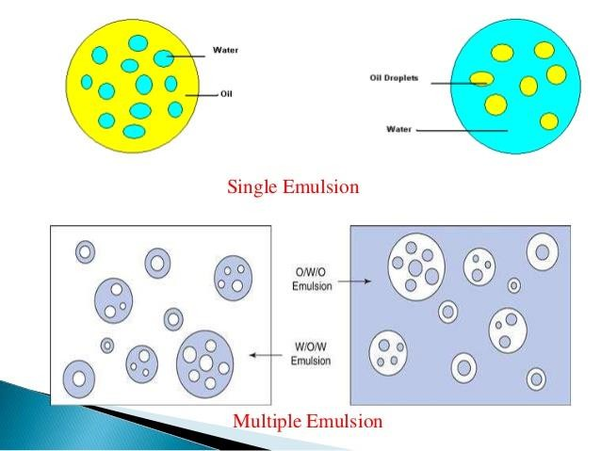
- Medicinal emulsions for oral administration are usually of the o/w type and require the use of an o/w emulsifying agents
- Include synthetic non ionic surfactants, acacia, tragacanth and gelatin, starch methyl cellulose,Na carboxymethyl cellulose, soluble salts of alginic acid
- Externally applied emulsions may be o/w or w/o
- Ex:Turpentine liniment and vanishing cream
- The various emulsifying agents are sodium lauryl sulfate,triethanolamine stearate,monovalent soaps like sodium oleate,glyceryl mono stearate mixed with a monovalent soap or alkyl sulfate
- Surfactants or mixture of surfactants having HLB values range 8-16 will yield O/W type emulsions

Water in oil type emulsions:
- when water is distributed as globule in oily continuous phase the emulsion is called as water in oil type
- Mainly for external use
- Ex: cold cream ,calamine lotion

- Various emulsifying agents used are polyvalent soaps like calcium palmitate, sorbitan esters, cholestrol, wool fat etc
- Surfactants whose HLB value 3 to 6 yields w/o type emulsions

Applications of emulsions
- Oral, rectal and topical administration of oils and oil-soluble drugs.
- The unpleasant taste or odor can be masked by emulsification.
- The absorption and penetration of medicament are enhanced by emulsification.
- Intramuscular injections of water-soluble drugs or vaccine to provide slow release.
- The use of sterile stable i.v emulsion containing fats, carbohydrates and vitamins as a potential nutrition ex: Taxol emulsion having antimitotic properties for iv administration
- When emulsion administered intravenously the droplets are normally rapidly taken by reticuloendothelial system in particular the fixed macrophases in liver
- The uptake can be reduced by stabilizing the emulsion by a non-ionic surfactant
- Radio opaque emulsions have found application as diagnostic agent in x-ray examinations
- Emulsification widely used in pharmaceutical and cosmetics for external use ex: cosmetic lotions and creams
- Emulsifications is used in aerosol products to produce foams
- The propellant that forms the dispersed liquid phase within the container vaporizes when the emulsion is discharged from the container

IDENTIFICATION TEST FOR EMULSIONS
- By using Naked eye, it is very difficult to differentiate between o/w or w/o emulsions. Thus, the following methods have been used to identify the type of emulsions.
- 1) Dye Test
- 2) Dilution Test
- 3) Electrical conductivity Test
- 4) Fluorescence Test.
5) Cobalt Chloride Test

DYE TEST:
Water-soluble dye will dissolve in the aqueous phase.

- Oil-soluble dye will dissolve in the oil phase.
- Water-soluble dye (e.g. Amaranth dye,methylene blue) may be dusted on the surface of an emulsion
- If the emulsion is o/w type the dye will dissolve in the continuous phase and diffuses through out water
- If the emulsion is w/o type the dye will lie as clumps on the surface
- Alternatively a oil soluble dye may be added to the emulsion and shaken
- If a drop of emulsion is observed under microscope the external phase is stained indicating emulsion is w/o type
- If the internal phase is stained emulsion is o/w type
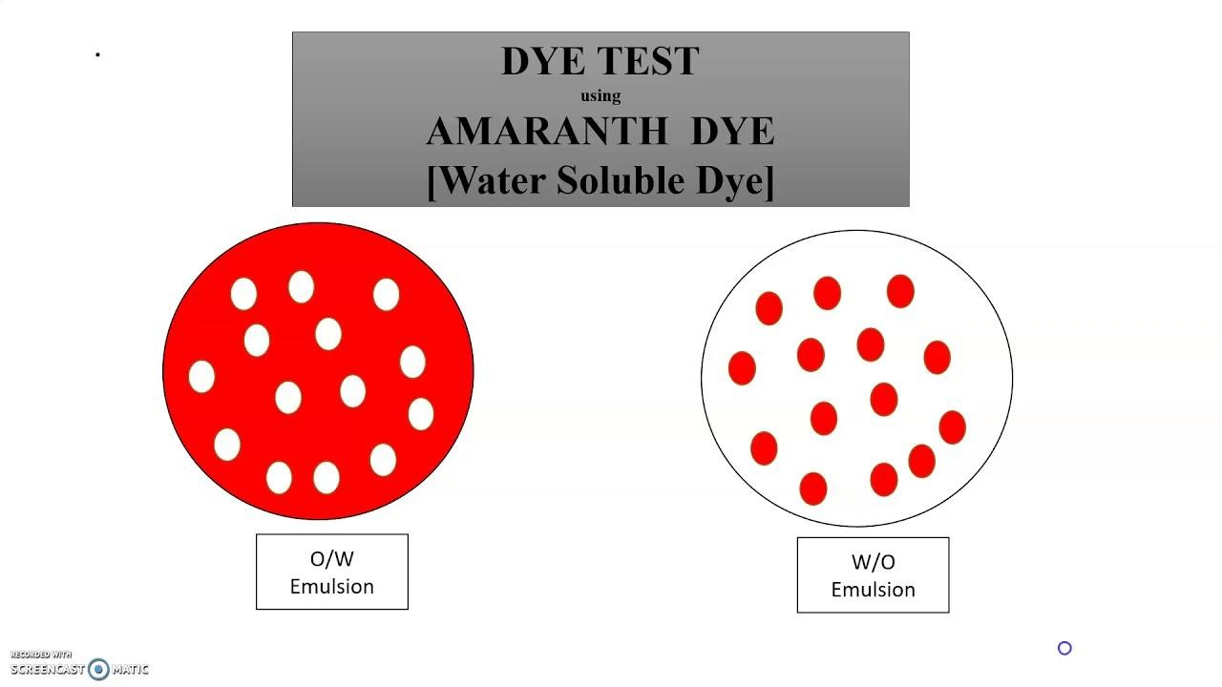

DILUTION TEST
- Based on the solubility of external phase of emulsion.
- Addition of the continuos phase to an emulsion will lead to dilution and the addition of internal phase to an emulsion will lead to seperation of added liquid
- O/W emulsion can be diluted with water and separation occurs when water is added to w/o emulsion
- W/O emulsion can be diluted with oil, and separation occurs when oil is added to o/w emulsion

ELECTRICAL CONDUCTIVITY TEST:

- As water is good conductor of electricity whereas oil is non-conductor.
- Therefore, continuous phase of water runs electricity more than continuous phase of oil.
- The emulsion is kept in a vessel with two electrodes dipped in
- It is connected to a battery ,switch and a bulb in series the circuit is closed by switching on
- If the bulb glows continuosly it indicates that continuous phase in the emulsion is water
- If the bulb flickers the emulsion is w/o type
- Bulb glows with O/W Bulb doesn’t glow with W/O
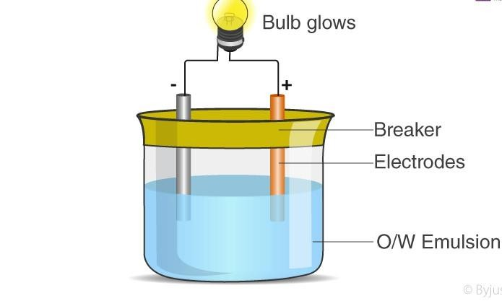
FLUORESCENCE TEST: Oils give fluorescence under UV light, while water doesn’t.
- Therefore, O/W emulsion shows spotty pattern when observed under UV.
- while W/O emulsion fluoresces.

COBALT CHLORIDE TEST:
Principle: Cobalt Chloride solution is used for identification of Emulsion. It is water soluble so it changes colour when encountered by O/W emulsion.
Procedure: Filter paper is Dipped in Emulsion. Filter paper changes its color from blue to Pink Result: Emulsion is O/W otherwise not.

By observing creaming or sedimentation pattern in emulsion

- Creaming is upward movement of the internal phase in an emulsion occurs in o/w type emulsion
- Nothing but separation of lower and higher density liquid
- The liquid with lower density tends to move upwards
- Sedimentation (negative creaming) is the downward movement of particles towards bottom of the container
- Occurs in w/o type emulsion the liquid globules with higher density settle at bottom

Theories of emulsification
- For a theory to be meanigful should be capable of explaining
- the stability of emulsion and
- the type of emulsion formed
  - Film theory or adsorption theory
  - Viscosity theory
  - Wedge theory
  - Interfacial tension theory

Film theory or adsorption theory
  - As per this theory, the added emulsifying agent forms a mechanical film by getting adsorption at the interface of the liquid and offers stability to the emulsion.
  - However, this theory could not explain the formation of type of emulsion.

Viscosity theory
  - As per this theory, an increase in viscosity of an emulsion will lead to an increase in stability.
  - This theory failed to explain about the milk which shows considerable stability even though its viscosity is less.

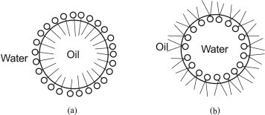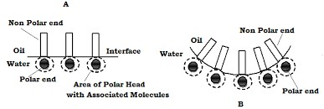

Wedge theory
- According to this theory, monovalent soap like sodium stearate give o/w type emulsion and divalent soap like calcium stearate give w/o type emulsion.
- This was explained by successful accommodation of the soap molecules to give the type of emulsion.
- Ex: Sodium stearate maybe expressed as follows C17H35COO Na and its accomodation possible only in o/w emulsion
- Divalent soaps like calcium stearate (C17H35COO) 2Ca accomodation possible only in w/o type emulsion
- This theory fails to explain stability of emulsion
- And calcium sterate will ionise and will not exist as wedge

Interfacial tension theory
- In accordance with this theory the added emulsifying agent reduces the interfacial tension between the oil and water phases and thus a stable emulsion is formed.
- This theory could not explain the formation of type of emulsion.
- When two immiscible liquids are agitated together so that one of the liquids is dispersed as small droplets in other
- Failure of two liquids to remain mixed is explained as the cohesive forces between the molecules of separating liquids is greater than the adhesive forces between the liquids

- When one liquid is broken small particles the interfacial area of globules constitutes a surface that is enormous compared to original liquid
- If 1cm3 of mineral oil is dispersed into globules having a volume surface diameter dvs of 0.01µm in 1cm3 of water to form a fine emulsion
- The surface area of droplets becomes 600m2
- The surface free energy associated with this area is about 34X10power7 ergs or 8 calories
- The total volume of the system has not increased
- Work input w=γowXΔA =57X6X106 cm2=34joules=8 calories
- If 1cm3 of oil is mixed with 1 cm3 water the surface area is equal to about 600m2 greater than a football court
- The increase in energy 8calories is associated with the enormous surface is sufficient to make the thermodynamically unstable hence the droplets have tendency to coalesce
- To prevent coalescence or at least to reduce its rate to negligible proportion
- It is necessary to introduce an emulsifying agent that will form a film around dispersed globules
- Emulsifying agents classified into three groups

Surface-active agents:
which are adsorbed at oil water interface to form monomolecular film and reduce interfacial tension

Hydrophilic colloids:
Which form a multi molecular film around the dispersed droplets in o/w emulsion

Finely diveded solid particles
Which are adsorbed at interface between two immiscible liquid phases and form what amounts to a film of particles around dispersed globules

Monomolecular Adsorption theory
  - Surface-active agents, or amphiphiles, reduce interfacial tension because of their adsorption at the oil- water interface to form monomolecular films.
  - Because of increase of surface free energy due to increased surface area of the dispersed phase will reduced if any decrease in interfacial tension and hence the tendency for coalescence(w=γXΔA)
  - The dispersed droplets are surrounded by a coherent monolayer that prevents coalescence between two droplets as they approach each other

  - Ideally such a film should be flexible so that it is capable of reforming rapidly if broken or disturbed
  - An additional effect promoting stability is the presence of surface charge cause repulsion between adjacent particles

Explanation
  - In practice, combinations of emulsifiers rather than single agents are used most frequently in the preparations of emulsions.
Hydrophilic emulsifier in the aqueous phase and a hydrophobic agent in the oil phase to form a complex film at the interface
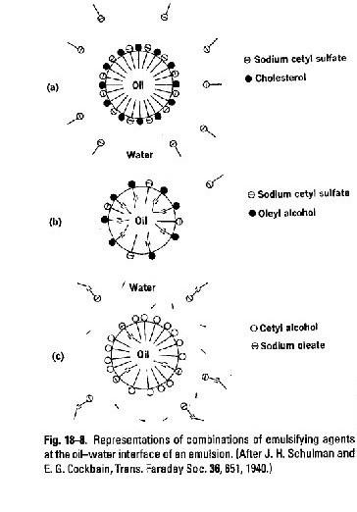
  - Three mixtures of emulsifying agents at the oil–water interface.
  - The combination of Sodium cetyl sulfate and cholesterol leads to a complex film that produces an excellent emulsion.
  - Sodium cetyl sulfate and 0leyl alcohol do not form a closely packed or condensed film, consequently, their combination results in a poor emulsion.

  - Cetyl alcohol and sodium oleate produce a close packed film but complexation is negligible and again poor emulsion results
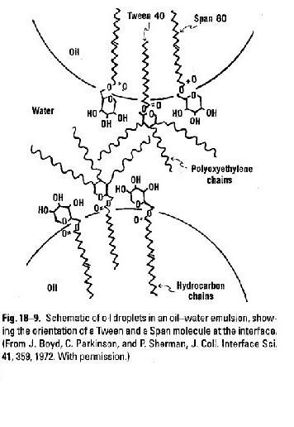
  - A mixture of hydrophilic tween and lipophilic span have an excellent emulsifying property
  - The hydrocarbon portion of span 80(sorbitan monooleate) molecule lies in the oil globule and sorbitan radical lies in the aqueous phase
  - The bulky sorbitan heads of span molecule prevent the hydrocarbon tails from associating closely in the oily phase
  - Upon addition of tween 40 it orients at interface such that part of its hydrocarbon tail is in oil phase and remainder of the chain together with sorbitan heads and poly oxy ethylene chains is located in water phase
  - The hydrocarbon chain of tween 40molecules situated in the oil globule between span 80 chains and the orientaion results effective vanderwall attractions

  - In this way interfacial film is strengthened and the stability of o/w emulsion is increased against particle coalescence
  - The same principle of mixed emulsifying agents can be applied to use of combination of
- Sodium stearate and cholestrol
- SLS and glyceryl monostearate
- Tragacanth and span
- The type of emulsion that is produced o/w or w/o depends primarily on the property of emulsifying agent
- The character is referred as Hydrophilic lipophilic balance i.e polar-non polar nature of the emlsifier
- The balance of hydrophilic and lipophilic properties of an emulsifier determines weather o/w or w/o emulsion will result
- HLB-9to12 o/w emulsion
- HLB-3to6 w/o emulsion
- A blend of Tween 20 and Span 20 having high HLB will result in o/w emulsion
- Span 60 alone having HLB 4.7 result in w/o Emulsion
Rule of Bancroft: The type of the emulsion is a function of the relative solubility of the surfactant, the phase in which it is more soluble being the continuous phase.
  - Surfactant with high HLB –More soluble in water –results in o/w emulsion
  - Surfactant with low HLB –More soluble in oil –results in w/o emulsion

