CLASS 16 TOPIC:STRESS,STRAIN,MODULUS
Elastic Modulus
- The elastic modulus is the constant of proportionality between stress and strain
- For sufficiently small stresses, the stress is directly proportional to the strain
- The constant of proportionality depends on the material being deformed and the nature of the deformation
- The elastic modulus can be thought of as the stiffness of the material
- A material with a large elastic modulus is very stiff and difficult to deform
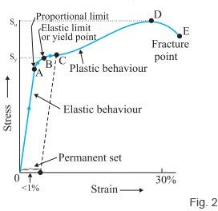

- s t r e s s = E l a s t i c m o d u l u s × s t r a i n

Young’s Modulus
- Tensile stress is the ratio of the external force to the cross-sectional area
- SI units of stress are Pascals, Pa 1 Pa = 1 N/m2
- The tensile strain is the ratio of the change in length to the original length
- Strain is dimensionless
- The elastic modulus is called Young’s modulus F/A=YΔL/Lo

Shear Modulus
- It defines the change in shape of an object caused by pushing its top and bottom surfaces in opposite directions.
- Shear stress is the force per unit area exerted on the top and bottom of solid.
- Shear strain is the distance the top surface has moved relative to the bottom surface divided by the perpendicular distance between them.
- Shear Modulus is the ratio of shear stress to shear strain and has a unit of N/m2.
- S = Shear stress / Shear Strain
= F/A/Δx/h
- Where
- F is applied force:
- A is area,
- Δx is the distance

- the top surface has moved relative to bottom surface, and h is perpendicular distance between the top and bottom surfaces.

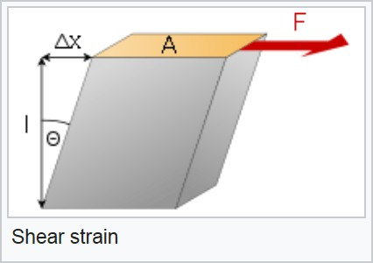

Bulk Modulus:
Volume Elasticity
- Bulk modulus characterizes the response of an object to uniform squeezing
- Suppose the forces are perpendicular to, and act on, all the surfaces
- Example: when an object is immersed in a fluid
- The object undergoes a change in volume without a change in shape
- Volume stress, ΔP, is the ratio of the force to the surface area
- This is also the Pressure

- The volume strain is equal to the ratio of the change in volume to the original volume
