PHYSICAL PHARMACEUTICS II BP(403T)
UNIT II(RHEOLOGY)

Topic- HECKEL EQUATION
Powder Properties
- Solid particles are made up of molecules that are held in close proximity to each other by intermolecular forces.
- The strength of interaction between two molecules is due to the individual atoms within the molecular structure.
- For example, hydrogen bonds occur as a result of an electrostatic attraction involving one hydrogen atom and one electronegative atom, such as oxygen.
- For molecules that cannot hydrogen bond, attraction is due to van derWaal's forces.
- dipole-dipole (Keesom),
- Dipole induced dipole (Debye) and
- induced dipole-induced dipole (London) forces.
COMPRESSION:
- The reduction in the bulk volume of a material as a result of the removal of the gaseous phase (air) by applied pressure.
CONSOLIDATION:
- Involves an increase in the mechanical strength of a material resulting from particle-particle interactions.
COMPACTION:

- The compression and consolidation of a 2 phase (solid + gas) system due to an applied force.

Compression
- When external mechanical forces are applied to a powder mass, there is reduction in bulk volume as follows,
- Repacking
- Particle deformation
- Elastic deformation e.g., acetyl salicylic acid, MCC
- - when elastic limit or yield point is reached.
- Plastic Deformation
- Brittle facture: sucrose
- Microsquashing: Irrespective of the behavior of larger particles smaller particles may deform plastically.

Stages involved in compression
- Initial repacking of particles.
- Elastic deformation of the particles until the elastic limit (yield point) is reached.
- Plastic deformation and/or
brittle fracture then predominate until all the voids are virtually eliminated.
- Compression of the solid crystal lattice then occurs

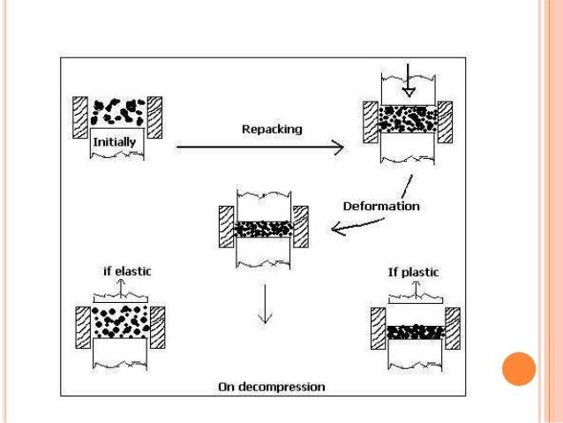

Deformation
  - The particle size distribution and shape of the granules determine initial packing or bulk density as the granulation is delivered into die cavity.
  - At low pressure, the granules flow with respect to each other, with the finer particles entering the void between the larger particles and the bulk density of the granulation is increased.

  - Spherical particles undergo less particle rearrangement than irregular particles as spherical particles assume a close packing arrangement initially.
  - When the particles of a granulation is so closely packed that no further filling of void occur, a further increase in compression force causes deformation at the points of contact.
  - Deformation increases the area of true contact, thereby increasing potential bonding areas.
Heckel Equation
  - The Heckel equation is one of the most useful equations for describing the compaction properties of pharmaceutical powders. Heckel measured that decline in the voids follows the first order kinetics connection with applied pressure.
  - The Heckel plot measures the log of 1/porosity as the compression force is increased. From the Heckel plot, the yield pressure of plastic deformation (YPpl) and yield pressure of elastic deformation (YPel) were derived.
  - For the compression process, Heckel proposed the following equation:
  - 𝑙𝑛𝑉/𝑉 − 𝑉∞ = 𝑘𝑃 +𝑉0/𝑉0−𝑉∞
  - 𝑃𝑜𝑟𝑜𝑠𝑖𝑡𝑦 =𝑉 − 𝑉∞/𝑉
  - 𝑉/𝑉 − 𝑉∞=1/𝑝𝑜𝑟𝑜𝑠𝑖𝑡𝑦 hence
  - 𝑙𝑜𝑔1/𝐸=𝑘𝑃/2.303+1/2.303𝐸0
  - 𝑙𝑜𝑔1/𝐸=𝑘𝑃/2.303+ 𝐴

- Where, V= volume at pressure P,
- V0=original volume of the powder including of voids,
- K is a material dependent constant (Heckel constant), inversely proportional to the yield value of the powder and V∞= volume of solid material.
- ln𝑉/𝑀/[𝑉/𝑀 −𝑉∞/𝑀]= 𝑘𝑃 +𝑉/V0 − 𝑉∞
- ln1/1 −𝑉∞𝑀/𝑀𝑉= 𝑘𝑃 +𝑉/𝑉0 − 𝑉∞
- Relative density(ρr)=density of a sample ρ under specific condition/true density of a material(ρt)
- The relative density is defined as the ratio of the density of the compact at pressure, P, to the density of the compact at zero void or true density of the material
- Therefore 𝑙𝑛1/1 −𝜌/𝜌t= 𝑘𝑃 +𝑉/𝑉0−𝑉∞
- 𝑙𝑛1/1 − 𝜌r= 𝑘𝑃+𝑉0/𝑉0−𝑉∞
- 𝑙𝑜𝑔1/1 − 𝜌r=𝑘𝑃/2.303+ 𝐴
- where ρR is the relative density at pressure P, and E is the porosity.
- Plotting the value of ln[1/(1- ρr)] against applied pressure P yields a linear graph having slope k and intercept A

Heckel equation
  - Heckel constant is inversely related to the yield pressure.
  - The curved portion of the Heckel plot at low pressure represents a value due to densification by particle rearrangement.

  - The intercept obtained from the slope of the upper portion of the curve is a reflection of the subsequent deformation process including densification after consolidation.
  - A large value of Heckel constant indicates the onset of plastic deformation at relatively low pressure
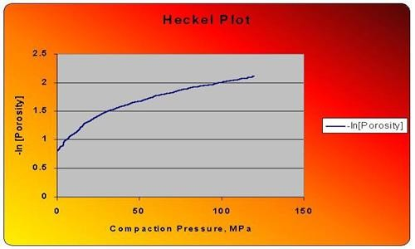

Based on Heckel equation – 3 types of powder-A, B & C
  - With type A materials, a linear relationship is observed, with the plots remaining parallel as the applied pressure is increased indicating deformation apparently only by plastic deformation eg: sodium chloride
  - Type A materials are usually comparatively soft and readily undergo plastic deformation retaining different degrees of porosity depending on the initial packing of the powder in the die

  - This is in turn influenced by the size distribution, shape, e. t. c., of the original particles.
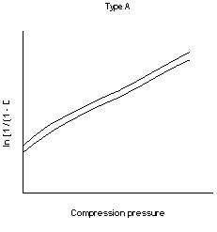
  - For type B materials, there is an initial curved region followed by a straight line
  - This indicates that the particles are fragmenting at the early stages of the compression process
  - Type B Heckel plots usually occur with harder materials with higher yield pressures which usually undergo compression by fragmentation first, to provide a denser packing.
  - Lactose is a typical example of such materials.

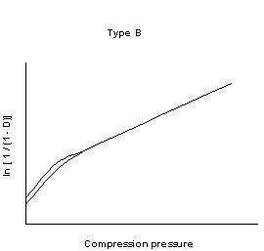
  - For type C materials, there is an initial steep linear region which become superimposed and flatten out as the applied pressure is increased
  - This behavior to the absence of rearrangement stage and densification is due to plastic deformation and asperity melting.

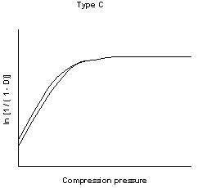
THE SIGNIFICANCE OF HECKEL PLOT
  - 1. The Heckel constant k has been related to the reciprocal of the mean yield pressure, which is the minimum pressure required to cause deformation of the material under compression.
  - 2. The intercept of the curve portion of the curve at low pressure represents a value due to densification by particle rearrangement.
  - 3. The intercept Obtained from the slope of the upper portion of the curve is a reflection of the densification after consolidation.
  - 4. A large value of the Heckel constant indicates the onset of plastic deformation at relatively low pressure.
  - 5. A Heckel plot permits an interpretation of the mechanism of bonding.

Application of Heckel equation
  - The crushing strength of tablets can be correlated with the values of k of the Heckel plot .
  - Larger k values usually indicate harder tablets.
  - Such information can be used as a means of binder selection when designing tablet formulations.
Heckel plots can be influenced by
- the overall time of compression,
- the degree of lubrication and
- even the size of the die,
so that the effects of these variables are also important and should be taken into consideration.

