PHYSICAL PHARMACEUTICS II BP(403T) UNIT II(RHEOLOGY)
CLASS11
Topic Name: Determination of Rheological properties
- Selection of correct instrumental method is important in the successful determination and evaluation of rheological properties
Based on the principle of measuring viscosity three types of viscometers available
- Capillary viscometer: Based on the rate of flow of a liquid through an orifice or a fine capillary
- Density dependent viscometer: based on the velocity of falling object (rising air bubble)through a liquid under the influence of gravity
- Rotational viscometer: based on the resistance of rotating element in contact with or immersed in the liquid
- The choice of instrument also depends on type of material to be analyzed
- Based on the type of rheogram obtained the instruments are classified as
One point instruments: provide a single point on rheogram
- Extrapolation of line from this point to the origin yields a complete rheogram
- Suitable only for newtonian fluids

Ex: capillary viscometers and falling sphere viscometers Multi-point instruments:
- Can be used for the non newtonian systems
- By characterizing the flow properties at variable rates of shear the complete rheogram can be obtained
- Can be used for the viscosity determination of newtonian fluids as well

- Examples: cup and bob viscometers and cone plate viscometers



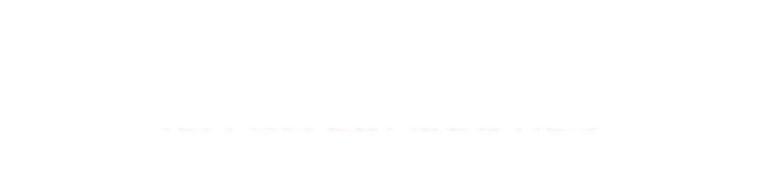






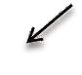
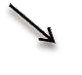
21-Feb-16

DETERMINATION OF RHEOLOGIC (FLOW) PROPERTIES
Selection of viscometer

Single point viscometer viscometer
Ostwald viscometer viscometer
Falling sphere viscometer
viscometer
Principle Stress α rate of shear Equipment works at Single rate of shear
Multi point Cup and bob Cone and plate
Principle Viscosity det. at several rates of shear to get consistency curves

Application
Newtonian flow
SINGLE POINT VISCOMETERS
Application
non -Newtonian flow ⁴¹

- Ostwald viscometer (Capillary) The Ostwald viscometer is used to determine the viscosity of Newtonian fluid.
- The viscosity of Newtonian fluid is determined by measuring time required for the fluid to pass between two marks.
Ostwalds viscometer
- Principle : in capillary or tube viscometer the fluid flows through a round bore or capillary or tube
- The fluid in immediate contact with the wall is motionless while that at centre is at the maximum velocity
- Between these two limits is then velocity gradient
- The driving force causing the liquid to flow is its weight, whereas viscous drag of liquid restrains the flow

- Flow of liquid through the narrow capillary is depicted by poiseullies equation

Ostwald viscometer

η = П r2 t Δ P / 8l V Eq:2

Where,
r = radius of capillary,
t = time of flow,
Δ P = pressure head dyne/cm2 ,
l = length of capillary cm,
V = volume of liquid flowing, cm3

For a given Ostwald viscometers, the r, V and l are combine into constant (K), then eq. 2 can be written as,
η = KtΔP Eq.3 In which,
The pressure head ΔP ( shear stress) depends on the density of liquid being measured, acceleration due to gravity (g) and difference in heights of liquid in viscometers(h).
Acceleration of gravity is constant, & if the levels in capillary are kept constant for all liquids,
If these constants are incorporate into the eq. 3 then, viscosity of liquids may be expressed as:

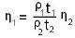
If these constants are incorporate into the eq. 3 then, viscosity of liquids may be expressed as:
η₁ = K’t1 ρ₁ eq. 4
η₂ = K’t₂ ρ₂
eq. 5
On division of eq. 4 and 5 gives the eq .1, which is given in the principle
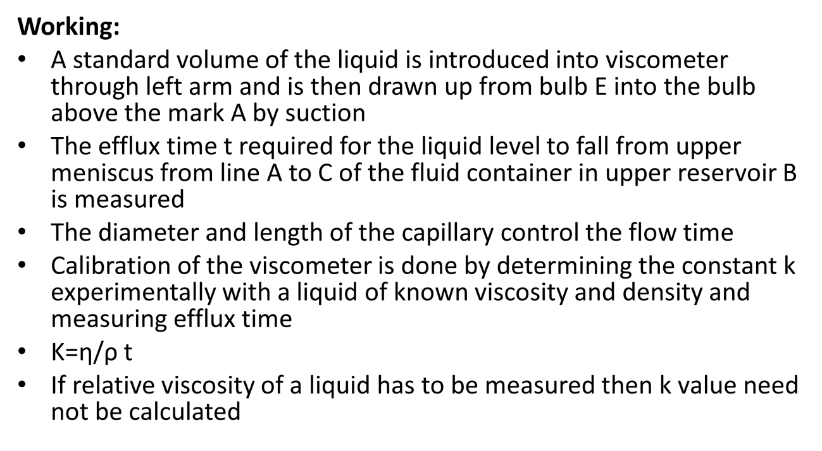

Ubbelohde suspended –level viscometer
Alternative versions of the classic ostwalds viscometer are

Ubbelohde suspended –level viscometer

- Consists of an additional third vertical arm attched to the bulb below the capillary part
- The third arm ventilates the liquid below capillary tube and keeps the volume in the middle arm constant
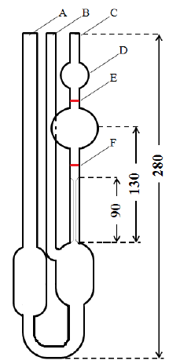
Extrusion Rheometer
- Consists replaceable capillary tubes and a variable driving force
- Provides maximum flexibility of use
- A sample storage chamber is loaded with sample to be investigated
- The sample extruded through a capillary tube attached to one end
- The chamber contents are forced through this exit capillary by the force of the piston

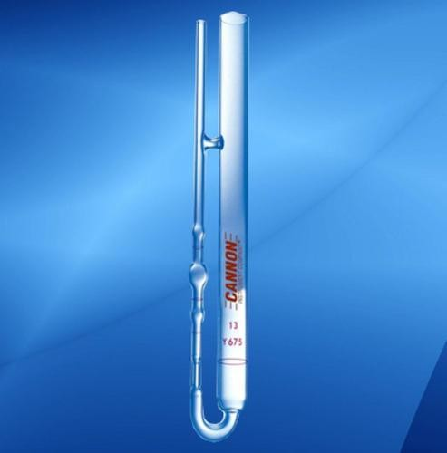
- Two versions are practical
- One piston is driven at a constant linear rate
- Alternative version requires that a constant force to be applied to the piston and the resultant displacement of the piston or sample extruded is measured
- The constant force is applied from gas cylinders with a good pressure regulation system

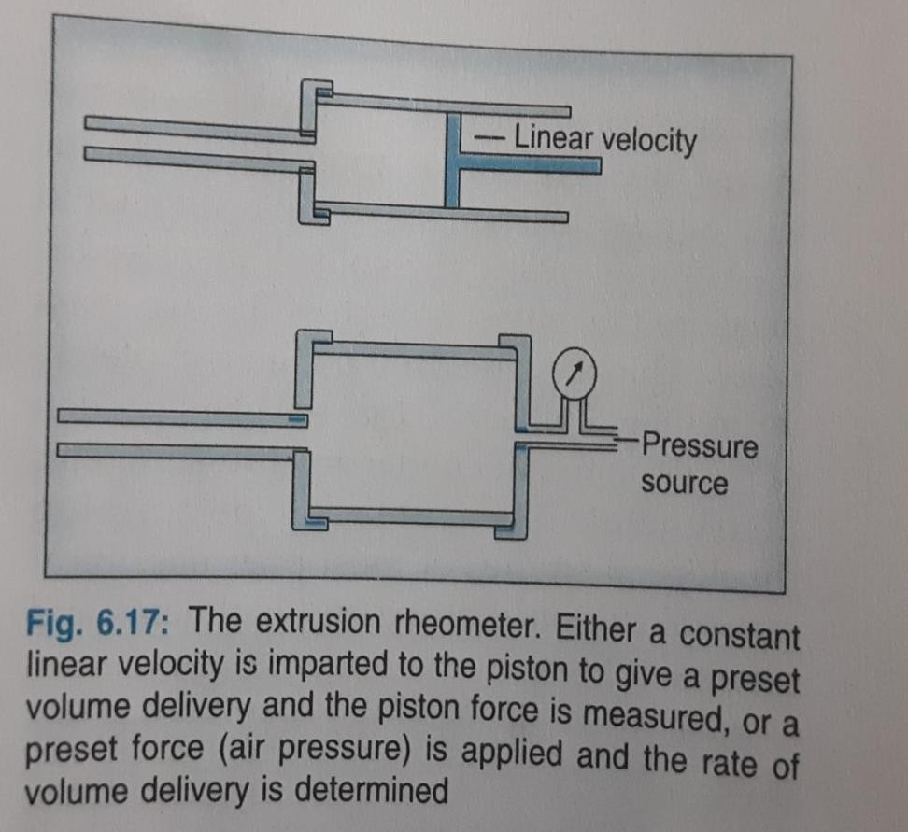

Cannon –manning pressure viscometer
- Commercially available extrusion rheometer is

Cannon –manning pressure viscometer
- The capillary is a metallic fixture between two swage nuts
- Pressure is applied through the side arm to the sample contained in the holding vessel
- The volume displaced is measured by either or both of the two glass bulbs
- The pressure drop occurs completely within capillary so that glass portion of the system is not under any pressure
- Capable of performing rheological studies of most pharmaceutical semisolid formulations:pastes,ointments and creams
FALLING SPHERE VISCOMETERS
- It is called as Hoeppler falling sphere viscometers.

- Principle: Strokes law is the basis for falling sphere viscometer A glass or ball rolls down in vertical glass tube containing the test liquid at a
known constant temperature.
- The rate at which the ball of particular density and diameter fall is an inverse function of viscosity of sample.
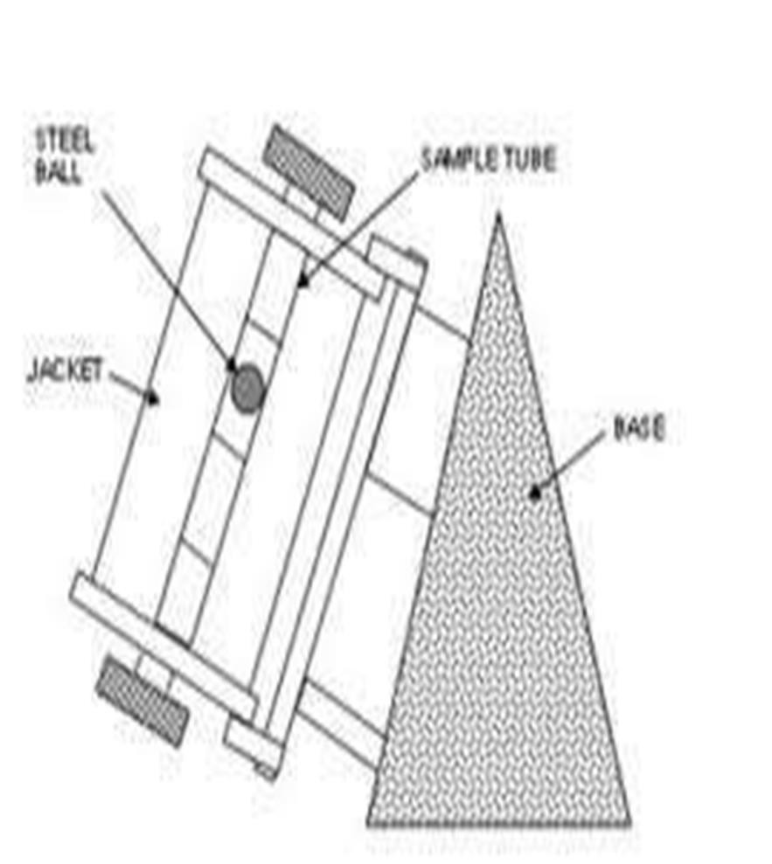
- Construction:
- Glass tube position vertically. Constant temperature jacket with Water circulation around glass tube
- Working: A glass or steel ball is dropped into the liquid & allowed to reach equilibrium with temprature of outer jacket.

- The tube with jacket is then inverted so that, ball at top of the inner glass tube. the time taken by the ball to fall between two marks is measured, repeated process for several times to get concurrent results.
- For better results select ball which takes NLT 30 sec. to fall between two marks

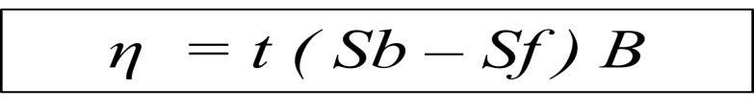
Where,
t = time in sec.for ball to fall between two marks
Sb & Sf = Specific gravities of ball and fluid under examination.
B = Constant for particular ball.
- The constant B includes wall interaction factors
- A liquid of known viscosity is then used to calibrate the instrument for general use
- Hoeppler viscometer is a commercial example
- A 200mm tube with 8mm radius and a normal 10o tilt from the vertical
- Can be used over the range of 0.5 to 200000poise
- For best results the t is not less than 30sec

Bubble viscometer
- Based on similar principle of falling sphere viscometer
- A series of standard sealed tubes have calibrated oils covering a range of viscosities
- Each has a small bubble of exact geometry

- The unknown sample is placed in an empty tube and stoppered so that it is identical in bubble content of the standards
- The unknown and standard tubes are inverted and bubble rise times are compared to determine the standard most resembling the unknown

