CLASS 10
TOPIC:Thixotropy
- Rheogram-rate of shear is progressively increased and plotted against resulting shear stress
- Assumed that if the rate of shear were reduced once the desired maximum had been reached the down curve super-imposable and identical with up curve-newtonian systems
- With shear thinning the down-curve frequently displaced towards left of the upcurve showing the material has lower consistency at any one rate of shear on the down curve than it on the upcurve
- This indicates a structural breakdown does not reform immediately when stress removed or reduced-thixotropy
- It is defined as, isothermal and comparatively slow recovery on standing of material of a consistency lost through shearing.
- It is shear thinning system, when agitated and kept aside it is expected to return its original state of fluidity, but takes longer time to recover compared to the time taken for agitation.
- Thixotropic behavior can be shown by plastic and pseudo plastic system.
- Thixotropic system consists asymmetric particles through numerous points of contact –loose three dimensional structure throughout the sample
- At rest the structure confers some degree of rigidity on the system and resembles-a gel
- As shear is applied and flow starts-the structure begins to break as points of contact disrupted –particles become alligned
- Material exhibits a gel to sol transformation exhibit shear thinning

- This process is non instantaneou rather progressive restoration of consistency as assymmetric particles come in contact with one another by brownian movement
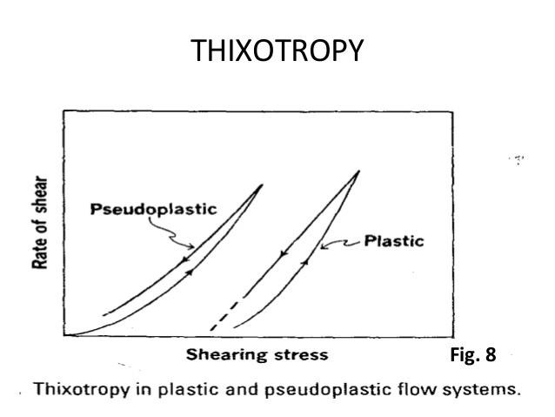

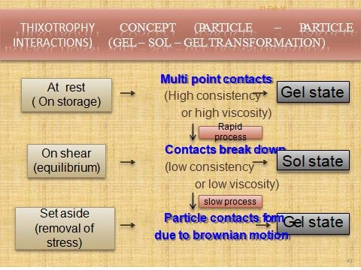
THIXOTROPHY (GEL-SOL-GEL)

- When these readings are plotted, the up curve ab is obtained from the desired maximum b if the rate of shear is reduced gradually, the down curve bc is obtained
- In case of non – Newtonian fluids, the down curve is frequently displaced to the left of up curve in Newtonian systems, the down curve is superimposed on the up curve
- The rheogram of a thixotropic material depends on
- The rate at which shear is increased or decreased
- The length of time during which a sample is subjected to any one rate of shear
Bulges and spurs
- Dispersions in pharmacy yield complex hysteresis loop when sheared in a viscometer in which shear rate increased to a point then decreased and shear stress is read at each shear rate value
- Two such complexes
- Bulges Spurs
THIXOTROPHY (GEL-SOL-GEL)

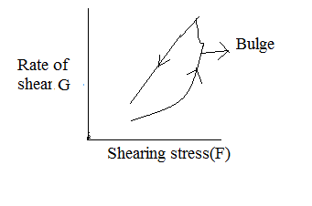

Bulges:
- Concentrated aqueous magma of bentonite (10 to 15% by weight) produces hystresis loop with a characteristic bulge is the up-curve
- The mechanism for such a behavior is as follows:
- The crystalline plates of bentonite form house of cards like structure that causes the swelling of magmas this three dimensional structure results in a bulged loop.

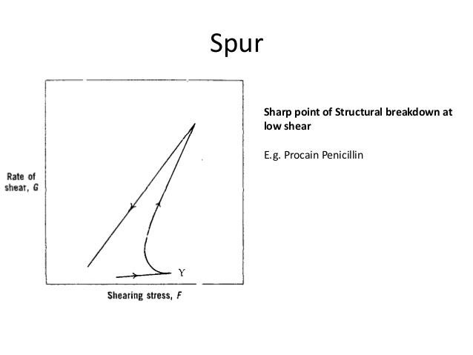

SPUR:
- Procaine penicillin gel produces a rheogram where in the bulged curve may actually develop into a spur like protrusion.
- The high spur value γ traces out a bowed upcurve when the three dimensional structure breaks in the viscometer
- The spur value represents a sharp point of structural break down at a low shear rate in the up curve.
Measurement of THIXOTROPHY
- In a thixotropic system, the hysteresis loop is formed by the up and down curve of the rheogram.

- The area of hysteresis loop has been proposed as a measure of thixotropic break down.
- It can be obtained readily with the help of a plani meter.
- In a thixotropic system, the nature of rheogram largely depends on the rate at which shear is increased or decreased.
Measurement of THIXOTROPHY(constant rate of shear)
- Consider a material that follows plastic flow, suppose shear rate is increased at a constant rate on the system upon a point ‘b’ and then decreased.
- When the results are plotted ‘abe’ rheogram is obtained.
- If the shear rate is maintained at ‘b’ for time t₁ seconds and then decreased ‘abce’ rheogram is obtained.
- Similarly at point ‘b’ if the shear rate is maintained for time t₂ seconds and then decreased, ‘abde’ curve is obtained.

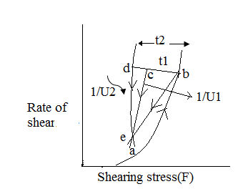
Measurement of THIXOTROPHY(constant rate of shear)
- The structural break down with respect to time at constant rate of shear gives the rheogram.
- Based on such rheograms, the thixotropic coefficient B, is calculated using equation.
- B = U₁-U₂/lnt₂/t₁
- U₁, U₂ are plastic viscosities calculated from equation U=F-f/G after shearing at constant rate for t1 and t2 seconds
Measurement of THIXOTROPHY(increased rate of shear)
- second approach is to determine structural breakdown with increasing shear rate

- U₁ and U₂ are plastic viscosities of the two down curves.
- In this method, the principle involved is subjected in which two hysteresis loops are obtained having different maximum rates of shear V₁and V₂
- The thixotropic coefficient M is calculated using the equation,
- M=(U₁-U₂)/ln(V₂/V₁)
- U₁, U₂ are plastic viscosities of down curves having shearing rates of V₁ and V₂ respectively.
- The value of M will depend on the rate of shear chosen because the shear rates will affect down curves
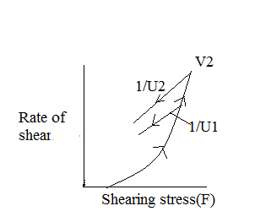
Applications of Thixotropy
- Thixotropy is a desirable property particularly in emulsions, suspensions and creams.

- The greater the thixotropy, the greater the physical stability of suspension, during storage, a suspension should have high consistency (gel) in the container, so that the suspended particles do not settle rapidly.
- On moderate shaking, the suspensions should become fluid, so that the contents can be poured easily from the container. This gel-sol-gel transformations improve the physical stability of dosage forms.
- Greater the thixotropy lower the rate of settling
- The degree of thixotropy is related to the specific surface of pencillin used, parenteral suspension containing 40 to 70% of procaine pencillin G in water has higher inherent viscosity while injecting the preparation, the structure of the suspended particles break down so that the product can pass through the hypodermic needle.
- After injection the original structure of gel will be rebuilt this leads to depot of the procaine pencillin G at the site of injection in the muscle, from which it is slowly released so as to provide sustained levels of drug in the body.

