PHARMACOGNOSY AND PHYTOCHEMISTRY I (Theory)

- Definition, history, scope and development of Pharmacognosy
- Sources of Drugs – Plants, Animals, Marine & Tissue culture
RCP
- Organized drugs, unorganized drugs (dried latex, dried juices, dried extracts, gums and mucilage, oleoresins and oleo- gum -resins.
:
Alphabetical, morphological, taxonomical, chemical, pharmacological, chemo and sero taxonomical classification of drugs


:
Adulteration of drugs of natural origin. Evaluation by organoleptic, microscopic, physical, chemical and biological methods and properties.
Quantitative microscopy of crude drugs including lycopodium spore method, leaf constants, camera lucida and diagrams of microscopic objects to scale with camera lucida.

Definition, history, scope and development of Pharmacognosy PHARMACOGNOSY DEFINITION:
It is defined as branch of science that involves the study of drugs including its biological source, Habitat, History, Distribution,cultivation,collection, processing, preservation, Microscopy, Macroscopy, physical properties, chemical constituents, therapeutic activity, uses, Adultrants, Substituents.
RCP
FATHER OF PHARMACOGNOSY: C.A SEYDLER a German scientist Book: Analytica pharmacognostica
SCOPE OF PHARMACOGNOSY:
- Drug discovery and development and act as bridge between modern or allopathic medicine and traditional system.
- Acts as a bridge between pharmacology, pharmaceutics, chemistry etc.
- And provide safe and effective combination of drug with the modern system of medicine.
- It includes the knowledge about safe use of herbal drugs including toxicity, side effects, and interaction by using it.
- By means of Pharmacognosy, natural products can be manufacture and dispensed, formulated in dosage form acceptable to modern system of medicine.
- Development of pharmacognosy leads to development of botany, biotechnology, pathology, taxonomy, genetics of plants, pharmaceutics and other branches of science.
HISTORY OF PHARMACOGNOSY:

NAME OF THE SCIENTIST | YEAR | DISCOVERY
SHEN NUNG | 2700 DC | *Medicinal value of several hundred of herbs
SHEN NUNG | 2700 DC | *he written a book "PEN-T SAL"
SHEN NUNG | 2700 DC | *Rhubarb podophyllum

SHANG DYNASTY | 1766-1122 BC | *Herbs used in medicinal treatment
CHIN& HAN | 300 BC | *Medical Treatise in China
CHANG CHUNG CHING | 142-240 AD | *He written an important clinical manual of traditional Chinese medicine &treatment of acute disease caused by cold
HONG JINGS | 456-536 AD | *Written book "Tao Hong jings" include stones - minerals, grass 7trees; Insects &animals, fruits &vegetables, grains& named but unused drugs
SUNG DYNASTY | 960- 1276 | *Gave establishment of pharmaceutical system.
MYNG DYNASTY | 1518-1593 | * Book - commentary contains 1892 drugs 376 described for 1st time with 1116 drawings & descriptions
ANCIENT EGYPT:
RCP

EBERS PAPYRUS | 1550 BC | * He written medical document & 800  prescription 700 drugs.
EDWIN SMITH PAPYRUS | 1600 BC | * It contains surgical instruction & formula for cosmetics.
KAHUN MEDICAL PAPYRUS | 1900 BC | * Deals with health of women including birth instruction
SMITH PAPYRUS |  | *It contains crude drugs like honey, Cenna, aloe, saffron, coriander.
ANCIENT INDIA:
From Ayurveda& rigveda (3500 -1500) BC AYUR- LIFE and VEDA -STUDY
*3 Major writings: *Chakra Samhitha, Sushruta Samhitha ,astangahrudaya Samhitha
*3 minor writings: *Sharangdhar Samhitha, bhava Prakhara Samhitha, Madhavan Dhana

Samhitha
ANCIENT GREECE AND ROME:
RCP

HIPPO CRATES | 460-370 BC | * Known as father of medicine
ARISTOTLE |  | *Student of Plato  ,philospher,written animal kingdom.
THEOPHRATUS | 370-207BC | * Student of aristotil, plant kingdom
DISCORDES | 1st century AD | *Described medicinal plants - belladonna
GALLEN | 131- 200 AD | * Preparation of plants and animals' drugs

DEVELOPMENT:
PARACELSUS | 1493- 1541 | *Mineral salt
LE MARY | 1645-1715 | *Extraction methods and importance
WILLIAM VETHERIN | 1785 | *Published importance of fox glove Leafs
DEROSEN | 1803 | *He isolated the nicotine from DPEM
STARS AND OTTO | 1852 | * New extraction process of alkaloids
POSSELT AND REIMEIN | 1828 | *Nicotine from tobacco Leafs
NEUMANN | 1860 | *Cocaine
IN 19TH CENTURY:
Materia medica- pharmacognosy coined as a term in 1850
Bentham & hooker | 1862 -1863 | *Development of plant classification
G. MENDEL |  | *Plant hybridization
BERG | 1865 | *Anatomical atlas of crude drugs
SWEED LINNAEUS | 1702- 170 | *Systemic classification of plants
DEVELOPMENT OF PHARMACOGNOSY

* It places during 1934-1960 mainly done four events:
*ISOLATION OF PENCILLIN:
In the year 1928 by William flemiling, large scale of production of penicillin in 1914 by flory & chain
RCP
*ISOLATION OF RESEROINE FROM RAUWOLFIA:
Used in hypertensive, low bp tranquilizer
- ISOLATION OF VIN BLASTIN & VINCRISTINE FROM VINCA ALKALOIDS
Used in leukemia & anticancer
- PROGESTERONE SYNTHESISED FROM DIASGENINE AND OTHER STERIOD
Cortisone & hydrocortisone by chemical & microbiological activity some steroids saponins also isolated by marker method
PRENCE STATUS AND FUTURE SCOPE OF PHARMACOGNOSY:
- Collection and domestication of medicinal plants
e.g. Mentha papyrita ,Plantago ovata,santalum Albam, osmium santum
- Analysis of phytochemicals
analyzation done by gas, thin layer chromatography, paper and HPLC techniques. many bioactive molecules are extracted and isolated from crude drugs.
- Preparation of general tonics & stimulants
e.g. LIV-52, LIVERGEN, LIVOMIN etc. Liver diseases they only give symptomatic relief
e.g. Tulasi, ashwagandha, Brahmi, ginseng are used as stimulant and adaprogenic drugs
- Steroid industry Extraction of diosgenin

it is important precursor to produce steroidal drugs such as sex hormones, contraceptives,
corticosteroids
- Herbal preparations
easily available, less cost, high effective safer. hence it mostly used
RCP
e.g. Andrographis paniculata (kalmegh)
Punarnava -boerheavia diffusia-anti hepatotoxic agent Brahmi- bacopa Mannine (memory enhancer)
- Preparation of antibiotics:
neem,tulasi,turmericare natural antibiotics
they also have antimicrobial activity, and very useful in maintaining health of people
- Flavouring agents & perfumes
flavoring agents e.g. Mentha; eucalyptus oil, lemon grass , dill, citronella
- Tissue culture e.g. Alkaloids, Glycosides, and flavonoids

Sources of Drugs – Plants, Animals, Marine & Tissue culture PLANT SOURCES:
  - RAUWOLIFA-
RCP
BIOLOGICAL SOURCE: Dried roots of rauwolfia serpentine family – Apocyanaceae.
CHEMICAL CONSTITUENTS: Serpentine, reserpine USES: Anti-hypertensive
  - NUX-VOMICA-
BIOLOGICAL SOURCE: Dried seeds of strychnous Nux-vomica family – Loganiaceae.
CHEMICAL CONSTITUENTS: Strychnine, Brucine USES: Stimulant increase appetite
  - VINCA-
BIOLOGICAL SOURCE: Dried entire plant of Catharanthus roseus Family-Apocyanaceae.
CHEMICAL CONSTITUENTS: Vincristine,Vinblastine,Vindesign. USES: Anti-cancer drug
  - TABACCO-
BIOLOGICAL SOURCE: Obtained from dried leaves of nictinatobacum Family-Solanaceae.
CHEMICAL CONSTITUENTS: Nicotine
USES: Sedative

  - SENNA-
BIOLOGICAL SOURCE: Obtained from dried leaves of cassia aqutifolia Family-Leguminaceae
CHEMICAL CONSTITUENTS: Sennosides A, B, C, D
USES: Purgative
RCP
  - DIGITALLS-
BIOLOGICAL SOURCE: Obtained from dried leaves of Digitalis purpurae Family-Scrophulariaceae
CHEMICAL CONSTITUENTS: Diagoxin,Diagitoxin USES: Cardiotonic
MARINE SOURCES:
    - ARA-A: It is semisynthetic antiviral agent based on arabinasyl nucleotide isolated from the marine sponge. (Tetya crypta).
USE: antiviral
    - EUCLISTOMINS:It is Beta-carboline clerixatia a isolated from sponges and gorgonians. Eudiistoma olivaceum
Family-polycintoridae. USE : antiviral
    - ALPHA -KAINIC ACID: Isolated from red alage Diagenia simplex. USE : Antihelminthic activity
    - BRYOSTATIN : Isolated from Bugula neritina a bryozoal-momhe organism. USE : Anti cancer
    - ELEDOISIN :Peptide compounds isolated from posterior salivary glands of cephalopod.

ANIMAL SOURCES:
- SHELLAC-
Lac or shellac is a vesinous substance obtained from bodies of Laccifera – Lacca - Laccidae
Chemical constituents- aleueritic acid, laccaic acid, shelloic acid Uses- preparation of sustain release tablets and pill.
RCP
- SILK-
It is obtained from cocoon larvae, mori - Bombycidae Chemical constituents- fibrin
Uses- sutures, sieves, ligatures
- WOOL:
It is a hair from flesh of sheep Bovis aries- bovidae Chemical constituents- keratin
Uses- sutures, bandages, staining medium
- HONEY:
Sugar secretion deposited in honeycomb by bees - Apis mellifera and Apis dorsata - Apidae
Chemical constituents- glucose, fructose, sucrose
Uses- smoothening on mucus membrane, demulcent, sweetening agent
- THYROID GLAND:
Obtained from ox, sheep, pig, sheep ovisaries, pig sus scrofa- bovidae Chemical constituents- T3 ( triiodothyronine).
T4 ( tetraiodothyronine)
Uses- goiter, obesity, myxoedema.
- SPERMACETI:

Waxy substance obtained from head of sperm whale Physeter – physteridae
Chemical constituents- cetyl palmitate, free cetyl alcohol, ester of laceric acid, stearic acid
Uses- ointments, cosmetic creams, smoothening on skin, emulsifying agent
- LARD:
RCP
It is purified intestinal fat obtained from abdomen of pig – sus scrofa – suidae Chemical constituents- 60% olein, 40% stearin, palmitin, myistein
Uses- ointment base, benzoinated lard, contain benzoin preservative PLANT TISSUE CULTURE SOURCES:
- ORGAN CULTURE: Vegetative organs Root culture- carrot
Leaf culture- vica
Shoot tip culture- ephedra
- HAIRY ROOT CULTURE:
Root apex developed - Agrobacterium rhizogenous – vinca, rauwolfia
- SUSPENSION CULTURE:
Catharanthus roseus – Ajmalicin Papaver somniferum – codeine Nicotiana tobacum- nicotine

Organized drugs, unorganized drugs (dried latex, dried juices, dried extracts, gums and mucilages, oleoresins and oleo- gum -resins.
It is defined as a product obtained from plant, animal ,mineral origin found in raw form either used directly or indirectly as a drug which have not been modified in its chemical composition.
Based on natural origin crude drugs are classified into two types: 1. Organized drugs
RCP
2. Unorganized drugs
They consist of cellular organization in the form of anatomical feature. Some examples are,
WOODS: Quassia, Sandalwood, Red sandalwood LEAVES: Digitalis, eucalyptus, mint, Tulasi BARKS: Arjuna, Ashoka, cinnamon ,kurchi FLOWERING PLANTS: Cloves, saffron, chamomile FRUITS: Amla, Amir, coriander, cumin
SEEDS: Bitter almond, mustard, nutmeg, nux vomica ROOTS AND RHIZOMES: Ashwagandha, garlic, ginger ,jalas PLANTS AND HERBS: Ergot, yeast, vinca, bacopa, datura HAIRS AND FIBRES: Cotton, hemp, jute, silk, flax
These drugs do not have anatomical and morphological organization and obtained from plant, animal, mineral sources.
Some examples are,

DRIED LATEX: Opium, papain DRIED JUICE: Aloe, kino
DRIED EXTRACTS: Agar, alginate, catechu, pectin WAXES: Beeswax, spermaceti
GUMS: Acacia, guar gum, Indian gum, tragacanth RESINS: Asafoetida ,benzoin, colophony, coal tar VOLATILE OILS: Terpentine oil, anise, clove, dill, lemon FIXED OILS AND FATS: Arachis, castor ,coconut , olive ANIMAL PRODUCTS: Beeswax, cod liver oil, honey
RCP
FOSSIL ORGANISMS AND MINERALS: Bentonite, kaolin, talc

DIFFERENCE BETWEEN ORGANISED AND UNORGANISED DRUGS:

ORGANISED DRUGS  - These are organs of plants and animals made up of cells of definite structure.  - These are solid in nature.  - Botanical or zoological terminology can be used to describe them. | UNORGANISED DRUGS  - These are derived from parts of plants and animals by some process of extraction followed by purification example: juices, extracts, resins ,etc  - They might be solid, semisolid, liquid in nature .example: oils, gums, balsams  - Such terminology is inadequate to describe them but has to look for their physical characters such as

RCP

 | solubility in various solvents, density, optical rotation, refractive index, wherever is applicable.
4.miroscopic characters are one of the important criteria for identification. | 4.chemical and physical tests are the confirmatory tests.

Alphabetical, morphological, taxonomical classifications
- SIMPLEST WAY OF CLASSI FICATION SYSTEMATIC ARRANGEMENT OF CRUDE DRUG
IN ALPHABETICAL ORDER OF THEIR "LATIN" AND "ENGLISH" NAMES (COMMON NAMES) OR SOMETIMES
RCP
LOCAL LANGUAGE NAMES (VERNACULAR NAMES)
- SOME OF THE PHARMACOPOEIAS, DICTIONARIES AND REFERENCE BOOKS WHICH CLASSIFY CRUDE DRUGS ACCORDING TO THIS SYSTEM ARE AS FOLLOWS:
- BRITISH HERBAL PHARMACOPOEIAS

- BRITISH PHARMACEUTICAL CODEX

UNITED STATES PHARMACOPOEIA AND NATIONAL FORMULARY
EUROPEAN PHARMACOPOEIA
IN EUROPEAN PHARMACOPOEIA THESE ARE ARRANGED ACCORDING TO THEIR NAMES IN LATIN WHERE IN UNITED STATES PHARMACOPOEIA AND BRITISH PHARMACEUTICAL CODEX, THESE ARE ARRANGED IN ENGLISH
MERITS
EASY AND TO USE

No REPETITION OF ENTRIES AND IS DEVOID OF CONFUSION DEMERITS-
No RELATIONSHIP BETWEEN PREVIOUS AND SUCCESSIVE DRUGS ENTRII
Systematic arrangement of crude drug based on morphological characters or external characters of plant parts, animal parts which is used for therapeutic effect.

Leaves - vasaka , Tulasi Roots - rauwolfia

Seeds - nux vomica, mustard Barks - kurchi , cinnamon.
RCP
Dried latex - opium, papain Dried juice - aloe, kino
Dried extract - agar, catechu Gum - acacia
Resins - oleoresin oleogum resin
- very useful in identifying the adulterants used. More convenient for practical study.
- it doesn't give an idea about chemical constituents and uses. TAXONOMICAL CLASSIFICATION:
The drugs are classified according to plants or animals from which they are obtained in phyla, orders, families, genera, species, subspecies. This method of classification Is based on the consideration of natural relationship or phylogeny among plants or animals. The Crude drugs of plant origin are classified on the basis of one of the

accepted systems of botanical classification. A large number of plant families have certain distinguishing characteristics that permit crude drugs from these families to be studied at one time. Thus, drugs obtained from plants having alternate leaves, cymose flowers and fruits that are berries or capsules are considered with other members of Solanaceae. In case of animals, arthropods are grouped, as all mammals, fish and other phylogenetic types. This system of classification is criticized for its failure to recognize the organized and unorganized nature of the crude drug. At first sight, this classification looks appealing, but many drugs are not entire plants and represent parts of the plants that have been processed systematically. Further, the system fails to take into an account chemical nature of active constituents and therapeutic significance of crude drugs.
RCP
The taxonomical classification of crude drugs derived from dicot plants as follows:
- Phylum - spermatophyte Division - Angiospermae Class - Dicotyledons Order - Rosales
Family - Leguminosae Sub-family -Papilionaceae
Genus – Glycyrrhiza, Astrgalus, Myroxylon
Species- Glycyrrhiza glabra, Astrgalus gummier, Myroxylon balsamum
- Phylum - Thallophyta Class - Ascomycetes Order - Clavicipitales Family - Clavicipitaceae Genus - Claviceps
Species – Claviceps purpurea

chemical, pharmacological, chemo and sero taxonomical classification of drugs
  - Crude drugs are grouped according to their pharmacological action of their chief active constituent.
  - The drugs differing in mechanism of action but having same Pharmacological action are also grouped together.
RCP
e.g. bulk purgatives, irritant purgatives. Drugs acting of Gastrointestinal tract:
  - Bitters - Gentian,Quassia,Cinchona
  - Carminatives - Dill, Mentha
  - Emetics - Ipacacuanha
  - Bulk laxatives - Agar, Banana Drugs acting on respiratory system:
  - Expectorant - Liquorice,vasaka
  - Anti Expectorant - Stramonium leaves.
  - Anti Tussive – Opium
Drugs acting on cardiovascular system:
  - Cardiotonic - Digitalis,Squill
  - Cardiac depressants - Cinchona
  - Vaso Constrictors -Ergot, Ephedra Drugs acting on CNS:
  - Central Analgesics - Opium
  - CNS Stimulants - Caffeine

  - Analeptics- Nux vomica, camphor
  - CNS Depressants - Belladona,opium Anti-Cancer:
  - Vinca, Taxus, Podophyllum Astringent:
RCP
  - Myrobalan, Black Catechu Advantages:
  - The special advantage is that if even chemical constituents is not known they can be classified based on their pharmacological action.
Disadvantages:
  - Regardless of morphology, taxonomy or chemical nature the drugs are grouped together, provided they exhibit similar pharmacological action.
:
  - Serology is defined as that portion of biology which is concerned with the nature and interaction of antigen material and antibody.
  - Phyto serology which deals with the immunological reactions, between serum antibodies and antigen, has also established itself as a valid method in systematics, because it helps to detect homologous protein.
  - Sero taxonomy the classification of very similar plant by means of difference in the protein they contain. The technique I s based on the highly specific between antigen and the antibodies produced in response to them. The application of serology in solving the taxonomic problems.
- The protein extract of the plant origin i.e. antigen
- The antigen is injected into the blood stream of an experimental
- animal to form antibodies.
- The experimental animal produces specific antibody in response

- to antigen.
- The serum with antibodies called antiserum. Antiserum is made
- to react invitro with antigen protein as well as proteins of other
- taxa whose affinities are to to be determined.
- The amount of precipitation shows the degree of homology
RCP

- The expanding knowledge of phytochemical screening has revealed the existence of close relationship between Constituents of plants and their taxonomical status. The ‘chemotaxonomy’ has brought the plant chemist back to systematic botany in view of the fact that certain compounds have been found to characterize certain groupings. Chemotaxonomy establishes a
- relationship between position of the plant and attempts to utilize chemical facts for more exact understanding of the biological evolution and relationships. The characters more often studied in chemotaxonomy are secondary metabolites of pharmaceutical significance such as alkaloids, glycosides, flavonoids. The knowledge of chemotaxonomy could serve as the classification of crude drugs. The location of berberine alkaloid in Hydrastis, Berberis and Argemome distribution of rutin, ranunclaceous alkaloids and flavonoids in species of higher plants are of chemotaxonomy significance. DNA hybridization, amino acids sequencing in proteins and sero taxonomy are also gaining significance in this method of classification.

: {Adulteration of drugs of natural

origin}

  - The process or a practice of substituting the original crude drug Partially or wholly with the other sub stranded drug is called adulteration. It is an oct of making original quality of crude drug to inferior drug or sub stranded drug.
RCP

  - Less availability of crude drug
  - To get profits
  - Adulteration is done either accidentally or intentionally
  - Due to unskilled labour
  - Due to less storage

  - Substitution with sub stranded commercial variety
  - Substitution with superficially similar inferior drugs
  - Substitution with artificially manufactured drugs
  - Substitution with exhausted drugs
  - Substitution with harmful products
  - Substitution with other vegetative parts of plant
  - Substitution with powdered drugs

- Itis the most common type of adulteration. the adulteration used as to resemble the original crude drug by morphological chemical or therapeutic characteristics, but ore sub stranded in nature.

- Eg: strychnous nux Blenda replace of strychnous nux vomica
:
- The adulterants resemble in morphologically may or may not be resemble in chemical or therapeutic characteristics.
- E.g.:- Bees wax substituted with Japanese wax SUBSTITUTION WITH ARRIFICIALLY MANUFACTURED DRUGS:
RCP
- The adulterants artificially prepared substances which resembles original crude drug used as substitutes. This is mainly used as costliest drugs.
- E.g.- Portugal ergot consisted up to 25%. SUBSTITUTION WITH EXHAUSTED DRUGS:
- Same drug is admixture and it does not contain any medicinally active constituent as they. are not already extracted out. Extracted by some special methods by steaming of solvent s by drying and etc. It is mainly done for volatile oil containing compounds.
- EXAMPLE:-Clove ,umbelliferous fruits, ginger, tea and etc.,

- In corporation in the genuine drug useless material like stones, sand etc. To increase the weight of drug to receive money.
Example:
- amphour colored glass in colophony
- Limestone in opium
- Paraffin in cocoa butter
- Rodent fecal matter in cardamom seed
- Other plants which are growing along with medicinal plants are mixed with drug due to their resembling color, odour,
Example:

- Lower plants like liver warts are mixed with cascara or cinchona
- Stem portions are mixed with leaf drugs like senna
- Substitution with powdered drug:
  - In this adulteration of powdered drugs like liquorise ,nux vomica, cinnamon. Example:
RCP
  - In chillis powder red sandals wood powder is added
  - Dried ginger powder with starch.

: {Evaluation by organoleptic,
microscopic}

It refers to evaluation of drugs by colour, odour, taste, size, shape and special features. e touch, texture, etc. It is a technique of qualitative evaluation based on the study of morphological and sensory profiles of whole drugs. Organoleptic evaluation means conclusions drawn for impressions on organs of senses. The study of form of a crude drug is Morphology while descriptor of the form is Morphography. The fractured surfaces in cinchona, qualia and cascara barks quassia wood are important characteristics. Aromatic odour of umbelliferous fruits and sweet taste liquorice are the examples of this type of evaluation. The ovoid tears of gum acacia, ribbon shape characteristic of tragacanth, disc-shaped structure of nux vomica, conical shape of aconite, quill cinnamon etc. are important diagnostic characters. The general appearance of the lot of a c drug often indicates whether it is likely to comply with prescribed standards, such as percentage seed in colocynth, stalk in clove, etc. Over drying, makes leaf drugs and flowers brittle and ca them to break in transit making the task of morphological evaluation difficult.

The wavy shape of Rauwolfia, pungent taste of capsicum and ginger, brown color cinnamon, odour and taste of spice-drugs like, asafoetida, black pepper, nutmeg, caraway, cum etc. are important diagnostic organoleptic characteristics.
RCP
This is a type of evaluation in which the organized drugs are classified based on their histological characters. This is used for qualitative evaluation of organized drugs in entire or powder forms. :
- Leaf constants
- Stomata
- Trichomes
- Quantitative microscopy

They are the diagnostic characters of leaves that are the important quantitative microscopic evaluations which can be used to identify some closely related species. Like:
- PALISIDE RATIO
- VEIN ISLET NUMBER
RCP
- VEIN TERMINATION NUMBER
- STOMATAL NUMBER
- STOMATAL INDEX

- Stomata are the minute openings usually found in the epidermis of the leaves. These openings are surrounded with a pair of kidney shaped cells called “Guard Cells”. The epidermal cells surrounding the guard cells are called “Neighboring Cells or Subsidiary Cells”. Depending on the arrangement of these subsidiary cells stomata are divided into four types:
- Paracytic or Parallel celled stomata
- Diacytic or Cross celled stomata
- Anisocytic or Unequal celled stomata
- Anomocytic or Irregular cell stomata
- Actinocytic or Radiate celled stomata

- Trichomes are fine outgrowths that consists of two parts - ‘root and ‘body’.Root is present in the epidermis.Body is present out of epidermis.
- Trichomes are basically classified into three types:
- Covering or Non-glandular Trichomes
- Glandular Trichomes
- Hydathodes

  - It is an analytical technique to analyse powered drugs.
  - This includes the“Lycopodium Spore Count Method” .The spores of lycopodium which are very characteristic in shape and appearance and exceptionally uniform in size I.e,“25 micrometers”. Hence this powder is used for quantitative microscopy
RCP

 physical, chemical and biological
methods and properties.}

  - Physical standards are to be determined for drugs wherever possible. These are rarely constant for crude drugs but may help in evaluation specifically with reference to moisture content, specific gravity, density, optical rotation, refractive index, melting point, viscosity and solubility in different solvents
- moisture content:
RCP
  - The percentage of active chemical in drugs mentioned on air dried basis Hence
,the moisture content of a drug should be determined should also be controlled. The moisture content is determined ne heating a drug at105°c.
- iscosity:
  - viscosity of a liquid constant at a given temperature and is an index of its composition. Hence it can be used as a means of standardizing liquid drugs.
  - Examples:
  - Liquid paraffin :kinematic viscosity not less than 64 centistokes at 37.8
  - Pyroxylin: kinematic viscosity 1100-2450centistokes
- Melting point:
  - itis one of the parameters to judge the purity of crude drugs. melting points are very sharp and constant. since the crude drugs from animal or plant origin contain the mixed chemicals they are described with certain range of melting point
  - Examples:
  - Cocoa butter -30-33°c
  - Kokum butter -39-72°c
- Solubility:

The presence of adulteration in a drug could be indicated by solubility studies.castor oil is soluble only in three volumes of 90 percent alcohol, while the adultered from may show good solubility in alcohol. Asafoetida is soluble in carbon disulfide.
- Optical rotation:
- certain compounds are found to have the property of rotating the plane of polarized light in pure state in solution form. The compound which shows optical rotation are called as optically active and property is called as optical rotation.
RCP
- Examples: Caraway oil :+75°to 80°
- Castor oil:3.5°to 6.0°
- Refractive index:
- when a ray of light passes from one medium to another of different density it is bent from original path thus the ratio of the velocity of light in vacuum is velocity in the substance is termed as refractive index of the second medium
- Examples:
- Arachis oil :1.4678 to 1470
- Clove oil:1527to 1535
- Ash values and Extractives :
As mentioned earlier, evaluation of drug basically needs to identification and can be done by morphological or microscopic characters .
- Ash content
  - The residue remaining after incineration is the ash content of the drug which simply represents inorganic salts naturally occurring in drug or adhering to it.
- Physiological ash:
  - Total Ash of the drug is inclusive of physiological ash as well as non physiological ash is derived from the plant tissues while non physiological ash consists of residue of the extraneous matter, sand ,soil,etc..
10.B.Extractives

- The extracts obtained by exhausting crude drugs are indicative of approximate measures of their chemical constituent taking into consideration the diversity in chemical nature and properties of contents of drugs.
- Water soluble extractives:
  - This method is applied to drugs which obtain or certain water soluble active constitutes of crude drugs such as tannis sugars plants, acids, mucilage
RCP
  - Example: aloe -NLT 10%w/w
- Alcohol soluble extractives:
  - Alcohol is an ideal solvent for extractive of various chemicals like tannins resins etc ..
  - Example: Benzoin-NLT 90.0%w/w
- Ether soluble extractives:
  - The types of ether soluble extractive values determined for evaluation of crude drugs are volatile and non volatile ether soluble extractives.
  - Example:
  - capsicum not less than 12.0
  - Linseed not less than 25.0
- Volatile oil content:
  - Pharmaceutical significance of aromatic drugs is due to their odorous principles i.e volatile oils
  - Example: caraway not less than 2.5
  - Clove not less than 15.0
  - Dill not less than 2.5

- Foreign organic matter:
  - The parts of the organ or organs than those named in the definition and description of the drug are defined as foreign organic matter

- Chromatographic techniques:
  - Chromatography represents a group of method for separating molecular mixtures that depend on the differential affinities of the solute between two immiscible phases
CHEMICAL EVALUATION
It comprises of different chemical tests and chemical assays
RCP
  - The isolation, purification, identification of active constituents are chemical method of evaluation.
  - The chemical evaluation covers phytochemical screening. ALKALOIDS:
- Dragendorff’s reagent: Alkaloids give reddish brown precipitate with dragendorff’s reagent (potassium bismuth iodide solution).
- Mayer’s reagent: Alkaloids give cream color precipitate with Mayer’s reagent (potassium mercuric iodide solution).
- Wagner’s reagent: Alkaloids give reddish brown precipitate with Wagner’s reagent (iodine potassium iodide solution)
- Hager’s reagent: Alkaloids give yellow precipitate with Hager’s reagent(saturated solution of picric acid)
- Tannic acid test :Alkaloids give buff color precipitate with tannic acid solution.
- Picrolonic acid test :Alkaloids give yellow color precipitate picronolic acid AMINO ACIDS:
  - Millon’s test: To the test solution add about 2ml of millon’s reagent ,white precipitate indicates presence of amino acid
  - Ninhydrine test: To the test solution add ninhydrine solution, boil ,violet color indicates presence of amino acid
VOLATILE OIL:
  - To a thin section of drug add Sudan 3 solution, red color obtained by globules indicates presence of volatile oil.
  - To a thin section of drug add few drops of Tincture alkane ,red color indicates presence of volatile oil

  - ​
STEROIDS and TRITERPENOIDS:
  - Libermann-Burchard test: Treat the extract with few drops of acetic anhydride, boil and cool. Then add concentrated sulphuric acid from the side of the test tube, brown ring is formed at the junction two layers and upper layer turns green which shows presence of steroids and formation of deep red color indicates presence of triterpenoids.
RCP
TANNINS(PHENOLIC COMPOUNDS):
  - Goldbeater’s skin test: Add 2%hydrochloric acid to a small piece of goldbeaters skin, rinse it with distilled water and place in the solution to be tested for five min. Then give wash of distilled water and 1% ferrous sulphate solution. A brown or black color on the skin indicates presence of tannins.
  - Ferric chloride test: Treat the extract with ferric chloride solution, blue color appears if hydrolysable tannins are present and green colour appears if condensed tannins are present.
  - Phenazone test: Add about 0.5gm of sodium acid phosphate to 5ml of aqueous extract warm it and filter. To the filtrate add 2% phenazone solution, bulky precipitate is formed which is often colored.
  - Gelatin test : To the test solution add 1% gelatin solution containing 10% sodium chloride. Precipitate is formed.
  - Test for catechin: Dip a matchstick in the solution, dry it and lastly moisten with concentrated hydrochloric acid. Then warm the stick near flame. The colour of the wood changes to pink due to phloroglucinol.
 :
This method is carried out when the drugs are not evaluated by any other methods, or chemical nature of the drug is unknown or chemical methods are not available or drugs which have different chemical composition but same biological activity. Generally in this method, the response produced by the test drug on a living system is compared with that of the standard preparation.
This method is used for:
- Measurement of the pharmacological activity of new or chemically undefined substances.

- Investigation of the function of endogenous mediators.
- Determination of the side effect profile, including the degree of drug toxicity.
- Measurement of the concentration of known substances.
- Assessing the amount of pollutants being released by a particular source such as waste water.
RCP
Example: Cardiac glycosides are evaluated by this method using frogs, cats, pigeons etc. Significance:
  - This method is used when the standardization is not done by physical or chemical method.
  - When the quantity of drug is very less or drug itself not available
  - This method is performed on living animals. Microbiological Assay:
The method of measuring compounds such as vitamins and amino acids usingb microorganisms. The principle is based on a comparison of the inhibition of growth of microorganisms by measured concentration of the antibiotics to be examined with that produced by known concentrations of a standard preparation of the antibiotic having a known activity. As per IP, two methods are used for assay viz. the cylinder plate method or cup plate method and the turbidity method. The cup plate method is depends upon diffusion of the antibiotic from a vertical cylinder through a solidified agar layer in a petri dish or plate to an extent such that growth of the added microorganism is prevented entirely in a zone around the cylinder containing a solution of the antibiotic. The method depends on the microbial growth inhibition in the culture of uniform antibiotic. This is favorable to the rapid growth in the absence of the antibiotics.

Quantitative microscopy of crude drugs including lycopodium spore method
It is an analytical technique for powdered drug, especially when chemical and other methods of evaluation of crude drugs fail as accurate measures of quality .it is inexpensive technique with official status Lycopodium spores are very characteristic in shape and appearance and exceptionally uniform in size (25μm) . on an average ,94000 spores per mg of powdered lycopodium.
The percentage purity of an authentic powdered ginger is calculated using the following equation
R P
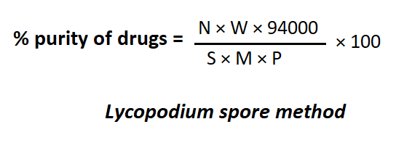

Where,

N = no. of characteristic structure in 26 feet. W = weight of lycopodium in mg
S = number of lycopodium spores M = weight of sample in mg
P = 2,86,000 in case of ginger starch grain powder
Procedure:
- Dry the powdered drug at 105° C and determine its steady weight at room
- Weigh accurately 200 mg of powdered test material (Ginger drug) and 100 mg of Lycopodium spores powder and mix them uniformly with the help of a glass rod/spatula in a small beaker.
(Proportion of 2:1 powdered drug to Lycopodium has been found to be satisfactory).
- Make a thin smooth paste by adding 5 ml of suspending medium (glycerine tragacanth mucilage: water, 2:1:2).
(Note: Adjust the final volume by suspending fluid such that about 10 to 20 spores may be present in a field of 4X objective of a compound

microscope. Oscillate the tube gently to get a uniform suspension). 4) Place a drop of above suspension on a glass slide, spread with a needle and put a coverslip and observe under microscope in low power (10X).
- Count the characteristics particles of the organic matter as well as the Lycopodium spores in the field.
- Make one more slide in the same way to get counts in 25 fields. and count 25 fields each for both preparations as above.
RCP
- Prepare another suspension as described above, prepare two more slides
- Determine the average of 4 sets of counts (4 x 25 = 100 fields in all) and also the percentage of the moisture present from the first step.
- Calculate the number of characteristics particles present in 1 mg of the powdered
material dried at 105 °C and report the results.
- Determine in a similar way the number of characteristic particles per mg of the pure foreign matter, calculated with reference to the material dried at 105 C (If this number can be obtained from the literature a special experiment is unnecessary).
- Calculate the percentage purity from the formula.

Quantitative microscopy of crude drugs including , leafconstants, camera lucida and diagrams of microscopic objects to scale with camera lucida.

:
  - THERE ARE FIVE TYPE OF LEAF CONSTANTS
PALASIDE RATIO = It is defined as average number of palisade cells beneath each epidermal cells.
EXAMPLE =Atropa belladona : 5.5-6.5
  - .VEIN ISLET NUMBER =It is defined as number of vein islet per square mm of the leaf surface between midrib and margin.
EXAMPLE =Digitalis Purpurea :2.5-3

  - VEIN TERMINATION=It is defined as number of vein termination per square mm of leaf surface between midrib and margin .
EXAMPLE=Senna:24.2-31.4
  - .STOMATAL NUMBER=It is defined as number of stomata per square mm of epidermal leaf .
EXAMPLE=Atropa Belladona: upper=7-10 lower=77-115
  - STOMATAL INDEX=It is defined as % which the stomata form to the total number of epidermal cells.
RCP
EXAMPLE=Atropa Belladoma:20.2-23.0
CALCULATED BY USING THIS FORMULA = S/E+S x 100

STOMATA:
They are the minute opening usually found in epidermis of the leaf ,young green stems
,in fruits.
*They are associated with exchange of gases
*These are the opening surrounded with a pair of kidney shaped cells called guard cells
*The epidermal cells surrounding the guard cells are called neighbouring cells or subsidary cells.
CLASSIFICATION:
Depending on guard cells and arrangement of subsidary cells stomata is divided into 4 types: 1.MOSS TYPE
- GYMNOSPEROUS TYPE
- GRAMINEOUS TYPE
- DICOTYLEDONOUS TYPE
- PARASYTIC (OR) RUBACEOUIS (OR) PARLLEL CELLED STOMATA = This type of
stomata comprises two guard cells surrounded by two subsidary cells ,the long axis of which are parallel to the of stomata .
Example- Coca , Senna
- DIACYTIC (OR) CAROPHYLLACEOUS (OR) CROSS CELLED STOMATA= This type of
stomata comprises two guard cells which are surrounded by two subsidary cells opposite to each other i.e. at right angle to the of stomata
Example-Peppermint ,Tulasi

- ANISOCYTIC (OR) CRUCIFEROUS (OR) UNEQUAL CELLED STOMATA =This type of
stomata comprises two guard cells surrounded by three subsidary cells in which one is smaller compared to others .
Example- Belladona ,Datura
- ANOMOCYTIC (OR) IRREGULAR SHAPED STOMATA = This type of stomata
comprises of two guard cells covered by multiple number of subsidary cells . Example- digitalis ,lobella
RCP
- ACTINOCYTIC (OR) RADIATE CELLED STOMATA =This type of stomata comprises two guard cells surrounded by radiating subsidary cells.
Example- pseudebenus
It is an optical device or instrument in which rays of light are reflected by a prism to produce an image on a sheet of paper, from which a drawing is made. It works on simple optical principle reflecting beam of light through a prism and a plane mirror. There are two types of camera lucida namely Swift Ives and Abbe model camera lucida. The Abbe camera lucida consists of a prism fitted over the eyepiece of the microscope. A side arm is carrying a mirror that supported vertical over the tracing paper Set up of Abbe camera lucida with microscope In Swift Ives Camera lucida the plane mirror is replaced by a small right angled prism. It is a small size and fitted over the eyepiece of the microscope with a screw.
Principle:
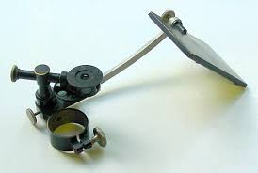
During use, the light from the drawing board is reflected by the plane mirror into the prism and further reflected into the observer’s eye that is seeing the drawing paper and the pencil in the direction of the stage of the microscope. The prism has a small opening through which the observer is seeing the image of the object. As a result, the superimposed image then conveniently traces the microscopic object
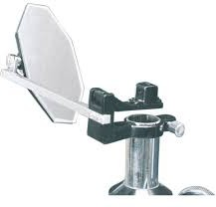

Very short answer questions (2MARKS)
- Define Pharmacognosy
- Write the difference between organized and unorganized drugs
- Write morphological classification
- What is stomatal index
RCP
- What is vein islet and vein termination number
- Write the formula for Lycopodium spore count method
- Write one example for taxonomical classification
Short answer questions (5 MARKS)
- Write scope and importance of Pharmacognosy
- Write pharmacological classification
- Write about adulteration of natural drugs
Long answer questions (10MARKS)
- Write about microscopic evaluation
- Write classification of crude drugs
- Write a note on adulteration with examples

10 Hours
Cultivation, Collection, Processing and storage of drugs of natural origin: Cultivation and Collection of drugs of natural origin
Factors influencing cultivation of medicinal plants. Plant hormones and their applications. Polyploidy, mutation and hybridization with reference to medicinal plants
RCP
Conservation of medicinal plants

: Cultivation & Collection
: Cultivation and collection of drugs of natural origin
Medicinal plants have curative properties due to the presence of various complex chemical substances of different composition, which are found as secondary plant metabolites in one or more parts of these plants. These plant metabolites, according to their composition, are grouped as alkaloids, glycosides, corticosteroids, essential oils, etc. World Health Organization (WHO) has estimated that at least 85% of the world population relies on traditional systems of medicine for their primary health needs. These systems are largely plant-based. According to WHO, over 21000 plant species are useful in the preparation of medicines. Due to the growing awareness about side effects and complications of chemical and synthetic medicines, cosmetics and health supplements, usage of herbal products has gained importance both in the Eastern and Western Worlds. It is estimated that more than 70,000 plant species, from lichens to towering trees, have been used at one time or another for medicinal purposes. The herbs provide the starting material for the isolation or synthesis of conventional drugs. India is endowed with a rich wealth of medicinal plants, which ranked our country in the list of top producers of herbal medicines. The varied agro-climate conditions in India make this suitable for growing a wide range and variety of valuable medicinal plants. This production of medicinal plants generates increased employment opportunities for the farmers and enhances their incomes. But due to over population and other conditions, the total forest area is reducing, which has reduced the total cultivation/ collection of medicinal plants in India. We may lose the wealth of medicinal plants if this deforestation continues, which will affect the growth of our economy. Therefore, it is essential to cultivate at large scale and to conserve heritage of medicinal plants. Recently Indian Government has set up a national level body, the NMPB (National Medicinal Plant Board) for the growth and development of medicinal plant sectors in the country. General guidelines on good agricultural practices (GAP) for medicinal plants are required to distribute to all the growing sectors, which describes general principles and provides technical details for the cultivation of medicinal plants, their quality control measures, where applicable. We are still at the developing stage with regard to cultivation of medicinal plants because there is no standard operation procedure for the cultivation in India. Indian farmers are facing various problems in cultivation of medicinal plants because of lack of proper agro-technology, high fees for packages developed by various organizations, lack of reliable and standardized technology package, lack of planting material, market potential and system, cultivated wild plants, organic farming techniques, etc. Knowledge of post-harvest processing technology of plants for the extraction of chemicals and preparations of active formulation is still
RCP

needed. Various aspects of medicinal plant cultivation include old philosophies, modern impact of traditional medicines and methods of assessing the spontaneous flora for industrial utilization, climatic variations, biological assessment, formulation, process technologies, phytochemical research and information sources. Indian herbal Industry is at blooming stage, but supply of raw materials through cultivation of medicinal plants is very difficult in all the seasons. In India, various medicinal plants are cultivated and domesticated, therefore, International trade is looking to procure medicinal plant materials from India for the production of pharmaceutical, nutraceutical and cosmeticeutical preparations.
RCP

: Cultivation & Collection
Processing of drugs of natural origin
Processing of crude drugs include:
- Drying
RCP
- Garbling
- Packing

  - It consists of removal of sufficient moisture content of crude drugs.
  - This process improves its quality and make it resistant to growth of
  - microorganisms
  - Methods of drying ;
    - Natural drying: direct Sun drying
    - Artificial drying:
  - Tray dryers: Hot air of desired temperature is circulated through dryers.
  - E.g.: Cinchona Bark
  - Vacuum dryers: The drugs that are sensitive to higher temperatures are dried through this process.
  - E.g.: Digitalis leaves.
  - Spray dryers: The technique is followed for quick drying.

  - The next step after drying is Garbling.
  - The process is desired when sand, dirt, foreign organic matter are required

  - to be removed.
  - E.g.: pieces of iron are removed with magnet in case of castor seeds before
  - crushing
  - E.g.: pieces of bark are removed by peeling in case of gum acacia.

  - The morphological and chemical nature of drug, its use, effects of climate conditions during transportation and storage should be taken into consideration while packing the drugs.
RCP
  - E.g. Aloe is packed in goat skin, colophony and balsam of tolu - kerosene tins; asafoetida - closed containers to prevent loss of volatile oil,
  - Cod liver oil, being sensitive to sunlight, should be stored in such containers, which will not have effect of sunlight, whereas, leaf drugs like senna, vinca are pressed baled.
  - The crude drugs like roots, seeds are packed in gunny bags

: Cultivation & Collection
: storage of drugs of natural origin:
- The good quantity of drug can be maintained , if they are preserved properly.
- All the drugs should be preserved in well closed and possibly in air filled container.
RCP
- The premises which are used to store the crude drug must be water proof , fire proof and rodent proof.
METHODS FOR STORAGE
- STORAGE IN WELL CLOSED CONTAINER :-
All the drugs must be kept in an well closed containers, that must water proof , fire proof and rodent proof.
- MOISTURE FREE STORAGE :-
Moisture will increase the enzymatic and fungal growth .
Ex:- In DIGITALIS leaves increase in enzymatic activity so chemical constituents become less active .
Other examples are Wild cherry bark & Ergot ( increases fungal growth ).
- STORAGE IN LIGHT RESISTENT CONTAINERS :-
Cod liver oil , digitalis stored away from sunlight .
- STORAGE FREE FROM AIR :-
Oxygen (O2) causes spoilage of drugs like shark liver oil , papain so replace it with nitrogen (N2) .
- STORAGE FREE FROM PEST :-
Treat with fumigants to remove pest like fungus . Ex : Methyl Bromide , Carbon Disulphide , Propylene Oxide , Chloropicrin.
- SPECIAL TREATMENT TO CONTROL MICROBIAL GROWTH :-

Examples – Ginger , Nutmeg coated with lime .
Squill stored in powdered form . To Lard add Siam benzoin.
- STORAGE AT LOW
TEMPERATURE:- Vitamins , fish oils , enzymes stored at low temperature .
- STORAGE FROM INSECTS :-
RCP
  - Flia beetles damage the mentha leaves .
  - Rauwolfia is damaged by Diaphania nilgirica .
  - Dill – Papilio maichon Hyadaphis coriandri .
  - Belladona Leaves – Gonocephalum species , Agrotis flammatra .
  - So insect proof area is required for storage .
- Rudents , squirrels proof area must be present.

: Cultivation & Collection
: Factors influencing cultivation of medicinal plants.
Cultivation of medicinal and aromatic plants take cognizance of plant habitats and climatic requirements for their favourable growth.
The factors which are given special attention for cultivation are listed below:
RCP
- Attitude, temperature and humidity
- Rainfall or irrigation
- Soil and soil fertilizers
- Fertilizers
- Pests and pest control


Altitude is a very important factor in cultivation of medicinal plants. Tea, cinchona and eucalyptus are cultivated favourably at an altitude of 1000 - 2000 meters. Cinnamon and cardamom are grown at a height of 500 - 1000 meters, while senna can be cultivated at sea level. The following are the examples of medicinal and aromatic plants indicating the altitude for their successful cultivation.
Examples:-
Tea - 1000-1500
Cinchona - 1000-2000
Camphor - 1500-2000
Cardamom - 600-1600
is another factor affecting the growth of a plant. Excessive temperature, as well as, frost also affect the quality of medicinal plants adversely. The following are few examples of range conducive for luxuriant growth of certain medicinal plants.

Examples:-Cinchona - 60-75
Coffee - 55-70
Tea - 70-90
Cardamom - 50-100
RCP
Camphor and coffee cannot withstand frost, whereas saffron needs only cold climate and pyrethrum requires dry whether for cultivation.

Except that xerophytes plants like aloe, acacia and few others, most of the plants need either proper arrangements for irrigation or sufficient rainfall for their favourable development. In a few cases, well distributed rainfall throughout the year is desired.

Soil is the most important natural resource as it supports growth of all plants. Soil provides mechanical anchorage as well as water and essential plant food elements for plant growth. The capacity of soil to supply plant nutrients in quantities and proportions required and to provide a suitable medium for plant growth is known as soil fertility. Soil makes chemical makeup and nutrients available to plants. Plant growth depends upon physical arrangement and nature of soil particles, organic matter content of soil and its living organisms.
The commonly known soil is the shallow upper layer and is the friable material in which plants find foothold and nourishment.
Clay is one of the highly weather and portions of the soil, consisting of finest particles. This provide the soil adhesive and cohesive properties and also holds plant nutrients with the result that nutrients are not lost through leaching.
Soil consists of mineral matter, air, water and organic matter. It is the mineral matter which makes a lot of difference in various forms of soil. Mineral matter may be coarse gravel, coarse sand or in the form of finest particles of clay and slit. Air and water give rise to pores, while purifier and decayed plant and animal parts constitute the organic matter.
Depending upon the size of mineral matter, following names are given to the soil.

Particle size (diameter) | Type of soil
Less than 0.002 mm | Fine clay
0.002-0.02 mm | Coarse clay or silt
0.02—0.2 mm | Fine sand
0.2—2.0 mm | Coarse sand

Depending upon the percentage covered by clay, soils are classified as given below.
RCP

Type of soil | Percentage covered by clay
Clay | More than 50% of clay
Loa my | 30-50% of clay
Silt loam | 20-30% of clay
Sandy loam | 10-20% of clay
Sandy soil | More than 70% sand
Calcarious soil | More than 20% of lime
Any type of soil containing Less than 0.5% of organic matter is considered as poor. If more than 1.5 to 5% of organic matter is present, it is described as rich soil. The soil with 0.5 to 1.5% of humus is termed as intermediate soil. A soil good for plant growth should have half of the pore spaces filled with water and the rest with air, since good aeration is essential for root development. The pH of soil decides favourable growth of plants and presence of microorganisms. The maximum availability of plant nutrients is in between the pH range of 6.5 to 7.5. To bring the pH to neutral, acidic soils can be limed or alkaline soils can be reclaimed by application of gypsum.
Acidic soils are not suitable for leguminous plants due to poor development of nodular bacteria. Therefore groundnut, sunflower seeds, cotton and rice grow better in alkaline soils only. Acidic pH is disadvantageous as it solubilizes more iron. Some of the plants like tobacco, cinchona, tea and potato grow well only in acidic soils. In alkaline soils, phosphorus is converted to insoluble forms of calcium phosphate and so it cannot be made available to before mentioned plants.

It is the capacity of soil to provide nutrients in adequate amounts and in balanced proportion to plants. If cropping is done without fortification of soil with plant nutrients, soil fertility gets lost. It also diminishes through leaching and erosion. Soil fertility can be maintained by addition of animal manures, nitrogen fixing bacteria or by application of chemical fertilizers. The latter is time saving and surest of all about techniques.

Plants also need food for their growth and development. What plants need

basically for the growth are the carbon dioxide, sunrays, water and mineral matter from soil. Thus, it is seen that with limited number of chemical elements plants build up fruits, grains, fiber, etc and synthesize a fixed and volatile oils, glycosides, alkaloids, sugar and many more chemicals.
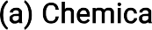
As animals are in need of vitamins, plants are in need of a 16 nutrient elements for synthesizing various compounds. Some of them are known as primary nutrients like nitrogen, phosphorus and potassium. Magnesium, calcium and sulfur are required in small quantities and hence they are known as secondary nutrients, trace elements like copper, manganese, iron, boron, molybdenum, silica, zinc are also necessary for healthy plant growth. Carbon, oxygen, hydrogen and chlorine are provided from water and air naturally.
RCP
Every element has to perform some specific function in growth and development of plants. Its deficiency is also characterized by certain symptoms. Various parts of the plants are used in pharmaceutical industry for their active constituents. For example, leaves, rhizomes, roots etc. Some of the nutrients are responsible for growth of particular part of the plant body and hence their usefulness and deficiency needs to be described systematically.
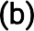
Farm yard manure (FYM/compost) castor seed cake, poultry manures, neem and Karanj seed cakes, vermi compost, etc. are manures. Oil cake and compost normally consist of 3 to 6% of nitrogen, 2% phosphates and potash 1 to 1.5% potash. They are made easily available to plants. Bone meal, fish meal, biogas slurry, blood meal and press mud are the other forms of organic fertilizers.
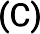
Inadequate supply, high cost and undesired effects if used successfully are the demerits of fertilizers or manures and hence the cultivator has to opt for some other type of fertilizer. The bio fertilizers are the most suitable forms that can be tried. These consist of different types of microorganisms or lower organisms which can fix the atmospheric nitrogen in soil and plants can use them for their day-to-day use. Thus they are symbiotic.
The examples of bio fertilizers are: Rhizobium, Azotobacter, Azosperillium, Bijericcia, Blue green algae, Azolla and phosphorus solubilizing organisms.

Population increases in arithmetic progression, whereas agriculture produce is enhanced in geometric progression. What man has reaped must be protected. At the same time, future yields must be improved. But, unfortunately this is not so because, between the times a medicinal crop is harvested and consumed by man, Considerable quantity of crude drug is wasted or destroyed by pests. Besides, there is loss in quality because these pests are allowed to grow on produce. The overall losses due to pest infestation tune to millions of rupees every year. The control of pests thus assumes

primary importance in the context of a cultivation of medicinal and aromatic plants. Pest is an undesired animal or plant species and pesticides are chemicals derived from synthetic and natural sources effective in small concentrations against pests.
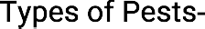 The different types of pests infesting medicinal plants are fungi, viruses, weeds, insects and non-insect pests including rodents.
Different types of fungi are known to occur on medicinal plants. Ascochyta atropae causes the formation of greyish white irregular spots which further cause necrosis of leaves. The disease is called leaf necrosis. Cercospora atropae causes round to angular brown spots with chestnut colored margins on both sides of leaves. It is called as lead spot. Phytophthora nicotianae is a dreadful disease occurring on belladonna and other plants in which dropping of young leaves and branches, yellowing of older leaves and drying of whole apical portion occurs. This disease is called as Phytophthora root. The association of a Fusarium solani and Pythium butleri causes damping off in young seedlings. The disease occurs on isolated branches of the roots of older plants. Phytophthora erythrosceptica causes damping off in young seedlings and wilt in matured plants. It causes black coloration of root. The disease is called Phytophthora root disease.
RCP
Ants, they are of different varieties, Argentine ant: Linepi- thema humile, Gray ants: Formica aerata and Formica perpilosa, Pavement ant: Tetramorium caespitum. Southern fire ant: Solenopsis xyloni, Thief ant: Solenopsis molesta, they spoil the soil by making nest and they feed honey dew secreted in plants. Branch and Twig Borer (Melalgus confertus) burrow into the canes through the base of the bud or into the crotch formed by the shoot and spur. Feeding is often deep enough to completely conceal the adult in the hole, When shoots reach a length of 10—12 inches, a strong wind can cause the infected parts to twist and break. The click beetle (Limo-nius canus) can feed on buds. Cutworms (Peridroma saucia) (_Amathes c-nigrum) (Orthndes rufula) injures the buds and so the buds may not develop, Leafhoppers (Erythroneura elegantuhi) (Erythroneum variabilis) remove the contents of leafeells, leaving behind empty cells that appear as pale yellow spots. Oak twig pruners (Anetaphiis spp. Linsley) are known as shoot, twig and root insects that affects the above mentioned parts.
- Controlling techniques: Tilling the soil will tilso affects the nesting sites of ants and help to reduce their populations, collection and destruction of eggs, larvae, pupae and adults of insects, trapping the insects, insecticides, creating a situation to compete among males for mating with females, cutworms can be prevented by natural enemies like, predaceous or parasitic insects, mammals, parasitic nematodes, pathogens, birds, and reptiles

They are divided in to vertebrates and invertebrates. Vertebrates that disrupt the plants are monkeys, rats, birds, squirrels, etc. non vertebrates are, Webspinning Spider Mites (Terranychuspacificus) (Eoterranychtts willamenei) (Terrany-chus urticae) causes discoloration in leaves and yellow spots, Nematodes (Meloidogvne incognita produces giant cell formation, disturbs the uptake of nutrients and water, and interferes with plant growth, crabs, snails are the other few invertebrates that causes trouble to the plant
RCP
- Controlling techniques: Construction of concrete ware houses, traps, biological methods, rodenticides, etc.
- Weeds reduce growth and yields Of plants by competing for water, nutrients, and sunlight. Weed control enhances the establishment of new plants and improves the growth and yield of established plants. The skill led persons have many weed management tools available to achieve these objectives; however, the methods of using these tools vary from year to year and from place to place, Soil characteristics are important to weed management. Soil texture and Organic matter influence the weed species that are present, the number and timing of cultivations required, and the activity of herbicides. Annual species, such as puncturevine, crabgrass. horseweed, and Panicum spp.. or perennials like johnsongrass, nutscdge, and bermudagrass are more prevalent on light-tcxtured soil while perenni-als such as curly dock. field bindweed, and all is grass are Ill• ore common on heavier-textured soils. Less preemergent herbicide is required for weed control on sandy, light soils, but residual control may be shorter than on clay or clay loam soils. Use IOW rates Of sandy soils those in Organic matter. Clay soils are slower to dry for effective cultivation l% sandy loam soils; thus, more frequent cultivation is practiced on lighter soils than heavy soils.
- Few common weeds are, Bermudagrass, It is a vigorous spring- and summer growing perennial. It grows from seed but its extensive system of rhizomes and stolons can also be spread during cultivation, Dallis grass, It is a common perennial weed that can be highly competitive in newly planted plants; in established plants area it competes for soil moisture and nutrients. Dallis grass seedlings germinate in spring and summer, and form new plants on short rhizomes that developed from the

original root system. The Other weeds are pigweeds Amaranthus spp. pineapple-weed Chamomilla suaveolens, nightshades Solanum spp„ etc.
- Apart from these, Parasitic and Epiphytic Plants like dodder (Cuscuta spp. L), mistletoe (Phoradendron spp. Nutt.), American squawroot (Conopholis americana), etc., too affects the growth of plants.
- Controlling techniques: Use of low rates of herbicides: Herbicides are traditionally discussed as two groups: those that are active against germinating weed seeds (Preemergent herbicides) and those that are active on growing plants (post emergent herbicides). Some herbicides have both pre-and post emergent activity. Herbicides vary in their ability to control different weed species.
RCP
- Preemergent herbicides are active in the soil against germinating weed seedlings. These herbicides are applied to bare soil and are leached into the soil with rain or irrigation where they affect germinating weed seeds. If herbicides remain on the soil surface without incorporation, some will degrade rapidly from sunlight. Weeds that emerge while the herbicide is on the surface, before it is activated by rain or irrigation, will not be controlled. Post emergent herbicides are applied to control weeds already growing in the vineyard. They can be combined with Preemergent herbicides or applied as spot treatments during the growing season. In newly planted plants, selective post emergent herbicides are available for the control of most annual and perennial grasses, but not broadleaf weeds.
- Frequent wetting of the soil promotes more rapid herbicide degradation in the soil. Herbicide degradation is generally faster in moist, warm soils than in dry, cold soils,
- General Methods of Pest Controls
Controlling techniques | Methods involved
Culture | Changing the time of sowing and harvesting, maintenance of storage, special cultivation methods, proper cleaning, using trap crops and resistant varieties
Physical | Mechanical control utilization of physical factors (Temperature, less oxygen concentration, humidity, passing co2)
Biological | Using predators, parasites, pathogens, sterilization, genetic manipulation

RCP

Chemical | Use of pesticides, herbicides, antifeedants

: Cultivation & Collection
: Plant hormones -1

: Plant hormones are the organic compounds (cellular messenger molecules) which in low concentration also regulate all the functions (complete life cycle) in plants.
RCP
- Plant hormones also known as phytohormones
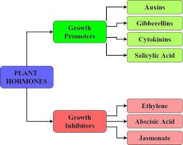

Structure:

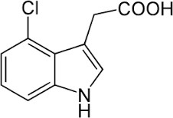

Types:
RCP
- Natural Auxins:
  - Examples:
  - IAA (Indole acetic acid),
  - IAN(Indole acetyl nitrate).
- Synthetic Auxins:
  - Examples:
  - IBA (Indole 3 butyric acid),
  - NAA (α-napthyl acetic acid),
  - 2,4D (2,4 Dichloro phenoxy acetic acid). Functions :
- Stimulate internode elongation (increase in stem length).
- Promote Abscission in older leaves & fruits.
- Differentiation of vascular tissue (xylem & phloem).
- Stimulate the root initiation on stem cutting.
- Delay senescence.
- Adventitious rooting in tissue culture.
- Tropic response (ability in response to gravity or light).

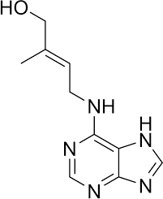

- Apical dominance. Applications :
- Vegetative propagation :
  - Examples:
  - IAA (promotes growth in cinchona, papaya, coffee)
RCP
  - NDA (specific for fruit setting)
  - IBA & NAA (rooting in cinchona).
- Development of parthenocarpic fruit.
- 2,4D in higher concentration used as herbicide to kill selective weeds.
- Helps in production of callus in plant tissue culture.
- Production of secondary metabolites.
  - Examples: Ergot (increase in production of indole alkaloids)
  - NAA (in mentha piperita increase 40% of volatile production).
Structure:

- It promotes cell division. TYPES:
- Natural cytokinins :
  - Zeatin,
  - N dimethyl aminopurine,
RCP
  - Iso pentanyl aminopurine.
II. Synthetic cytokinins:
- Kinetin,
- adenine,
- 6-benzyl adenine benzimidazole. Functions:
- Stimulate cell division.
- Stimulate morphogenesis.
- Promote leaf expansion.
- Increases in the synthesis of chlorophyll.
- Delay of senescence.
- Development of embryo during seed formation.
- Enhance stomata opening in some species.
- Promotes seed germination.
- Growth of lateral buds (shoot development). Applications :
- Induce cell division in tissue culture.
i.e.; formation of callus (root & shoot) in which shoot is from – cytokinines and root is from auxins.

- Increase growth of vegetables and enhance yield production.
- Break seed dormancy.
- Increase secondary metabolites.
e.g. : Increase sennosides content in Tinnevelley senna.
- Shoot initiation in tissue culture and release of lateral bud dormancy.
RCP
- Reduces rate and extent of chlorophyll degradation, protein degradation and leaf drop.

RCP

: Cultivation & Collection
: Plant hormones -2
Structure:
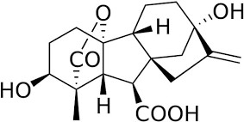

Types:
- These are endogenous plant growth regulator.
- These are mostly present in young tissue, root, embryo, germinating seeds, shoot bud.
- And these are named as GA1, GA2, GA3 GAn.GA3 – Gibberlic acid was the most common type (this was first identified).
- This was discovered by kurosawa, a Japanese physiologist from fungus Gibberella fujikuroi
grown on rice plants.
- The numbering of gibberellins like GA1, GA2, GA3 GAn was given based on their
order of discovery.
- Kurosawa observed that in some rice plants seedling was observed as abnormal growth grow
long coloured yellow.

- And this yellow colour was due to disease called Baknae foolish seedling. FUNCTIONS:
- Promote stem elongation (when GA applied genetically for a dwarf plant to increase its length).
- Increase in length of inter nodes by cell elongation.
RCP
- Breaking seed & bud dormancy.
- By providing GA to plant it gives the ability to seed germination even in the dark (in light
dependents).
- Promotes seed germination.
- Increases in size of leaves.
- Delay senescence in leaves and citrus fruits.
- Production of parthenocarpic fruit (seedless fruits).
- Promote bolting and flowering long day plants. Applications:
- Quality of medicinal plants was increased when they are treated with GA.
- Even at the low dose the yield of glycoside per shoot of digitalis is increased.
- The production of digoxin from the roots & leaves of digitalis is increased.
- Increased volatile content of Anethum species (Dill).
- Increased in height of castor plant.
- Production of parthenocarpic fruits.
- Delay fruit maturity.
- Senescence delayed in citrus fruits.
- Increase size and yield of grapes.

Structure:
RCP
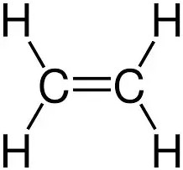

- Simple organic molecule present in the form of Gas (Gaseous growth regulator).
- Ethylene present as volatile hormone at room temperature it will get evaporated.
- It is a growth inhibitor present in the more amount of ripening fruits after flowers, stem, root
tubers, seed, leaf etc.....
- It was discovered by Gane in 1934. He was found that a gas evolved from ripe apple can also
effect the ripening of green apple and found that it was Ethylene gas.
- Crocker recognized that it was a plant hormone in 1935. Functions:
- promote fruit ripening.
- Stimulate leaf and fruit abscission.
- Suppress stem and root elongation.

- Promotes flower petal discoloration.
- Stimulate aging of flowers and leaves.
- Break dormancy.
- Induces stem swelling and leaf bending. Applications:
RCP
- Responsible for detachment or separation of plant parts.
- Decrease stem and root elongation.
- Stimulate flower and leaf senescence
- increases seed germination.
- Ethylene along with auxin suppress lateral bud formation and increase horizontal growth.
- Stimulation of latex flow in rubber trees.
- At low concentration increase sennosides content in cassia angustifolia.
- Stimulate production of phytuberin and phytuberal in terpenoid.
Structure:

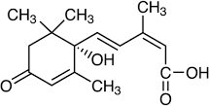

- Abscisic acid is a natural plant growth inhibitor.

- It was produced by aging leaves and fruits when plants are stressed (stress hormone) at
unforcing conditions also called Dormus.
- It was discovered by Addicott and associated in 1963.
- First isolated are Abscission I and Abscission II it is also known as Abscisic acid.
RCP
- Abscisic means detachment from cotton balls.
- Osborne found it in senescent aging of leaves. Functions:
- Abscission of different organs in plant like leaves & flowers and fruits.
- Promote seed and bud dormancy.
- Reverse the effect of other growth stimulating hormones.
- Anti-transpirant (it promotes closure of stomata).
- Plant growth inhibitor.
- Stress hormone. Applications:
- Inhibit Gibberellin synthesis of α-amylase and other hydrolytic enzyme.
- Enhance survival of plant in stress in condition such as water deficiency, injury, drought, flooding,
freezing temperatures.
- Synthetic substances called morphactins in use reduction of apical dominance and promoting lateral growth.

: Cultivation & Collection
Polyploidy Polyploidy In Plants

- Introduction
RCP

Polyploidy word is the combination of two words- „Poly‟+ „Ploidy‟, in which „Poly‟ means “many or more‟‟ and „Ploidy‟ means „„the number of pairs or sets of chromosomes available in cell of any living things‟‟. So polyploidy defined as the condition at which the number of sets or pairs of chromosomes will be more than two in cell of any living things. In which one set inherited from each parents or excess of the diploid number[1]
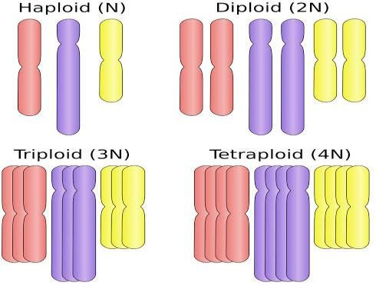

Fig. 1 Normal and Polyploids chromosomes

- Poly= many or more (may be 3,4,5,6......etc)&Ploidy= the number of pairs or sets of chromosomes available in cell of any living things (denoted by X or N), so Polyploidy= more than two sets or pairs of chromosomes available in cell of living things[2].

- The number of sets or pairs of chromosomes (which is denoted by X or N). Haploid (1n= gametes or chromatids) & diploid (2n) are normal form of chromosomes, but triploid (3n) & tetraploid (4n) are the example of polyploidy[3] (fig. 1).

- Causes Of Polyploidy:

There are four types of causes behind the polyploidy: 2.1 Non-disjunction in mitosis
RCP
  - Non-reduction in meiosis
  - Polyspermy
  - Endo-replication or Endo-reduplication

  - Non-disjunction in mitosis:

    - As we know mitosis is the process of formation of two daughter cells from one parent cell.
    - In the fig. 2 diploids (2n) has taken as an example for mitosis (generally found in early embryo in cell), in which diploids are in the form of chromatids (single strand chromosomes) then replicated and form copy of each chromatids and converted in to double strand of chromosomes.
    - Undergoes to separation of chromatids for cell division with formation of spindles but due to disturbance in spindle protein, segregation of chromatids (non-disjunction) not occurs.
    - Finally cell division not occurs.
    - So the duplicated chromatids are present in same cell, ultimately the number of chromatids will be increased. Result is that polyploidy occurs.

Fig. 2.1 Non-disjunction in mitosis

  - Non-reduction in meiosis:

    - As we know meiosis is the process of formation of four daughter cells from one parent cell.
    - In the fig. 3 diploids (2n) has taken as an example for meiosis-1 (generally found

in early embryo in cell), in which 1diploids contains homologous chromosomes and 1 diploids contains non-reduced chromosomes, then replicated and form copy of each chromatids and converted in to double strand of chromosomes.
    - Undergoes to separation of chromatids for cell division with formation of spindles but due to non disjunction it forms only 2 daughter cells in meiosis-1.
    - But during meiosis-2 this daughter cells are form haploids & triploids which further fertilized and form tetraploids (4n= 1n+ 3n) from haploids (1n) & triploids (3n), which is the example of polyploidy.
RCP
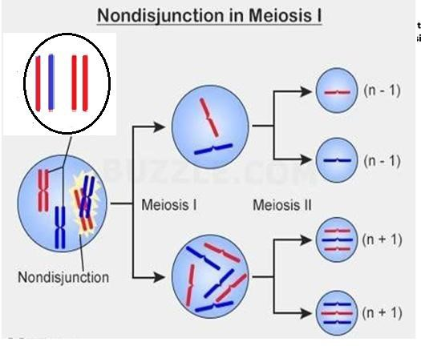

Fig. 2.2 Non-reduction in meiosis

  - Polyspermy:-

    - If the fertilization of egg (female nuclei) is done by more than one male nuclei (in fig. 4), this condition is called Polyspermy.
    - Which result is that triploid (example of polyploidy) is occurs. Very rarely polyploidy is occurs due to polyspermy.
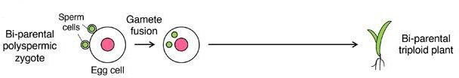

Fig. 2.3 Polyspermy

  - Endo-replication or Endo-reduplication:-

    - When the replication of DNA occurs in which the number of chromosomes gets duplicated.
    - But cytokinesis (cell-division) not occurs.
    - Ultimately the increased numbers of chromosomes present in single cell.
    - Result is polyploidy occurs during Endo-reduplication or Endo-reduplication [4][5].
RCP

- Factors Promoting Polyploidy:

There are three factors which promotes the polyploidy which are as follows: 3.1Physical factor
3.2Chemical factor
3.3 Biological factor

  - Physical factor:

    - Temperature: heat temperature & cold temperature
    - Centrifugation
    - X-rays
    - Gamma rays
    - Cosmic rays
    - Ionizing & non-ionizing radiations
    - UV-radiations

  - Chemical factor:

    - Alkylating agents: nitrogen & sulphur mustard
    - Acridines Proflavins
    - Nitrous acid
    - Colchicines [6]
    - Colchicines (Poisonous alkaloids):-

Extracted from bulbs (0.1-0.5%) & seeds (0.2-0.8%) of Autumn crocus or Meadow saffron (Colchicum autumnale)
Binds to spindle protein during cell division

Inhibit the segregation of chromatids Increase the number of chromatids or chromosomes
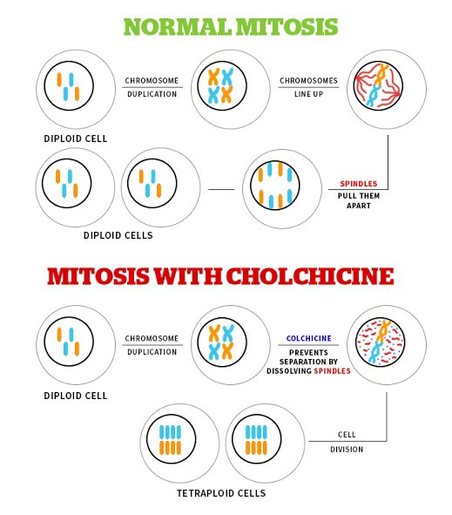
Polyploidy occurs (fig. 5)
R P

  - Biological factor:
- Mode of reproduction
- Mode of fertilization
- Breeding system present (Hybridization)
- Growth habit of the plant
- Size of chromosomes [7]

- Types Of Polyploidy:

They are two types as follows:

  - Euploidy
    - Auto polyploidy
    - Allopolyploidy
  - Aneuploidy

  - Euploidy:
RCP

Itis the types of polyploidy with multiple numbers of sets of chromosomes which is complete in numbers to a specific species depending upon the combination of the genomes. It is further classified in to 2 types:

    - Auto polyploidy:

      - „Auto‟ means self or same species.
      - „Polyploidy‟ means the multiplication the number of chromosomes.
      - So the multiplication the number of chromosomes between in same species is called “auto polyploidy”.
      - In fig. 4.1 2n=6 is taken as diploid parent species in example of auto polyploidy.
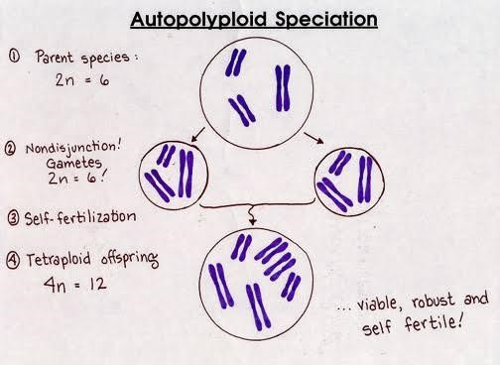
      - Then this species undergoes to self fertilization but due to error or chromosomal variations by nondisjunction gametes form 4n=12 tetraploid offspring.

Fig. 4.1.1 Autopolyploid 4.1.2Allopolyploidy:-
      - „Allo‟ means other or different species.
      - „Polyploidy‟ means the multiplication the number of chromosomes.
      - So the multiplication the number of chromosomes between in different species is called “allopolyploidy”.
RCP
      - In fig. 4.2 2n=6 is taken as diploid parent species-A & 2n=4 is as diploid parent species-B in example of allopolyploidy.
      - Then the species-A & species-B undergoes to hybridization but due to meiotic error or chromosomal variations by non-disjunction gametes (2n=4)of species-B (2n=4)and hybridized with normal gametes (n=3) of species-A (2n=6)which produced hybrid with 7 chromosomes. When this hybrid which contains unreduced gametes with 7 chromosomes, further undergoes to hybridization with normal gametes (n=3) of species-A (2n=6) which produced viable fertile hybrid (2n=10)[8][9][10].

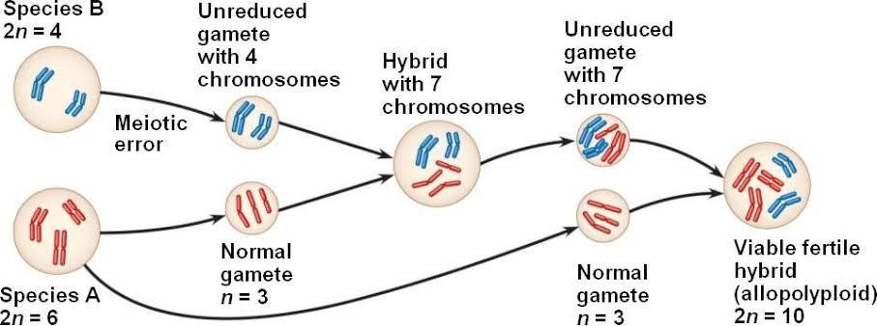

Fig. 4.1.2Allopolyploidy
In this polyploidy, it contains one or more specific chromosomes either an addition or subtraction to the total number of chromosomes. Result is that it forms univalent and multivalent during meiosis of Euploidy.

They are further classified as:- 4.2.1 Monosomy= 2n-1
    - Nullisomy= 2n-2

    - Trisomy= 2n+1
    - Tetrasomy= 2n+2
    - Pentasomy= 2n+3

- Examples Of Polyploidy:-

- Diploid= Rice (2n= 24)
RCP
- Triploid= Banana (3n= 33)
- Tetraploid= Potato (4n= 48)
- Hexaploid= Wheat (6n= 42)
- Octaploid= Sugarcane (8n= 80)[11]

- Mechanisms Of Polyploidy Formation:
  - In fig. 6 the mechanisms of polyploidy can be understand in which diploid genome species-AA & species-BB are taken as an example.

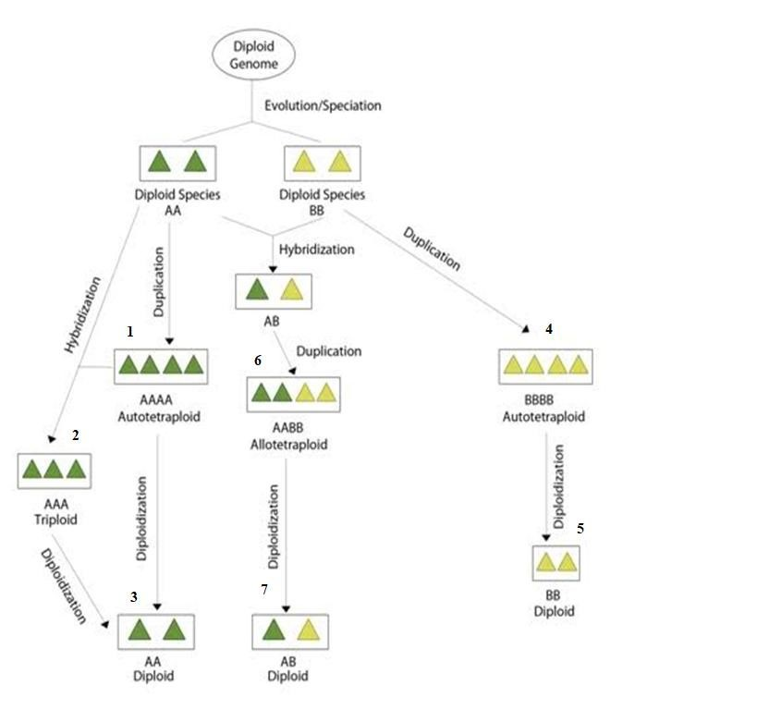

Fig. 6Mechanisms of polyploidy formation
RCP
  - diploid species-AA self fertilized and duplicated but due to non-disjunction form tetraploid species-AAAA (autopolyploid).
  - diploid species-AA & tetraploid species-AAAA undergoes to hybridization which produces triploid species-AAA.
  - tetraploid species- AAAA & triploid species-AAA undergoes to diplodization and forms their diploid species-AA.
  - Diplodization is the process by which polyploids converts into the diploids.
  - diploid species-BB self fertilized and duplicated but due to non-disjunction form tetraploid species-BBBB (autopolyploid).

  - tetraploid species-BBBB undergoes to diplodization and forms their diploid species-BB.
  - diploid species-AA & diploid species-BB undergoes to hybridization & duplication which gives tetraploid species-AABB (allopolyploid) from different species.
  - tetraploid species-AABB undergoes to diplodization and forms their diploid species-AB[12][13].
RCP

VII. Application Of Polyploidy:
There are many applications of polyploidy which are as below: 7.1 Mutation breeding
  - Seedless fruits production
  - Bridge crossing
  - Ornamental & forage breeding
  - Disease resistance through aneuploidy
  - Industrial application of polyploidy

 Polyploidy can rise the mutation frequency due to alteration in the nucleotide sequence of the genome.

 Example: Seedless watermelon& orange fruits, tomatoes etc can be produced.
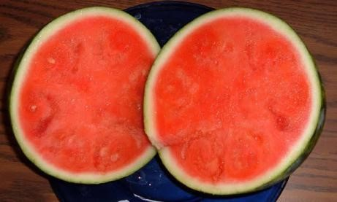
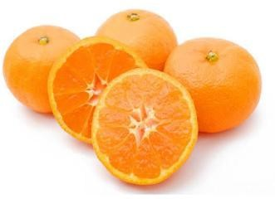
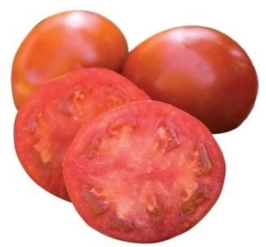

Fig. 7.2 Seedless fruits production by polyploidy

Transitional crosses can be going through. In which two different characters of plants species gets in to one single offspring plant by the help of bridge crossing. Examples: a) Superior tall fescue grass Italian ryegrass & b) Tall fescue meadow grass.
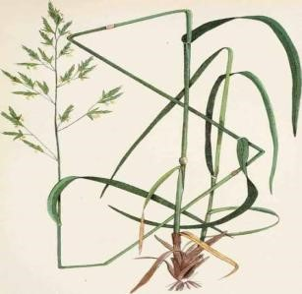
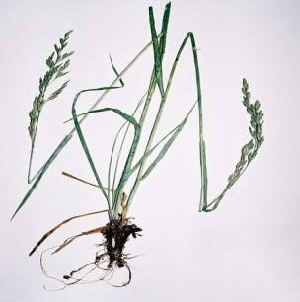

Fig. 7.3 Bridge crossing between polyploidy plants
RCP


Polyploidy canincrease the cell size of plants which phenomenon is called „Gigas‟.The chromosomes doubling (polyploidy) can increase larger seeds & seed protein and alsoraise water not biomass of the plant or part of the plant. Example: ornamental crops such as marigolds, used to improve their quality, size &blossoms.
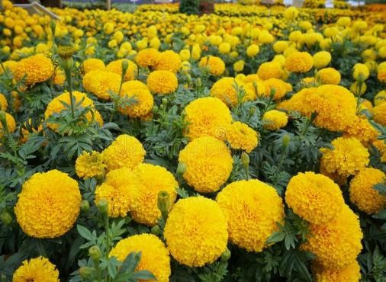
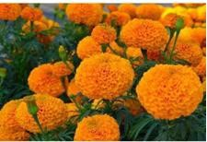

Fig. 7.4 Ornamental& forage breeding in polyploidy

Addition & deletion of chromosomes from the normal sets of chromosomes is called „aneuploidy‟. By which we can produce the disease resistance plants.

 By the help of polyploidy also can synthesize the sex hormones like- corticosteroids, production of terpenes & resistance to pests and pathogens[14].
- Advantages Of Polyploidy:
    - Enlargement & increased vigour which is strength of the plant.
    - Production of sterile triploids seedless fruits,generally by the help of vegetative propagation except seedling & fertilization.
RCP
    - Restoring fertility in hybrids.
    - Overcoming barriers in hybridization.
    - Enhancing pest resistance, disease resistance &stress tolerance plants.
- Disadvantages Of Polyploidy:
    - Inbreeding in polyploids which reduces cross compatibility in plants.
    - Effect of polyploidy on sterility.
    - Effect of polyploidy on inheritance & population genetics 15][16].
- Conclusion:
Here, this review provides an up-to-date information about the polyploidy and we can better understand about the correlations of polyploidization with change in plants as well as environment like stress and many other fields. That has guide to a raise in recognition of their short-term adaptively potential. Also we can know very well about how once polyploidy has been occurs, then the duplicated genes have unique retention character. Which can explain key longer-term evolutionary transitions can produce a general raise in new species and makes biological complexity? The great significance of polyploidy in the world of plant can be visualize by in the field of medicinal plants like resistance to different diseases and provide vigor hybrids in stress through the combinations of required characters into one species from different species, in the field of commercial crops such as sugarcane, wheat, oats, cotton, pear, apples, tobacco etc., in the industrial field such as production and synthesis of many hormones and enzymes and in the field of ornamental plants can be improved their size, quality and blossoms by the help of gigas. So the overall conclusion is that by the help of polyploidy in genetics or molecular technology in pharmacognosy we can easily tackle future challenges in the area of development in new diseases treatment, diversity in plants such as medicinal, crops and agricultural and diversity of environment as global warming and climate change.

: Cultivation & Collection

Sudden heritable change in genetic material or character of an organism is known as mutation Individuals showing these changes are known as mutants
  - An individual showing an altered phenotype due to mutation are known as variant
RCP
  - Factor or agents causing mutation are known as mutagens
  - Mutation which causes changes in base sequence of a gene are known as gene mutation or point mutation
  - English farmer Seth Wright recorded case of mutation first time in 1791 in male lamb with unusual short legs
  - The term mutation is coined by Hugo de Vries in 1900 by his observation in Oenothera
  - Systematic study of mutation was started in 1910 when Morgan genetically analyzed white eye mutant of Drosophila
  - H. J. Muller induced mutation in Drosophila by using X-rays in 1927; he was awarded with Nobel prize in 1946
  - Generally mutant alleles are recessive to their wild type or normal alleles
  - Most mutations have harmful effect, but some mutations are beneficial
  - Spontaneous mutations occurs at very low rate
  - Some genes shows high rate of mutation such genes are called as mutable gene
  - Highly mutable sites within a gene are known as hot spots.
  - Mutation can occur in any tissue/cell (somatic or germinal) of an organism

Based on the survival of an individual
- Lethal mutation when mutation causes death of all individuals undergoing mutation are known as lethal
- Sub lethal mutation - causes death of 90% individuals
- Sub vital mutation- such mutation kills less than 90% individuals
RCP
- Vital mutation when mutation don't affect the survival of an individual are known as vital
- Super vital mutation - This kind of mutation enhances the survival of individual
- Spontaneous mutation-
  - Spontaneous mutation occurs naturally without any cause. The rate of spontaneous mutation is very slow
  - e.g.- Methylation followed by deamination of cytosine.
  - Rate of spontaneous mutation is higher in eukaryotes than prokaryotes.
  - E.g. UV light of sunlight causing mutation in bacteria
- Induced Mutation-
  - Mutations produced due to treatment with either a chemical or physical agent are called induced mutation
  - The agents capable of inducing such mutations are known as mutagen. use of induced mutation for crop improvement program is known as mutation breeding.
  - E.g. X-rays causing mutation in cereals
- Somatic mutation-
  - A mutation occurring in somatic cell is called somatic mutation.
  - In asexually reproducing species somatic mutations transmits from one progeny to the next progeny
- Germinal Mutation-

  - When mutation occur in gametic cells or reproductive cells are known as germinal mutation.
  - In sexually reproductive species only germinal mutation are transmitted to the next generation
  - Based on direction of mutation
- Forward mutation- When mutation occurs from the normal/wild type allele to mutant allele are known as forward mutation
RCP
- Reverse mutation- When mutation occurs in reverse direction that is from mutant allele to the normal/wild type allele are known as reverse mutation

- Visible mutation- Those mutation which affects on phenotypic character and can be detected by normal observation are known as visible mutation
- Biochemical mutation- mutation which affect the production of biochemicals and which does not not show any phenotypic character are known as biochemical mutation

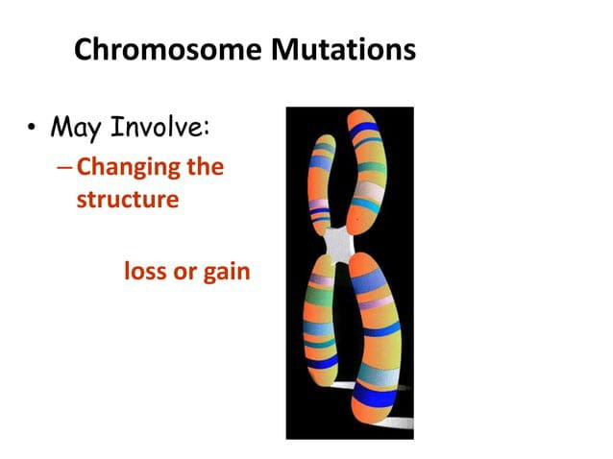

Chromosome Mutations
R P
  - Five types exist:
    - -Deletion
    - -Inversion
    - -Translocation
    - -Nondisjunction
    - -Duplication

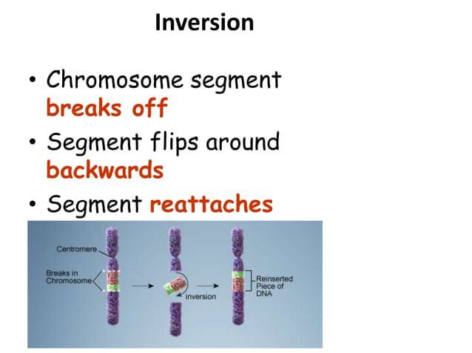
RCP

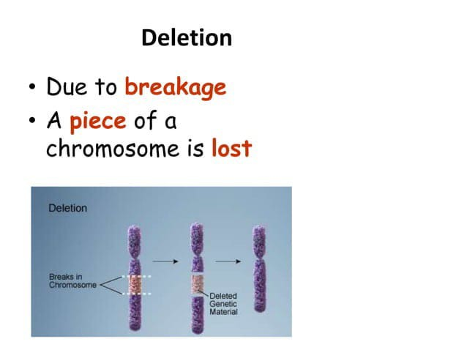
RCP

RCP

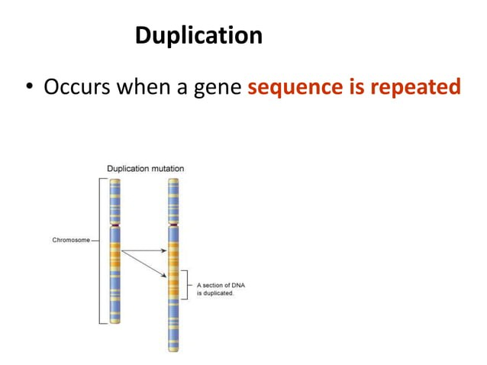

Translocation
R P
- Involves two chromosomes that aren't homologous
- Part of one chromosome is transferred to another chromosomes

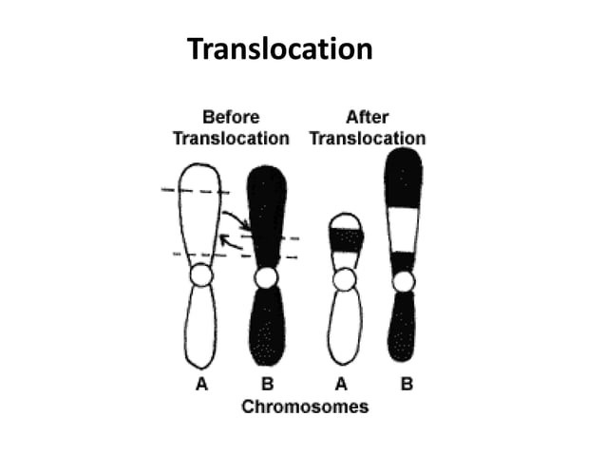

Nondisjunction
R P
  - Failure of chromosomes to separate during meiosis
  - Causes gamete to have too many or too few chromosomes
  - Disorders:
- Down Syndrome -
- Turner Syndrome -
- Klinefelter's Syndrome –

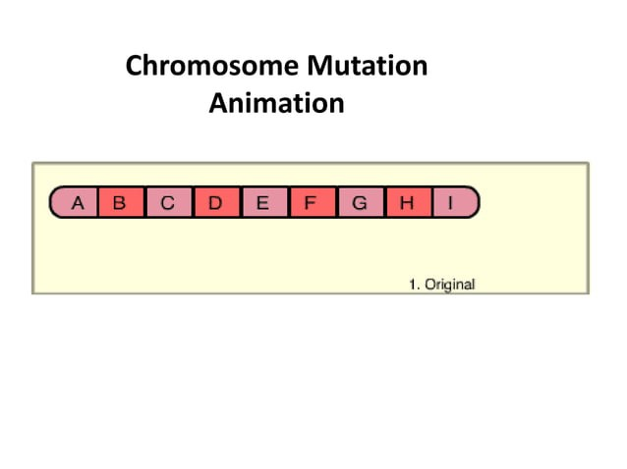

- Include:
- -Point Mutations
R P
- -Substitutions
- -Insertions
- -Deletions
- -Frameshift
- Point Mutation
  - Change of a single nucleotide

  - 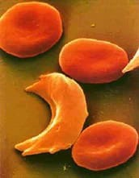
RCP
  - Includes the deletion, insertion, or substitution of ONE nucleotide in a gene
- Frameshift Mutation
  - Inserting or deleting one or more nucleotides
  - Changes the "reading frame" like changing a sentence
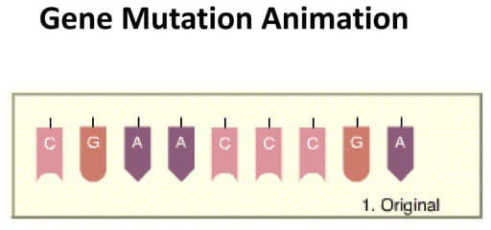
  - Proteins built incorrectly

: Cultivation & Collection


:
RCP
  - It is a natural (or) artificial process that results in the formation of a hybrid from using of two species (or) genetically dissimilar (or) varieties differing atleast in one set of characters, is known as hybridisation.
  - In hybridisation, for plant breeding we have to select two varieties of plants (or) two species in which one with a desirable character is selected and the 2nd one with another desirable character which is not present in the 1st variety (it doesn’t have the desirable character of the first variety as well) is selected. Both are crossed and a plant is developed with desirable characters from both the species.

- To improve the crop quality of the medicinal plants
  - 2* metabolites increased.
  - Morphological characters are increased/improved.
→Artificial hybridization : In this artificial hybrid plants are developed.
→Hybrid: New plant produced resulted from crossing of 2 species/varieties differing atleast
one set of character.
→steps:
- Selection of prevent plant: tea plants with desired characters are selected based on the hybrid plant with desirable characters to be developed.
E.g.: the hybrid plant should have high yielding and disease resistant characters.(this variety has poor yield (this variety has high yield but is disease But is disease resistant) susceptible , i.e., it is easily attached by Insects or micro-organisms)
- Emasculation: Generally universal plants are crossed but if the plants is bisexual, their

emasculation is carried out. In this removal of stamen/anther are removed using hand and scissors. It the flower is small the stamens are removed using hot water, alcohol (ethanol), section pump.
- The stamens are sensitive to hot water and proper core of ethanol compared to
- female reproductive organs.
RCP
- Emasculation is done to prevent self-pollination.
- Bagging and Tagging:
  - After emasculation, the flower/inflorescence of the female plant is enclosed in a bag mode up of butter paper or vegetable parchment bag or fine cloth. The bagging is done to prevent cross pollination/undesirable pollination.
Tagging:
  - A tag is attached to the emasculated flower which consists of the emasculated dose, pollination dose and the two plant varieties names.
- Crossing/Pollination:
Artificial cross pollination-it consists of collecting pollen grains from another of the male plant and dusting this pollen on the stigma of the female plant by using brush.
  - The flower of male plant covered with bags, that consists of stamen, anther. At maturation, the anther bursts which causes the pollen grains to come out. Thus,pollen grains are collected in the bag.
- Harvesting and storing of Fl seed: Due to fertilization fruits is developed which consists of a hybrid seed. The crossed plants are harvested and the seeds are properly dried and stored. These seeds are further sowed separately to raise Fl hybrid plants and rest them.
- Raising Fl generation from Flseed: Here the Fl generation (hybrid plants) are cultivated from the Flseeds (produced from crossed plants). These Flseeds are also tested here. If the plant cultivated/grown from Fl seeds consists of the desirable characters then the hybrid plant is a success.

- To improve the yield and quality of the crop, i.e., the 2o metabolite production is

increased.
- To provide resistance to diseases and insects.
- To develop seedless varieties of crop. [parthenocarpic]
- Improve the fruit size and the storage capacity/capability of the plant.
  - ➔ New techniques in Hybridisation in plant tissue culture = Asexual Hybridization. Asexual Hybridisation: In this protoplast fusion (cell without cell wall) is carried out, where two plant cells whose cell wall is removed and fused farming an hybrid (somatic hybrid) [has desirable characters]
RCP
- Intra varietal: Hybridization between two plants of same variety used to improve in the
same crop.
- Inter varietal [Intra specific]: Hybridization between two different varieties of same species.
- Interspecific [Intragenic]: Crossing between two different species but of same genus.
- Introgressive: Transfer of genome from one specific to the other.

: Cultivation & Collection
Conservation of medicinal plants
Medicinal plant conservation strategies are based on an understanding of indigenous knowledge and practices. Conservation of medicinal plants in its bio-cultural perspective not only implies conservation of biodiversity but also provides conservation of cultural diversity. As per the world conservation strategy (1980), the conservation is defined as “the management of human use of the biodiversity so that it may yield the greatest sustainable benefit to present generation while maintaining its definitions invokes two complementary components conservation and sustainability”. Many drugs contain herbal ingredients and it has been said that 80-90% of the world’s population relies on some form of non-conventional medicine, but the market demand has led to an increased pressure on the natural resources that lend to the production of some of these plants. The most serious proximate threats when extracting medicinal plants generally are habitat loss, habitat degradation, global climate change and over harvesting. Hence highly threatened species must not be collected at all in order to increase their prospects of survival. There should be clear information on which plants are threatened. In such cases the practitioners and communities should try to discover ways of using alternatives. Additionally, legislation should be put in place to ban not only the collection but the possession of and trade in those plants. The practitioners should be involved in the processes of conserving the threatened plants concerned. The regulation should also draw on the harvesting practices observing ethical, legal and social rights of all those concerned in the communities where the plants are native. As per recent statistical reports, about 17,000 species of medicinal and aromatic plants are well documented and about 50,000 plant species are used globally. About 3,000 species are traded internationally and about 900 species are commercially cultivated in world wide.
According to WWF (World Wide Fund for Nature) about 30 – 45% of medicinal plant species may be threatened with extinction in the wild, which means around 4000 to 10,000 plants are may be at risk. Various national and international agencies have formulated various policies and strategies for the conservation of the medicinal plants. According to these strategies, the primary goals are:
RCP
  - Maintenance of essential ecological processes and life support systems for human

survival.
  - Preservation of species and genetic diversity.
  - Sustainable use of species and ecosystems which supports rural communities and
also the industries.
RCP
  - Maintenance and assessment of germplasm for future use. Some agencies are:
- IUCN (The International Union for Conservation of Nature and Natural Resources): Founded in 1948.
- WWF (World Wide Fund for Nature): It is established in 1961.
- UNDP (United Nations Development Programme): It is established in 1965.
- UNEP (United Nations Environment Programme): It is established in 1972.
- WRI (World Resources Institute): It is founded in 1982.
- FRLHT (Foundation for Revitalization of Local Health Traditions): It is established in
1993. plants:
NMPB (National Medicinal Plants Board): It is established in 2000 by the Government of India has the primary mandate of coordinating all matters relating to medicinal plants and support policies and programmes for growth of trade, export, conservation and cultivation. The Board is located in the Department of Ayurveda, Yoga & Naturopathy, Unani, Siddha & Homeopathy (AYUSH) of the Ministry of Health & Family Welfare. According to IUCN, the number of endangered plant species is about 8500 worldwide, in which more than 250 plant species are in India. Some of the important endangered plant species are Rauwolfia serpentine, Taxus baccata, Taxus brevifolia, Santalum album etc. Guidelines on The Conservation of Medicinal Plants (IUCN, WWF, 1993), WHO (World Health Organization) Guidelines on good agricultural and collection practices (GACP) for medicinal plants (WHO, 2003) have been established where the significance of ecology, identification and traditional use of plants, as well as cultivation and conservation of plants both in situ and ex situ are strongly emphasized. The mission for the conservation of plants and their habitats are:

- To preserve wild populations of different plants species with their inherent intraspecific diversity for further evolution.
- Revitalization of social processes for transmission of traditional knowledge of health care for its wider use and applications.
:
- Establish a system of protected areas where special measures needs to be taken to conserve biological diversity;
RCP
- Promote the protection of ecosystems, natural habitats and the maintenance of viable populations of species in natural surroundings; and
- Develop necessary regulatory provisions for the protection of threatened species and populations.
The states like Karnataka, Tamil Nadu, Kerala and UP are involved in the conservation of medicinal plants. The most widely accepted scientific technologies of biodiversity conservation are the in-situ and ex-situ methods.
:
This process is also known as on site conservation. This is the process of protecting the existing biological and genetic diversity at best and cost effective way. In this technique wild species or stock of a biological community or endangered plant is preserved in its natural habitat either by protecting or cleaning up the habitat.
- Medicinal plant conservation areas: During 1997 FRLHT (Foundation for Revitalization of Local Health traditions) Bangalore, Karnataka, in collaboration with State Forest Departments established a coordinated network of in-situ medicinal plants conservation areas (around 30 Nos.) located within the protected areas of Kerala, Tamil Nadu and Karnataka.
- Sacred Groves: These are the combinations of forest whose entire biodiversity along with other natural resources is conserved by the forest village communities. This method provides the conservation of forest biodiversity, conservation of threatened taxa etc.
- Conservation of Ethnomedicinal plants: There are more than 6000 plant species are exist with their medicinal values but not have scientific evidences, is traditionally passed on orally through generations. Those plants are requires to conserve for future uses and to know their therapeutic activities through scientific research.

It is a process of protecting endangered plants from threatened habitat and placing in a new location which are in wild area or within them of humans i.e., by cultivating and maintaining plants in biotic gardens, parks, other suitable sites.
RCP
- Ethno medicinal plant gardens: It is an important process for creating a network of regional and sub-regional ethno medicinal plant gardens which contain all the ethnic communities’ medicinal plants from the different regions of India. These gardens provide ethno medicinal history and their detailed knowledge and also act as regional repositories of our culture.
- Gene banks: Gene banks are a type of bio-repository which preserves genetic material. In plants, this is by freezing cuts from the plant, or stocking the seeds. In plants, it is possible to unfreeze the material and propagate it. Gene banks are used to store and conserve the plant genetic resources of major crop plants and their crop wild relatives that results in conservation of agricultural biodiversity. Various types of gene banks include seed bank, tissue bank, Cryo bank, pollen bank, field gene bank etc.
- Nursery or demonstration plots: This is one of the important methods for conservation of traditional medicinal plants and to get the proper idea about the history of the medicinal plants. These nurseries are the primary sources of supply of the plants, seed materials etc. The forest departments, agricultural extension agencies, various non Governmental Organizations (NGOs) should be encouraged to establish various nurseries and allot plots for growing medicinal plants in existing ones.
Some of the important National institutions for Agricultural Research:
  - Central Arid Zone Research Institute (Czari), Jodhpur-3, Rajasthan.
  - Central Plantation Crops Research Institute, Kasaragod, Kerala. Central Research Institute for Dryland Agriculture, Hyderabad, A.P.
  - Central Rice Research Institute, Cuttack, Orissa.
  - Central Soil and Water Conservation Research and Training Institute, Dehradun,Uttaranchal.

  - Central Soil Salinity Research Institute, Karnal, Haryana.
  - Central Tobacco Research Institute, Rajamundry, AP.
  - Indian Agricultural Research Institute, New Delhi.
There some legal protection and conservation rules for medicinal plants by which farmers are benefited in India such as: Plant Variety Protection Act 1970 (PVPA): It is an intellectual property statute in the USA. The PVPA gives breeders up to 25 years of exclusive control over new, distinct, uniform and stable sexually reproduced or tuber propagated plant varieties. It is a right for limited period of legal control to breeders of sexually reproduced or tuber propagated plant varieties. Farmer’s Right Act 2001: The Protection of Plant Variety and Farmers Right Act, 2001 (PPVFR Act) is an Act of the Parliament of India. This act enacted to provide for the establishment of an effective system for protection of various plant varieties, the rights of farmers and plant breeders and to encourage the development and cultivation of new varieties of plants. Farmers are entitled to save, use, sow, re-sow, exchange or sell their farm produce including seed of a registered variety in an unbranded manner. Farmers are totally exempted from payment of any fee in any proceedings under this Act. Annual fee is required to pay every year for maintaining the registration and renewal fee is also to pay for the extended period of registration.
RCP
:
  - For trees and vines (Perennials): 18 years from the date of registration of the variety.
  - For other crops (Annuals): 15 years from the date of registration of the variety.
  - For extant varieties: 15 years from the date of notification of that variety by the Central Government under section 5 of the Seeds Act, 1966. Exemptions provided by the Act:
  - Farmers' Exemption: Farmer shall be entitled to produce, save, use, sow, re-sow, exchange, share or sell his farm produce including seed of a variety protected under this Act.
  - Researcher's Exemption: the use of registered variety for conducting experiment. the use of variety as an initial source of variety for the purpose of creating other varieties.

Very short answer questions (2 MARKS)
- Write about auxins
- Define polyploidy and mutation
- Define Hybridization
Short answer questions (5MARKS)
RCP
- Write the cultivation of drugs from natural origin
- Write detailed note on polyploidy, mutation
- Write note on plant hormones
Long answer questions (10 MARKS)

07 Hours
:
Historical development of plant tissue culture, types of cultures, Nutritional requirements, growth and their maintenance. Applications of plant tissue culture in Pharmacognosy. Edible vaccine.
RCP

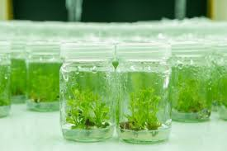
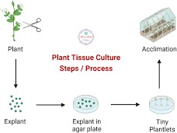

:
RCP

Plant cell and tissue culture technique has a great significance in the field of plant biotechnology especially in the crop improvement strategies. Plant tissue culture is defined as the process of in-vitro culture of explants (pieces of living differentiated tissues) in nutrient medium either in solid (Agar medium) or liquid (suspension culture) media under aseptic conditions for the growth of cells, tissues, organs or plantlets. It is one of the most beneficial of all the sciences and has immense interest to the molecular biologists, plant breeders and industrialists for the product development as well as helps in improving the plants of economic importance.

:
Historical development of plant tissue culture
A, German botanist, Gottlieb Haberlandt, cultured fully differentiated plant cells isolated from different plants in the year 1902. This was the very first step or concept for the beginning of plant cell and tissue culture. Cell Doctrine further admitted that a cell is capable of showing totipotency. Totipotency is the regeneration capacity of the parenchyma cells. Thereafter Scientist Hannig cultured embryos from several cruciferous species in 1904.Scientist Kolte and Robbins cultured root and stem tips respectively in 1922. Scientist Went discovered first plant hormone Indole Acetic Acid (IAA) in 1926. In 1932, Prof. White developed plant tissue culture medium for in-vitro culture of meristematic cells of Tomato. The composition of medium was salt, yeast extract, sucrose and three vitamins namely pyridoxine, thiamine and nicotinic acid. Thereafter Prof. White introduced vitamin B as growth supplement in tissue culture media for tissue culture of tomato root tip in 1934. Scientists Gautheret, White and Nobecourt are also made valuable contributions to the development of plant tissue culture techniques through proliferation of callus culture in 1939 of tobacco tumor tissues from interspecific hybrid of Nicotiana glaucum and Nicotiana longsdorffi. The first true plant tissue cultures were obtained by Gautheret from cambial tissue of Acer pseudoplatanus. With the identification of a variety of plant growth regulators such as cytokinin, auxin, other hormones, vitamins, etc. and their role in affecting cell division and differentiation, the methods of plant tissue culture developed in a proper manner. Further in 1941, Van Overbeek discovered nutritional value of liquid endosperm of coconut for culture of isolated carrot embryo. Scientist White and Braun together experimented on crown gall and tumor formation in plants, growth of bacteria free crown gall tissues in 1942.
RCP
Year Discovery
1932 Developed root tip and root fragment culture. 1934 Developed cambium culture of woody plants.
1937 Discovered Indole Acetic acid promotes root growth.
1939 Discovered carrot explants develops undifferentiated mass and that can be maintained by repeatedly subculturing. Embryo culture also had its beginning early in the first decade of the last century with barley embryos. Scientist Ball discovered

whole plant from shoot tip and organ regenerated
on callus in 1950. In 1954, Scientist Muir, discovered plant from single cell. Scientist Miller in 1955, discovered Kinetin hormone. In 1957, Miller and Skoog proposed that root and shoot differentiation is regulated by Auxin and cytokinin ratio. The first plant from a mature plant cell was regenerated by Braun in the year 1959. Foundation of commercial plant tissue culture was laid in 1960 with the discovery for a million fold increase in the multiplication of an orchid which was accomplished by G.M. Morel. Some other discoveries related to plant tissue culture are tabulated.
RCP

Year | Discovery | Scientist
1960 | Development of planting technique for
isolation of single cell Bergmann
1962 | Developed new medium for plant tissue
 | Culture | Murashige and Skook
1970 | Successful protoplast fusion Power
1970  Guha | Successful Anther culture | Shri S.C. Maheshwari and Sipra
1971 Plant regenerated from protoplast Takabe
1974 Biotransformation in plant tissue culture Reinhard 1978 Production of somatic hybrid pomato Melchers

- •Explant: An excised piece of differentiated tissue or organ is regarded as an explant. The explant may be taken from any part of the plant body e.g., leaf, stem, root.
- •Callus: The unorganized, autonomus, uncontrolled and undifferentiated mass of plant cells is known as callus. Generally, when plant cells are cultured in a suitable medium, they divide to form callus i.e., a mass of parenchymatous cells.
- •Differentiation: It is the process by which meristem cells are converted into two or more types of cells or tissues that are different from each other.

- •Dedifferentiation: The phenomenon of mature cells reverting to meristematic state to produce callus, means the process of formation of unorganized tissues from the highly organized tissues. Dedifferentiation is possible since the non-dividing quiescent cells of the explant, when grown in a suitable culture medium revert to meristematic state.
- •Re-differentiation: The ability of the callus cells to differentiate into a plant organ or a whole plant is regarded as re-differentiation, that means the dedifferentiated cells lose the capacity of division and becomes mature to form specific functions.
RCP
- •Totipotency: The ability of an individual cell to develop into a whole plant is referred to as cellular Totipotency. The inherent characteristic features of plant cells namely dedifferentiation and re-differentiation are responsible for the phenomenon of totipotency.
- •Plasticity: It is the condition of the adaptability of a plant species to change in its environment or differences between its various habitats.
- •Organogenesis: The development of adventitious organs or primordia from undifferentiated cell mass in tissue culture by the process of differentiation.
- •Synthetic seed: It is the condition where artificial encapsulation of somatic embryos, shoot bud or aggregates of cell of any tissues done by a hydrogel which have the ability to form a plant in In-vitro or Ex-vivo condition.
- •Somoclonal variation: The genetic variations found in the In-vitro cultured cells are known as Somoclonal variations. It occurs due to change in chromosome number and/or structure in plant tissue cultures.
- •Micropropagation: The production of a large number of individual plants from a small piece of plant tissue cultured without formation of callus in an aseptic nutrient medium.

:

Types of cultures
TYPES OF PLANT TISSUE CULTURE
- ON THE BASIS OF EXPLANT USED:
  - Seed culture
RCP
  - Meristem/shoot tip culture
  - Root tip culture
  - Leaf/leaf-primordia culture
  - Complete flower culture
  - Bud culture
  - Embryo culture
  - Anther and pollen
  - Ovary culture
  - Protoplast culture
  - Hairy root culture
- ON THE BASIS OF TYPE OF INVITRO CULTURE:
  - CALLUS CULTURE
  - SUSPENSION CULTURE SUSPENSION CULTURE:
Single cell or small aggregates of cells multiply while suspended in agitated liquid medium (uniform suspension of separate cells in liquid medium).
PREPARATION OF SUSPENSION CULTURE
Isolation of single cell
    - Callus culture

    - Plant organ



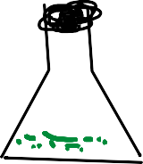
Mechanical (grinding)
/enzymatic method
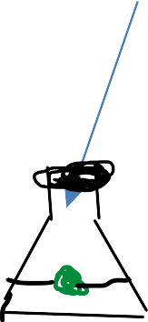
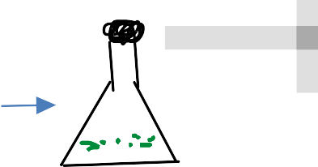
plant part explant (macerozyme) suspension
RCP

Plant cell

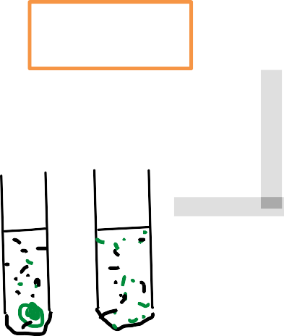
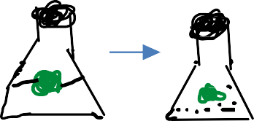
Agar medium
filtration
liquidnutrientmedia
shaker

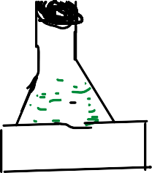
subculturing with fresh medium centrifugation/resuspensionintofreshmedium
agarmedium selectionofmoreproductiveclones
plant regeneration

bioreactors colonies

extractionof2metabolite

Time
RCP


callus culture: production and maintenance of callus on a solidified nutrient medium under aseptic conditions.
STEPS OF CALLUS CULTURE:
- selection and collection of explant material
- selection and preparation of culture media
- surface sterilization of explant material
- preparation of explant
- inoculation (transfer) of explant in culture medium

- inoculation of culture
- subculture of callus
- regeneration of plant from callus
  - Organo genetic method
  - embryogenesis
RCP
STAGE OF DEVELOPMENT OF CALLUS:
- SEED CULTURE:
Seed(explant) invitro culture seedling
Nutrient media
USES:
- increases the efficiency of germination of seed
- clean seedling for explant/meristem culture
2.MERISTEM/SHOOT TIP CULTURE:
Explant meristem culture media new shoot rooting and conditioning of

Transplanted shoot

Hardened plant


USES: 1. Disease free (virus free) plant
2.micropropagation
3. germ plasm conservation.
3. ROOT TIP CULTURE:
Root tip explant surface sterilization

culture root multiply

 Nutrient media
USES:
- clones of isolated root
- production of virus free germplasm
- LEAF/LEAF PRIMORDIA CULTURE:
RCP

Explant surface sterilization solid nutrient media
- COMPLETE FLOWER CULTURE:
EXPLANT Sterilization (2% calcium hypochlorite fl ower culture fruit (2days after pollination) Wash with distilled water
Agar nutrient media
- EMBRYO CULTURE:
Culture of excised mature or immature embryo into plantlet



Embryo (explant) plumule plant let Filter paper bridge
USES:
- overcome the seed dormancy
- embryo rescue (overcome the embryo immaturity)
- disease free plant
- BUD CULTURE:
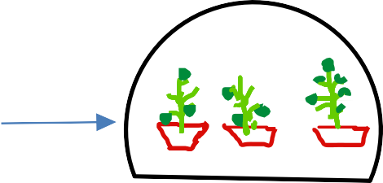
Axillary bud (contains active meristem) develop in plantlet.
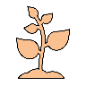

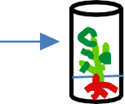
Explant bud in nutrient media plantlet Green house
- OVARY CULTURE:
Culture of unfertilized ovary to obtain haploid plant

USES:
- production of haploid plant
- studies on fruit development
- preferred explant – somatic embryogenesis


- ANTHER /POLLEN CULTURE
RCP

Unopened flower bud surface sterilization
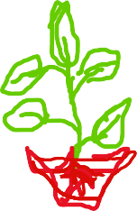
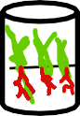
Anther nutrient media embryogenesis


- PROTOPLAST CULTURE:
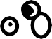
Surface sterilization peeled pieces centrifuge
 Cellulose enzyme isolated

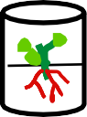
protoplast

Plantlets callus nutrient media plating of protoplast (incubate)
- HAIRY ROOT CULTURE:



Extraction of 2*  Explant
metabolite Nutrient medium callus agrobacterium rhizo genes root hair

:
Nutritional requirements growth and their maintenance.
To maintain the vital functions of a culture, the culture media consists of various elements ,they are as
RCP
follows:-
- inorganic
-macronutrients
-micronutrients
- Organic (carbon source)
-vitamins
-carbon /energy source
-growth regulators (phyto hormones)
- solidifying agents
- antibiotics
- pH
* Nutritional medium contain all essential supplements which required to growth of plant ,so we can
say that it is the house for plant (explant)
- INORGANIC SALTS:
Macronutrients - required in large amount
Eg:- nitrogen (N) , calcium (ca) , sulfur (P) etc..
Micronutrients:required in very small amounts for growth and development Eg:- iodine,copper, cobalt,manganese,iron,zinc etc...
- ORGANIC NUTRIENTS:

cell in culture can synthesize in a less amount so required externally in small quantities for
better growth and development
Eg:- thiamine (vit B౹) , pyridoxine (vit B6) , nicotinic acid (vit B౩) etc..

: In culture plant need extreme source of energy they required= sucrose, glucose, galactose, lactose, maltose, sorbitol etc..
RCP
  - Growth regulators/phtohoromes(plant hormones ):- the growth regulators or plant hormones are required to promote the growth of cell (plant cell)
Eg:- auxins, cytokinin , gibberellins,abscissic acid , ethylene etc...
- SOLIDIFYING AGENTS:
solidifying agents are used in the preparation of semi-solid or soled tissue culture medium
Eg:- agar, gelatin, pellets, starch, silica gel etc...
- ANTIBIOTICS:
It prevents the growth of microbes in plant tissue culture Eg:- streptomycin, kanomycine etc...
- PH:
-The pH of nutritional medium is generally adjusted b/w 5to6
* Nutritional medium depends upon the type of plant tissue or cell which we used for culture (Plant
tissue culture) Maintenance:-
-Make a list to reduce errors and be more organized. ...
-Only use healthy explants. ...
-Keep your work area clean and sterilized. ...
-Prepare media ahead of time. ...

-Let the media cool to prevent condensation. ...
-Use these chemicals to prevent the browning of explants and media.
-Label your culture vessels clearly and accurately
- Regularly inspect equipment and supplies
- Document and record everything
RCP
-Practice patience and avoid rushing.

:
Applications of plant tissue culture in pharmacognosy APPLICATIONS OF PLANT TISSUE CULTURE
Now a days the plant tissue culture is widely used in the field of biotech and also in pharmacognosy and it's applications are as follows:
RCP
- In production of secondary metabolites
- Biotransformation
- clonal propagation / micropropagation
- Soma clonal variation
- Immobilization of plant cell
- Others
- IN PRODUCTION OF SECONDARY METABOLITES:
The plants are the important source of variety of chemicals used in pharmacy ,medicine industries. In recent years suspension culture and callus culture are well used in production of chemicals. The most important chemicals produced by using cell culture are secondary metabolites such as alkaloids,glycosides,tannins,terpenoids,steroids and several flavours ,colours, performs etc....
Eg:

Plant species | Product | Culture type | Activity
Atropa belladonna | Atropine | suspension | Anticholinergic
Catharanthus roseus | Vincristine Vinblastine  Ajmalicine | Shoot culture Shoot culture  suspension | Anti cancer Anti cancer  hypotensive
Digitalis purpurea | Digitoxin  digoxin | Suspension and callus cultures | Cardiotonic

Coffea arabica | Caffeine | Callus culture | CNS stimulant
Datura stromonium | Scopolamine | Hairy root culture | Anti hypertensive

- BIOTRANSFORMATION:
A biotransformation or bioconversions is conversion of one chemical into another (i.e. conversion of precursor/substrate to final product using a cell suspension acting as biocatalyst ). It includes formation of low cost precursor to high cost product.
RCP
Eg: 1.conversion of beta methyl digitoxin into beta methyl digoxin in Digitalis lenata cell culture.
- In mentha cell culture conversion of levo(-) menthone into dextro(+) neo menthol.
- In cell cultures of Stevia rebaudiana and Digitalis purpurea can convert steviol into steviobiocide and stevioside which are 100 times sweeter than cane sugar.

- MICROPROPAGATION / CLONAL PROPAGATION:
The propagation of identical clones in invitro through their cells, tissues, organs by using culturing techniques in a short duration is described as micropropagation.
  - It gives high yielding crop with desirable characters.
  - And also helps in conservation of Endangered/Rare plant species.
Eg: Uniform clones of fennel are produced with narrow variation in composition of volatile oil.

- SOMA CLONAL VARIATION:
In clonal propagation clones are produced from tissue culture with uniform characters but few clones may show variations from their parent cells. This formation of variant clones from cultured tissues is called as soma clonal variation.
  - The obtained variant with desirable characters gives crop improvement. Eg:

RCP

SPECIES | MODIFIED CHARACTERS
Oryza sativa | Plant height; Heading date; seed fertility;grain number & weight
Loleum hybrids | Leaf size; flower; vigour; survival
Solanum tuberosum | Tubers shape; maturity date; plant morphology; resistence for early and late blight; photo period; leaf colour; vigour; height; skin colour;

:
Topic: EDIBLE VACCINE
. EDIBLE VACCINE
    - Edible vaccines are transgenic plants &animals based on production (or) those that contains agents triger an animal immune system.
RCP
    - The genes encoding antigens of bacterial and viral pathogens can be expressed in plants in a form in which they retain native immunogenic properties.
    - Edible vaccines concept was developed in 1990 by Charles amtzen, Example:-
Transgenic potatoes-diarrhoea (b-subunit of Ecoli)
Tansgenic tomateses-diarrhoea [surface protein of virus
Rabies glycoprotein being expressed in virus vectol in speinach Hepatites B surface antigen in potatoes.
Preparation:-
- Agrobacterium mediated gene transfer
- biostatic method 3)Electrophoration
:
In this suitable gene (recombinant DNA) is incorporated into the T-region of Ti-plasmid of
agrobacterium. Then a plant cell is co-cultured is transformed.

Sophisticated guns are used this is the sophisticated method involve the use of gun called gene gun. The gun fires the gene containing DNA coated with metals (gold/tungsten)metals particals enter into plant cells, then these plant cells are permitted to grow into a new plant
:
In this method, DNA inserted into the cell after exposed to high voltage electric. pulse cells grown into new plant.
RCP
- Through oral route, it is administered & produces mucosal immunity, antibody mediated immune Response immunity & cell mediated.
- Because of the lough outer cell, the cell cannot be disintegrate col destroy in gastric enzymes.
- The transgenic plants containing antigens acts. by the process bioencapsulation. The rigid walls are hydrolysed & released into the intestine.
- The released antigen are taken up by M-cell in intestinal lining placed on payer- payer's patches & gut associated lymphoidal dissues. (GALT) :
- They are further passed to maciophages & locally lymphocytes producing serum Igg & Ig response & local IgA response that rapidly counter balance the attack by real infections. agent.

  - These are edible vaccines having efficient mode of action for immunization
  - It will be producing mucosal immunity as that" of traditional vaccines
  - It is cheapel, cost effective.
  - Storage is not required.
  - Geeds can be stored for prolonged period.
  - No need of any sophisticated equipments. >
  - widely accepted as they are administered.
  - Rapid bleeding.

- Development of immunotolerance to vaccine peptide or protein.
- Consistency of dosage form fruit to fruit, plant-to-plant, and generation- to-generation is not
- similar.
RCP
- Stability of vaccine in fruit is not known.
- Dosage of vaccines would be variable.
- Selection of best plant is difficult.
- Certain foods like potato are not eaten raw, and cooking the food might weakens the medicine
- present in it.
- Not convenient for infants.

Long answer questions (10 MARKS)
- Explain plant tissue culture with types of tissue culture
- Explain nutrients, growth of tissue culture

Short answer questions (5 MARKS)
- What are the application s of plant tissue culture
- What are the types of tissue culture
- What are edible vaccines
Very short answer questions (2MARKS)
- What are examples of edible vaccines
- Write any important application of tissue culture

10 Hours
RCP
Role of Pharmacognosy in allopathy and traditional systems of medicine namely, Ayurveda, Unani, Siddha, Homeopathy and Chinese systems of medicine
Definition, classification, properties and test for identification of Alkaloids, Glycosides, Flavonoids, Tannins, Volatile oil and Resins.

:

- The system of medical practice which treats disease by the use of remedies which produce effects different from those produced by the disease under treatment. Example- Anti-bacterials, anti-virals and for acidity.
- The term allopathy was coined in the year 1810 by Samuel hahnemann
RCP
- Pharmacognosy plays an important role in the treatment of many diseases in allopathy
- It plays a crucial role in the discovery characterization production of drugs
- In this system the drugs or medicines are manufactured using synthetic chemicals or
chemicals derived from natural products like plants animals minerals etc.
- This system also uses modern equipment for diagnosis analysis surgery etc.
:
- The traditional system of medicine is also known as folk medicine or alternative medicine
comprises of medical aspects of knowledge skills and practices based on different cultures and their use to treat disease.

:
Traditional systems of medicine namely, Ayurveda, Unani
- It is an Indian system of medicine
- It is an oldest medicinal system that came into existence in about 900 BC
RCP
- There are 4 Veda’s:
*Rig veda
*Sham veda
*yajur veda
*Atharva veda
Into that ayurveda is the part of atharva veda.
- Charaka and sushruta made significant contribution to ayurveda.
- The book “charaka samhita” was written by “charaka” and he was known as the father
of ayurveda.
:
- Prithvi(earth)
- Jal(water)
- Teja(fire)
- Vayu(air)
- Akash(spaces)
  - TRIDOSA THEORY:

- Kapha(lubrication)
- Vata(respiration)
- Pitta(Metabolism)
:
- Satva(good)
RCP
- Raja(Aggressive)
- Toma(Dullness)
:
- Rasa(Theoretically active substance )
- Guna (Quality principle involved in it)
- Virya (Active principle and potency?)
- Vipaka(End product of digestion is known)
- Prabhava (Actual effect of drug on body)
:
- Rasa(Plasma/lymph)
- Raktam(Blood)
- Mamsa(muscle)
- Moda(Fat)
- Asthi(Bone)
- Majja(None marrow & nerves)
- Shukra(Reproduction fluid)
  - The diseases are diagnosed by observation of dosha
  - Under this ,skin, eyes nails ,and tongue is observed

  - Recording the pulse
  - Investigation of urine stools and sweat
:
    - Ayurveda treatment starts with an internal purification process, followed by a special diet, herbal remedies, massage therapy, yoga and medication.
RCP
    - The concepts of universal interconnectedness, the body’s constitution and life forces are the primary basis of Ayurvedic medicine.
      - ➢ This system of medicine is organised team Greece by Greek philosopher
      - “Hippocrates”.
      - ➢ In India Arabs introduced unani system by mughals
      - ➢ Unani considers the human body to be made up of 7 components they are:
- Arkan-Elements
- Mizaj-Temperature
- Aklath-Humours
- Anza-organs
- Arawh-Spirits
- Quo-Faculties
- Afal-Functions
  - Unani medicine is based on 4 basic elements that is earth, air, water and fire which have different temperatures that is cold, hot, wet and dry.
  - The body has simple and complex organs which got nourishment through 4 humours that is blood, phlegm, yellow bile, Blackbile.
- Blood-hot & wet

- Phlegm-cold &hot
- Yellow bile-hot & dry
- Black bile-cold & dry
  - According to this system health is a state of body in which there is equilibrium in humours and temperature
RCP
  - When the equilibrium of the humours is disturbed disease produces .
- DIAGNOSES:
- The diseases are mainly diagnosed with the help of pulse, physical examination of urine and stool.
- TREATMENT:
  - Regimental Same drugless reginens are advised for treatment of diseases:
Ex: exercise, massage.
  - Herbs and drugs are used
  - Different diets are recommended for the patients of different diseases.

:
Traditional systems of medicine namely Siddha, Homeopathy and Chinese systems of medicine
Siddha medicine is also one of the oldest traditional medicines. This healing system is originated in South India. This system is based on ancient medicinal practices as well as spiritual disciplines. It also includes alchemy and mysticism. This system is thought to have developed between 2500 and 1700 BC. Siddha medicine originated in Tamil Nadu, India as evident in the earliest Tamil writings (Tamil is one of the principal Dravidian languages). There are references in literature of Tamil shangam (1st–4th century CE), in the Tolkappiyam (“Ancient Literature”), a treatise on grammar and poetics, and in Tirukkural (“Sacred Couplets”), a work attributed to the Tamil poet-saint Tiruvalluvar about this system.
The concepts of the Siddha medicine system is also allied to the Ayurveda system. The only difference is that the siddha medicine based on the concept of Vaadham, Pitham and Kabam in childhood, adulthood and old age, respectively, whereas in ayurveda, it is totally reversed, as said Kabam is dominant in childhood, Vaatham in old age and Pitham in adults. According to the Siddha medicine, various psychological and physiological functions of the body are made up of the combination of seven elements namely:
RCP
- ooneer (plasma) is responsible for growth, development and nourishment;
- ischeneer (blood) is responsible for nourishing muscles, imparting colour and improving intellect;
- oon (muscle) is responsible for shape of the body;
- koluppu/Kozhuppu (fatty tissue) is responsible for lubricating joints as well as oil balance;
- elumbu (bone) is responsible for body structure and posture and movement;
- elumbu majjai (bone marrow) is responsible for formation of blood corpuscles;

and
- sukkilam (semen) which is responsible for human reproduction.
In this medicine system, the physiological components of the humans are classified
as Vaadham (air), Pitham (fire) and Kabam (earth and water) as like as Ayurveda system.
RCP
The Five Elements:
According to this medicine system, the five elements that exist in nature are earth, water, fire, air, and ether, all of which form the original basis of all corporeal things. Traditionally, it believed that there is an intimate connection between the macrocosm of the external world and the microcosm of the corporeal being. As per the system the element of earth is present in the human bone, flesh, nerves, skin and hair; water, as element, is present in bile, blood semen, glandular secretions, and sweat; the fire element is present in hunger, thirst, sleep, beauty, and indolence; the air is present in contraction, expansion, and motion; and the ether is present in stomach, heart, neck and head.
The siddhars did extensive research on plants and devised methods by which plants are used to control many diseases and also cures medicinally. There are many plants that are also described by them which are poisonous in nature as well as some plants are also used as antidotes for them. Therefore, plants are classified based on the way they affected the body. Siddha medicine gives importance to the multiple uses of plants and minerals. For simple ailments, herbs are used as preliminary treatment in this system. According to Siddha theory, it is believed that mercury preparations provided immunity to the body from decay, enabling it to conquer disease. Mercury and sulfur are used as supreme curatives even though those minerals are extremely toxic to the human body. Siddha medicines are used for the management of chronic diseases and degenerative conditions, such as autoimmune conditions, rheumatoid arthritis, collagen disorders, and conditions of the central nervous system but the effectiveness are varied as per the situations. Some examples are like the leaf extract of Adhatoda vasica is used to cure bronchial asthma, eosinophilia, seeds and leaves of Apium graveolens are used in the treatment of asthma and bronchitis as well as liver and spleen diseases, roots of Boerhavia diffusa is used for the treatment of asthma etc.

Homeopathic medicine system works on the principle of 'like cures like' (Similia Similibus Curanter). This medicine system of healing was coined by Dr. Samuel Hahnemann, German physician. He has translated a book on the medicinal properties of drugs. During that time he read the properties of the medicine Cinchona and saw Cinchona cures malaria, because of its bitter taste. After that he named his new healing science by combining the two Greek words homeo-, meaning "same," and pathy, meaning "disease." Materia Medica is a book where the properties of medicines are listed on healthy individuals. Homeopathy system relies on this book.
RCP

Homeopathic medicine believes, various materials found in nature contain an energy field that can exert a healing effect on the body. This energy field is amplified, or "potentiated," by a series of dilutions. It is noticed that dilution enhanced the medicinal power of the drugs. The more the "mother tincture" is diluted, the healing effect will be stronger. It is based on the Dynamization theory by which the quality of the medicines is improved by vigorous shaking. This method is also helps to remove the poisonous properties of the drugs. The materials used in homeopathic formulations can come from natural herbs, from minerals, or from animal parts. Homeopathic preparations are written as 2X, 4X, 6X etc., “X” indicates potency. These indicate the number of times the mother tincture is diluted and potentiated. The higher number indicates more dilute with stronger healing effect.

Homeopathy is based on the principle of “like with like”, that is a substance which causes symptoms when taken in large doses, can be used in small amount to treat those same symptoms. The treatment is based on the concept of proving and prover. Prover is the healthy person whereas proving is the symptoms that are caused in prover by the various potencies of medicines. Like, drinking too much coffee can cause sleeplessness and agitation, so according to this principle, it could be used to treat people with these symptoms. Homeopathic medicines are prepared by specialist pharmacies using a careful process of dilution and a specific form of vigorous shaking.
:
Traditional medicines are used by people about 60% of the world’s population for their primary health care system. Most of the drugs used in modern medicine and

ancient Indian medicinal system are of plant origin. Dilutions of the drugs are prepared uniform drug strength which is represented by the dry crude drug as the unit strength. In case of mother Tincture, it is made from dried substances and the plant juice as the unit from the fresh plant. Homoeopathy uses animal, plant, mineral, and synthetic substances in its remedies. Arsenicum album (arsenic oxide), Natrum muriaticum (sodium chloride), opium (plant), and thyroidinum (thyroid hormone) are some of the homoeopathic medicines extracted from different sources.
RCP
Some important medicinal plants used in Homeopathic medicine systems are:
- Rhus toxicodendron, used in treating paralysis of the lower extremities,
- Aconite napellus and Gelsemium sempervirens are used in homeopathic for treatment of paralysis.
- Agaricus muscarius, Cocculus indicus, Solanum dulcamara, and Hypericum perforatum which are all poisonous sources, are used in Homeopathic medicine system.
- Arnica Montana, Strychnos and Nux-vomica are another well-known plant source, used in pain relief as well as antacid respectively in homeopathy medicine.
- Belladona liquid from Atropa belladonna is used for running nose and any cold conditions in Homeopathic medicine.
Chinese medicine (CM) is a broad range of medicine practices that developed in China. It is based on a tradition of more than 2,000 years, including various forms of herbal medicine, acupuncture, massage, exercise and dietary therapy. The medicine practitioners used herbal medicines and various mind and body practices, such as acupuncture and tai chi, to treat or prevent health problems. The traditional Chinese medicine is based on 5,000 years of practice and experiences. This medicine system provides a complete assessment based on a unique cultural, diagnostic, and therapeutic approach. Chinese medicine system consist of three parts namely theory, treatment and prevention.
Chinese Medicine system is based on two systems viz. Yin and Yang theory, and five element theory. Yin and Yang Theory is based on the “Principle of Chi” that promotes biological activities by energy generation. This Yin and Yang theory

represent positive and negative side of the energy which are opposite to each other. Health reflects the balance between Yin and Yang. If Yin principle predominates the body then weakness, exhaustion are the result. Excess Yang causes irritability and excitement. When the Yin and Yang elements in a person’s body are balanced the person is in good health. The five element theory is based on vital five organs namely heart, liver, spleen, lungs and kidney are related to five elements such as earth, wood, metal, fire and water. They all are interlinked and together they are known as “Wu Xing”.
RCP

The Eight Principles are in this system as follows:
- Yin: Yin is cold. Yin with Yang is indicates for pattern diagnosis and describes the relationship between other three pairs of Principles.
- Yang: Yang with Yin describes relationship between the other three pairs of the  Like heat is Yang.
- Interior: Interior describes diseases at manifest themselves in deep inside the body (Zang-fuorgans), such as qi, blood, and bone marrow.
- Exterior: Exterior describes diseases that manifest themselves on surface of the body namely hair, skin, nails, and meridians. Its clinical features include body chills, fever, a weak pulse, headache etc.
- Heat: Heat describes the absence of Cold. Its symptoms are rapid pulse, fever, body chills, dehydration, and a sore throat when it combines with exterior pattern but in combination with an interior pattern, its symptoms are cold drinks, clear urine, and a slow pulse.
- Cold: Cold describes the absence of heat. With combination of Exterior pattern, its symptoms are body aches, a tense pulse, fever, body chills, and headaches but with an Interior pattern, its symptoms show nausea, stomach pain, vomiting, and diarrhoea.
- Deficiency: Deficiency is used to describe a vacuity in qi, blood (Xue), or body fluids (Jinye) but it depend on the relation to Interior/Exterior and Cold/Heat, it can manifest as constipation, having a small appetite, dizziness, and slow pulse.
- Excess: Excess is classified as any disease that cannot be identified as a Deficiency pattern. It means that one of the six excesses is present. Depending on how it relates to Interior/Exterior and Cold/Heat and show quick pulse, sweaty

palms, and sharp stomach pains.

It aims to restore harmony between Yin and Yang with the patients as well as between patients to the World. Treatments are carried out with help of Herbalism, Acupuncture, Moxibustion, Cupping and Massage therapy.
:
RCP
Chinese herbal medicines are mainly plant based and they packaged as powders, pastes, lotions or tablets forms, based on uses of herbs. In this system, herbs are sometimes combined in formulations and given as teas and other various dosage forms. The system believes that herbs help boost Qi (Life force) and balance Yin and Yang in formulated drugs where many herbs are used in combinations that have scientific validation of their effectiveness as tonics or remedies for specific illness. Herbs restore energy balance to the opposing forces of energy i.e. Yin and Yang which run through invisible channels in the body. More than 300 herbs are traditionally used in Chinese medicine system. Some of important.

:
Plants produce a vast number of different chemical compounds which are broadly categorized by primary metabolites and secondary metabolites. Primary metabolites are essentials for the plants for their survival likely: sugar, proteins, amino acid etc. Thereafter secondary metabolites are the products that are considered as waste substances of plants. These secondary metabolites are not essential, but stored in various parts of the plant bodies and provide protections to the plants from attacks of microorganisms, attractors for pollinators etc. They are produced by the plants are extremely diverse. These secondary metabolites are relatively produced in low quantities in plants but have significant economic and medicinal value to the humans. High concentration of secondary metabolites present in plants indicates more resistant plants. They are categorized based on chemical structure (like presence of sugars, different rings), composition, their solubility in various solvents and the various biosynthesis pathways. A simple classification includes three main groups: the terpenes (made from mevalonic acid, composed almost entirely of carbon and hydrogen), phenolics (made from simple sugars, containing benzene rings, hydrogen, and oxygen), and nitrogen-containing compounds. Furthermore various scientific research evidences proved that the therapeutic efficacy and pharmacological actions are mainly by the action of secondary metabolites and hence plant secondary metabolites are gaining importance to natural product chemists. Based on the characterization, secondary metabolites of few plants are described in this section.
RCP

:
Alkaloids
INTRODUCTION: ALKALOIDS

- Alkaloids are the secondary metabolites. These are heterogenous compounds and contain basic nitrogen.
RCP
- The term alkaloid was coined by Carl Friedrich Meissner.
- First synthesized alkaloid is coniine.

DEFINITION
These are the organic products of natural or synthetic origin which are basic in nature and contain one or more nitrogen atoms, normally of heterocyclic nature and possess specific physiological actions on human/animal body when used in small quantities.

TYPES
- True Alkaloids: These are toxic in nature which contain heterocyclic nitrogen which is derived from amino acids and always basic in nature.
- Proto Alkaloid: Simple amines in which the nitrogen is not in a heterocyclic ring. These are considered as biological amines. These are basic in nature, prepared in plants from amino acids. Mescaline and ephedrine are examples.
- Pseudo Alkaloids: Includes mainly steroidal &terpenoid alkaloids & purines. These are not derived from amino acids. Conessine and caffeine are examples.

PHYSICAL PROPERTIES:
- Alkaloids are crystalline in nature but few are amorphous solid.
- Alkaloids are insoluble in water but soluble in most of the organic solvents.
- Alkaloids are bitter in taste and have pronounced physiological activity.

CHEMICAL PROPERTIES:
- Most of alkaloids are basic in reactions, due to availability of lone pair of e⁻ on

nitrogen atom.
- Due to basic nature sensitive to decomposition & causes problem during storage. Their salt formation with an inorganic acid prevents decomposition.

CLASSIFICATION:
Alkaloids are classified into:
RCP
  - IIIT (Indole, Imidazole, Isoquinoline, Tropane).
    - Indole Alkaloids (from tryptophan) Examples: P - Physostigmine
V- Vinca
R- Rauwolfia N- Nux vomica E- Ergot.
    - Imidazole: Pilocarpus (from Threonine, Histidine)
    - Isoquinoline: B - Berberis.
I – Ipecac O – Opium C – Curare
H – Hydrastis.
    - Tropane from ornithine:
S – Stramonium B- Belladona
H- Hyoscyamus D- Datura
D- Dubosia C- Coca
  - QQP (Quinoline, Quinazoline, Piperidine).
    - Quinoline (from tryptophan): Cinchona, Camphotheca.

    - Quinazoline (from Anthranilic acid): Vasaksa.
    - Piperidine (from nicotinic acid & lysine): Areca
  - SAP (Steroidal, Amino Alkaloids, purine alkaloids)
    - Steroidal (from hygrine,ornithine): K- Kurchi V- Veratrum
A-Aswagandha
    - Amino Alkaloids: C- Colchicum
RCP
E- Ephedra.
    - Purine: C- Coffee
T- Tea.

  - PD (Pyridine, Diterpenoid)
    - Pyridine: Tobacco
    - Diterpenoid: Aconite.

CHEMICAL TEST FOR ALKALOIDS.
  - Alkaloids give precipitate as salts of organic acids or with compounds of heavy metals, like mercury, gold, platinum.
  - Mayer’s reagent (potassium mercuric iodide solution): Alkaloids give cream precipitate.
  - Dragendroff’s test (potassium bismuth iodide solution): Alkaloids gives reddish brown precipitate.
  - Wagner’s reagent (iodine potassium iodide): Alkaloids gives reddish brown precipitate.
  - Hager’s reagent (Picric acid): Alkaloids give yellow precipitate.
  - Some alkaloids do not give such test like caffeine which is highly water soluble. Hence the tests with heavy metals give false reactions so specific tests for individual alkaloids are more important for qualitative evaluation of crude drugs.

Flavonoids, Tannins, Volatile oil and Resins.

:
Glycosides

- Naturally occuring organic compounds.
- Found in both plants and animals.
RCP
- On hydrolysis, gives one or more sugar moiety (glycone) and non sugar moiety (aglycone).
- Aglycon is also called GENIN.
- Pharamacological activity is due to the genin part.
- Glycone part facilitates the transportation of genin to site of action.

- Glycone and Aglycone are linked by Glycoside linkage.

SYNONYMS: Mulethi, Radix glycyrrhizae, licorice, yashtimadhu

BIOLOGICAL SOURCE : it consists of peeled and unpeeled stolons, roots, stems of Glycorrhiza glabra belonging to the family Leguminaceae.

HISTOLOGICAL CHARACTERS: Sweet in taste, cylindrical in shape. Surface has yellowish brown longitudinal wrinkles (unpeeled), peeled ones are yellow colored with longitudinal ridges. In case of stolons, buds are also seen.

CHEMICAL CONSTITUENTS : Anthraquinones, glycosides of aloin, barbaloin, C-glycosides, Resins GLYCOSIDES, Aloe-emodin, Aloinoside-A & Aloinoside-B

CHEMICAL TESTS :
Alcoholic extract of drug → evaporated → dry
→extracted with CHCl3 + few drops of acetic anhydride + conc.salphuric acid (from the side wall of test tube) → appearance of violet ring → blue colour → presence of sterol group in drug.

Alcoholic extract of drug→evaporated →dry → extracted with CHCl3 + conc. H2SO4(from side wall of test tube) →appearance of yellow colored ring (at the junction of two liquids) → turn to red → presence of sterol group in drug
RCP

1 gm of drug sample + 5ml of dilute HCl + 5 ml of ferric chloride →Boil for 10 min. on waterbath → cool (on room temperature)
→filter → extract of filterate with carbon tetrachloride or benzene + equal amount of ammonia solution →appearance of pink to red colour → presence of anthraquinone moiety.

1gm of drug sample + 5-10 ml of dilute HCl + 10 min. boil on waterbath and filter + extract of filterate with CCl4 or benzene + equal amount of ammonia solution to filterate + shake → appearance of pink to red colour → indicate presence of anthraquinone moiety.

 1 gm of drug sample + 5 ml of alcoholic KOH → transfer it to aqueous solution of FeSO4 and FeCl3 → keep it on room temperature for10 minutes. → transfer whole solution to 20 % HCl →appearance of Prussian blue colour → the presence of cynogenetic glycosides .

Generation of HCN gas by→reduction of aqueous mercurous nitrite solution → metallic Hg → the presence of cyanogenetic glycosides.

1 gm of sample drug + 10 to 20 ml of water →well shaked
→generation of froths → the presence of saponins.

The glycosides can be classified by the glycone, by the type of glycosidal linkage, and by the aglycone.
RCP

If the glycone group of a glycoside is glucose, then the molecule is a glucoside; if it is fructose, then the molecule is a fructoside; if it is glucuronic acid, then the molecule is a glucuronide, etc.

- 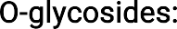 Sugar molecule is combined with phenol or –OH group of aglycon, for example, Amygdaline, Indesine, Arbutin, Salicin, cardiac glycosides, anthraquinone glycosides like sennosides etc
- 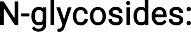 Sugar molecule is combined with N of the –NH (amino group) of aglycon, for example, nucleosides
- 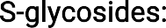 Sugar molecule is combined with the S or SH (thiol group) of aglycon, for example, Sinigrin.
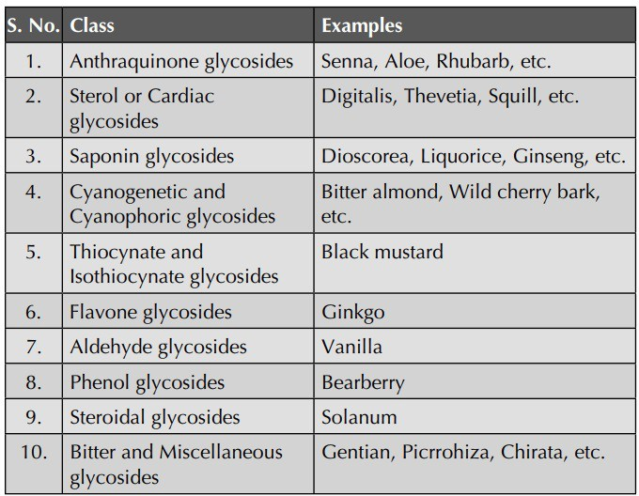
- 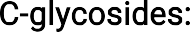 Sugar molecule is directly attached with C—atom of aglycon, for example, Anthraquinone
glycosides like Aloin, Barbaloin, Cascaroside and Flavan glycosides, etc.

USES :
RCP
- Analgesic, antiinflammatory, cardiotonic, antibacterial, antifungal, antiviral, and anticancer effects.
- Used as natural sweeteners also.
- Used to treat patients with atrial fibrillation and atrial flutter.
They can be prescribed for congestive heart failure when the use of other medications fails

:
Flavonoids
Flavonoids are polyphenolic compound and vastly available in maximum plant species. They are generally yellow colored pigments. They are larger group of glycosides. They are 2-phenylbenzopyrones derivatives and produce a large number of physiological activities. Flavonoids are the largest group of naturally occurring phenols and occur in free states in the plants as glycosides. They may be described as a series of C6-C3-C6 compounds (Fig. 4.16). They are largely found in Polygonaceae, Rutaceae, Fabaceae and Rosaceae families.
RCP
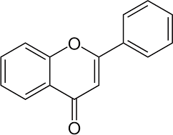

General structure of Flavonoid

- They are crystalline substances with certain melting point.
- Catechins, Flavanes, Isoflavanes, Flavanones, Flavanonoles are colourless crystals whereas Flavones, Flavonols, Chalcones are yellow coloured crystals. Anthocyanidins are red in acidic media and blue in alkaline media.
- Anthocyanes are sap pigments. The actual colour of the plant organ is determined by the pH of the sap. Example: Blue colour of the cornflower and red colour of roses are due to these glycosides.
- Flavonoid glycosides are generally soluble in water and alcohol but insoluble in organic solvents.
- Aglycone parts of flavonoids are soluble in diethylether, acetone, alcohols etc.

- Flavanols are optically active.
- Flavanones and flavonones are unstable compounds.
- Flavonoid O-glycosides are undergoes hydrolysis when treated with acid, alkali.
- Rutin is yellow crystalline powder, soluble in alkali but slightly soluble in water.
- Rutin on hydrolysis gives quercetin, rhamnose and glucose whereas hesperidin yields hesperitin, rhamnose and glucose.
RCP
- Under the UV light flavonoids shows fluorescence of different colours (yellow, orange, brown, red).

- Chemically flavonoids are based upon a fifteen-carbon skeleton (C15) consisting of two benzene rings (A and B) linked via a heterocyclic pyrane ring (C).
- They occur as aglycones, glycosides, and methylated derivatives.
- Six-member ring condensed with the benzene ring is either a α-pyrone (flavonols and flavanones) or its dihydroderivative (flavonols and flavanones).
- The position of the benzenoid substituent divides the flavonoid class into flavonoids (2-position) and isoflavonoids (3-position).
- Flavonols differ from flavanones by hydroxyl group at the 3-position and a C2–C3 double bond.
- Flavonoids are often hydroxylated at positions 3, 5, 7, 2, 3′, 4′, and 5′. Methyl ethers and acetyl esters of the alcohol group are known to occur in nature.
- The glycosidic linkage is normally located in flavonoid at positions 3 or 7.
Broadly flavonoids are classified into two classes namely based on groups and based on place of B-ring location.
- Based on Groups:
Flavonoids are classified into flavones (e.g. apigenin, and luteolin), flavonols (e.g.

quercetin, kaempferol, myricetin, and fisetin), flavanones (e.g. flavanone, hesperetin, and naringenin), Flavanol (Example: Catechin).
- As per the Place of B-ring location:
As per the location of the B-ring, they are three types like true flavonoids, isoflavonoid and neoflavonoid. True Flavonoids are derived from 2-phenylchromen-4-one (2-phenyl-l, 4-benzopyrone) structure. Isoflavonoids are derived from 3-phenylchromen- 4-one (3-phenyl-1,4-benzopyrone) structure and Neo-flavonoids are derived from 4-phenylcoumarine (4-phenyl-1,2-benzopyrone) structure. True Flavonoids are also known as bioflavonoid due to origin from plants. Bioflavonoids are anthoxanthin i.e. mixture of flavones and flavonols.
RCP
:
Dried plant materials are powdered and extracted with various solvents based on the type of flavonoids such as less polar flavonoids (like Isoflavones, flavanones, flavonols) are extracted with chloroform, diethyl ether or ethyl acetate whereas more polar flavonoid glycosides are extracted with alcohol or mixed solvent of alcohol and water. Soxhlet method is used for the extraction. N-Hexane solvent is used for defatted the plant materials followed by ethyl acetate solvent is used for the extraction of flavonoids. Generally, successive solvent extraction method is used for the extraction. First, dichloromethane is used for extraction of flavonoid aglycone and other less polar constituents. Then alcohol is used for extraction of glycone part of flavonoid and other polar constituents. The crude extract is purified by using shaking with sodium carbonate or sodium bicarbonate (for strong acidic OH group) or by column chromatography using polyamide column, Sephadex LH-20 column. Sephadex LH-20 column is suitable for separation of proanthocyanidins where alcohol is used as an eluent and acetone is used for separation of high molecular weight polyphenols.

: The alcoholic solution of flavone or flavonol when treated with metallic magnesium (or Zinc) and hydrochloric acid gives an orange, red or violet colour. This test is also known as cyanidin reaction.
: To small quantity of residue, add lead subacetate solution.
Yellow coloured precipitate is formed. Addition of increasing amount of sodium hydroxide to the residue shows yellow colouration, which decolouration after

addition of acid.
: Flavonoids form complexes with boric acid which is not
destroyed by addition of citric acid alcoholic solution (or oxalic acid).
: Alcoholic solution of sample when reacts with antimony pentachloride the solution produces red or violet colour.
RCP
Functions:
- They act as powerful antioxidant like Quercetin, Xanthohumol, Isoxanthohumol etc.
- They control the plant growth.
- They inhibit and activate plant enzymes.
- They having a role in the biochemistry of reproduction.
- They have fungicidal properties. They protect the plant from parasites attack.
- They are the pigments of flowers that attract insects for pollination.
- They are having significant therapeutic efficacy such as antiviral, antiallergic, antiplatlets, anti-inflammatory, antitumor etc

:
Tannins
  - The complex,organic,non-nitrogenous,polyphenolic substances of higher molecular weight. They are used as antiseptics and in git diseases like diarrhea and also used in leather industries.
  - They are polyphenolic substances found in many plants product of secondary metabolism. Its water soluble nature allows easy extraction and is useful in various applications in the chemical and pharmaceutical industry.
RCP
SYNONYMS: Pale catechu, gambier, kattha.
BIOLOGICAL SOURCE : It consists of dried aqueous extract prepared from the leaves of Uncaria gambier belonging to the family RUBIACEAE.
HISTOLOGICAL CHARACTERS: Non crystalline
CHEMICAL CONSTITUENTS : Catechins 7-33%, catechutannic acid 22-50% & catechu red. Also contains quercetin & gambier fluorescin.
CHEMICAL TESTS :


Alkaloids such as caffeine, cinchonine, quinine or strychnine, precipitates polyphenols and tannins. This property can be used in a quantitation method.

When goldbeater's skin or ox skin is dipped in HCl, rinsed in water, soaked in the tannin solution for 5 minutes, washed in water, and then treated with 1% FeSO4 solution, it gives a blue black color if tannin was present

Use of ferric chloride (FeCl3) tests for phenolics in general. Powdered plant leaves of the test plant (1.0 g) are weighed into a beaker and 10 ml of distilled water are added. The mixture is boiled for five minutes. Two drops of 5% FeCl3 are then added. Production of a greenish precipitate is an indication of the

presence of tannins.]Alternatively, a portion of the water extract is diluted with distilled water in a ratio of 1:4 and few drops of 10% ferric chloride solution is added. A blue or green color indicates the presence of tannins
RCP
A 10ml of aqueous extract of a tannin and sodium acid phosphate is heated and cooled and filtered. A 2% solution of phenazone is added to the filtrate. A bulky colored precipitate is formed.

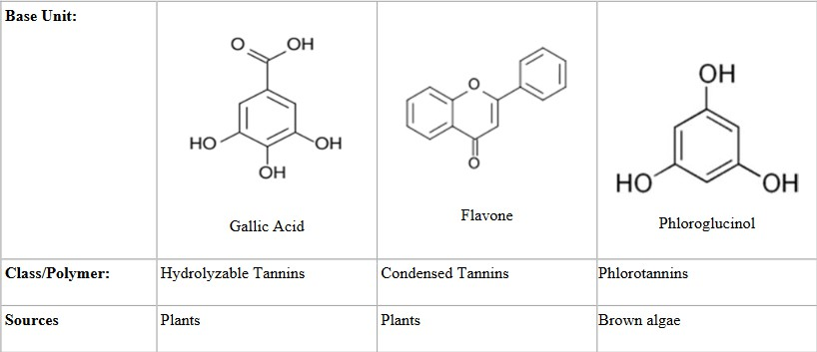
Tannins can be classified into three broad groups – hydrolysable tannins, condensed tannins and Pseudotannins.

USES :
- Used as an astringent
- Used in the treatment of diarrhoea.
- Used i the preparation of lozenges.
- Used externally in the treatment of burns.

:

Volatile oil

Volatile oils are the odorous liquid obtained from various plant parts. They are evaporate on exposure to air at ordinary temperature. As volatile oils are responsible for the essence or odour of the plant they are also known as essential oils.
RCP
- Hydrocarbons
- Alcohols
- Aldehydes
- Ketones
- Phenols
- Phenolic ethers
- Oxides
- Esters
Hydrocarbons occur in practically all volatile oils, they occur as:
  - A.Monocyclic monoterpenes: e.g. Limonene
  - B.A dicyclic monoterpene: e.g. Pinene and Sabinen.
  - C.Acyclic monoterpene hydrocarbons: e.g. myrcene.
  - D.Sesquiterpene hydrocarbon: e.g. Cadinene
- spirits of turpentine is the volatile oil distilled from the oleoresin obtained from Pinus palustris and from other species of Pinus Linné (Fam. Pinaceae). Uses: Turpentine oil is used as a counterirritant in Vicks Vaporub, and as expectorant.
- Alcohol Volatile Oils Alcohols found in volatile oils may be classified into:
  - Acyclic alcohols: e.g. gerarniol, linalool, citronellol
  - Monocyclic alcohols: e.g. menthol (from peppermint) and αterpineol.

  - Dicyclic alcohols: e.g. Borneol Among the important alcohol volatile oil drugs are peppermint, cardamom oil, rose oil, orange flower oil, and pine oil. Peppermint Peppermint consists of the dried leaf and flowering top of Mentha piperita (Farn. Labiatae). Peppermint oil contains menthol as a major constituent.
  - : It has been used as a carminative, a stimulant, and a counterirritant, commercial use is as a flavoring agent, especially for chewing gum and in the antacid products.
RCP
- Aldehyde Volatile Oils Aldehydes occurring in volatile oils may be divided into acyclic and cyclic.
  - Acyclic aldehyde: Neral
  - Cyclic aldehyde: Cyclocitial.
  - Aromatic aldehyde: Cinnamaldehyde, vanillin and Anise oil. Plants containing aldehyde volatile oil
    - Cinnamon: is the dried bark of Cinnamonium loureirii. (Fam. Lauraceae). Contains cinnamaldehyde and terpenes.
    - : as flavoring agent, carminative and antiseptic.
    - 2.Lemon Peel: Lemon is the fruit of Citrus limon (Fam. Rutaceae). Lemon peel is the outer yellow rind of the fresh ripe fruit of C. limon.
    - : Lemon peel is a flavoring agent, and stimulant.
      - Lemon oil: is the volatile oil obtained by expression, without the aid of heat, from the fresh peel of the fruit of C. limon.
    - Lemon oil is a flavoring agent. It has stimulant, and carminative. It is also used in cosmetics and liquid cleansers because the aroma and flavor are widely accepted by consumers
.4. Ketone Volatile Oils Ketones occurring in volatile oils may be divided into:
- Monocylic terpene ketones: including menthone.
- Dicyclic ketones: including camphor. Plants containing ketone volatile oils
  - Camphor: Camphor is a ketone obtained from Cinnamomum camphora (F: Lauraceae) Uses: Camphor is a topical antipruritic, rubefacient, and anti-infective.
  - Caraway: Consist of dried ripe fruit of Carum carvi (F: Umbellifarae). Contains volatile oil from 5-7% and 2% fixed oil.
    - Uses: It used as flavoring agent and carminative.
      - Spearmint: Spearmint consists of the dried leaf and flowering top of Mentha spicata (Fam. Labiatae). Uses: Spearmint is flavoring agent and possesses carminative properties. almond: is the dried ripe kernels of prunus amygdalis, F: Rosaceae. Contains benzaldehyde

- Phenol Volatile Oils Two kinds of phenols occur in volatile oils: those that are present naturally and those that are produced as the result of destructive distillation of certain plant products. Eugenol, thymol, and carvacrol are the most important phenols occurring in volatile oils. Plants containing phenol volatile oil
  - Thymol: is a phenol obtained from thyme oil (Thymus vulgaris) F: labiatae. Uses: Thymol is an antifungal and antibacterial agent. It is employed topically in lotions, creams, and ointments. Thyrnol is used in the feminine hygiene products
RCP
  - Clove: Clove or cloves is the dried flower bud of Eugenia caryophyllus (Fam. Myrtaceac). Contains chiefly eugenol. Uses: Clove oil is classed as a flavor. It is commonly employed as a toothache remedy that is applied topically to dental cavities as required. Clove oil also possesses antiseptic, counterirritant, and carminative properties.
- Phenolic Ether Volatile Oils A number of phenolic ethers occur in volatile oils as anethole from anise, safrole from sassafras and nutmeg. myristicin (methoxysafrole) is a derivative of safrole from nutmeg. Plants containing phenolic ether volatile oils
  - Nutmeg Nutmeg or myristica is the dried, ripe seed of Myristica fragrans (Fam. Myristicacea). Contain volatile oil (myristicin) and safrol and fixed oils.
  - Uses: Myristica is a flavor and a condiment. it is a useful agent for controlling diarrhea associated with certain carcinomas. Has CNS effects, large quantity up to 15mg cause hallucination.
  - Anise: consists of dried ripe fruit of pimpinella anisum F:umbellifarae. Contains 1
-3 % volatile oils consist of 90-93% anethol.
  - Uses: It used as carminative and flavorin
- Oxide Volatile Oils Cineole (eucalyptol) is found in eucalyptus which consist of fresh leaves of Eucalyptus globus F: Myrtacea. Contains about 70 to 85% cineole. USES: Eucalyptus oil is classed as a flavor. It is frequently used as an antiseptic, diaphoretic, and
- Ester Volatile Oils A wide variety of esters occurs in volatile oils.
  - The most common are the acetates of terpineol, borneol, and geraniol.
  - Examples of esters in volatile oils are allyl isothiocyanate in mustard oil and methyl salicylate in wintergreen oil. Methyl salicylate is obtained from the leaves of Gultheria procunbens F: Ericaceae. Uses: It used as analgesic, antiinflammatory drug, has antiseptic, and antirheurnatic properties. Alleviate fever, headache, sore throat and various ache pain. It’s a common flavoring agent for chewing gums, candies, and for dental hygiene products such as mouth wash

and paste

Properties of volatile oils
- Volatile oils are colorless, particularly when they are fresh, but on long standing they may oxide and resinify, thus darkening in color. To prevent this darkening, they should be stored in a cool, dry place.
RCP
- They possess characteristic odors, immiscible with water, but they are sufficiently soluble to impart their odor to water as aromatic waters. Volatile oils, are soluble in ether, alcohol, and most organic solvents.
- THIN SECTION OF DRUG ON TREATMENT WITH ALCOHOLIC SOLUTION DEVELOPS RED COLOUR IN THE PRESENCE OF VOLATILE OILS
- THIN SECTION OF DRUG IS TREATED WITH TINCTURE OF ALKANA, WHICH PRODUCES RED COLOUR THAT INDICATES THE PRESENCE OF VOLATILE OILS

:

Resins.

Resins are complex substances that are derived from various plants and have been used in pharmacognosy for centuries .They are usually formed as a result of plant injury or stress, and serve aprotective role for the plant .Resins are characterized by their sticky and viscous nature, and can be obtained through extraction processes.
: These are a combination of resin, gum, and essential oils. Examples include myrrh and frankincense.
: These contain both resin and gum components. Examples include asafoetida and gamboge.
RCP
s: These are concentrated forms of resins obtained through solvent extraction. Examples include benzoin and storax.

: Resins have been used in traditional medicine for their antimicrobial, anti-inflammatory, and wound healing properties.
: Resins are commonly used in the formulation of skincare and hair care products due to their astringent and soothing effects.
: Resins are utilized in the manufacturing of adhesives, dividing strong bonding properties in various industries.

: Resins can cause allergic reactions in some individuals, leading to skin irritation, redness, or even respiratory issues.
: Some resins are derived from rare or endangered plant species, making their availability limited and their extraction sustainable.

: Resins may undergo physical changes, such as reduction or oxidation, which can affect their efficacy over time.
Resins play a significant role in pharmacognosy, offering a wide range of therapeutic and practical applications. However, it is important to consider the potential disadvantages associated with their use, such as allergies and limited availability. Further research and sustainable sourcing methods can help overcome these challenges and maximize the benefits of resins in pharmacognosy

Long answer questions (10 MARKS)
RCP
- Explain classification of glycosides
- Explain classification of alkaloids
- Write about ayurveda and siddha
- Write about allopathy and traditional system of medicine
Short answer questions (5 MARKS)
- Write about unani system of medicine
- Write classification of tannins
- Write classification of volatile oils

Very short answer questions (2MARKS)
- Define glycoside
- Define alkaloids
- Define flavonoids
- Write role of Pharmacognosy in allopathy and traditional system of medicine
- Write identification tests for alkaloids
- Write identification tests for Glycosides
- Write identification tests for tannins
- Write identification tests for flavonoids
- Write identification tests for volatile oils

Study of biological source, chemical nature and uses of drugs of natural origin containing
following drugs

Fibers - Cotton, Jute, Hemp
RCP
Hallucinogens, Teratogens, Natural allergens
General introduction, detailed study with respect to chemistry, sources, preparation,
evaluation, preservation, storage, therapeutic used and commercial utility as Pharmaceutical
Aids and/or Medicines for the following Primary metabolites: : Acacia, Agar, Tragacanth, Honey
Gelatin, casein, proteolytic enzymes (Papain, bromelain,
serratiopeptidase, urokinase, streptokinase, pepsin). Lipids(Waxes, fats, fixed oils) : Castor oil, Chaulmoogra oil, Wool Fat, Bees Wax
Novel medicinal agents from marine sources.

Cotton, Jute, Hemp

These are elongated thick walled cells with pointed ends. In medical practice fibres are used as surgical dressings made up of natural or artificial materials.
Cell wall consists of cellulose or lignin.
RCP
Natural materials are obtained from plants, animal & mineral source. Artificial materials are obtained from synthetic source.
Fibres are one of the element in sclerenchyma.
Sclerenchyma is a supporting tissue and provides mechanical functioning present in stems, roots, leaves and other parts along with xylem.
Sclerenchyma has two elements. They are stone cells & fibres. Fibres are named based on place where they present,
- Periapelic fibres
- Xylem fibres
- Phloem fibres

Fibres obtained from various source can be categorized as follows :
- PLANT FIBRES – JUTE, COTTON, HEMP, FLAX
- ANIMAL FIBRES – SILK, WOOL
- SYNTHETIC FIBRES – NYLON, TERYLENE, ORLON
- MINERAL FIBRES – GLASS, ASBESTOS

SYNONYMS: Raw cotton, Cotton wool, Purified cotton, Absorbent cotton, Surgical cotton.
RCP

BIOLOGICAL SOURCE : cotton consists of epidermal trichomes or hairs of seeds of cultivated species of ( Gossypium herbaceurre, Gossypium barbadens ) belonging to family
PREPARATION:
Ripened balls are collected, dried and subjected to ginning process ( easily seperaten cotton seeds from cotton fibres ) to separate hairs from seeds. Gin is a roller designed to pull hairs through narrow space which is too small to allow seeds to pass. Hairs are separated by gin. The hairs with short length are known as linters and are used for manufacture of absorbent cotton, while long hairs are used for preparation of cloth.
Raw cotton contains some impurities like wax, fat, coloring matter, vegetable debris etc. It is processed to get rid of most of impurities, which is passed through machine cotton opener followed by treatment with dil.soda or soda ash solution under pressure for about 10-15 hrs to remove impurities. Then washed with water treated with bleaching agent and again wash with water and dried. Finally packed in flat sheets or wrappers which are sterilized by gamma radiations.

HISTOLOGICAL CHARACTERS: Trichomes are unicellular flattened and ribbon like with slightly thickened and rounded apex. They are tubular and hollow.

CHEMICAL CONSTITUENTS : Raw cotton contains Cellulose – 90%, moisture, wax, fat – 7 to 8%

CHEMICAL TESTS :
RCP
- Soak cotton fibres in iodine water and dry. Add few m of 80% sulphuric acid. Trichomes appears as purplish blue or bluish green.
- Ammonical copper oxide solution (uixam reagent ) dissolves raw cotton fibres with formation of balloons, which absorbent cotton dissolves completely with uniform swelling.
- Cotton is insoluble in di.NaoH solution & Hcl. It is soluble in 66% of Sulphuric Acid.

USES :
- Used as a filtering medium and in surgical dressing.
- Used as an insulating material.
- Absorbent cotton absorbs blood, mucus, pus and prevent wound from infections.

STORAGE: Absorbent cotton should be stored in cool place. Absorbent cotton should be wrapped in wrappers so as to prevent dust and microbial contamination. Heat and long storage makes absorbent cotton non absorbent.
:
Synonyms : cannabis
Biological source : It is a pericyclic fiber obtained from cannabis sativa Family : cannabinaceae
Geological source : China,America,Germany,Switzerland,Australia Canada,France,Norway,India

Chemical Constituents : It mainly consists of cellulose and lignin Uses :
- It is used in paints,printing inks,varnishes,paper,bank notes and textile
industries
- Due to high tensile strength bast fibres are used in preparation of tea bags ,currency notes,cigarette paper,industrial filter
RCP

BIOLOGICAL SOURCE : It consists of phloem fibres of stem of various species of Corchorus { Corchorus olitorius and Corchorus capsularis belonging to family Lilliacea.

CHEMICAL CONSTITUENTS : These are yellowish-brown in color and contains cellulose-53%, hemicelluloses- 20% & lignin- 10%.

CHEMICAL TESTS : The middle lamella is highly lignified and gives red color with phloroglucinol & HCL

USES :
- Used in manufacture of tows (stupa), padding splints, filtering and staining medium.
- Used for preparation of coarse bags (gunny bags).

Hallucinogens
Hallucinogens contains secondary metabolities. Makes CNS stimulates and stops neurotransmittors such as acetyl choline which leads to depression, over reactive, alone and excited.
Hallucinogens are two types :
RCP
- Contains N in its group. and .
- Do not contain N in its group.
Memory loss, increased heart rate, nausea. Mood swings, loss of sense, depression.
Loss of family and friends.
Visual hallucinogens or auditory.

Increases feeling of detachments.


Teratogens

The teratogens are the chemical,physical or biologic agents which on exposure to the pregnant
RCP
mother may cause birth defects to the developing foetus or developmental abnormalities eg;
alchol,nicotine ,mercury , phenytoin, radiation,etc… Teratogenesis: the formation of an abnormal embryo
Teratology: the study of abnormal development in embryos and the causes of birth defects
Natural Teratogens : these drugs are contraindicated during pregnancy

Biological source: Nicotiana Tobacum Family: Solanaceae
Chemical constituents: Nicotine,Nor-Nicotinine
Uses: shows CNS stimulant effect,uses as an insecticide,used in preparation of cigarettes
(Ciggerate smoking during pregnancy may rise the cause of teratogenesis)
(Cocaine produces teratogenic effect on foetus) Biological source:Erythoxylum coca
Family: Erythoxylaceae

Chemical constituents: Cocaine(teratogens),alpha and beta truxilline,ecognine
Uses: It shows CNS stimulant effect, coca extract is used for stimulant stomach , treating asthama etc..
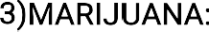 Cannabis/Hemp
(Growth retardation and malformations are reported after marijuana used during pregnancy)
RCP
Biological source: Cannabis sativa Family:Cannabaceae
Chemical constituents: Cannabidiol,Cannabigerol,Cannabinol Uses: produces hallucination effect
-Cannabis can be used to reduce nausea and vomiting during chemotherapy
-To improve appetite in people with HIV/AIDS
-To treat chronic pain muscle spams
: It is a natural alkaloid obtained from ergot fungus Biological source:Claviceps purpurea
Family:Clavicipitaceae
Uses: used to treat migraine and headache : Shatavari
Biological source: Asparagus Racemosus Family:Asparagaceae
Chemical constituents: It contains asparagine,resin ,tannin, flavonoids etc….
Uses: In the treatment of joint pain(Rheumatism), constipation,to prevent stones in kidney and bladder
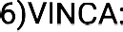 Sadabahar,sadaphuli

Biological source: Catharanthus Roseus Family: Apocynaceae
Chemical constituents:It contains vincristine, vinblastin,etc… Uses:It is used in therapy of cancer
Biological source:It constitutes dried ripe seeds of colchicum leutum Family:Liliaceae
Chemical constituents:Colchicine,Demecolcine,colchicoside,starch,gum,tannin etc….. Uses : In the treatment of gout and cancer
RCP

Natural Allergens


: Allergens are a type of antigen that produces an abnormally vigorous immune response. They are inciting agents of the allergy. That means they are the substances that are capable of sensitizing the body in such a way that an unusual response occurs, in hypersensitive person. It may be biological, chemical or synthetic origin. The substances such as pollens, danders, dust etc. are as natural allergens. They are protein and glycoprotein in nature. They are mainly of 5 types:
( : They are air borne substances that are chemicals which cause respiratory diseases, inflammation in nose, lungs etc. They are causes by pollen, dust mites, pets and moulds and results Hay fever, Asthma etc. Symptoms: Sneezing, lacrimation, coughing, itching eyes, nose etc.
RCP
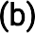 These are also known as food allergy. Allergens which are present in food staff and swallowed are termed as ingestants. A food allergy is an immune system that coexists with inhalant allergies. When the foods are digested and the nutrients are absorbed, substances in food stimulate allergic response. Foods induce respiratory symptoms by both reaginic and non-reaginic mechanisms. Most common food allergens ingested by patients are milk, egg, peanut, fish, soy, wheat etc. Symptoms: Skin rash, migraine, Bronchial asthma, GIT disturbance etc.
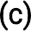 : They are injectable preparations and some insects. They cause allergy in hypersensitive person. Symptoms: Itching, peeling of skin, Erythema etc. The natural sources of injectable allergens are produced by the sting of bees, wasps, hornets etc.
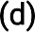 : Allergens produce manifestation of hypersensitivity at the site of skin or other mucous. Aeroallergens such as the various pollen grains containing oils trichomes from various leaves, flowers are carried by smoke originating from brush fires, grass fires are also cause for contact allergens. A number of plant products used as additives in cosmetic preparations are irritants and cause skin allergy. Wool fats in cosmetics, soap, soap powder, enzyme detergents, nail polishes, hair dyes are also major cause of contact dermatitis.
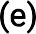 : Allergy caused by metabolic products of living microorganism in the human body. The continual presence of certain types of bacteria, molds, protozoas, in the human body being are responsible for chronic infection. Sometimes bacterial

metabolic wastes are considered to be infectant allergens.
:
These are the drugs that are pharmacologically inactive but when exposed to sun light are converted to their active metabolites to produce a beneficial reaction affecting the diseased tissue. They have property to fluorescence. On expose to visible light it absorbs a quantum of energy and the molecules became activated. This energy is transferred to another molecule such as amino acids, histamine, tryptophan, tyrosine which in turn become activated, subsequently decompose for further reaction. As per the reaction they are of three types:
RCP
- Photo allergy/reaction: It is an allergic reaction of the skin to UV light.
- Photophobia: It is the strong desire to avoid all light sources based on a painful sensitivity of the eyes to strong light.
- Phototoxicity: It is an irritation of the skin after exposure to UV light. Immediate reactions are included as itching, burning, swelling and rashes.
Photosensitizers are broadly classified as photodynamic and photosensitizing agents. Photodynamic agents require oxygen for their action. This group includes photodynamic dyes, hypericin, Bengal rose, quinine etc. These substances photo-oxidize terpenene, blood serum and causes haemolysis. They are topically inactive, but cause immediate photoreaction with intra dermal injection. Photosensitizing agents do not require oxygen for their reaction. They include furanocoumarins and their derivatives. These agents neither cause photooxidation of terpenene nor haemolysis. They combine with UV light and cause photoaging, skin cancers, allergic reaction etc. They are used for treatment of vitiligo in which melanin formation is less.
Photodynamic therapy is based on the discovery that certain chemicals can kill one celled in presence of light. It is a bio-component therapy method. This method is used for treatment of tumor diseases.


They are also known as mycotoxin. They are chemicals produced by fungi, molds under certain condition. They are essential for fungal growth and reproduction, but harmful for the human. There are more than 250 fungal toxins available. The diseases, that are caused by mycotoxins, are known as mycotoxicosis. The diseases, that are caused by molds, are known as mycosis.
- Aflatoxins: They are produced by Aspergillus flavus. There are five types of aflatoxins likely B1, B2, G1, G2 and M. Aflatoxins are extremely toxic and their target organ is liver. Aflatoxin B1 is 3 times more potent than G1. They are naturally occurring

hepatocarcinogens.
- Stearigmatocystins: These are produced by Aspergillus versicolor. They are also highly toxic in nature same as aflatoxin B1. It is considered as potent carcinogen, mutagen and teratogen. The toxic effect is located in kidney and liver.
- Ergotoxins: They are produced from fungal infection of Rye plant Claviceps purpurea. They produce alkaloids which cause ergotism in humans. They cause CNS and peripheral disorders and also cause hallucination. It also causes abortion in pregnant women.
RCP
- Ochratoxins: They are produced by Aspergillus ochraceus. Ochratoxin A has been associated with the disease known as Balkan nephropathy. They can form in cold temperature on cheese and cake. Ochratoxin B is non-toxic. The toxic effect is located
\in kidney followed by liver.

General introduction of carbohydrates


They are organic compounds found in the major part of fruits, vegetables, legumes and cereal grains. They carry out many functions in all living organisms. These are large biomolecules, consisting of carbon (C), hydrogen (H) and oxygen (O) in their basic structure.
Chemically, they are simple organic compounds that are aldehydes or ketones with many hydroxyl groups added on each carbon atom which are not part of either of these both functional groups. The basic formula is Cm(H2O)n where “m” is different from “n”. The hydrogen and oxygen ratio is 2 : 1, hence they are known as hydrates of carbon. So, carbohydrate is defined as polyhydroxy aldehydes or polyhydroxy ketones which give these on hydrolysis and contains at least one chiral carbon atom. Carbohydrates are produced in green plants by photosynthesis and serve as a major source of energy in animals. They also serve as structural components, such as cellulose in plants and chitin in some animals.
RCP

Carbohydrates are of three types namely simple sugar, polysaccharides and oligosaccharides. The simplest carbohydrates are the three-carbon sugars,
i.e. monosaccharides, and further cannot be hydrolysed to simple sugars.
Depending on the number of carbon atoms, monosaccharides are further classified into following:
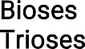
- are two-carbon compounds, but do not occur in free form in the nature.
- are three-carbon compounds. They are in the form of phosphoric esters. Example: Glyceraldehyde.
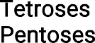
- are four-carbon compounds. Examples: Erythrose, Threose.
- are five-carbon compounds and occur in plants. They are the products of polysaccharides such as hemicelluloses, mucilage etc. Examples: Ribose, Arabinose, Xylose etc.
- are six-carbon molecules and are abundantly available. On hydrolysis they produce starch and inulin. Examples: Glucose, Fructose etc.

Monosaccharides are classified according to three different characteristics: the placement of carbonyl group, the number of carbon atoms they contain, and their chiral handedness. If the carbonyl group is an aldehyde, the monosaccharide is an aldose, and if the carbonyl group is a ketone, the monosaccharide is a ketose. Aldose or aldo sugar containing compounds are glucose, galactose, ribose etc., whereas ketose or keto sugar containing compound is fructose. Depending on the chemical nature of the sugar, they are also classified as reducing and non-reducing sugars.
- : Contain a hemiacetal or hemiketal group. Sugars include glucose, galactose, fructose, maltose, lactose.
RCP
-  : Hemiacetal groups are absent. Sucrose and all polysaccharides are present in this group. Heptoses contain seven carbon atoms and so on. Disaccharides are the compounds in which two monosaccharides are joined together and these are the simplest polysaccharides. Examples: Sucrose, lactose etc.
- Sucrose = Glucose and Fructose; Lactose = Galactose and Glucose; Maltose = Glucose and Glucose
- are oligosaccharides composed of three monosaccharides with two glycosidic bonds connecting in between them. Examples: Raffinose (Glucose
+ Fructose + Galactose).
- are polymeric carbohydrates that are composed of long or branched chains of monosaccharide units bounded together by glycosidic bonds. They are of two types viz. Structural polysaccharides and Digestible polysaccharides. Former one are digestible by herbivorous species — cellulose, lignin, dextrans, mannans, inulin, pentosans, pectic acids, algic acids, agar and chitin. Later one is starch.
-  are saccharide polymers containing a small number of simple sugars. Some examples are fructo-oligosaccharides (FOS), which are found in many vegetables.

- They are used for energy storage and production. Starch and glycogen, respectively in plants and animals, are stored as carbohydrates from which glucose can be mobilized for energy production.
- They exert a protein-saving action.
- The presence of carbohydrates is necessary for the normal lipid metabolism.
- Glucose is indispensable for the maintenance of the integrity of nervous tissue and red blood cells.

- Two sugars, ribose and deoxyribose, are part of the bearing structure, respectively of the RNA and DNA and present in the nucleotide structure.
- They take part in detoxifying processes. For example, at hepatic level glucuronic acid, synthesized from glucose, combines with endogenous substances, as hormones, bilirubin etc.
- Carbohydrates are also found linked to many proteins and lipids. Within cells they act as signals that determine the metabolic fate or intracellular localization of the molecules which are bound.
RCP
- Two homopolysaccharides, cellulose and chitin, serve as structural elements.
- The cellulose in plants is used to manufacture paper, wood for construction, and fabrics.

  - : Molisch reagent is mixed with a dilute solution of carbohydrate. The test reagent dehydrates pentoses to form furfural (top reaction) and dehydrates hexoses to form 5-hydroxymethyl furfural (bottom reaction). The furfurals further react with alpha-naphthol present in the test reagent to produce a purple product. Pentoses and hexoses form five-member oxygen containing rings on dehydration. This test is known as Molisch test and is used to detect carbohydrates in several substances.
  - : Fehling’s solution (containing Cu2+) changes colour from blue to red/brown in the presence of reducing sugars.
  - : This test is performed to identify the reducing sugars. Few ml of a sample solution is placed in a test tube. Two ml of Benedict’s reagent (a solution of sodium citrate and sodium carbonate mixed with a solution of copper sulfate) is added. The solution is then heated in a boiling water bath for three minutes. A reddish precipitate will form within three minutes.
  - : This test is performed to distinguish between mono and disaccharides. Barfoed’s reagent is copper acetate in acetic acid and is not as reactive as Benedict’s reagent. A positive reaction may only be a light red precipitate. Monosaccharides produce the red precipitate in 2 to 3 minutes; disaccharides produce the precipitate in 10 minutes.
  - Starch is a polysaccharide
that can be easily identified by the iodine test. Cellulose do not form colour complex with Iodine solution. Starch reacts with iodine solution and forms blue-violet color. Many glucose in starch trap iodine molecule and form the colour.
  - : Seliwanoff’s test is used to distinguish aldohexoses from ketohexoses. A ketohexose like fructose will form a deep red colour with Seliwanoff’s reagent (a solution of resorcinol in HCl), while an aldohexose will show a light pink colour and takes a longer time to develop the colour.

  - This test is used to distinguish pentoses and hexoses. Pentoses give a positive test with Bial’s reagent (contains orcinol, HCl and ferric chloride). In the presence of concentrated HCl, pentoses form a five-membered ring, known as furfural. A positive test is the formation of a bluish colour within 5 minutes without the formation of a precipitate. Hexoses generally react to form green, red, or brown products.
RCP

Acacia, Agar, Tragacanth, Honey : Gum acacia, Gum arabic ,indian gum .
India gum is the dried gummy exudation obtained from the stem and branches of Acacia arabic wild,belonging to family ( Leguminosae).
RCP
: The plant found in india , sri lanka, sudan , morocoo and africa. In india , it occurs in punjab, rajasthan and western ghats, About 85% of world supply of gum acacia is from sudan.
: It is a common member of dry monsoon forests of india.it is not cultivated on commercial scale.Gum is collected from wild grown plants, made free of bark and foregin organic matter , dried in sun .

colour – Tears are cream – brown to red in colour , while powder is light brown in colour.
Odour – odourless
taste – Bland and mucilaginous
size and shape – irregular brown tears of varying size .
EXTRA FEATURES : The tears are glossy and marked with minute fissures and are brittle in nature.
SOUBILITY : It is soluble in water , the watery solution is viscous and acidic . It is insoluble in alcohol .
STANDARD : it should contain not more than 15 % of moisture and 5 % of ash indian gum should not contain tannin , starch and dextrin .
: It consists principal of arabin, which is a complex mixture of calicum , magnesium and potassium salts of arabic acid . Arabic acid on hydrolysis gives L - arabinose , L – rhamnose , D – galactose and Dglucuronic acid . It also contains an enzyme oxidase and perioxdase.

- Solution of lead subacetate gelatinises the aqueous solution of indian gum.
- It does not produce a pink colour with the solution of rhuthenium red.
3 . On addition of solutions of hydrogen peroxide and benzidine in alcohol to aqueous solutin of gum , blue colour is produced due to oxidase enzyme.
RCP
SUBSTITUTES AND ADULTERANTS : B.P variety consists of gum obtained from acacia senegal wild , { Leguminosae }, a plant of african origin and grown in africa . The tears are rounded or ovoid and about 5-40 mm in diameter. Indian gum is adultered withgum ghatti , obtained from Anogeissus latifolia ( Combretaceae ) . Starch , tragacanth , dextrin and sterculia gum are the other adulterants of acacia.
: Acacia is demulcent . In the form of mucilage , it is used as suspending agent , specifically in mixtures with resinous substance.Acacia is a good emulsfying agent for fixed oils , volatile oils and also for liquid paraffin . It is a good binding agent and is used in the preparation of lozenges, pastills and compressed tablets.
: Acacia or powdered acacia should be stored in cool dry place in air tight containers.

Agar-Agar, Japanese- isinglass, Vegetable gelatin.

It is dried geltinous substance obtained from Gelidium amansi(Gelidaceae)and other species of red algae like (Glacilariceae) andPterocladia(Gelidaceae).

Agar is produced commercially in Japan, Australia,NewZealand,the USA,and India.In India,it is produced in the coastalregions of Bay of Bengal.
:
In Japan,the red-algae are grown on the bamboos spread in theocean.The collection of the material is done between may and October.The seaweeds are scarred from the bamboos,dried and shaken.This is necessary to bleach the product to some extent and even to remove and foreign material like shells,sand etc.The entire material is then

taken to high altitudes where it is washed and bleeched by exposing to sun.It is boiled for 5 to 6 hrs with large quantity of dilute acidified water .The extract is then strained while hot through the cloth and transferred to wooden troughs .On cooling ,jelly is produced .These rectangular solid pieces of jelly are then passed through the netting under pressure. Narrow strips ,thus formed ,are allowed to melt during the daytime in the sun, which removes the excess water .This operation is continued for several days to remove the excess of water .The manufacture of agar takes in winter and moisture is removed by successively freezing, thawing and drying at about 35°c.Japan is taking advantage of natural climatic conditions since centuries for the preparation of agar.
RCP

Colour - Depending upon the shape and the form it is yellowish-grey or white to nearly colourless .
Odour - Odourless . Taste - Mucilaginous
Shape - It is found in various forms like strips sheets flakes or coarse powder.
Size - Sheets are 45-60 cm long and 10-15 cm wide .Bands are about 4 cm wide while strips are 4 mm in width Strips are translucent, lustrous and slender while the flakes are greyish-white in colour.
:
Acid-insoluble ash - Not more than 1.0 percent Sulphated ash - Not more than 5.0 per cent Foreign organic matter - Not more than 1.0 per cent Loss on drying - Not more than 18.0 per cent
Starch - Negative with iodine solution

- ∙ Agar constists of Agarose and Agaropectin.
- ∙ Agarose is responsible for gel strength of agar and agaropectin is responsible for viscocity of agar.
- ∙ Agar consists of 3.5 % cellulose and 6% nitrogen.

- Boil about 1.5g agar with 100ml water .Cool the solution to room temperature .It forms a stiff jelly.
- When mounted in the solution of ruthenium red and examined under microscope .The mounted particles acquire pink colour .
- To 0.2 per cent solution of agar in water ,add solution of tannic acid ;no precipitate is produced.
RCP

Agar is used as emulsifying agent and bulk laxative .It is used in the precipitation of Jellies ,confectionary items and in microbiology .It is employed in preparation of bacteriological culture
Tragacanth gum is a natural plant-based gum that has been used for centuries due to its unique properties and various applications. It is obtained from the sap of certain species of the Astragalus plant, which is native to arid regions of the Middle East. We will be discussing the following topics:
  - Natural Source
  - Physical Properties
  - Uses
  - Medicinal Uses
  - Challenges
  - Alternatives

Tragacanth gum is harvested by making incisions in the stems and branches of the Astragalus plant, allowing the sap to ooze out and harden into flakes.
Tragacanth gum is known for its exceptional water-holding capacity, making it an excellent thickening and stabilizing agent. It can absorb many times its own weight in

water and form a gel-like substance.

    - Food Industry: Tragacanth gum is used in food products as a thickener, emulsifier, and stabilizer. It’s commonly found in salad dressings, ice cream, and confectionery.
    - Pharmaceuticals: It’s used to bind tablets, control drug release, and as a suspending agent in liquid medications.
RCP
    - Cosmetics: Tragacanth gum is used in cosmetics and personal care products, such as creams, lotions, and toothpaste, to improve texture and stability.
    - Traditional Medicine: It has been used in traditional herbal medicine for its soothing and demulcent properties.

Historically, tragacanth gum has been used to treat various ailments, including digestive issues and throat irritation.

Tragacanth gum can be difficult to dissolve in water, which can be a challenge in some applications. Sourcing and sustainability have become concerns due to overharvesting of the Astragalus plant.

In some applications, synthetic alternatives or other natural gums like xanthan gum or guar gum are used as substitutes.
: Madhu, honey purified, mel.
: Honey is a sugar secretion depoited in honey comb by Apis mellifera, Apis dorsata, of family Apidae.
Pale yellow color to yellowish brown and odour is pleasant. Taste is sweat and faintly acid.

:
- Aqueous solution of glucose 35%, fructose 45% and sucrose about 2%.

- Some amount of maltose gum, traces of succinic acid, acetic acid, dextrin, formic acid and traces of vitamins
- Invertase enzyme is present.
- Honey + fehlings A & B gives red ppt.
- Honey + molischs reagent + conc.H2So4 gives Purple color ring.
RCP
- Used as demulcent and sweetening agent.
- Good nutrients to infants and patients.
- Antiseptic and applied to burns and wounds.
- Used for oxymel and squill oxymel.
- Used in the preparation of creams, lotions, soft drinks and candies.
Invert sugar, sucrose and commercial glucose. Invert sugar is and adulterant of honey and it has furfural which is detected by Fiehe’s test.

Gelatin & casein
Protein was first described by the Dutch chemist Gerhardus Johannes Mulder and further named by the Swedish chemist Jons Jakob Berzelius in 1838. The term protein, derived from the Greek proteios, meaning first, are a class of organic compounds that are present in and vital to every living cell. Proteins are large biochemical compounds (carbon, hydrogen, oxygen, and nitrogen) consisting of one or more polypeptides (amino acid residue) typically folded into a globular or fibrous form in a biologically functional way. A polypeptide is a single linear polymer chain of amino acids bonded together by peptide bonds between the carboxyl and amino groups of adjacent amino acid residues
i.e. an amine group (NH2), a carboxylic acid group (R–C=O–OH) and a side-chain (usually denoted as R) (Fig. 5.16). They required for the structure, function, and regulation of the body’s cells, tissues, and organs. Examples: Hormones, enzymes
RCP
They are stored in the form of aleurone grains in plants and can be extracted easily. They are purified from other cellular components using a variety of techniques such as ultracentrifugation, precipitation, electrophoresis, and chromatography techniques.
:
  - The length of proteins and complexity vary based on the number and type of amino acid chains. There are about 20 different amino acids, each with a different chemical structure and characteristics; for instance, some are polar, others are non-polar. The final protein structure is dependent upon the composition of amino acids.

  - They consist of two polypeptide chains, a long chain which is on the left side, consisting of 346 amino acids and a short chain which is on the right side having 99 amino acids. The long chain is also known as heavy chain that contains 5 domains. In that 3 are extracellular domains (N1, C1 and C2) and a transmembrane domain where the polypeptide chain passes through the cell and a cytoplasmic domains (C-terminal) within the cytoplasm of the cell.
  - They are hydrolysed with acids or enzymes and break into amino acids.
  - They form colloidal solution in water.
  - Proteins are amphoteric in nature and get easily denatured due to heat, changes in pH,

reaction with organic solvents etc…

Various modern isolation techniques are used for the isolation of proteins that include cell disruption method, mechanical homogenization, solid-phase micro-extraction, supercritical-fluid extraction, pressurized-liquid extraction, microwave-assisted extraction, solid-phase extraction and surfactant-mediated techniques. Generally, protein is extracted with trichloroacetic acid (TCA) and acetone or by using phenol or by homogenization with buffer. Plant tissue is homogenized in 10% TCA containing 2% beta mercaptoethanol using liquid nitrogen. Further the solution is kept at –20°C for overnight to form the precipitate which is subjected to centrifugation at high r.p.m for 30-40 minutes at 4°C. The precipitate is washed with cold acetone.
RCP
  - Biuret Method: A violet-purplish colour is produced when cupric ions (Cu2+) interact with peptide bonds under alkaline conditions. The biuret reagent is mixed with a protein solution and then allowed to stand for 15-30 minutes and then the absorbance is taken at 540 nm.
  - Lowry Method: The lowry method combines the biuret reagent with another reagent i.e. Folin-Ciocalteau phenol reagent which reacts with tyrosine and tryptophan residues in proteins. This gives a bluish color which can be read somewhere between 500-750 nm. There is a small peak around 500 nm that can be used to determine high protein concentrations and a large peak around 750 nm that can be used to determine low protein concentrations.
  - Turbimetric Method: Protein molecules which are normally soluble in solution are precipitated by the addition of certain chemicals, e.g., trichloroacetic acid. Protein precipitation causes the solution to become turbid and the final concentration of protein is determined by measuring the degree of turbidity.
Some other methods are like Kjeldahl method, Dye binding method, UV spectroscopy method etc..
:
  - Biuret Reaction: Sample solution is mixed with 10% sodium hydroxide and 0.1% copper sulphate solution. The solution becomes violet or pink colour. Compounds with two or more peptide bonds give a violet colour with alkaline copper sulphate solution. Proteins in the alkaline environment reduce Cu2+ to Cu+, which forms a coordination complex with proteins, leading to a blue to light violet colour change.
  - Ninhydrin Test: Sample solution is mixed with 0.1% freshly prepared Ninhydrin solution

and then boiled to get violet or purple colour.
  - Xanthoproteic Reaction: Sample solution is mixed with few ml of concentrated nitric acid and boiled. Then 40% sodium hydroxide is added slowly. The yellow colour of solution turns to deep orange colour. The yellow colour is due to the nitro derivatives of the aromatic amino acids present in the protein. The sodium salts of nitro derivatives are orange in colour.
  - Sulphur Test: Sample solution is mixed with few ml of 40% NaOH and few drops of 2% lead acetate solution and then boiled. The solution forms black precipitate after cooling.
RCP
  - Sakaguchi Reaction: Sample solution is mixed with 0.02% alpha naphthol solution, 10% sodium hydroxide solution and few drops of alkaline hypobromide solution. The solution gives intense red colour.
GELATIN
: Collagen Hydrolysate, Denatured Collagen, Gelatina.
: Gelatin is mainly polypeptide with higher molecular weight protein obtained by boiling skin, tendons, ligaments, and/or bones with water. It is usually obtained from cattle bones, cattle hides and pork skins.
: Cattle: Bos taurus, Family: Bovinae Pork: Sus scrofa.
 Suidae
: Gelatin is prepared by hydrolysis of collage. Animal skins and bones are used as the raw materials. There are two main types of gelatin. Type-A gelatin which has isoionic point of 7-9. It is derived from collagen with exclusively acid pretreatment and it takes about 7-10 days. Whereas, Type-B gelatin has isoionic point of 4.8 to 5.2. It is prepared by an alkaline pretreatment of the collagen and it takes more time than former one. The bones are defatted and then decalcified with organic solvent and acid respectively to give a soft sponge like material called ossein. Calcium phosphate is produced as a byproduct. The ossein is soaked in lime pits for several weeks for hydrolysis and then treated with hot water at 85°C to get solubilized gelatin from collagen. The resultant weak solution of gelatin is concentrated in a series of evaporators and chilled to form gel. Gels are spread into metal trays and allowed to set into jelly and then removed by drying at 10°, 30° and 60°C for a month. They are further bleached in sulphur dioxide to produce light coloured gelatin, which is then dried at room temperature.
Physical Properties:
Appearance : Translucent, brittle when dried.

Colour : Colourless Odour : None Taste : Unpleasant
Solubility : Soluble in hot water, but forms gel when cooled. Insoluble in alcohol, ether Stability : Stable in air, but in moisture condition it is degraded.
RCP
Extra feature : In cold water it swells and softens
Strength : Determined by bloom strength (Bloom is a test to measure the strength of gelatin. The test was originally developed and patented in 1925 by O.T. Bloom. The test determines the weight in gm, needed by a probe with a diameter of 0.5 inch to deflect the surface of the gel 4 mm without breaking it. The result is expressed in Bloom. It is usually between 30 and 300 Bloom).
Relative density : 1.3 to 1.4 Isoionic point : 5-9
Foaming property : Efficient foam stabilizer pH (1%) : 5 Moisture : 16%
Gelatin contains 98-99% protein by dry weight. Gelatin is unusually high in the non-essential amino acids like glycine (26%), proline (16%), hydroxyproline (14%), glutamic acid, alanine, arginine, aspartic acid, lysine, serine, baline, etc.

- Aqueous sample solution + Tannic acid = White precipitation
- Aqueous sample solution + Picric acid = Yellow precipitation
- Aqueous sample solution + Millon’s reagent = White precipitation
- Aqueous sample solution + Soda lime → Ammonia gas evolves
Sterile Gelatin: They are of two types like absorbable gelatin sponge and absorbable gelatin film. Sterile gelatin sponges are sterile white products. They are absorbable and water-insoluble. They are prepared by warming gelatin solution to form foam and then dried and cut into small pieces. They are finally sterilized at 150°C, whereas absorbable

gelatin film is light amber coloured and transparent. They are insoluble in water.
It is used in face masks, shampoos and other cosmetics; as a thickener for fruit gelatins and puddings, in candies, marshmallows, cakes, ice cream, and yogurts. It is used in preparation of bacteriological culture media. It is also used on photographic films, in vitamins as a coating and as capsules shells. Medically it is used for weight loss, treating osteoarthritis, rheumatoid arthritis and brittle bones (osteoporosis).
Casein
RCP
Casein He's a principal phosphor protein in milk and constituent 3.0% milk. It comprises about 80% of the protein content of milk.There are two types of casein in the market.

  - : Warm skimmed milk is esterified with dilute acid, The way is separated, word is washed several times, dried and pulverised.
  - : Skimmed milk is treated with an enzyme, renate extract.product is separated, and purified.
It is white, slightly yellow, tasteless, odourless, amorphous solid, hydroscopic commerce table when dry, but dry how much can deteriorates rapidly when damp.
: It is insoluble in water, soluble in dilute alkalis, concentrated acids, but precipitates from dilute acid solutions. Chemistry of Casein: Casein is a phosphate protein containing about 0.85%. Phosphorus and 0.75% sulphur. It contains about 15 amino acids also rich in essential amino acids. Molecular weight 75,000 to 3,70,000, isoelectric point 4.7, nitrogen content 15 to 16%.

Loss on drying - Not more than 6.0% Sulphated ash - Not more than 1.5% Specific gravity - 1.25-1.31.

-It is useful dietary supplement source of protein in pre and post operative care, as a base in the standardization of proteolytic enzyme and as emulsifying agent.
-Industrially, it is used in sizing of textile and paper, as an adhesive, in preparation of casein plastic and casein paint.

proteolytic enzymes (Papain, bromelain, serratiopeptidase, urokinase, streptokinase, pepsin).

It is a mixture of proteolytic enzymes derived from the latex of unripe fruit of tropical melon tree,CARICA PAPAYA,belonging to CARICACEAE.
For processing of PAPAIN,the latex of these fruits is collected in aluminium trays.To the collected latex ,Potassium metabisulphate(5g/kg of latex) is added.The extreneous matter is cleared out by passing through sieves and latex is dried in the vaccum shelf drier at 55-60C.It is also processed by spray-drying method.Thia dried latex is called papain.
Papain is available as light brown or white coloured amaophous powder with typical odour and taste.It shows maximum proteolytic activity between PH-5to6. It is soluble in water and glycerine.
The different proteolytic enzymes present in papain are the mixyure of papin and chymopapain,proteolytic enzymes act on the polypeptides and amides.
- It decolourises aqurous potassium permanganate solutions.
- It causes curdling of milk(proteolytic activity)
RCP
It is used in clarification of beverages and as ameat tenderiser. It is empolyed in cheese manufracture as a substitute of reninin.It is also used for degumming of silk fabrics in textile industry and in lather industry for dehairing of skins and hides.
Medicinally,it is used as an anti-inflamatory agent. It has shown relieving

symptoms of episitomy.
One N.F unit of papain represents the activity which releases equivalent of 1ug of tyrosine from a standard casein substrate.
In 1995-1996 and 96-97,India has exported pure papain of Rs.132Lakhs and Rs.143 lakhs respectively.
RCP

Bromelain is a mixture of proteolytic enzymes from the stem and ripen fruits of pineapple plant Ananas comosus,belonging to the family Bromeliaceae.
It is available as odourless to slightly putrid buff coloured powder with irritating taste.
It has slight solubility in water. It is insoluble in organic solvents like ether,choloroform,alcohol etc.
It is used in treatment of soft tissue inflammation and oedema due to surgery and injury.
It is a proteolytic enzyme derived from the bacteria belonging to genus Serratia, present in the gut of the silkworm. Originally, it was discovered in serretia E15 species. Now- a-days,it is produced by fermentation bio-technology.
Serratiopeptidase is considered as very effective bacterial enzyme and it is found to have better effects than trpsin and chymotrypsin,with negligible toxcity and side-effects.
Given orally,it enters systemic circulation in unchanged form and can pentrate into all tissues,especially inflammed areas.It exerts histamin and bradykinin hydrolysing and proteolytic effects. Hence ,it reduces capillary permeability and also breaks down proteins and excudates and hence,supports wound healing.Unlike,chymotrypsin, serratiopeptidase, being a bacterial enzyme, shows rarely the allergic reactions.
Serratiopeptidase has a number of therapeutic applications, like (a) resolution of

inflammation,(b) sputum liquification due to lysis of various proteins in sputum and hence lowering viscosity,(c) enhancement of antibiotic effects due to removal of inflammatory barrier and hence,increasing antibiotic tranfer to infected areas.

It is an enzyme produced by kidney and obtained from human urine or kidney tissue cultures.
It is a lyophilised white powder, soluble in water. It is an activator of endogenous fibrinolytic system, which converts plasminogen to plasmin and degrades fibrinogen,fibrin clots and other plasma proteins.
RCP
It is used to dissolve (lyse)fibrin or blood clots in anterior chamber of eye and in acute massive pulmonary emboli. As it is derived from human source ,it is less antigenic than enzymeswith similar actions like streptokinase.
It is an enzyme obtained from culture filterates of beta-hemolytic. Streptococci group C. The enzyme has the property of activating human plasminogen to plasmin.
It is available as asterile,friable solid or white powder. It is soluble in water with maximum activity at PH-7.The solution at higher concentrations is stable for 6 hrs at 4C, otherwise the solutions are unstable. It is used in the treatment of thromboembolic disorders for the lysis of pulmonary emboli, arterial thrombus,deep vein thrombus and acute coronary artery thrombosis. The activity of this enzyme is due to activation of plasminogen to a proteolytic enzyme,viz. plasmin which degrades fibrin clots,fibrinogen and other plasma proteins.

It is a substance containing proteolytic enzyme and is present in the gastric juice of animals. It is obtained from the glandular layer(mucous membranes) of fresh stomach of hog,Sus scorfa vardomesticus, belonging to family suidae.
Pepsin is light buff or white coloured amorphous powder. It also occurs as translucent sacles.It has a little acidic or saline taste with slightly meaty odour. It is soluble in water,but insoluble in alcohol, ether and chloroform. If pepsin is heated with alkali or pancreatic enzymes ,its biological activity is lost . it shows maximum activity at PH 1.8 . pepsin has the capcity to digest 2500times its weight coagulated egg albumin. It is also available in other forms which may digest even upto 10,000 times their weight of coagulated egg albumin.

For prepartion , the minced stomach linings are digested with hydrochloric acid followed by clarification , controlled evaporation, dialysis and concentration of the digested solution. When processed , solution is subjected carefully to vaccum evaporation, spongy pepsin is obtained.
Pepsin degrades proteins into peptones and proteoses.
RCP

RCP

Lipids (Waxes, fats, fixed oils): Castor oil, Chaulmoogra oil, Wool Fat, Bees Wax

Lipids are the structural and functional building blocks of the living cells and they are made up of hydrocarbons with highly reduced form of carbon. Chemically they are heterogenous group of compounds related to fatty acids. Examples: Fats, oils, waxes etc.
: Lipids are a wide-ranging group of organic compounds found in all living organisms, including humans, plants and other animals. Lipids exist in tissues in many different physical forms. The simple lipids are often part of large aggregates in storage tissues, such as oil bodies or adipose tissue. Membranes are constituted with complex lipids and occur in a close association with such compounds as proteins and polysaccharides. In plants, lipids are stored in the form of triglycerides. The most known of these is jojoba, which stores its seed lipid as a liquid wax. Storage lipids are accumulated in one or both of the main types of seed tissue and endosperm. In oilseeds such as sunflower, linseed or rapeseed, the cotyledons of the embryo are the major sites of lipid accumulation. The endosperm of castor bean, coriander or carrot, is the main site of lipid accumulation. In tobacco, both embryo and endosperm tissues store lipids. Phospholipids are another class of lipids which are found in animal and plant cell membranes.

- They are hydrophobic or amphiphilic compounds.
- They are insoluble in water, but soluble in organic solvents like chloroform.
- When metabolized, lipids are oxidized to release large amounts of energy and thus are useful to living organisms.
- Lipids are organic compounds formed mainly from alcohol and fatty acids combined together by ester linkage.
- They are hydrophobic small molecules consisting of two biochemical subunits like keto acyl (Polyketides) and isoprene (C5H8) (Sterol lipids and Prenol lipids).
- Triglycerides are the most commonly occurring class of lipids.

- Triglycerides have a glycerol backbone bonded to three fatty acids.
- Phospholipids also contain glycerol and fatty acids, plus phosphoric acid and a lowmolecular-weight alcohol.
- Common phospholipids include lecithins and cephalins.
- The tail of fatty acid is a long hydrocarbon chain, which is hydrophobic, and the head of the molecule is a carboxyl group, which is hydrophilic in nature.
RCP

- Lipids are important sources of metabolic energy (ATP). They are the most energy rich of all classes of nutrients.
- They form the structural components of cell membranes and form various messengers and signalling molecules within the body.
- Lipids serve as biological carriers for the absorption of fat-soluble vitamins A, D, E and K.
- Lipids are a source of essential fatty acids, which are required for optimal lipid transport and are precursors of the prostaglandin hormones.
- Lipids function as a mechanical support for the vital body organs.
- Lipids are a source of essential steroids, which in turn perform a wide range of important biological functions.
- Lipids also act as lubricants for the passage of feed through pellet diet.
- Lipids are applied in the cosmetic and nanotechnology.
Classification of Lipids:
Lipids are broadly classified into three group that is listed in below flow chart:

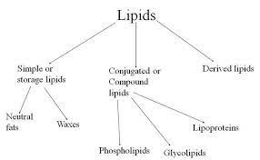

Ricinus oil, Oleum ricin
RCP

  - Castor oil is a fixed oil obtained by cold expression of the seeds of Ricinus Communis family Euphorbiaceae.

  - Castor seeds are produced in all tropical and subtropical countries. • Brazil, U.S.S.R., Thailand, U.S.A. Romania, India.

  - Colour : Pale yellow or colourless liquid.
  - Odour : Slight and characteristic
  - Taste : Bland then slightly acrid & nauseating
  - It is viscous and transparent liquid
  - It is soluble in alcohol. Insoluble in mineral oil. Miscible in chloroform, solvent ether, glacial acetic acid and petroleum ether.

  - Castor oil contains triglyceride of Ricinoleic acid 80%.
  - The viscosity of castor oil is due to Ricinoleic acid.
  - Other glycerides are Isoricinoleic, linoleic, stearic and Isostearic acid.
  - It contains Heptaldehyde. Undecenoic acid & Sebacic acid.
  - Ricinoleic acid : CH3 (CH2)6 CHOHCH2 CH = CH (CH2)7 copy.
RCP

- Castor oil is obtained from castor seeds. The oil is obtained from by two ways; either after the removal of the seed coat or with the seed coat.
- Seed coats are removed by crushing the seeds under the grooved rollers and then they are subjected to a current of air to blow the testas.
- the kernels are fed in oil expellers and at room temperature they are expressed with 1 to 2 tons pressure per square inch till about 30% oil is obtained.
- The oil is filtered, steamed 80-1000 c to facilitate the coagulation and precipitation of poisonous principles ricin, proteins and enzyme lipase present in it.
- Oil is then filtered and this oil with 1% acidity is used for medical purpose.

  - Castor oil is cathartic.
  - It is used as lubricant, in paints, enamel, varnish, grease, polish, printing ink, hydraulic and brake spirit, aromatic castor oil, or in thenform of capsules, abortifacient paste, Ricinoleic acid is used in creams, jellies, lip sticks, perfumed hair oil, soap etc. Purgative.
  - Castor seeds cake is used as manure, enzyme lipase etc..

- Gynocordia oil, Hydynocarpus oil.

- Chaulmoogra oil is fixed oil obtained by cold Expression method from ripe seeds of TARAKTOGENOS KURZII KING, HYDNOCARPUS ANTHELMINTIC P.,
H. HETEROPHYLLA K, H. WIGHTIANA, H. LAURIFOLIA, FAMILY FLACOURTRIACEAE.
RCP

- Chaulmoogra plants found in Myanmar,

- Colour : yellow to brownish (liquid yellow)
- Odour : characteristic
- Taste : some what acrid
- Solubility : Slightly soluble in alcohol, soluble in chloroform, ether, benzene, carbon disulphide.
- Storage : light and in cool place.
- Dose : 0.3 to 1.0 ml by intramuscular subcutaneous injection.

Seeds are decorticated by Machine after grading the kernels are pressed with the hydraulic press and the oil obtained is filtered.

- It contains Easter of unsaturated fatty acid of chaulmoogra acid 27% and Hydnocarpic acid 48% and glycerides of Palmitic acid.
USES :
- It Gives strong bactericidal effect against Mycobacterium leprae and m.Tuberculosis.
- It is useful in the treatment of T.B., leprosy, psoriasis, and rheumatism. ✓ It is used

externally only.

- The Hydynocarpus oil is replaced by ethyl esters and salts of Hydnocarpic and chaulmoogra acid
: Lanolin, purified wool fat.
: It is a yellow waxy substance secreted by the sebaceous glands of wool bearing animals like sheeps, Ovis aries.
RCP

: Bovidae.

: Commercially it is prepared in New Zealand, Australia, USA and
India.
: Sheep’s wool contains about 45% of a fat known as suint, which
must be removed. Crude lanolin is separated by washing with sulphuric acid and then purified and bleached. The product is known as anhydrous lanolin or wool fat. Further the hydrous wool fat is produced by intimately mixing wool fat with 30% of water.

Colour : Whitish yellow Odour : Characteristic Taste : Bland
Solubility : Insoluble in water but forms turbidity with ether and chloroform
Melting-point : 40° to 44.4°C Saponification value : 92 - 106
Iodine value : 18 - 35 Acid value : Less than 1
: Wool fat contains the alcohols, cholesterol and isocholesterol,

together with various esters. Hydrous wool fat also contains the acids in combination with lanoceric, lanopalmitic, carnaubic, myristic, oleic, cerotic and palmitic acids. It contains 50% of water.

- 1 g of wool fat is boiled with 20 ml of alcohol and the solution is filtered and cooled, the filtrate should not be rendered turbid by the addition of a 5% alcoholic solution of silver nitrate. This indicates the absence of chlorides.
RCP
- 1 g of the fat is dissolved in 3 or 4 ml of acetic anhydride and few drops of sulphuric acid are added. An initial pink colour changes to green and then finally blue. This indicates the presence of cholesterol.
- When a 2% solution in chloroform is gently poured over the surface of concentrated sulphuric acid, it gradually develops a purple-red colouration at the junction of the liquids.
- 10 g of wool fat is heated with 50 ml of water on a water-bath. The aqueous layer on filtration should not yield glycerin on evaporation, and when boiled with potassium hydroxide should not evolve the odour of ammonia. This indicates the absence of nitrogenous organic matter.
: It is used as a moisturizer to treat dry, rough, scaly, itchy skin and in minor skin irritations. It is mainly used as water absorbable ointment base. Lanolin is often used as a raw material for producing cholecalciferol using irradiation (vitamin D).

Apis mellifera.
: Apidae.
: Yellow beeswax, Cera-flava.
: It is a purified wax obtained from the honey comb of the bee species,

: Two wax extraction methods are generally used — melting and

chemical extraction. Melting is the most frequently used procedure. Wax can be melted by boiling water, by steam, or by electrical or solar power. Chemical extraction by solvents is feasible only in a laboratory, where small scale wax production is needed. Good wax solvents are gasoline and xylene. The disadvantage of this method is that all organic wax contaminants and constituents of the pupae, propolis and pollen are dissolved. Thus the quality of wax is impaired. The combs of honey comb are broken and boiled in soft water and is kept for some time in water by enclosing in porous bag. After some time the wax oozes out from the bag and forms a cake which is collected

after cooling. The foreign matters from debris are removed by scraping. The beeswax is purified by treating with dilute sulphuric acid or in hot water and thereafter bleaching of wax is carried out by treatment with hydrogen peroxide or chromic acid to get white bees wax. Soft water is used because during the manufacturing of wax, there is often the formation of water emulsions. There are two emulsion types: in the first one, water particles are dispersed into wax, and in the second one, wax particles are dispersed into water. These emulsions are built with the help of emulsifiers. Proteins and dextrines are emulsifiers, contained in honey, pollen and salts of wax fatty acids with sodium and potassium. The second type of emulsion is caused by the salts of wax fatty acids with calcium, copper and iron cations. Hard water contains cations that are diffused out of the vessels and used for wax production.
RCP
: Beeswax consists primarily of a mixture of esters of fatty acids and fatty alcohols, paraffinic hydrocarbons and free fatty acids. Two types of beeswax are marketed — yellow beeswax and white beeswax. Yellow beeswax is light-brown solid, brittle in nature when cold and presents a characteristic odour of honey. White beeswax is a white or yellowish white solid having a characteristic, but faint, odour of honey. Yellow beeswax is smooth and soft to touch but breaks with granular fracture. It is insoluble in water, but soluble in hot alcohol and other organic solvents. In hot water it melts in liquid form and can be made any required shape and design after cooling. They are partially soluble in cold carbon disulfide and completely soluble in the same solution at temperatures of 30° and above. Beeswax has a specific gravity of about 0.95.
Melting range : 60 - 65°C Acid value : 17 - 24
Peroxide value : Not more than 5 Saponification value : 87 - 104
Ester value : 72 - 79
The composition of beeswax depends to some extent on the subspecies of the bees, the age of the wax and the climatic circumstances of its production, and hence the physical properties are also varied.
:
Beeswax consists of five main groups of components:
- Free fatty acids, most of them are saturated and have chain length of C24- C32.
- Free primary fatty alcohols with a chain length of C28- C38.

- Linear wax monoesters and hydroxymonoesters (35-45%) with chain lengths generally C40-C48. The esters are derived almost exclusively from palmitic acid, 15-hydroxypalmitic acid and oleic acid.
- Complex wax esters (15-27%) containing 15-hydroxypalmitic acid or diols, which, through their hydroxyl group, are linked to another fatty-acid molecule.
- In addition to such diesters, tri and higher esters are also found. The main constituents of beeswax are myricin (80%), cerotic acid, melissic acid and 15% hydrocarbons.
RCP
: Beeswax is used as a component in dietary food supplements (soft gelatin capsules and tablets), glazings and coatings, chewing gum, water-based flavoured drinks, and as a carrier for food additives (including flavours and colours) and cosmetics (Lipsticks, face creams). Beeswax is suitable stabilizer for keeping oil-based capsule contents in suspension as well as in tablet formulations. Beeswax is blended with other oils and is used as a glazing agent for confectionery (including chocolate), in small products of fine bakery ware coated with chocolate, in snacks, nuts, coffee beans, dietary food supplements and in certain fresh fruits.
: Beeswax is adulterated with paraffin, microcrystalline wax, Jan wax, carnauba wax, tallow and stearic acid. They are identified by saponification values and as well as solubility and melting point which is about 10-20°C lower than other waxes. Beeswax will not give turbidity when boiled with sodium hydroxide and cooled, but other waxes will form turbidity.

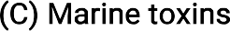

Novel medicinal agents from marine sources.
  - The drugs which are obtained from marine organisms are known as marine drugs.
  - Marine Pharmacognosy is a sub-branch of Pharmacognosy, which is mainly concerned with the naturally occurring substances of medicinal value from marine.
RCP
  - These marine drugs are used since ancient times. Chines and Japanese are very famous to use these resources and interstingly, innumarable products derived from the marine organisms in several 'crude forms' have been widely used across the globe by the traditional practitioners for thousands of years.
  - Several show pharmacological activities and are effective against cancer, AIDS, arthritis etc
  - The quantum of newer and potent drug molecule derived from the wide spectrum of marine organism across the world may be judiciously and logically classified their specific as stated below



The two prominent US-based research institute, namely: 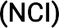 and 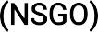 have discovered
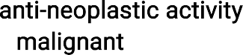
thousands of pure and semi- pure compounds derived from the marine origin that distinctly exhibited in a good number of cell line; besides, in vivo actions against both tumors and in various animal models.
: It is the member of cembronoids which are cyclic diterpenes. Biological source: It is obtained from the CARIBBEAN GORGONIAN (Pseudoplexauraporosa) family: Plexauridae
RCP
Crassin acetate was observed to be extremely cytotoxic to human leukemic cells in vitro and also to the mouse fibroblasts.

2.
The cardiovascular active drugs may be broadly classified under the following two categories, namely:

Biological source: Laminin is obtained from a marine algae family: Laminariaceae
: It shows hypotensive effect.

: It is a powerful hypotensive compound. it also shows strong vasodilator effects
: Eldoisin is obtained from the posterior salivary glands of eledone spp.[small octopus]
:
- It is found to extra vascular smooth muscle.
- acts as a and  agent.
- It also stimulate secretion.

- It causes , and enhances  permeability in certain specific species.

A host of marine toxins have been obtained from a wide variety of marine organisms in their crude, semi-pure and other forms between 1960-1970.
: It is frequently abbreviated as TTX, it is a potent
RCP

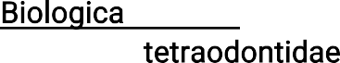
Tetrodotoxin is obtained from the and of a large number of ; especially the Spheroidsrubripes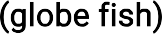 it is also obtained from the (tetradou species) which begin a top most delicacy in japanese cuisine

:
: Brevetoxins are commonly known as from the generic nomenclature that is toxins obtained from shell fish toxin.
:
It exerts an excitatory effect on the isolated neuromuscular and other cells . It causes both neurological and gastrointestinal disorder



Antimicrobial drugs substances have been isolated, characterized and studied extensively over the past three decades particularly from the vast domain of marine organism.
A few examples are, brown and red algae.

: zonarol and iso- zonarol are both obtained from dictyopteriszonaroides (brown algae).
USES: Zonarol is used as anti inflammatory.
fanceu: it is obtained fromL r i lformis, the two different species

of algae.
RCP

A plethora of chemical substance have been isolated from the broad spectrum of marine organisms which attribute either anti-inflammatory or antispasmodic activities.
Tetradotoxin is obtained from liver and ovaries of puffer fish.
- It is used as
- It has  effect
- it acts as

A good number of pharmacologically active substance have been isolated and characterized from marine organisms that invariably exhibit a variety of interesting actions.
A few imported and typical example have been grouped together under this section .

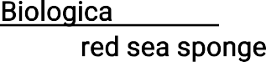
latruncullins are obtained from
keller ( ).
They are exclusively in establishing of molecular mechanism of motile.
RCP
It is obtained from Chondria armata okamura (rhodomelaceace) (red algae) also known as japanese as DOMOI and hence the name domoic acid.

Domoic acid is a that inhibits neurochemical processes, causing short-term memory loss, brain damage, and, in severe cases, death in humans. In marine mammals, domoic acid typically causes seizures and tremors.

Long answer questions (10 MARKS)
- Give a brief account of teratogens and natural allergens
- Write about primary metabolites
- Write about acacia and tragacanth
Short answer questions (5 MARKS)

- What are carbohydrates . Write a note on honey
- Write a note on proteolytic enzymes
- What are lipids. Write a note on castor oil and bees wax
Very short answer questions (2MARKS)
- Write the biological source, chemical constituents , and uses of gelatin
- Write the biological source and uses of chaulmoogra oil
- Write about marine sources with examples

RCP

