HUMAN ANATOMY AND PHYSIOLOGY-I_ BP101T

UNIT : 1( Tissue level of organization)
CLASS:9

TOPIC: Classification of tissues, structure, location and functions of epithelial, muscular tissue.
Tissue is a group of cells which have similar structure and perform relatively one or more common functions.
There are four basic tissue types defined by their morphology and function: epithelial tissue, connective tissue, muscle tissue, and nervous tissue.
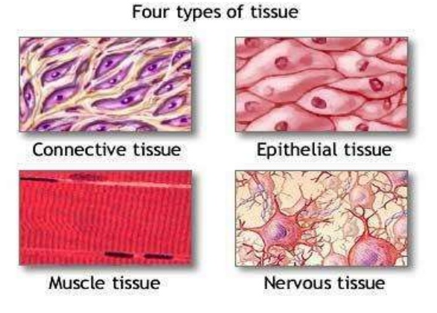
Epithelial tissue: is made up of epithelial cells, which are vastly different from the muscle cells we just talked about. These cells can be flat, cuboidal, or columnar. They are joined tightly together, making a single or stacked continuous sheet. Like a quilt that is tightly stitched, epithelium makes an excellent protective cover for the body, in the form of skin. Epithelial tissue can also be found lining some internal cavities and organs.
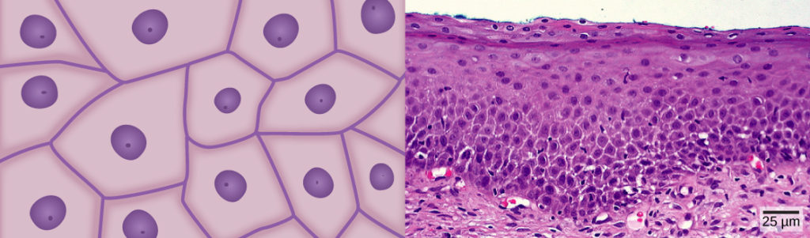
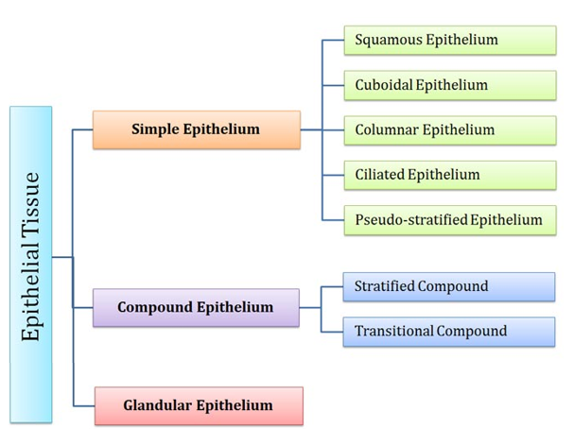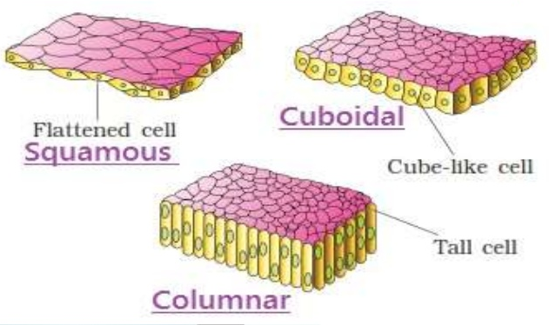
Functions of Epithelial Tissue
Epithelial tissue covers body surfaces, lines cavities, and forms glands. Its functions are diverse and depend on location.
1. Protection
- Protects underlying tissues from injury, microbes, and dehydration
- Example: skin epithelium
2. Absorption
- Absorbs nutrients and substances
- Example: intestinal lining absorbs digested food
3. Secretion
- Produces and releases substances like:
  - Enzymes
  - Hormones
  - Mucus
- Example: glandular epithelium
4. Excretion
- Eliminates waste products
- Example: epithelium of kidneys removes waste in urine
5. Filtration
- Filters substances (especially in kidneys)
- Example: filtration in renal corpuscles

6. Diffusion
- Allows exchange of gases and substances
- Example: alveoli of lungs (oxygen and carbon dioxide exchange)
7. Sensory Reception
- Contains sensory receptors to detect stimuli
- Example: epithelium in nose, tongue, and skin

Muscular Tissue
Definition
Muscular tissue is a specialized tissue responsible for movement of the body and its parts by contraction and relaxation of muscle fibers.
Properties of Muscular Tissue
- Excitability – responds to stimuli
- Contractility – ability to contract
- Extensibility – can stretch
- Elasticity – returns to original shape
Types of Muscular Tissue
1. Skeletal Muscle (Striated Muscle)
- Attached to bones
- Voluntary (under conscious control)
- Long, cylindrical, multinucleated fibers
- Shows striations (striped appearance)
Functions
- Movement of body
- Posture maintenance
- Heat production

2. Smooth Muscle (Non-striated Muscle)
- Present in walls of internal organs (intestine, blood vessels, uterus)
- Involuntary
- Spindle-shaped cells
- No striations
Functions
- Movement of substances (e.g., food in intestine)
- Regulation of blood vessel diameter

3. Cardiac Muscle
- Found only in the heart
- Involuntary
- Branched fibers with intercalated discs
- Striated
Functions
- Pumps blood throughout the body

