HUMAN ANATOMY AND PHYSIOLOGY-I_ BP101T

UNIT : 2 ( Joints)
CLASS: 8

TOPIC: Structural and functional classification of joints
Introduction to Joints
A joint (also called an articulation) is the place where two or more bones meet. Joints are essential for movement, flexibility, and stability of the body.
Definition
A joint is a structure that connects bones together and allows varying degrees of movement.
Functions of Joints
- Movement: Enable body movements like walking, bending, and rotation
- Stability: Hold bones together and maintain posture
- Flexibility: Allow different ranges of motion
- Support: Help in weight bearing (especially in lower limbs)
Basic Components of a Joint
- Bones – form the joint
- Cartilage – reduces friction and absorbs shock
- Ligaments – connect bone to bone
- Synovial fluid (in movable joints) – lubricates the joint
Types of Joints (Basic Classification)
- Fibrous Joints
- Fibrous joint lacks joint cavity.
- Two bones are joined together by fibrous connective tissue.
- Fibrous joints are joined together tightly so they are generally immobile in adults although some allows slight movement.
Types of fibrous joints
- Suture:
- Syndesmosis
- Gomphosis
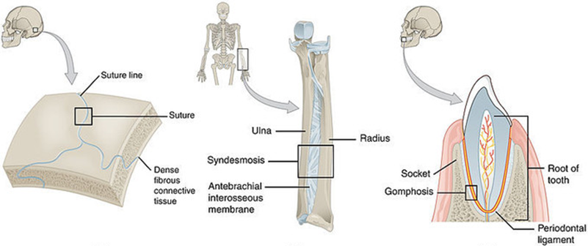
2. Cartilaginous Joints
- In cartilaginous joints, bones are united together by a plate of hyaline cartilage.
- Cartilaginous joints lack joint cavity
- They are slightly movable or immobile
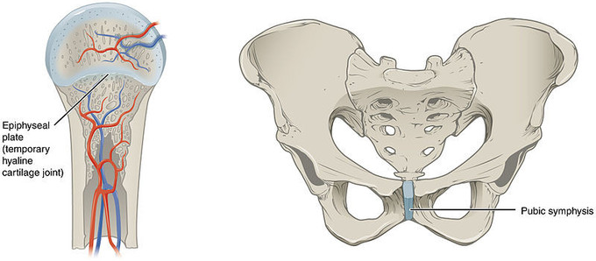
- Synovial Joint
- Most of the permanent joints of body is synovial joint
- All of the synovial joints allow greatest range of movement.
- Movement is possible because, the end of bone at articulation is covered with smooth hyaline cartilage and joint is lubricated by thick fluid called synovial fluid.
- The joint is covered by flexible articular capsule

Types of synovial joints;
- Hinge joint
- Pivot joint
- Condyloid joint
- Gliding joint
- Saddle joint
- Ball and Socket joint

