HUMAN ANATOMY AND PHYSIOLOGY-I_ BP101T

UNIT : 1( Cellular level of organization)
CLASS:7

TOPIC: General principles of cell communication, intracellular signaling pathway activation by extracellular signal molecule
Cell communication (cell signaling) is the process by which cells detect, interpret, and respond to signals from their internal or external environment to coordinate physiological functions.
General Principles
- Signals act through specific receptors
- Only target cells with the correct receptor respond
Example: Insulin acts only on insulin-receptor–bearing cells
Types of Signaling
- Autocrine – cell signals itself
- Paracrine – signals nearby cells
- Endocrine – hormones act at distant sites
- Juxtacrine (contact-dependent) – direct cell-to-cell contact
- Synaptic – neurotransmitter signaling

Autocrine Signaling
'Auto' means 'self' and 'crine' means 'to secrete'. Thus, 'autocrine' means 'secrete to itself' Thus, in this type of signaling, the molecules (receptor molecules) are secreted from the cell and act on the same cell. In other words, some cells respond to signaling molecules that they themselves produce.
For example, the cytokine, Interleukin-1 (IL-1) in monocytes. The interelukin is produced in monocytes response to some external stimuli and it binds to receptor present on the surface of its own cell.
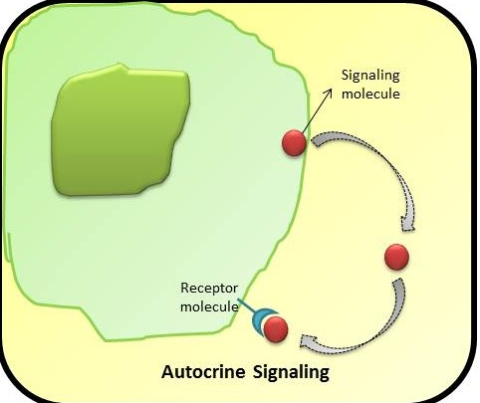
Paracrine Signaling
'Para' means 'nearby' and 'crine' means ' to secrete'. Thus, 'paracrine' word means 'secretion nearby'. Thus, in this type of signaling, the molecules (signaling molecule) released by one cell acts on or bind to the receptor on the nearby neighbouring cell. A very common example of paracrine signaling is the neurotrasmitters. These are present at the synapse or junction of neuron cells and help in transmitting the signals. So, neurotransmitters are released by one neuron cell and they act on nearby neuron cell to transmit the signal.i.e-Transfer of information from one cell to another, via passive diffusion or bulk flow in intercellular fluid.
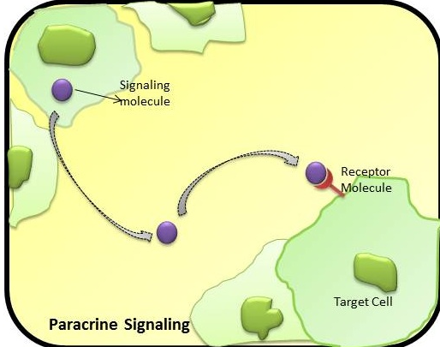
Endocrine Signaling
The word “endocrine” originates from two words, 'endo' and 'crine'. The former word means 'within' and the suffix 'crine' means 'to secrete' or 'separate' Thus, the word endocrine means ‘secrete from within’. In this type of signaling, the signaling molecules are secreted from within the endocrine glands; they travel through the circulation system and act on/ bind to receptor molecules on the target cell (as can be seen in the above figure). The signaling molecules in this type of signaling are ‘hormones'. An example of endocrine signaling: The hormone, insulin, is secreted by pancreas which then travel through the circulatory system which has an effect of stimulating muscle cell or adipose cells.
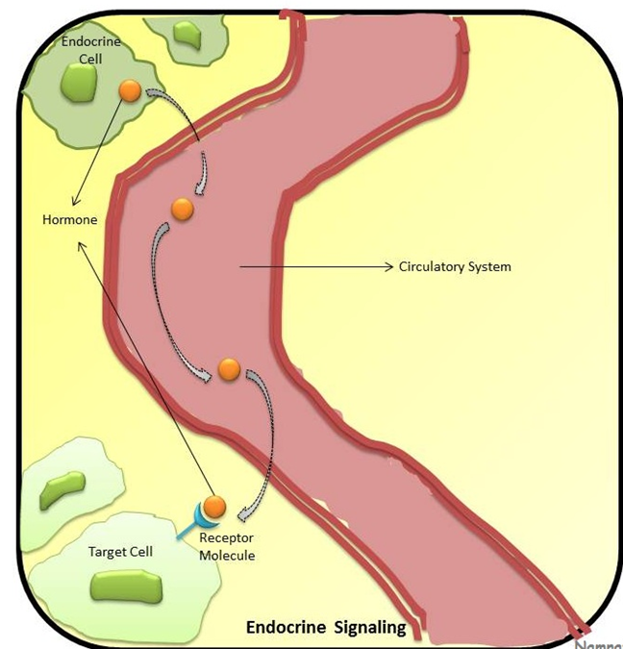
Cell-Cell Signaling or Contact-dependent
Cell signaling can take place by direct cell-to-cell interaction (as can be seen in the adjacent figure) where, on the surface of one cell, is the signaling molecule that binds directly to receptor, which is present on the surface of the other cell. The cell signaling/ cell-cell communication can also take place by the action of various signaling molecules. As already mentioned above, various cell receptors are present on the target cells which bind to signaling molecules.
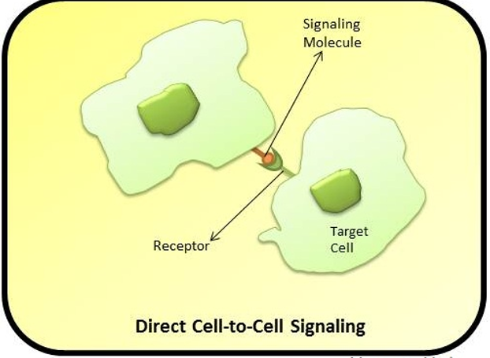

Synaptic signaling
Synaptic signaling is a form of cell communication in which a neuron transmits a signal to another neuron or effector cell through the release of neurotransmitters across a synaptic cleft.
Electrical impulse travels along the neuron
Neurotransmitters are released from presynaptic terminal
They diffuse across the synaptic cleft
Bind to specific receptors on the postsynaptic cell
Produce a rapid and specific response
Examples: Acetylcholine, dopamine, serotonin, noradrenaline
