HUMAN ANATOMY AND PHYSIOLOGY-I_ BP101T

UNIT : 1( Cellular level of organization)
CLASS:6

TOPIC: Cell division, cell junctions
Cell Division
Cell division is the process by which a parent cell divides to form new daughter cells. It is essential for growth, development, repair, regeneration, and reproduction in living organisms.
Types of Cell Division: Mitosis & Meiosis
- Mitosis (Equational Division):Occurs in somatic (body) cells.
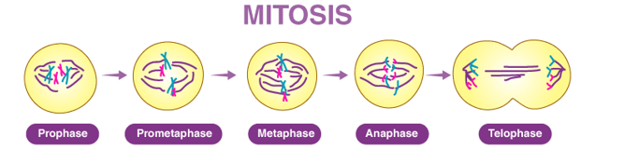
Functions
- Growth of multicellular organisms
- Replacement of damaged or dead cells
- Wound healing
- Asexual reproduction
Stages of Mitosis
- Prophase
  - Chromatin condenses into chromosomes
  - Nuclear membrane disappears
  - Spindle fibers form
- Metaphase
  - Chromosomes align at the equatorial plate
  - Spindle fibers attach to centromeres

- Anaphase
  - Sister chromatids separate
  - Move toward opposite poles
- Telophase
Chromosomes decondense
Nuclear membrane reforms
2. Meiosis: Meiosis has two stages
Meiosis I (Reduction Division)
Functions: Formation of gametes (sperm and ova), Genetic variation, Maintains chromosome number across generations
1. Prophase I: of meiosis is the longest phase during which homologous chromosomes pair, crossing over occurs, and genetic recombination takes place.
2. Metaphase I
Bivalents align at the equatorial plate
Spindle fibers attach to centromeres
Orientation is random → genetic variation
3. Anaphase I
Homologous chromosomes separate
Centromeres do not divide
Each chromosome still has two chromatids
4. Telophase I
Chromosomes reach opposite poles
Nuclear membrane may reform
Followed by Cytokinesis
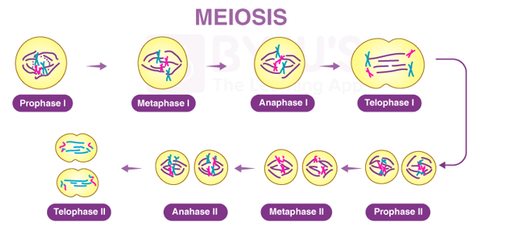
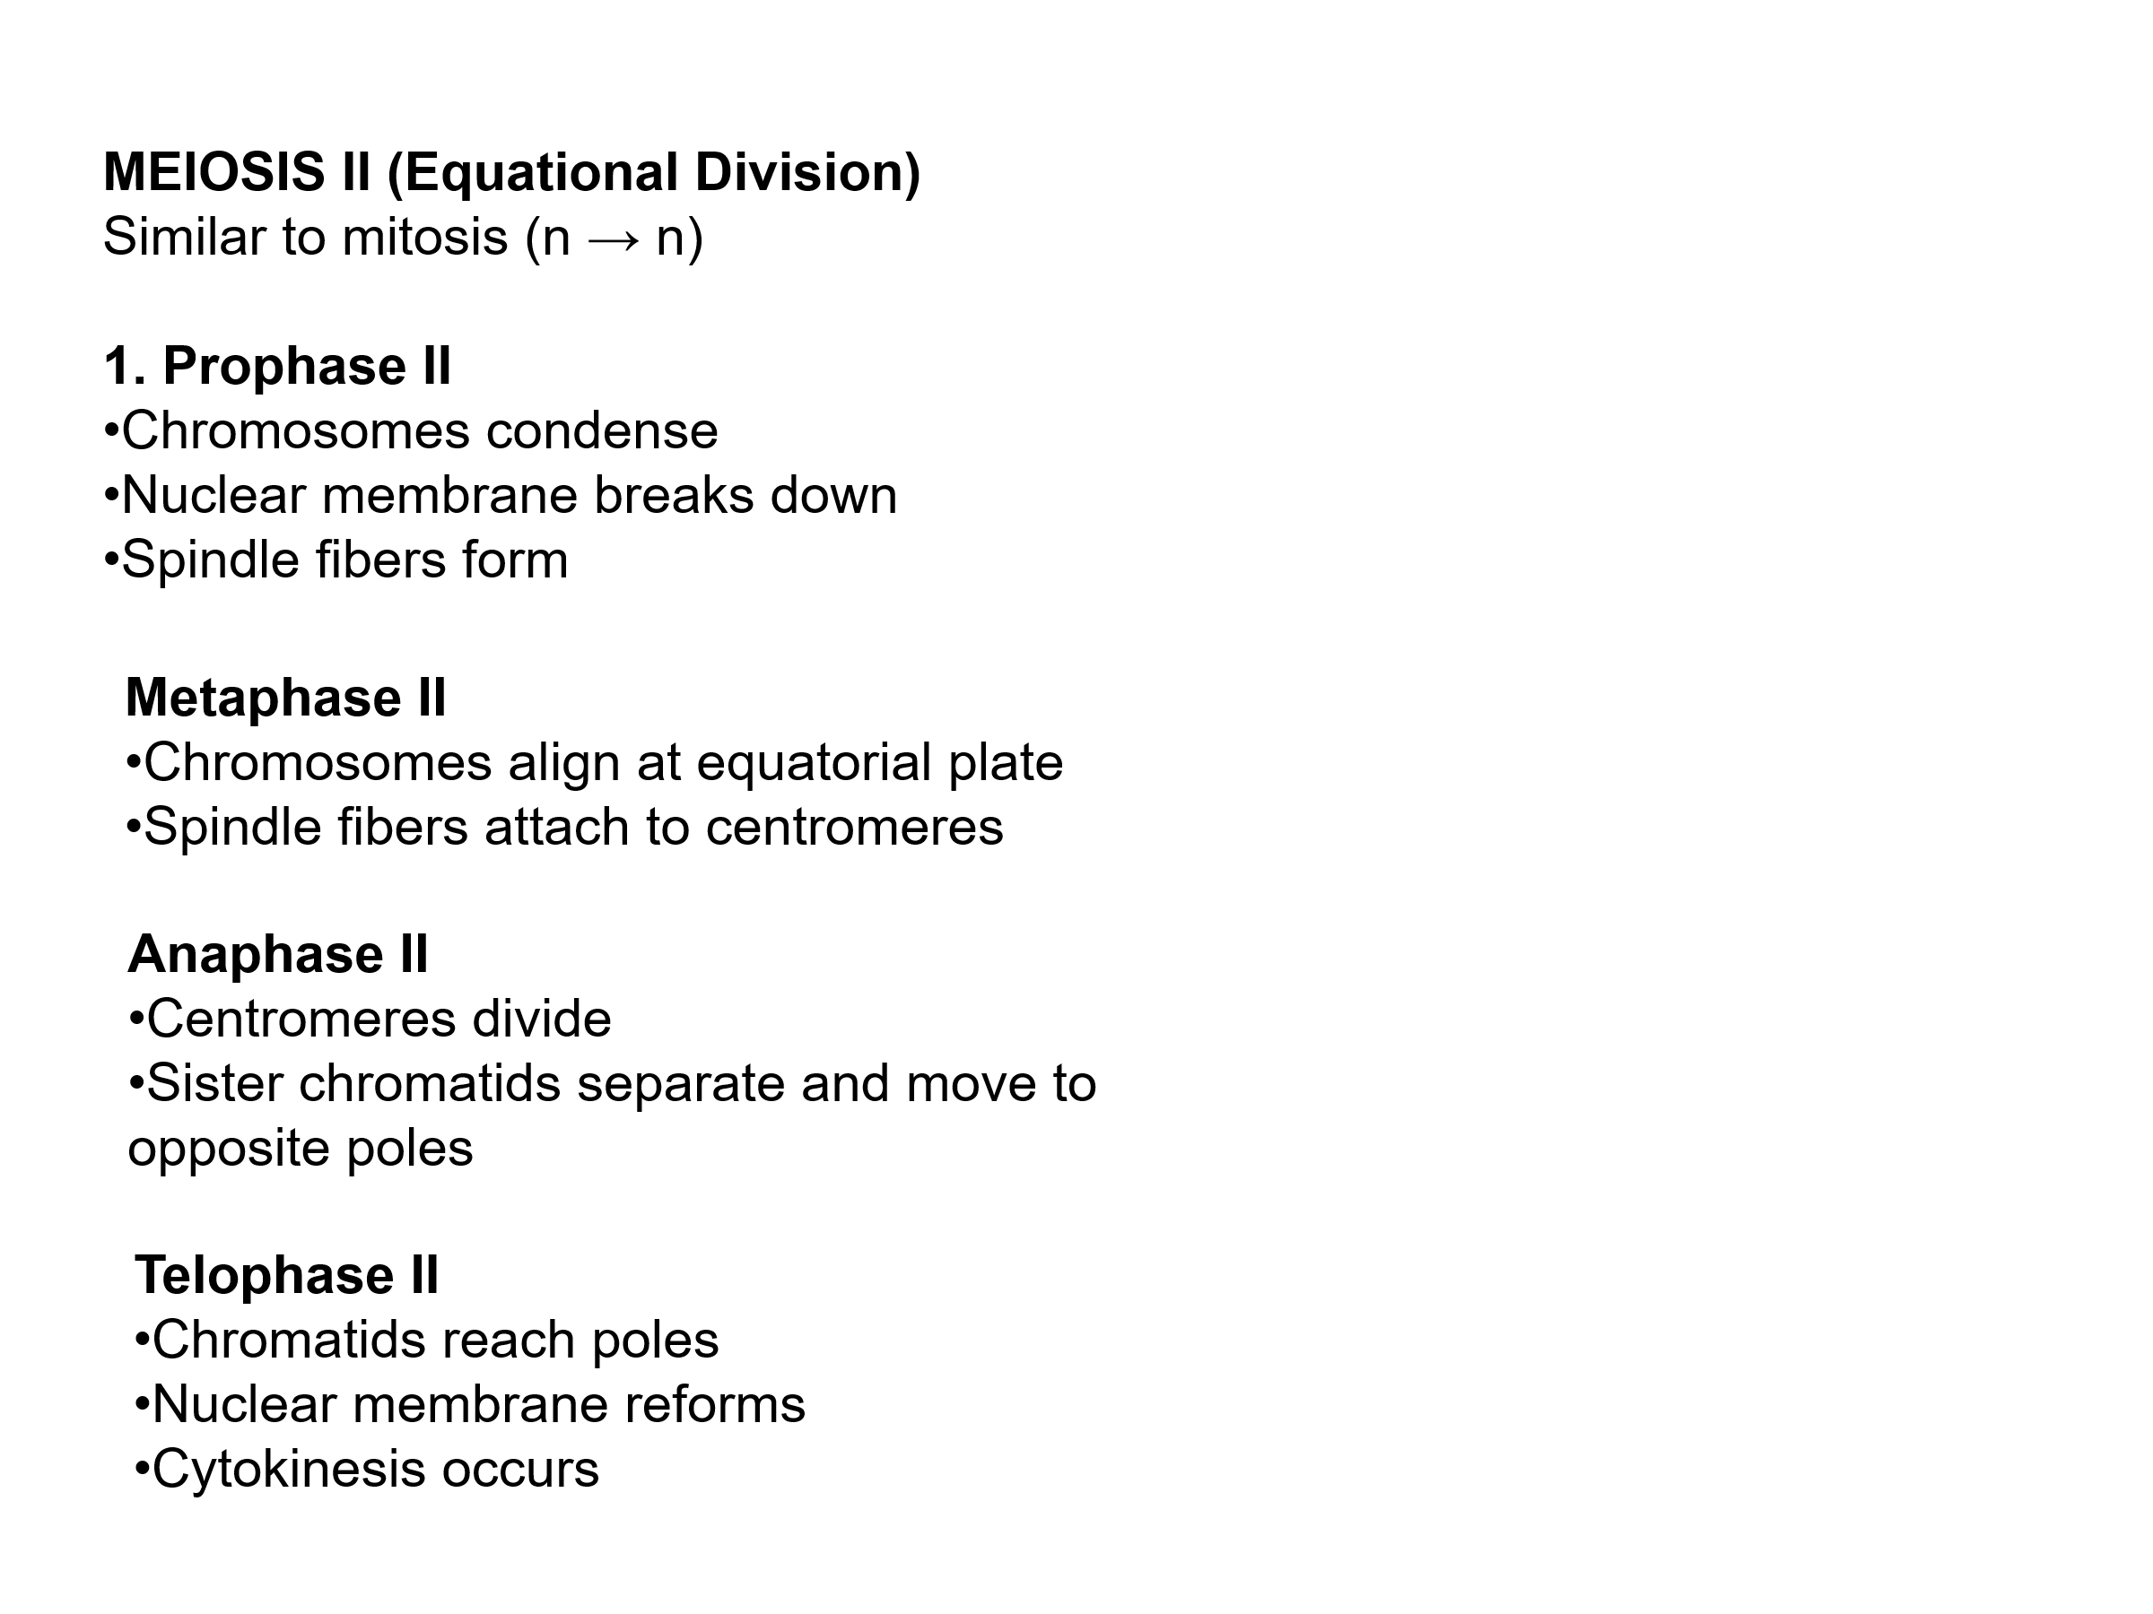
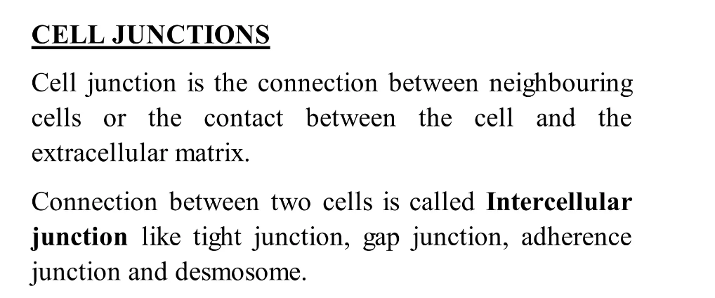
- Intracellular space in closely packed tissue is about 20nm. The cells are bound together by the specific adhesive glycoprotein.
- Epithelial cells adhere to each other through glycoproteins called Cadherins.

Occulding junction | Communicating junction | Anchoring junction
- Which prevenet intracellular exchange of substance. i.e movement of ion, molecules.  - All tight junction belongs to this category, as the cell membrane of adjacent cell fuse together firmly they are known Zona occuldens.  - Hold neighbour cells and tissue firmly.  - Form selective barrier for small molecule and total barrier for large molecule.  - Prevent lateral movement of proteins and lipids act like fence.  - BBB Made up by this tight junction to prevent entry of frequent substances. | - Permit the intercellular exchange of substance i.e ion, molecule.  - Gap junction is one of the communicating junction, also known as nexus, present in heart.  - Diameter of the channel gap is 1.5 to 3 nm, permit transport of glucose, amino acid, ions and other having molecule weight below 1000.  - Rapid Propagation of action potentials and chemical exchange. | - They are strength providing junction.  - They provide firm structural attachment between two cells or between a cell and extracellular matrix.  - Present in heart muscle, epidermis of skin, which are subject to severemechanical stress.

