HUMAN ANATOMY AND PHYSIOLOGY-I_ BP101T

UNIT : 1( Cellular level of organization)
CLASS:5

TOPIC: Structure and functions of cell, transport across cell membrane
Structure of Cell
A cell is defined as the smallest, basic unit of life that is responsible for all of life’s processes.
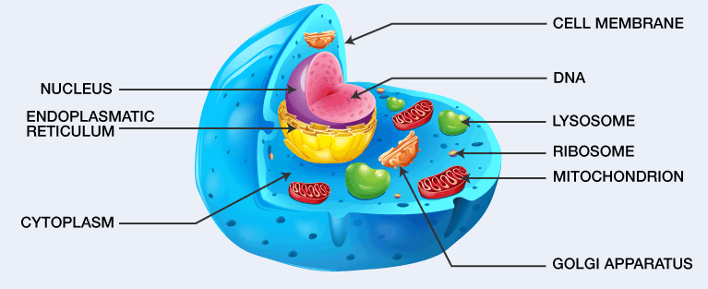
The cell structure comprises individual components with specific functions essential to carry out life’s processes. These components include- cell wall, cell membrane, cytoplasm, nucleus, and cell organelles.
Cells are two types-
- Prokaryotic Cells
Primitive and simple cells
No true nucleus (nuclear material is scattered in cytoplasm)
No membrane-bound organelles
Usually unicellular
Small in size
Examples:Bacteria, Blue-green algae (cyanobacteria)

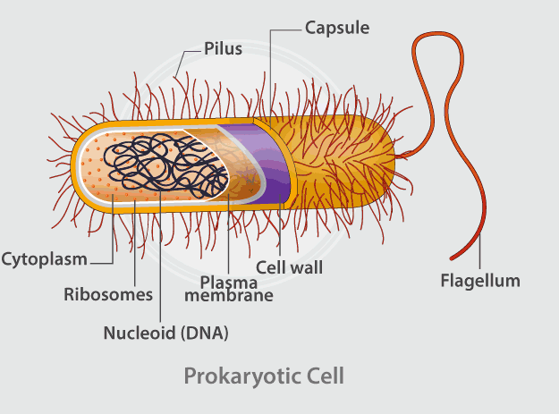
2. Eukaryotic Cells
- Advanced and complex cells
- True nucleus present (enclosed by nuclear membrane)
- Membrane-bound organelles present (mitochondria, ER, Golgi apparatus)
- Can be unicellular or multicellular
- Larger in size
Examples
- Animal cells
- Plant cells
- Human body cells
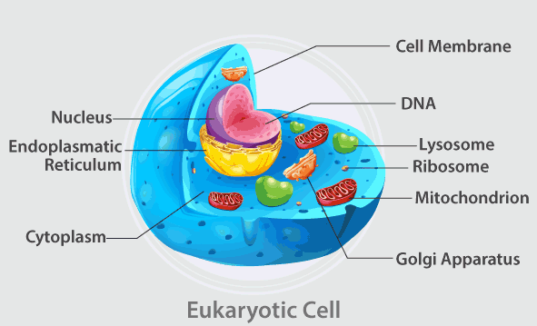
Key Differences
Feature | Prokaryotic Cells | Eukaryotic Cells
Nucleus | Absent | Present
Organelles | Absent | Present
Size | Small | Large
Complexity | Simple | Complex
Examples | Bacteria | Human cells

Cell Organelle and its Functions
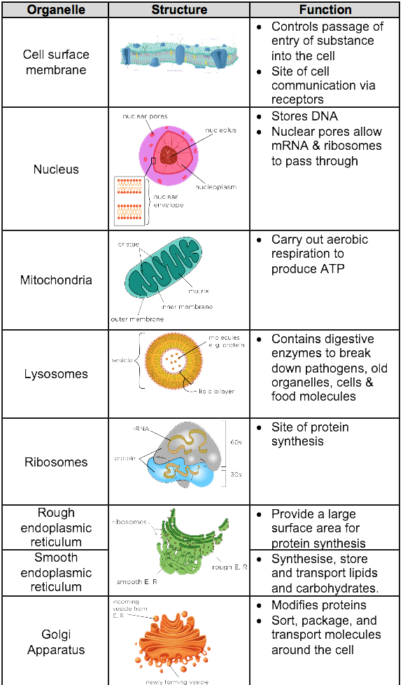

Transport across cell membrane
Cell membrane is selectively permeable, allowing controlled movement of substances to maintain cellular homeostasis.
1. Passive Transport
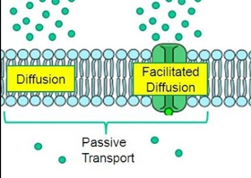
- Simple Diffusion:
Direct movement through lipid bilayer, No energy (ATP) required. Applies to small, non-polar molecules. Examples: O₂, CO₂, lipid-soluble drugs
- Facilitated Diffusion:
Requires carrier or channel proteins. No ATP required,Specific and saturable
Examples:Glucose transport (GLUT transporters),Amino acids

- Osmosis:
Movement occurs along the concentration gradient (high → low)
Diffusion of water across a semipermeable membrane
Occurs via aquaporins
Depends on osmotic pressure

