HUMAN ANATOMY AND PHYSIOLOGY-I_ BP101T

UNIT : 2 ( Skeletal system)
CLASS: 5

TOPIC: Organization of skeletal muscle
Introduction:
- Each skeletal muscle is a separate organ in the body.
- It is made up of hundreds to thousands of muscle fibers (myocytes).
Structure of Skeletal Muscle
Skeletal muscle contains:
- Muscle fibers (cells) : These are elongated, cylindrical cells, contains multiple nuclei and specialized organelles for contraction (like myofibrils).
- Connective tissues (support and protect muscle fibers)
- Blood vessels (supply oxygen and nutrients)
- Nerves (control muscle contraction)
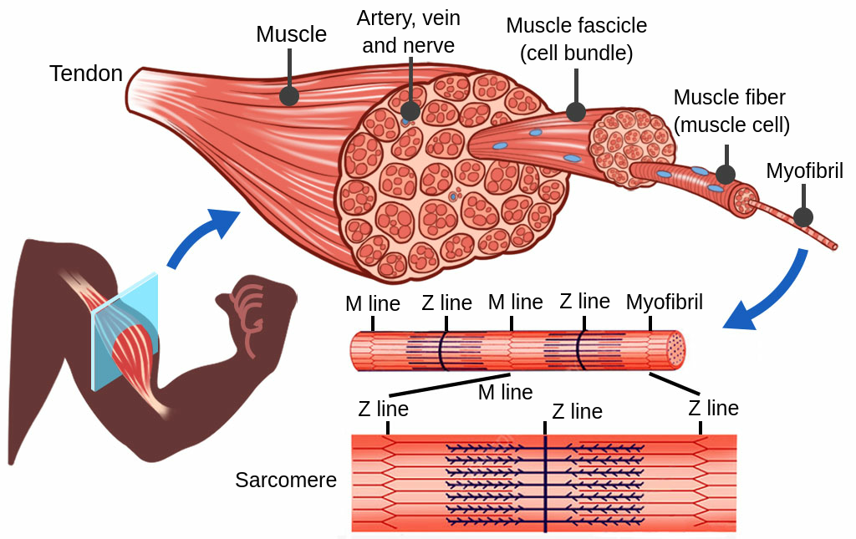
Levels of Skeletal Muscle Organization:
- Skeletal muscle is organized in layers, from the largest structure (whole muscle) down to the smallest functional unit (sarcomere).
- Each level is surrounded by connective tissue layers that protect, support, and connect muscle fibers.
- Skeletal Muscle (whole muscle) :
- A skeletal muscle is an organ made up of many bundles of fascicles.
- The Connective Tissue surrounds the entire muscle is known as Epimysium
- Epimysium is outer most layer of the muscle tissue.
- It’s made of dense irregular connective tissue.
- It protects and helps the muscle maintain its shape.
- Epimysium is continuous with tendons, which attach muscle to bones.
2. Fascicles (Bundles of Muscle Fibers):
- Fascicles are groups (bundles) of muscle fibers (cells).
- You can see fascicles in a cross-section of meat, where they appear as visible "grains".
- The Connective Tissue present here is Perimysium
- Perimysium surrounds each fascicle.
- Also made of dense irregular connective tissue.
- It contains blood vessels and nerves that supply the muscle fibers in the fascicle.
3. Muscle Fibers (Muscle Cells / Myocytes):
- A muscle fiber is a single muscle cell, long and cylindrical in shape and multinucleated cell formed by the fusion of myoblasts. It is surrounded by the sarcolemma (plasma membrane) and contains sarcoplasm (cytoplasm).
Each fiber contains many myofibrils.
- Muscle fibers are responsible for contraction.
- The Connective Tissue present here is Endomysium
- Endomysium surrounds each individual muscle fiber within a fascicle.
- Made of areolar connective tissue (mostly reticular fibers).
It contains capillaries and nerve fibers for individual muscle fiber nourishment.
4. Myofibrils (Inside Muscle Fibers):
- Each muscle fiber is packed with myofibrils, which run the length of the cell.
- Myofibrils are composed of sarcomeres, the functional units of contraction.
- Sarcomeres are repeating units within myofibrils.
- They are made up of thin (actin) and thick (myosin) filaments.
- Sarcomeres are responsible for muscle contraction (sliding filament theory).

Function of These Connective Tissues:
- Protect and support muscle structures.
- Provide pathways for nerves, blood vessels, and lymphatics.
- Help transmit force generated by muscle fibers to bones (via tendons).

