HUMAN ANATOMY AND PHYSIOLOGY-I_ BP101T

UNIT : 1( Introduction to human body)
CLASS:4

TOPIC: Basic anatomical terminology
Directional Terms
- Superior and Inferior. Superior means above, inferior means below. The elbow is superior (above) to the hand. The foot is inferior (below) to the knee.
- Anterior and Posterior. Anterior means toward the front (chest side) of the body, posterior means toward the back.
- Medial and Lateral. Medial means toward the midline of the body, lateral means away from the midline. Ipsilateral means on the same side—the left arm is ipsilateral (on the same side) to the left leg.
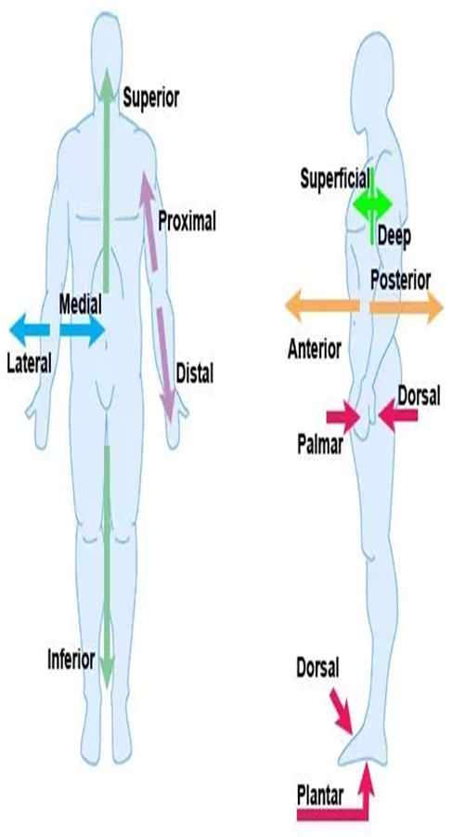
- Proximal and Distal. Proximal means closest to the point of origin or trunk of the body, distal means farthest away. As example in the fingers of the hand, a proximal joint is closest to the wrist and a distal joint is farthest from the wrist.
- Superficial and Deep. Superficial means toward the body surface, deep means farthest from the body surface.
- Intermediate – means between—your heart is intermediate to your lungs.
- Caudal – at or near the tail or posterior end of the body.
- Visceral – may be used instead of deep.

Anatomical Reference Planes
A plane is a two-dimensional surface — its dimensions are length and width.
The body reference planes are used to locate or describe the location of structures in the body.
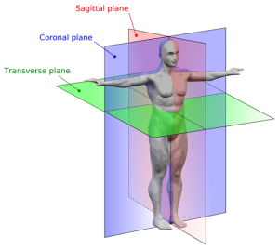
Body Cavities
Body cavities are areas in the body that contain our internal organs. The dorsal and ventral cavities are the two main cavities. The dorsal cavity is on the posterior (back side) of the body and contains the cranial cavity and spinal cavity. In human anatomy, dorsal, caudal and posterior mean the same thing. The ventral cavity is on the front (anterior) of the body and is divided into the thoracic cavity (chest) and abdominopelvic cavity.
The dorsal cavity is further divided into subcavities:
Cranial cavity (also called the calvaria) which surrounds and holds the brain
Vertebral cavity (also called the spinal cavity) which includes the vertebrae (Spinal column) and spinal cord.

