HUMAN ANATOMY AND PHYSIOLOGY-I_ BP101T

UNIT : 1( Tissue level of organization)
CLASS:10

TOPIC: Classification of tissues, structure, location and functions of nervous and connective tissues.
Tissue is a group of cells which have similar structure and perform relatively one or more common functions. There are four basic tissue types defined by their morphology and function: epithelial tissue, connective tissue, muscle tissue, and nervous tissue.
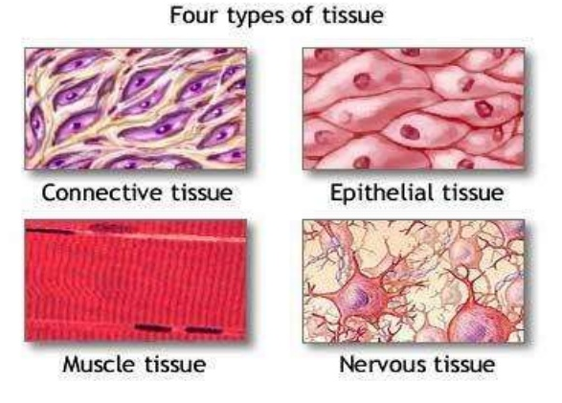
Nervous Tissue
Nervous tissue is a specialized tissue that is responsible for receiving stimuli and transmitting nerve impulses throughout the body to control and coordinate activities.
Location
- Brain
- Spinal cord
- Nerves (peripheral nervous system)
Functions
- Receives internal and external stimuli
- Transmits electrical impulses
- Controls and coordinates body activities
- Maintains homeostasis
- Responsible for sensations, thinking, memory, and emotions
Components of Nervous Tissue
1. Neurons (Nerve Cells)
- Structural and functional unit of nervous tissue
- Specialized for impulse conduction
Structure of Neuron
- Cell body (cyton) – contains nucleus
- Dendrites – receive impulses
- Axon – transmits impulses away from cell body
Function
- Carry nerve impulses from one part of body to another
2. Neuroglia (Glial Cells)
- Supporting cells
- Do not conduct impulses
Functions
- Provide support and protection
- Nourish neurons
- Maintain environment for proper functioning

- Properties of Nervous Tissue
Excitability – ability to respond to stimuli
Conductivity – ability to transmit impulses

Types of Neurons (Based on Function)
- Sensory (Afferent) Neurons
  - Carry impulses from receptors to brain/spinal cord
- Motor (Efferent) Neurons
  - Carry impulses from brain/spinal cord to muscles or glands
- Interneurons
  - Connect sensory and motor neurons within CNS

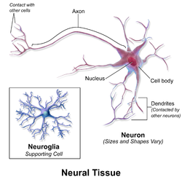

Connective tissues: It is most abundant tissue in the body. Connective tissues cells are more widely separated from each other than in epithelial tissues and intercellular substance (matrix) is present in larger amount. Made up of cells like fibroblast, fat cells, macrophages,leukocytes and mast cells.
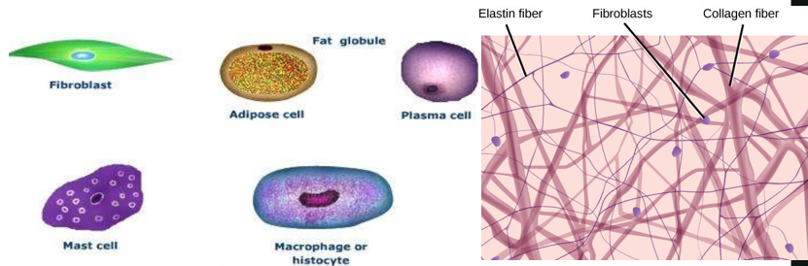
Types
1. Loose Connective Tissue
a. Areolar Tissue
Location:
- Between skin and muscles
- Around blood vessels and nerves
Function:
- Binds tissues together
- Provides support and elasticity
- Helps in repair of tissues
b. Adipose Tissue
Location:
- Under the skin
- Around kidneys, heart, and eyes
Function:
- Stores fat (energy reserve)
- Insulation (maintains body temperature)
- Protects organs (shock absorber)

2. Dense Connective Tissue
a. Tendons
Location:
- Between muscles and bones
Function:
- Attach muscles to bones
- Help in movement

b. Ligaments
Location:
- Between bones at joints
Function:
- Connect bones
- Provide joint stability
3. Supporting Connective Tissue
a. Cartilage
Location:
- Nose, ear, trachea, joints
Function:
- Provides flexible support
- Reduces friction in joints
b. Bone
Location:
- Skeleton
Function:
- Support and shape of body
- Protection of organs
- Blood cell formation
- Mineral storage (calcium, phosphorus)
4. Fluid Connective Tissue
a. Blood
Location:
- Within blood vessels
Function:
- Transport of oxygen, nutrients, hormones
- Removal of waste
- Immunity
b. Lymph
Location:
- Lymphatic vessels
Function:
- Returns tissue fluid to blood
- Defense against infection

