HUMAN ANATOMY AND PHYSIOLOGY-I_ BP101T

UNIT : 2 ( Body fluids and blood)
CLASS: 1

TOPIC: Body fluids, composition and functions of blood
Body fluids
Body Fluids are liquids present in the human body that help maintain life by transporting substances, regulating temperature, and supporting physiological functions.
Classification of Body Fluids
Body fluids are broadly classified into two compartments:
1. Intracellular Fluid (ICF)
- Location: Inside the cells
- Percentage: ~60–65% of total body water
- Major ions:
  - Potassium (K⁺)
  - Magnesium (Mg²⁺)
  - Phosphate (PO₄³⁻)
- Functions:
  - Maintains cell shape and volume
  - Site of metabolic reactions
2. Extracellular Fluid (ECF)
- Location: Outside the cells
- Percentage: ~35–40% of total body water
- Major ions: Sodium (Na⁺), Chloride (Cl⁻), Bicarbonate (HCO₃⁻)
Components of ECF
- Plasma
  - Liquid part of blood
  - Contains proteins (albumin, globulin, fibrinogen)
  - Transports nutrients, hormones, waste
- Interstitial Fluid
  - Surrounds tissue cells
  - Helps in exchange between blood and cells
- Specialized Fluids
  - Cerebrospinal fluid (CSF)
  - Synovial fluid
  - Pleural, peritoneal, pericardial fluids
Aqueous and vitreous humor of eye
Functions of Body Fluids
- Transport of oxygen, nutrients, hormones
- Removal of metabolic waste
- Regulation of body temperature
- Maintenance of acid–base balance
- Lubrication of joints and organs
- Shock absorption (e.g., CSF)

Composition of Blood
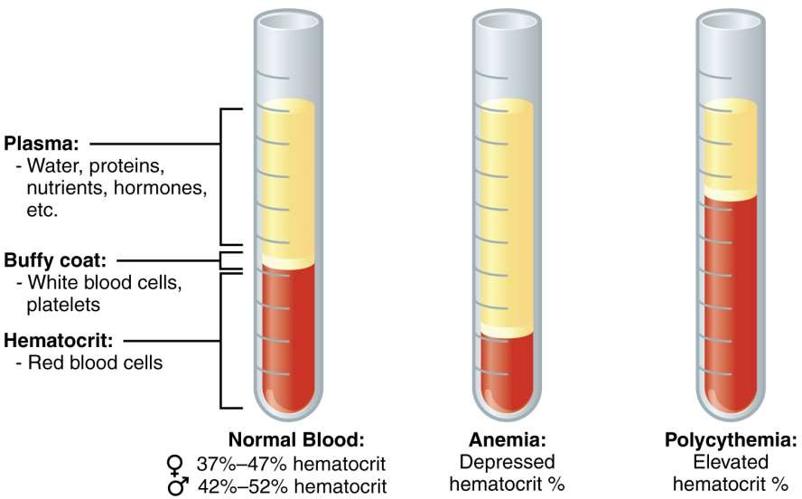
The blood is made up of more than 10 different cell types. Each of these cell types falls into one of three broad categories:
- Red blood cells (erythrocytes): These transport oxygen and hemoglobin throughout the body.
- White blood cells (leukocytes): These support the immune system. There are several different types of white blood cells:
  - Lymphocytes: Including T cells and B cells, which help fight some viruses and tumors.
  - Neutrophils: These help fight bacterial and fungal infections.
  - Eosinophils: These play a role in the inflammatory response, and help fight some parasites. Basophils: These release the histamines necessary for the inflammatory response. Macrophages: These engulf and digest debris, including bacteria.
3. Platelets (thrombocytes): These help the blood to clot.

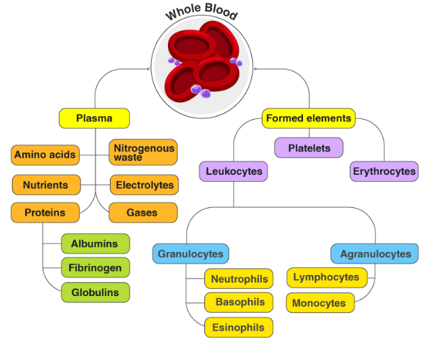
Functions of Blood
1. Transport Functions
- Oxygen from lungs to tissues
- Carbon dioxide from tissues to lungs
- Nutrients from digestive tract
- Hormones from endocrine glands
- Waste products to excretory organs
3. Protective Functions
Immunity (WBCs, antibodies)
Blood clotting (platelets, fibrinogen)
Prevents infection and excessive bleeding
2. Regulatory Functions
- Maintains body temperature
- Maintains pH (acid–base balance)
- Regulates water and electrolyte balance
Maintains blood pressure

