HUMAN ANATOMY AND PHYSIOLOGY-I_ BP101T

UNIT : 2 ( Integumentary system)
CLASS: 1

TOPIC: Structure and functions of skin
The integumentary system is the body’s outer protective covering. It includes the skin and its accessory structures such as hair, nails, sweat glands, and sebaceous (oil) glands.
Components
- Skin
- Hair
- Nails
- Glands
  - Sweat glands (eccrine & apocrine)
  - Sebaceous glands

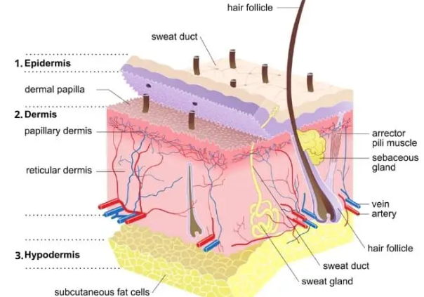
Structure of Skin
The skin has three main layers:
1. Epidermis: Outermost layer made up by Stratified squamous epithelium tissue. No blood vessels presence.
Major cells:
  - Keratinocytes – protection, keratin formation
  - Melanocytes – melanin pigment (skin color, UV protection)
  - Langerhans cells – immune defense
  - Merkel cells – touch sensation
Layers of epidermis (deep → superficial):
- Stratum basale
- Stratum spinosum
- Stratum granulosum
- Stratum lucidum (only in thick skin)
Stratum corneum
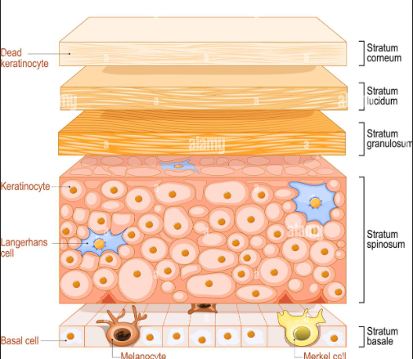

2. Dermis
- Middle layer
- Dense connective tissue
- Contains:
  - Blood vessels
  - Nerves
  - Hair follicles
  - Sweat and sebaceous glands
- Provides strength, elasticity, and nourishment
3. Hypodermis (Subcutaneous layer)
- Innermost layer
- Composed of adipose and connective tissue
- Functions:
  - Insulation
  - Shock absorption
Energy storage

Functions of the Integumentary System
- Protection (physical, chemical, microbial, UV)
- Thermoregulation (sweating, vasodilation, vasoconstriction)
- Sensation (touch, pain, temperature, pressure)
- Excretion (sweat removes salts and urea)
- Vitamin D synthesis
Prevention of water loss

