UNIT5
CLASSI
Definition of Semisolid Dosage Forms
Semisolid dosage forms are pharmaceutical preparations that have a consistency between solid and liquid.
They are intended mainly for external application to the skin or mucous membranes for local or systemic effects.
They are commonly used in dermatology, ophthalmology, rectal, and vaginal drug delivery.

Classification of Semisolid Dosage Forms
1️⃣ Ointments
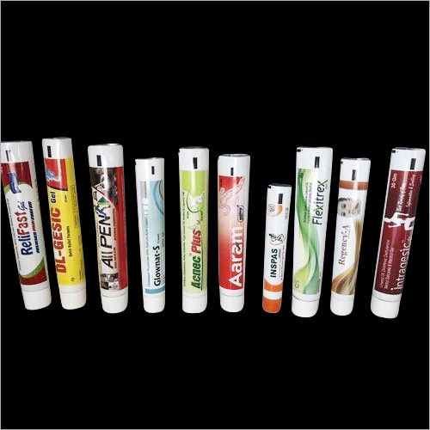

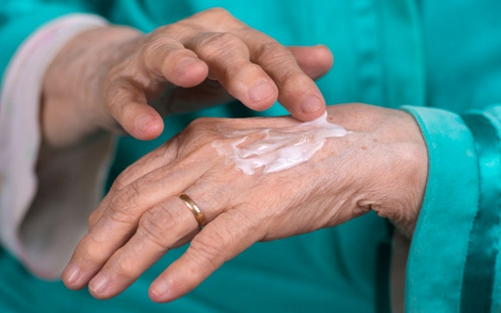
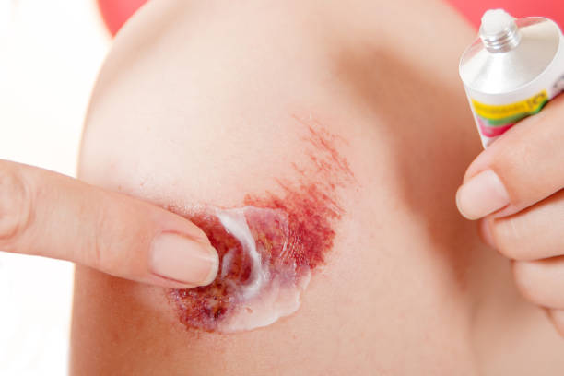
Definition:
Ointments are greasy, semisolid preparations intended for application to the skin or mucous membranes.
Characteristics:
- High viscosity
- Occlusive (retain moisture)
- Suitable for dry skin conditions
Types of Ointment Bases:
- Hydrocarbon bases (e.g., petroleum jelly)
- Absorption bases
- Water-removable bases
- Water-soluble bases

2️⃣ Creams
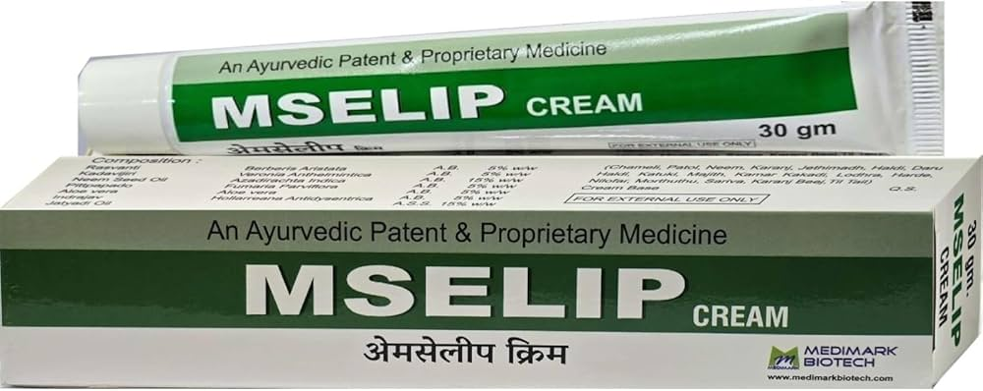

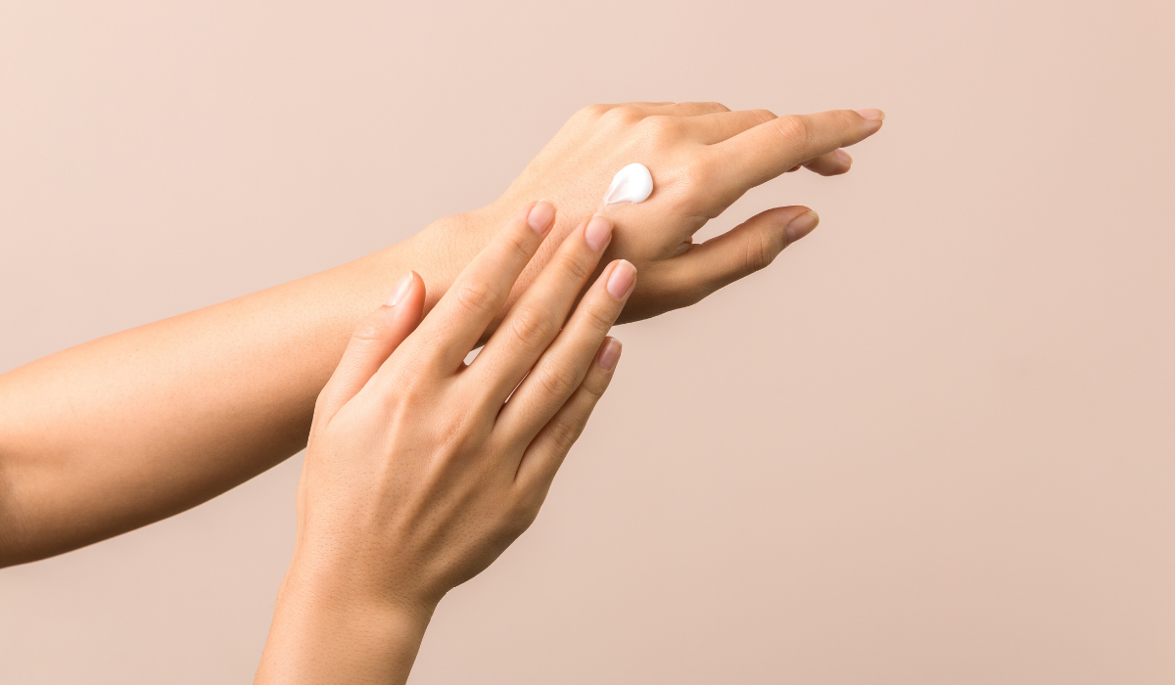
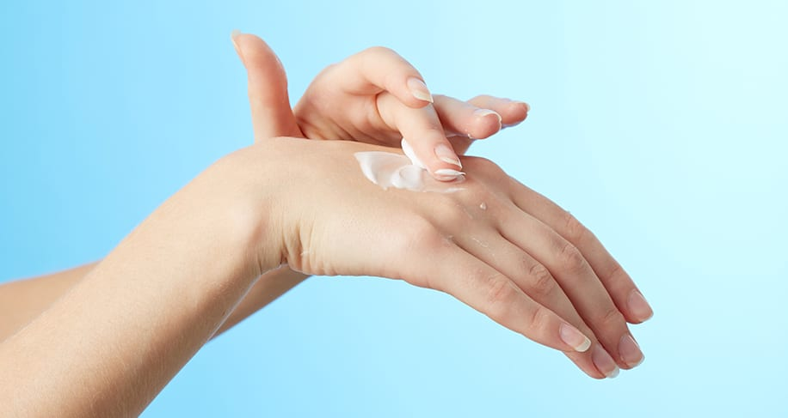
Definition:
Creams are semisolid emulsions containing oil and water.
Types:
- Oil-in-water (O/W) creams – non-greasy, washable
- Water-in-oil (W/O) creams – greasy, moisturizing
Uses:
Used for inflammatory and infectious skin conditions.

3️⃣ Gels
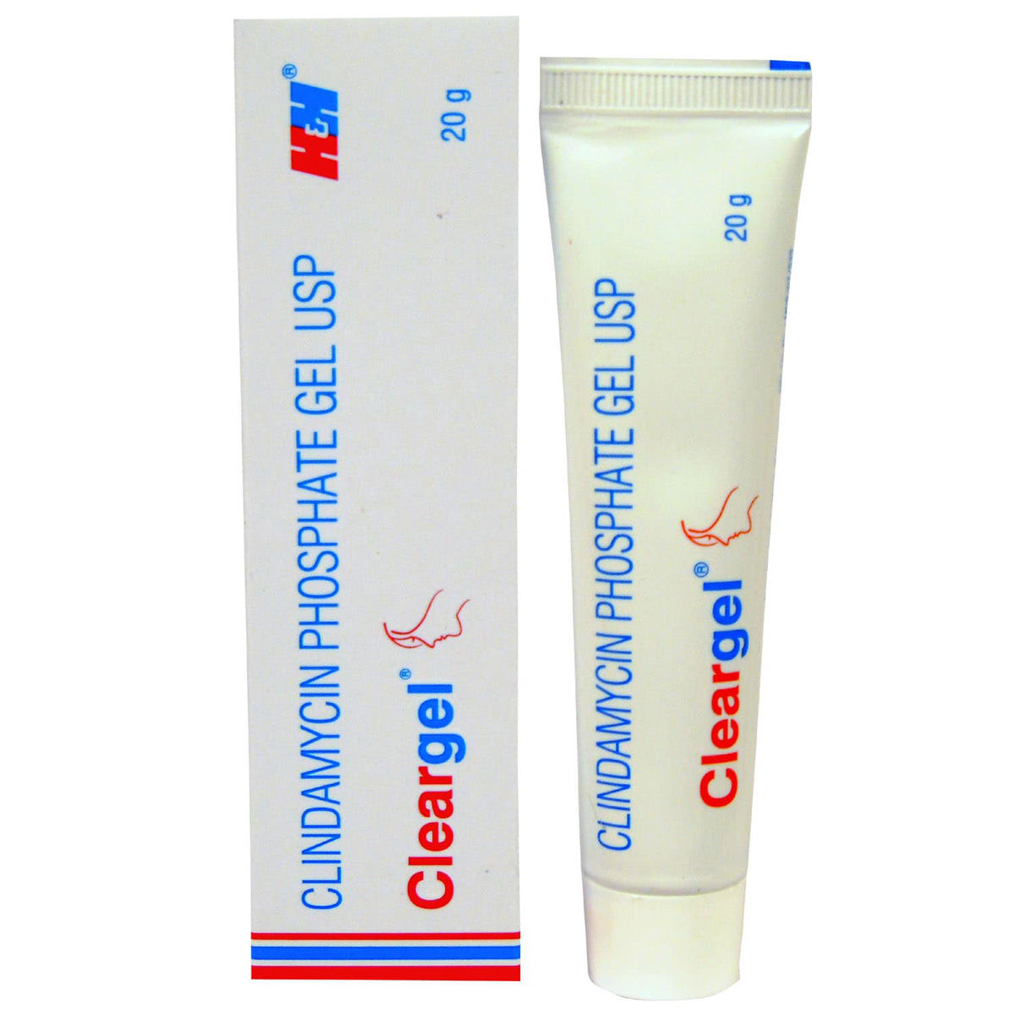

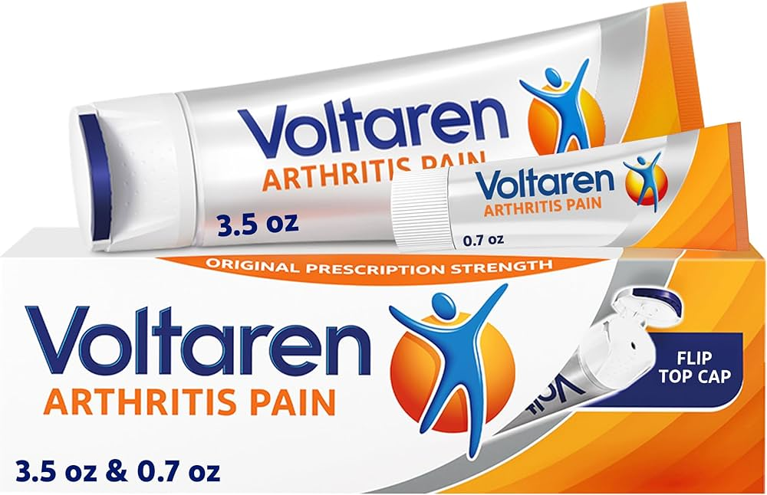
Definition:
Gels are semisolid systems consisting of a liquid phase entrapped within a three-dimensional polymeric network.
Characteristics:
- Transparent or translucent
- Non-greasy
- Good drug release
4️⃣ Pastes
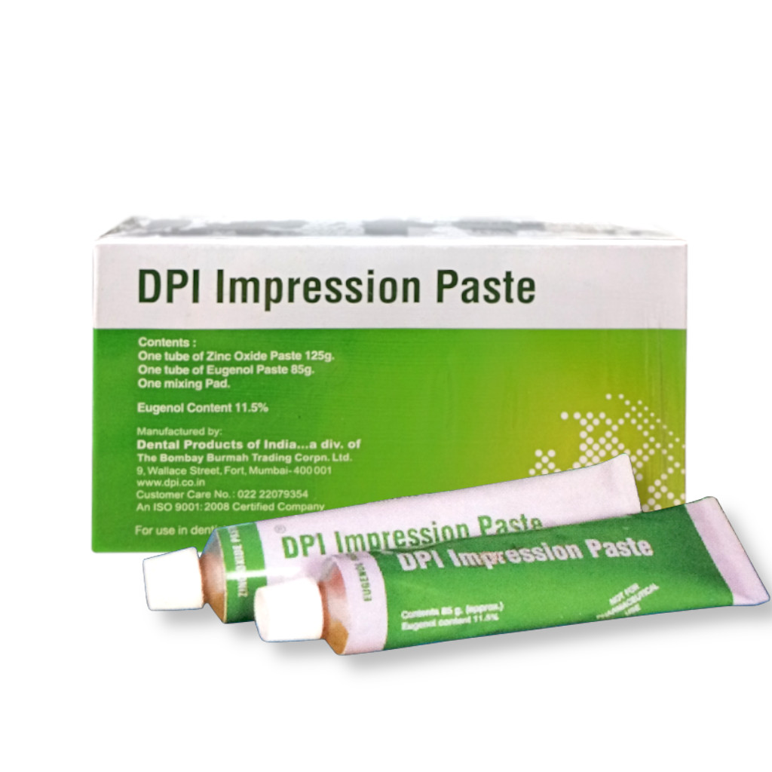
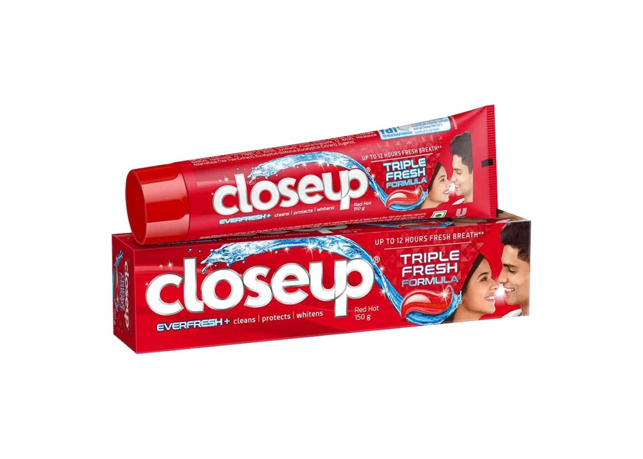
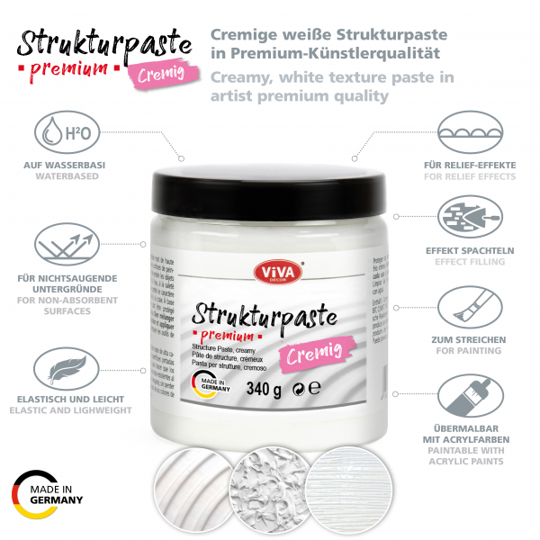
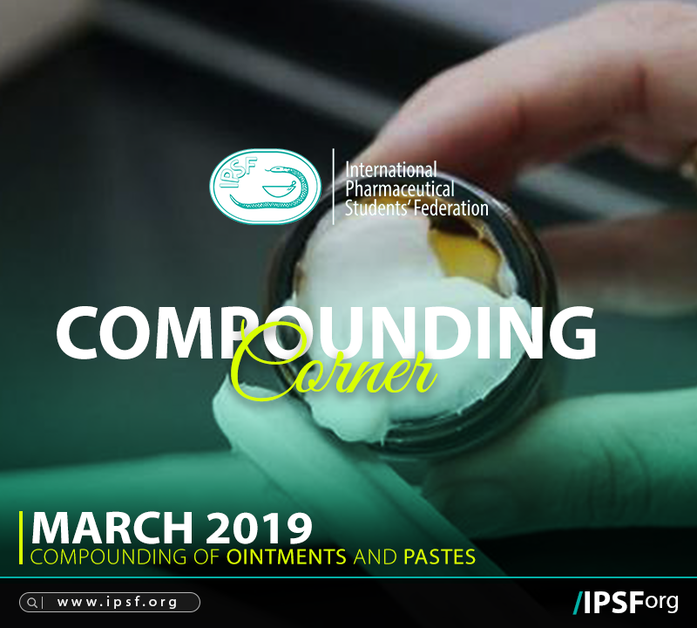
Definition:
Pastes are stiff semisolid preparations containing a high percentage (20–50%) of finely dispersed solids.
Characteristics:
- Thick consistency
- Protective
- Less greasy than ointments

5️⃣ Jellies
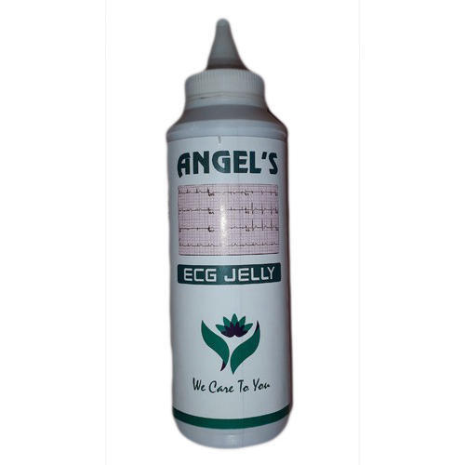

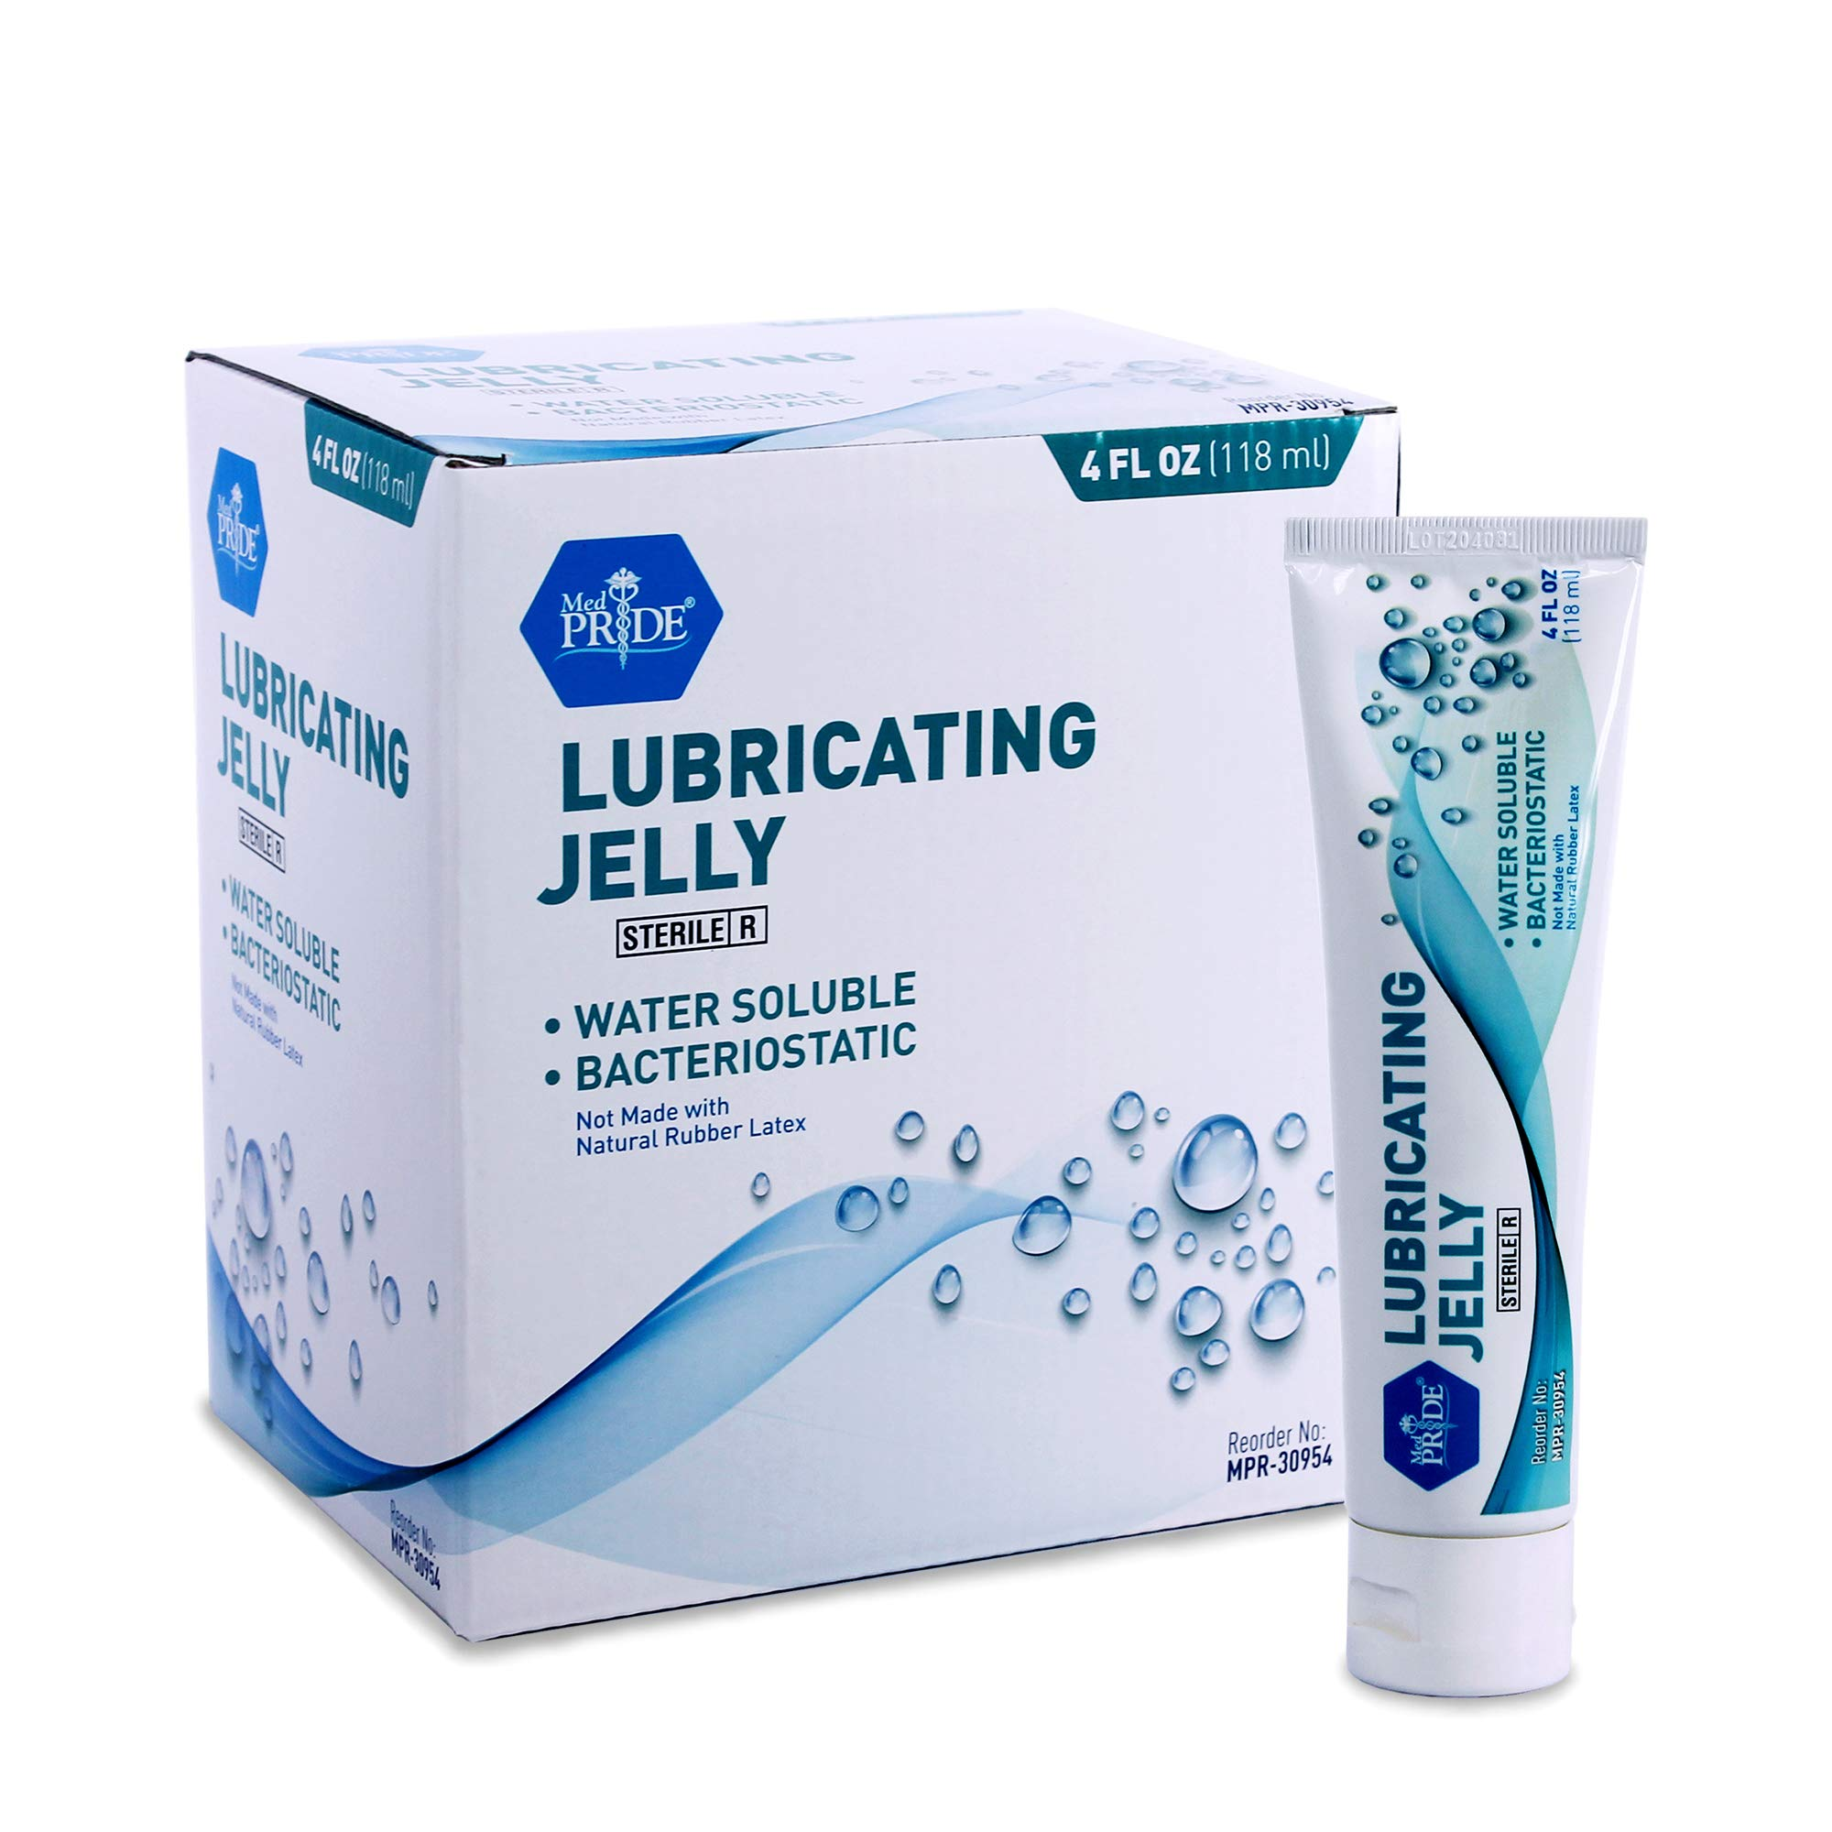
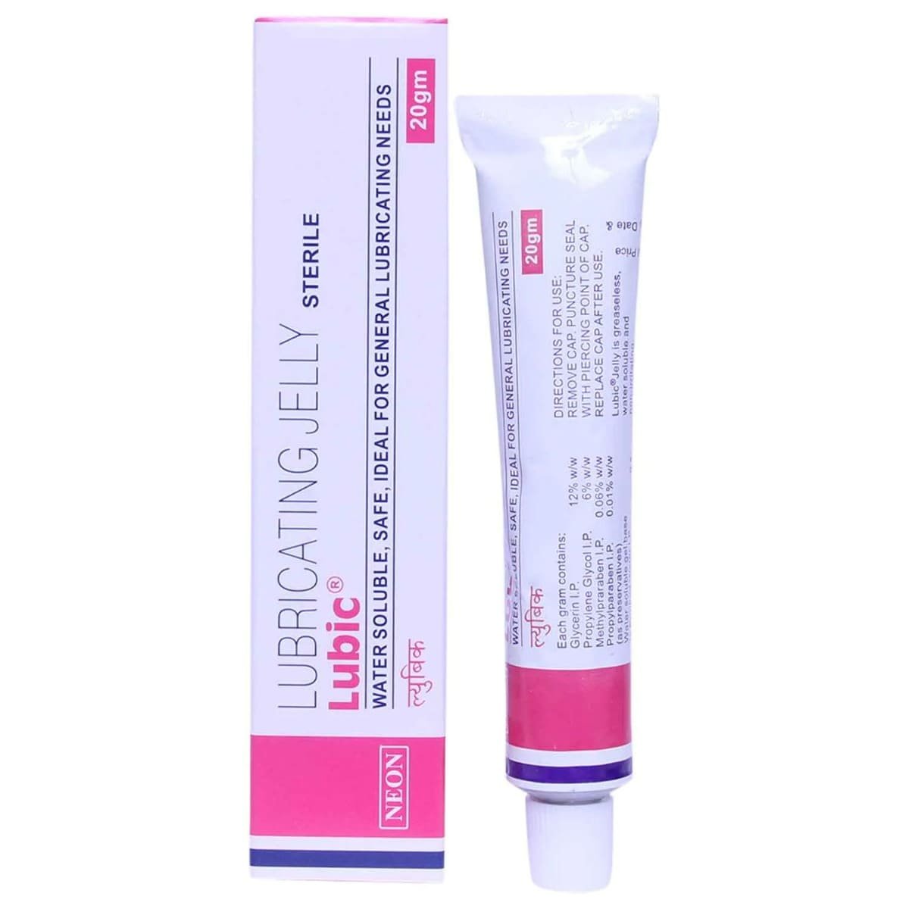
Definition:
Jellies are transparent or translucent semisolid preparations prepared using gelling agents.
Uses:
- Lubrication
- Local anesthetic preparations
- Vaginal or urethral applications
Semisolid dosage forms are classified into:
- Ointments
- Creams
- Gels
- Pastes
- Jellies

