HERBAL DRUG TECHNOLOGY BP603T

UNIT: II
TOPIC: Drug (herbal drug) interactions CLASS: 7

Drug (herbal drug) interactions



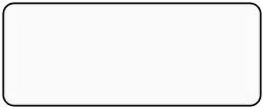

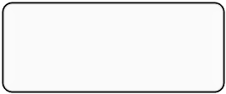

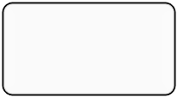

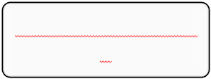

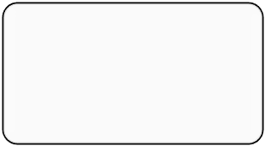
- Def: A drug interaction is a change in the action or side effects of a drug caused by concomitant administration with a food, beverage, supplement, or another drug. A cause of a drug interaction involves one drug which alters the pharmacokinetics of another medical drug.
- Drug interaction may occur while simultaneous administer of allopathic drug along with another drug/ herbal medicine/ raw herb/ some food/ some beverages/ supplements inside our body.
- The result of this interaction may cause the drug less effective, increase activity otherwise it may cause the unwanted side effects.
Result of interactions:

Drug (herb) interactions

Pharmacokineti c
Pharmacodynami c

Change in ADME
Adsorption, Distribution, Metabolism, Excretion

May cause additive, synergistic, antagonist, unidentified response

Interactions observed in public
- It is observed as per report nearly 5-20% of people are consuming herbal medicines because of: naturally available, safe, readily available and cheap.
- About 70-80% of some herbs may increase the risk of bleeding.

- 30-40% herbs may cause the hepatic failure.
- Ephedra results 54 deaths, 1600 adverse events were recorded.
- Penny royal tea 2 infants multiple organs dysfunction.
- Aloe vera injections may cause the four deaths.
- Aristolochic acid from Kidamari (Aristolochia bracteolata) – death of 100 Beljan women




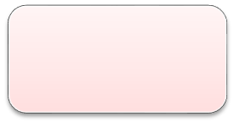
Reasons of interactions:
Lack of knowledge
Avoidance of patient history & Lack of documentations
Reasons
r
esearch facility and
Lack of advance
no
quality control tests
Blind belief &
Mythological belief
Classification of drug interactions:








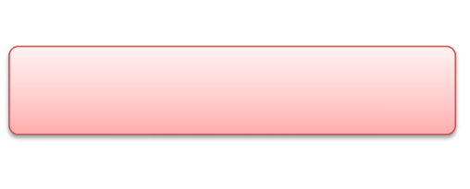

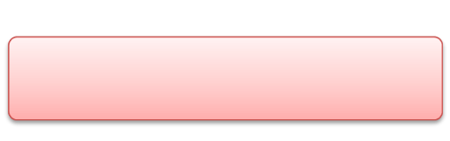

Herb-herb interaction

  - Herb-food interaction

Drug interactions 3. Herb-drug interaction

Herb-animal origin drug
interaction

Drug-disease related drug interaction

- Herb-herb interaction: When the two different herbs taken simultaneously then it may shows interaction. Ex:1 glycyrrhiza root shows antagonistic action to Euphorbia pekinensis root, Euphorbia kansui root, Daphne genkwa flower, Sargassum spp. (seaweed). Ex:2 Piper betel is contraindicated with Garcenia morella, Ex:3 Astragalus membranaceus and Rehmannia glutinosa shows synergistic action in wound healing activity.
- Herb-food interaction: Some herbal drugs shows interaction with some food materials. Ex: milk preparation contraindicated with mentha; wine with steamed grains, raddish with milk These combinations may cause loss of strength, stirility, oligospermia (low sperm count) and even death.
- Herb-drug interaction: Ex:1: St. John’s wort (Hypericum perforatum):
  - Ex:1: Warfarin (to cause bleeding);
  - Indinavir (decreased bioavailability);
  - digitoxin, theophylline, cyclosporin, phenprocoumon, and oral contraceptives (all with reduced bioavailability)
  - Ex:2: Ginseng (Panax ginseng):
  - Antidepressants such as phenelzine sulfate (to cause manic episodes, headaches);
  - Warfarin (to cause bleeding or to decrease effectiveness);
  - Corticosteroids (potentiation);
  - Estrogens (potentiation)
  - Ex: 3: Ginkgo (Ginkgo biloba) :

  - Warfarin (to cause bleeding)
  - Ex:4: Aloe (Aloe ferox):
  - Cardiac glycosides and antiarrhythmic agents (potentiating by reducing potassium via laxative effect)

Herb-animal origin drug interaction:
Herbal products interacted with animal originated food materials such as: Ex:1-Kapotamamsa (meat of pigeon) is contraindicated with Sarshapataila (Brassica alba). Ex:2-Pork is contraindicated with Narikelataila (oil of Coccus nucifera), Ex:3-Equal quantity of Madhu (Honey) with Grutha (Ghee) is contraindicated and this has been proved to produce toxic effect by combinaton; Ex:4- Piper longum with fish fat; Ex:5- Mallotus philippinensis with butter milk

Drug-disease related drug interaction
  - Haritaki (Terminalia chebula) contraindicated in pregnancy, malnourished, anorexia after bloodletting.
  - St. John's wort may harm an unborn baby. Do not use this product without medical advice if you are pregnant.
  - Kava is contraindicated with Hepatitis: acute, chronic, or any history
  - Ginkgo leaf extract might increase the risk of bruising and bleeding, hence should not take if they have bleeding disorder.

