HERBAL DRUG TECHNOLOGY BP603T
UNIT: II
TOPIC: Study of following herbs as health food: Ginseng, Aswagandha CLASS: 6

Ginseng

Common names:
- Panax Asiatic ginseng
- Chinese ginseng
- Ginseng root
- Pannag Ninjin

Biological source:
- It consists of dried roots of Panax ginseng and other species of Panax like Panax japonicus (Japanese Ginseng), Panax pseudoginseng (Himalayan Ginseng), Panax quinque-
folius (American Ginseng), Panax trifolius (Dwarf Ginseng) and Panax vietnamensis (Vietnamese Ginseng), belonging to family Araliaceae.
- It is mainly found in China, Russia, Korea, Japan, Canada and India.

CHEMICAL CONSTITUENTS:
- These include

Triterpene saponins
- Essential oil-containing--- polyacetylenes, Sesquiterpenes
- Carbohydrates --Polysaccharides – peptidoglycans
- phenolic compounds -- major biologically active constituents – 20(S)- protopanaxadiol and 20(S)- protopanaxatriol
- Several saponin glycosides belonging to triterpenoid group ginsenoside, chikusetsu saponin,
panxoside.
- More than 13 ginsenosides have been identified.
- Ginsenosides consists of aglycone dammarol
- panaxosides have oleanolic acid as aglycone.
- It also contains large amount of starch, gum, some resin and a very small amount of volatile oil.

Medicinal uses and health benefits:
- anti –stress
- Anticancer
- immune system Modulation
- Cardiovascular
- CNS, and hormonal effects for improvement of athletic performance.

Great Heart Tonic:
- Red panax ginseng are particularly beneficial to patients with heart disorders as it decreases the oxidation of LDL cholesterol.
- It contributes to the health of the cardiovascular system and promotes healthy blood flow and used to prevent the hypertension.
- Treatment of Erectile Dysfunction
- Ginseng can treat sex related conditions like erectile dysfunction in men.

- Red panax ginseng has been used in Chinese herbal medicine for the treatment of sexual disorders.
- Benefits for Women American ginseng tea is often recommended to young women to ease menstrual cramps.
- This herb is effective in relieving stomach pain associated with menstruation.
- Ginseng is often recommended to menopausal women to improve oestrogen production in the body

Aswagandha
- Synonyms: Withania root. Ashwagandha, Clustered Wintercherry.
- Biological Source: It consists of the dried roots and stem bases of Withania somnifera Dunal, belonging to family Solanaceae.

Chemical Constituents:
- The plants contain the alkaloid withanine as the main constituent and somniferine, pseudowithanine, tropine and pseudotropine, hygrine, isopellederine, anaferine, anahygrine and steroid lactones.
- The leaves contain steroid lactone, commonly known as withanolides.

Uses
- All plant parts are used including the roots, bark, leaves, fruit and seed are used to treat nervous disorders, intestinal infections and leprosy.
- Ashwagandha is one of the most widespread tranquillizers used in India.
- It acts mainly on the reproductive and nervous systems, having a rejuvenative effect on the body, and is used to improve vitality and aid recovery after chronic illness.
- It is also used to treat nervous exhaustion, debility, insomnia, wasting diseases, impotence, infertility; multiple sclerosis, etc.
- Externally it has been applied as a poultice to boils, swellings and other painful parts.
- Withania is considered as an adaptogen and so is used in number of diseases.

Marketed Products:
- It is one of the ingredients of the preparations known as Abana, Geriforte, Mentat, Mentat syrup, Reosto, Tentexforte, AntiStress Massage Oil, Nourishing Baby Oil, Nourishing Skin Cream, Anxocare, Galactin Vet, Geriforte Aqua, Geriforte Vet, Immunol, Speman forte Vet, Tentex forte Vet, Ashvagandha tablet (Himalaya Drug Company), Balarishta (Baidyanath), Aswagandha tablet (BAPS AMRUT).

Spirulina
- Biological source: Spirulina (Arthrospira Platensis, family: oscillatoriaceae is a unique fresh water
biomass of cyanobacteria (blue-green algae) that can be consumed by humans and animals.

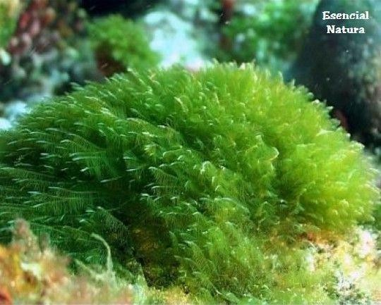
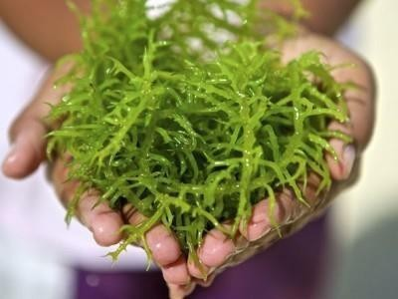
Description:
- Common name: spirulina, blue green algae
- Part used : whole plant
Description: In spirulina edible and toxic varieties are available. The edible varieties are Arthrospira Platensis and A. maxima are cultivated world wide.
- It naturally grows in alkaline and warm media; in the sea and fresh water of Asia, Africa, Europe, South and North America.

Chemical constituents:
Macro- and Micronutrients
- high quality protein (Spirulina is about sixty percent complete, highly digestible protein), iron, gama- linolenic acid, vitamins, minerals and polysaccharides.
- It has the highest known source of beta carotene. (25 times more than raw carrots)
- Spirulina has more vitamin B12 than any other known source.
- Spirulina has a number of natural antioxidants like betacarotene, vitamin E and contains vitamin
B1, B5, & B6, minerals such as zinc, manganese, copper and selenium & amino acid -- methionine.
- Spirulina is richest source of chlorophyll.

Macro & micronutrients:
  - Calories 343 kcal
  - Protein 60 to70%

Fat
  - Total fat (g) 4.3
  - Saturated fat 1.95
  - Polyunsaturated fat 1.93
  - Monounsaturated fat 0.26
  - Cholesterol <0.1
  - Total carbohydrate (g) 17.8
  - Dietary fiber 7.7
  - Sugars 1.3
  - Lactose <0.1
- Vitamin A (as β-carotene) 352.000 IU
- Vitamin K 1090 mcg
- Thiamine HCL (Vitamin B1) 0.5 mg
- Rivoflavin (Vitamin B2) 4.53 mg
- Niacin (Vitamine B3) 14.9 mg
- Vitamin B6 (Pyridox. HCL) 0.96 mg
- Vitamin B12 162 mcg

- Minerals:
- Calcium 468 mg
- Iron 87.4 mg
- Phosphorus 961 mg
- Iodine 142 mcg
- Magnesium 319 mg
- Zinc 1.45 mg
- Selenium 25.5 mcg
- Copper 0.47 mg
- Manganese 3.26 mg
- Chromium <400 mcg
- Potassium 1,660 mg
- Sodium 641 mg
Medicinal uses and health benefits:
- Reduces blood cholestrol
- Spirulina helps to control diabetes
- Helps in kidney detoxification
- Useful in combating malnutrition
- Preventing vitamin A deficiency
- Aids in the prevention of anaemia.
- Shows anti-inflammatory effects
- Used to prevent cancer, hepatotoxicity.
- Acts against viral and cardiovascular diseases.
- Inhibition of mother-child transmission of HIV
- Radiological protection
- Prevents Neurodegenrative disorders (Parkinson’s & Alzheimer’s disease)
- Control of allergic rhinitis.
