UNIT-4 EXPECTORANTS

Lession-1

TOPIC- EXPECTORANTS
The latin word Expectorate means to drive from the chest.
Expectorants are drug used to help in removal of secretions from trachea, bronchii or lungs hence they are used in the treatments of cough.
Also called as mucokinetics.
Examples of expectorants are- Ammonium salt (Ammonium chloride), iodide (Potassium/Sodium iodide), citrates.
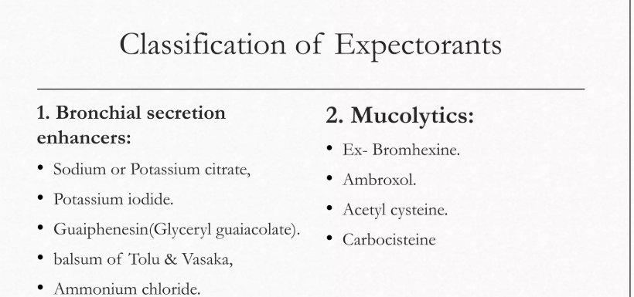

POTASSIUM IODIDE
Chemical Formula- KI Molecular Weight- 166.01 Synonym- Kalii iodidum
Method of preparation- 2K + I₂ 2KI
Properties-
Odourless, transparent, white granular powder Soluble in water, alchol
KI + I2 KI3
Uses-
Treatments of goitre.
KI solution used as iodine supplements.

AMMONIUM CHLORIDE
Chemical Formula- NH4Cl Molecular weight- 53.49
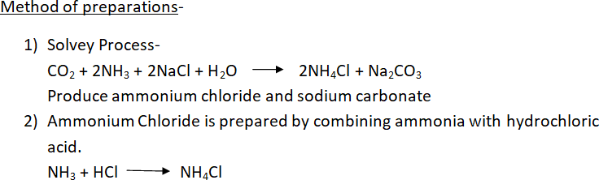

Properties-
White, fine crystalline powder, odourless.Soluble in water & alchol.Freely soluble in glycerine
Ammonium chloride also reacts with strong base (e.g- Sodium hydroxide) to release ammonia gas.
NH4Cl + NaOH NH3 + NaCl + H2O
Assay-
Weigh 0.1gm of NH4Cl dissolve in 20ml of H2O & add a mixture of 5ml of previously neutralized formaldehyde solution & 20ml water. After 2 minutes the contents of conical flask is titrated against 0.1NaOH using phenopthelein indicator. End point is the appearance of permanent pale pink colour.
(Equivalent factor- Each ml of 0.1N NaOH is equivalent to 0.005349 gm of NH4Cl.)

Uses- As a nitrogen source in fertilizers. Used as an expectorants in cough medicine. Use as a systemic acidifying agent in treatment of severe metabolic alkalosis.

