HERBAL DRUG TECHNOLOGY BP603T
UNIT: II
TOPIC: Study of following herbs as health food -Alfaalfa, Chicory, Ginger, Fenugreek, Garlic

CLASS: 4

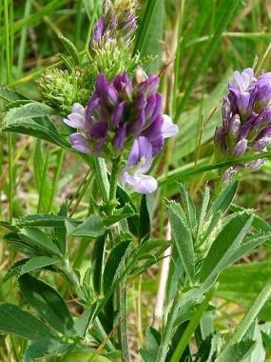
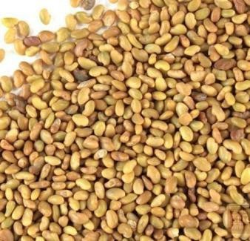
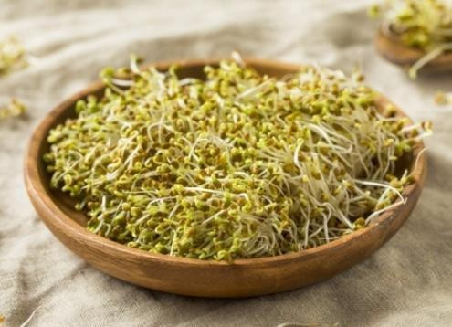
1) Alfaalfa
- Alfalfa, also known as lucerne or Medicago sativa, is a perennial flowering plant in the legume family Fabaceae.
- The seeds, dried leaves, sprouts are taken as a supplement. Plants, seeds& sprouts image of alfalfa

Constituents of Alfalfa:
- Alkaloids: asparagines, trigoneline, stachydrine, l-homostachydrine.
- Amino acids: medicanine, lysine, arginine, histidine, tyrosine, phenylalanine, methionine, aspartic acid, glutamic acid, asparagine, serine
- Carotene, Coumarins: myrsellinol, scopoletin, esculetin, 4-coumaric acid,
- Digestive enzymes: isoflavone reductase, vestitone reductase, iminopeptidase, and two aminopeptidases,
- Flavonoids: quercetin, myricetin, luteolin, apigenin, chrysoeriol, tricin, O-glycosyltransferases,
- Minerals: Ca, K, P, Mg, Fe, Zn, Cu, Al, B, Cr, Co, Mn, Mo, Se, Si, Na, Sn,
- Organic acids: citrate, malate, malonate, succinate, fumarate, lactate, benzoate
- Phytosterols: β-sitosterol, stigmasterol
- Vitamins: A, B1, B6, B12, C, D, E, K, niacin, pantothenic acid, biotin, folic acid

Phenolic compounds:
- p-hydroxybenzoic acid, vanillic acid, p-coumaric acid, ferulic acids, salicylic acid, caffeic acid, hesperetin, naringenin, chlorogenic acid, tannic acid
- Volatile components: terpenes, limonene, linalool, benzaldehyde, ethyl benzaldehyde, alcohols, butanol, hexanol, octanol,
- It also contains proteins, saponins
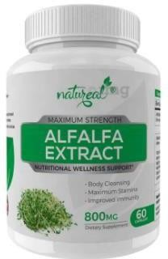
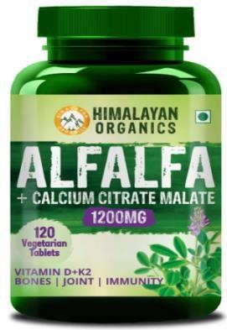
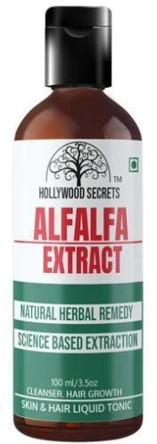
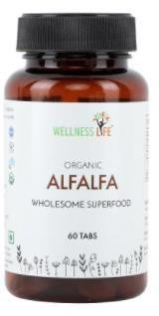
Uses of Alfalfa:
- M. sativa top (stem and leaves) saponins have been reported to decrease plasma cholesterol concentrations.
- M. sativa seeds (80-60 g daily), serum cholesterol, total cholesterol and LDL-cholesterol. concentrations were reported to be reduced.

Prevent atherosclerosis.
- Reduce the incidence of cholesterol gallstones was served with the diet of the higher fiber content
(85% alfalfa)
- It is used in treatment of neuro vegetative menopausal symptoms in women.
- It is used to decrease the blood pressure.
- Used as diuretics
- Used to increase the breast milk production in lactating mothers.
- It also reduces the kidney stones.
Marketed nutraceuticals products of alfalfa:

2. Chicory:

Chicory (Cichorium intybus) is a woody, perennial herbaceous plant of the dandelion family Asteraceae
- The roots are taken as a supplement.
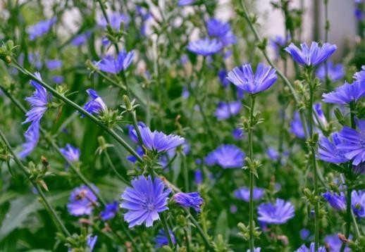
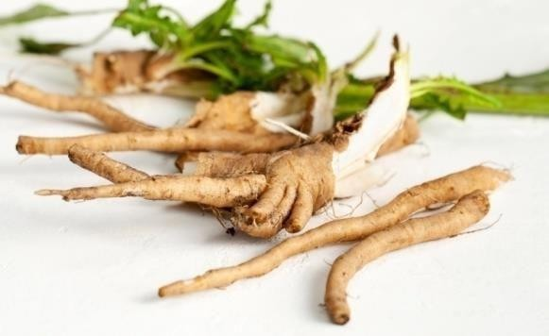
- The leaves and flowers are usually used as vegetables in salads and the roots are used as a coffee substitute.

Constituents of Chicory:
- Chicory root contains some phytochemicals such as inulin (starch-like polysaccharide), coumarins, flavonoids, sesquiterpene lactones (lactucin and lactucopicrin), tannins, alkaloids, vitamins, minerals, and volatile oils
- Fresh chicory roots contain, 68% of inulin (a polysaccharide similar to starch), 14% sucrose, 5% cellulose, 6% protein, 4% ash, and 3% other compounds
- Dry chicory root extract contains, by weight, approximately 98% inulin and 2% of other compounds.
- It includes condensed tannins.
- The very common phytocompounds are phenolic acids, which include chlorogenic acids, and flavonoids (anthocyanins, flavonols, flavanone, and flavan-3-ols).
- The plant polyphenols usually occur as glycosides,
- The anthocyanins have been reported to reduce the risk of coronary heart disease in animals by exhibiting arterial protection, inhibition of platelet aggregation, and protection of endothelial tissues
- Chicory comprises less fibre, more protein, more soluble sugars, and greater mineral content (P, K, S, Ca, Mg, Na, Zn, Cu, and B).
- The leaves contains-Gallic acid, Protocatechuic acid Chlorogenic acid, p-Hydroxybenzoic acid Caffeic acid, Isovanillic acid, p-Coumaric acid
- Roots contains - Protocatechuic acid Chlorogenic acid, Caffeic acid, m-Coumaric acid, p-Coumaric acid

Uses of Chicory:
- Chicory is used for loss of appetite, upset stomach, constipation, liver and gallbladd - er disorders, cancer, and rapid heartbeat.
- It is also used as a “tonic,” to increase urine production, to protect the liver, and to balance the

stimulant effect of coffee.

- Some people apply a paste of chicory leaves directly to the skin for swelling and inflammation.
- The anthocyanins have been reported to reduce the risk of coronary heart disease in animals by exhibiting arterial protection, inhibition of platelet aggregation, and protection of endothelial tissues.

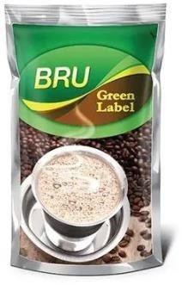
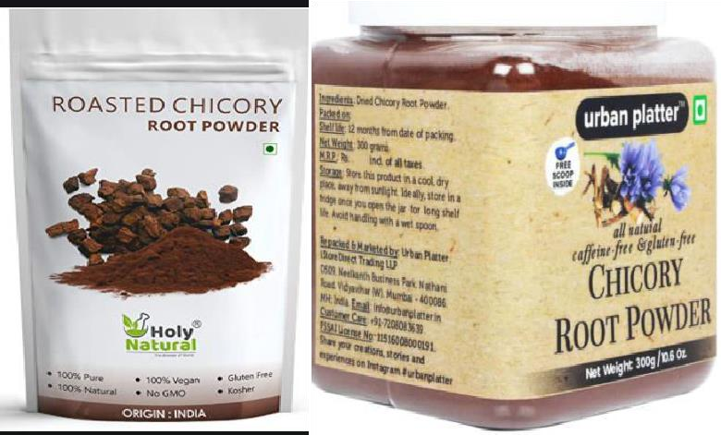
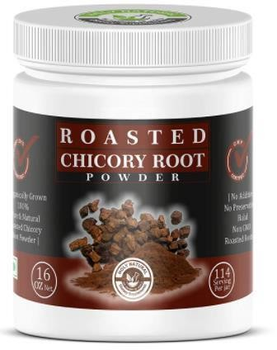
3) Ginger
Synonyms: Rhizoma zingiberis, Zingibere.

Biological Source: Ginger consists of the dried rhizomes of the Zingiber officinale Roscoe, belonging to family Zingiberaceae.
Constituents of Ginger:

Chemical Constituents
- Ginger contains 1 to 2% volatile oil (aromatic odour, pungency)
- Pungency: yellowish oily body called gingerol which is odourless.
- 5 to 8% pungent resinous mass and starch.
- Volatile oil is composed of sesquiterpene hydrocarbon like α-zingiberol; α-sesquiterpene alcohol α- bisabolene, α-farnesene, α-sesquiphellandrene.
- Less pungent components: like gingerone and shogaol are also present.
- Shogal is formed by the dehydration of gingerol and is not present in fresh rhizome.

Uses of Ginger:
- Ginger is used as an antiemetic, positive inotropic, spasmolytic, aromatic stimulant, carminative, condiment, and flavouring agent.
- It is prescribed in dyspepsia, flatulent, colic, vomiting spasms, as an adjunct to many tonic and stimulating remedies, for painful affections of the stomach, cold, cough, and asthma.
- Sore throat, hoarseness, and loss of voice are benefited by chewing a piece of ginger.

Marketed nutraceuticals products of Ginger:
- It is one of the ingredients of the preparations known as Pain kill oil, J.P. Liver syrup (Jamuna Pharma), Abana, Gasex (Himalaya Drug Company), Hajmola (Dabur), Strepsils (Boots Piramal Healthcare), and Sage Massaj oil (Sage Herbals).

