HERBAL DRUG TECHNOLOGY BP603T
UNIT: II
TOPIC: Health benefits and role of Nutraceuticals in ailments like Diabetes, CVS diseases
CLASS: 3
- Health benefits and role of Nutraceuticals in ailments like Cancer
- Cancer: Cancer is the uncontrolled growth of abnormal cells anywhere in a body. These abnormal cells are termed cancer cells, malignant cells, or tumor cells.
- There are over 200 types of cancer. Some of them are:
- Bladder Cancer.
- Breast Cancer.
- Colorectal Cancer.
- Kidney Cancer.
- Lung Cancer - Non-Small Cell.
- Lymphoma - Non-Hodgkin.
- Melanoma.
- Oral and Oropharyngeal Cancer etc.
Types of Cancer:
Cancers are named for the area in which they begin and the type of cell they are made of, even if they spread to other parts of the body. For example, a cancer that begins in the lungs and spreads to the liver is still called lung cancer. There are also several clinical terms used for certain general types of cancer:
- Carcinoma is a cancer that starts in the skin or the tissues that line other organs.
- Sarcoma is a cancer of connective tissues such as bones, muscles, cartilage, and blood vessels.
- Leukemia is a cancer of bone marrow, which creates blood cells.
- Lymphoma and myeloma are cancers of the immune system.
Causes for cancer:

The direct cause of cancer is changes (or mutations) to the DNA in your cells. Genetic mutations can be inherited. They can also occur after birth as a result of environmental forces. Some of these forces include:
  - exposure to cancer-causing chemicals, called carcinogens
  - exposure to radiation
  - unprotected exposure to the sun
  - certain viruses, such as human papilloma virus (HPV)
  - smoking
  - lifestyle choices, such as type of diet and level of physical activity
Cancer risk tends to increase with age. Some existing health conditions that cause inflammation may also increase your risk of cancer. An example is ulcerative colitis, a chronic inflammatory bowel disease.

Nutraceuticals in cancer:
- Polyphenols: the groups of phenolic acids, flavonoid, stilbenes and curcuminoids are the most important for their capacity for blocking initiation of carcinogenic process and to suppress cancer progression.Sources: mainly, wine, tea, coffee, cocoa, vegetables and cereals
- Epigallocatechin-3-gallate: EGCG is the major catechin found in green tea (Camellia sinensis). the wide range of antitumor effects exerted by EGCG suggests that this compound is a potential tool for cancer prevention and therapy, both alone and in combination with antitumor drugs or other phytochemical. it is a potent anti oxidant.
- Resveratrol: Resveratrol is the most important stilbene related to cancer. It possesses a natural anti-proliferative activity due to its role as a phytoalexin (plant antibiotic). It is believed to have also multiple bioactivities including anti-cancer, anti-carcinogenesis and anti-inflammatory effects. Source: black grapes, red wine.

- Quercetin: Quercetin, a representative member of the flavonoid class, is a plant-derived compound obtained from various fruits and vegetables that can reach levels in the human diet as high as 16-25 mg/day, oral administration can prevent induced carcinogenesis, particularly in the colon and furthermore, quercetin can inhibit melanoma growth, invasion, and metastatic potential. Source: apples, honey, raspberries, onions, red grapes, cherries, citrus fruits, and green leafy vegetables.
- 5. Vitamins and Minerals in Cancer Management

The role of vitamins A, C, E and trace elements like selenium has been suggested to prevent cancer in several independent studies
- Genistein: A Potent Isoflavone. Many phytochemicals are currently being investigated for their promising anticarcinogenic properties.
Among isoflavones, the three major constituents that have been shown to have remarkable influences in cancer prevention and therapy are genistein, diadzein, and glycitin.
They are collectively grouped as phytoestrogens for their weak estrogen-like activity and bind preferentially to ERβ receptors and prevent colon cancer as well as Brest cancer.
Sources: soya beans, cereals, soy food
- Vitamin D (Vit D) has potent tumor prevention ability and can induce differentiation and apoptosis in some of the most predominant cancers.
- Herbs: vinca (Catharanthus roseus)- vinchristine and vinblastine: prevents blood cancer,
Taxus brevifolia- taxol: prevents breast cancer

Marketed nutraceuticals for the treatment and prevention of cancer
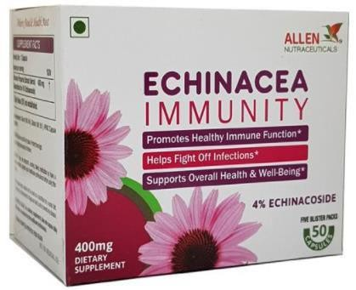
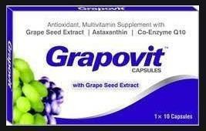
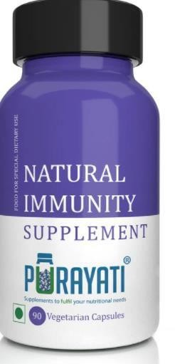
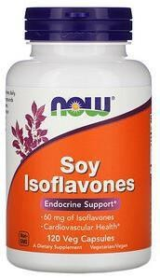
- Health benefits and role of Nutraceuticals in ailments like Irritable Bowel Syndrome
Risk factors leading to Irritable bowl syndrome:
- Irritable bowel syndrome (IBS) is a common disorder that affects the large intestine.
- Signs and symptoms include cramping, abdominal pain, bloating, gas, and diarrhea or constipation, or both.
- IBS is a chronic condition that you'll need to manage long term.

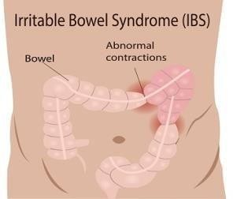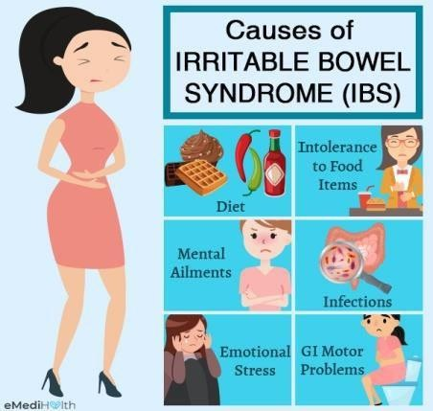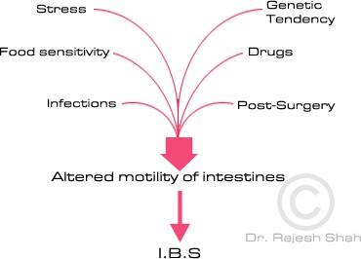

Nutraceuticals in ailments like Irritable bowl syndrome

- Probiotics:
  - Probiotics are defined as live microorganisms that are believed to provide health benefits when consumed.
  - Probiotics are often called "good" or "helpful" bacteria because they help keep your gut healthy.
  - They can help balance your "good" and "bad" bacteria to keep your body working like it should. Species of Lactobacillus, Bifidobacterium, yeast Saccharomyces cerevisiae, some E. coli and Bacillus species are also used as probiotics.
- Prebiotics:

  - Prebiotics are food ingredients that induce the growth or activity of beneficial microorganisms
(e.g., bacteria and fungi).
  - The most common example is in the gastrointestinal tract, where prebiotics can alter the composition of organisms in the gut microbiome.
  - In diet, prebiotics are typically non-digestible fiber (fructo oligosaccharides) compounds that pass undigested through the upper part of the gastrointestinal tract and stimulate the growth or activity of advantageous bacteria that colonize the large bowel by acting as substrate for them.
  - Sources: Apples. Artichokes, Asparagus, Bananas, Barley, Berries, Chicory, Cocoa. Sources of probiotics:

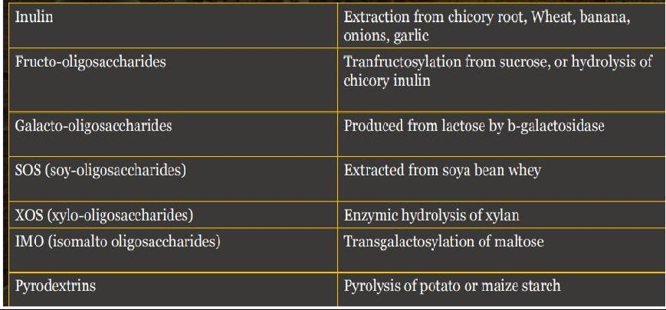
- Super Fibers: Dietary fiber found in plant foods (fruits,vegetables and whole grains) and is essential to maintain healthy digestive system.
  - Two types of fiber i.e. soluble fiber (gums & pectins) which can dissolve in water which helps to lower blood fat and maintain blood sugar. E.g. beans, fruit such as strawberry & banana and oat products, barley.
  - Insoluble fibers cant dissolve in water, so directly passes through the digestive tract and helps to trap cholesterol, toxins etc. that are then expelled through feces. E.g. cellulose, hemicelluloses in bran, leafy vegetables.
- Antioxidants:
  - An antioxidant is a molecule that inhibits the oxidation of other molecules.
  - Antioxidants terminate these chain reactions by removing free radical intermediates, and inhibit other oxidation reactions and in turn oxidizing themselves.
  - Dietary antioxidants and some accessory molecules, such as zinc and certain vitamins are important in maintaining free radical scavenging systems, biosynthetic capacity, membranes, enzymes.
  - Antioxidants are found in the vegetable oils. e.g.- Soybean oil, canola oil, corn oil, oat oil, wheat germ oil, palm oil, evening prime rose oil.
  - 5. Dietary peptides and amino acids (AAs): These have been shown to modulate intestinal
immune functions and influence inflammatory responses, being involved in reducing inflammation, oxidative stress, and apoptosis in the gut.
  - Any protein source can produce bioactive peptides, milk being the best studied, but bioactive peptides from egg, fish, meat, algae or soy have also been reported.
  - 6. Dietary lipids are one of the most active nutritional substrates modulating the human immune response and, in particular, the gut mucosal immune system.

  - The behavior of polyunsaturated fatty acids (PUFA) have been widely investigated during inflammatory processes and also in the IBD setting.
  - The most interesting fatty acids are the n-6 PUFA arachidonic acid (AA), which is the precursor of inflammatory eicosanoids like prostaglandin E(2) and leukotriene B(4), and the n-3 PUFAs eicosapentaenoic acid (EPA) and docosahexaenoic acid (DHA), which are abundant in fish oils.
  - 7. Phytochemicals: curcumin, aloe gel, flavonoids, pista and anthocyanins can prevent IBS.
Marketed nutraceuticals for the treatment and prevention of Irritable bowl syndrome:
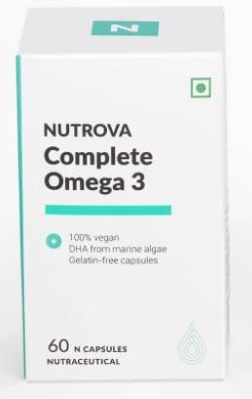
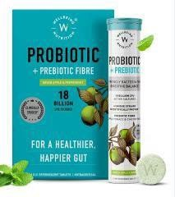
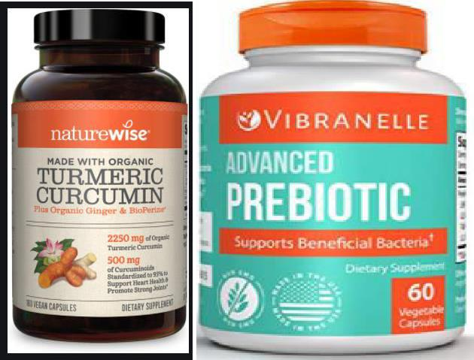

- Health benefits and role of Nutraceuticals in ailments like GI Diseases
The 13 most common gastrointestinal conditions:
- Celiac Disease: Celiac disease is an autoimmune disorder that's triggered when you eat gluten. It's also known as celiac sprue, nontropical sprue, or gluten-sensitive enteropathy.
- Irritable Bowel Syndrome (IBS):
- Lactose Intolerance
- Chronic Diarrhea
- Constipation
- Gastroesophageal Reflux Disease (GERD)
- Peptic Ulcer Disease
- Crohn’s Disease: Crohn's disease is a type of inflammatory bowel disease (IBD). It causes inflammation of your digestive tract, which can lead to abdominal pain, severe diarrhea, fatigue, weight

loss and malnutrition. Inflammation caused by Crohn's disease can involve different areas of the digestive tract in different people
- Ulcerative Colitis
- Gallstones
- Acute and Chronic Pancreatitis
- Liver Disease
- Diverticulitis: Diverticulitis is the infection or inflammation of pouches that can form in your intestines. These pouches are called diverticula. The pouches generally aren't harmful. They can show up anywhere in your intestines. If you have them, it's called diverticulosis.

Symptoms for Gastro Intestinal diseases:
  - Symptoms of digestive disorders obviously vary from condition to condition and from person to person. However, some symptoms are common to most gastrointestinal problems. Common symptoms include:
  - Abdominal discomfort (bloating, pain or cramps)
  - Unintentional weight loss
  - Vomiting and nausea
  - Acid reflux (heartburn)
  - Diarrhea, constipation (or sometimes both)
  - Fecal incontinence
  - Fatigue
  - Loss of appetite
  - Difficulty swallowing.
Causes for Gastro Intestinal diseases:
  - A low fiber diet
  - Being stressed
  - Not drinking enough water
  - Eating a lot of dairy foods
  - Inactive lifestyle
  - Aging
  - Genetic factors

Nutraceuticals in Gastro Intestinal diseases:
    - Flavonoids: provide an antimicrobial effect, offering protection against pathogenic bacteria, fungi, and viruses. In this era of antimicrobial resistance, flavonoids may be considered suitable alternatives to antibiotics, especially in mild/moderate infections or in their prevention. Sources: fruits (apples, all berries, grapes) and vegetables (tomatoes, broccoli, spinach etc.)

    - Aloe vera is one of the common herbal remedies that has been used in GI conditions such as diarrhea, including inflammatory bowel disease (IBD).
It contains several compounds (anthraquinones, carbohydrates, vitamins, minerals, enzymes, and amino acids) with many beneficial effects. Moreover, it is considered an important and natural source of prebiotics.
It is also used Aloe vera in the treatment of ulcerative colitis (UC).
    - Turmeric (Curcuma longa) is commonly used as a spice, food preservative, and a coloring agent in foods. It contains a class of phenols, known as curcuminoids.
Oral administration of curcumin proved to be a therapeutic agent in the maintenance of UC. Curcumin can also be used as enema and was demonstrated to be very effective in chronic enteritis such as IBD, without raising concerns regarding its safety. Curcuminoids act as an antiinflammatory agents. It suppresses the nuclear factor kappa light-chain-enhancer of the activated B cells (NF-κB)-related inflammatory pathway. Curcumin modulates the immune response as a safe and promising agent for the treatment of chronic diarrhea.

    - Capsaicin is present in hot chilies, and it requires calcium to inhibit SNAT2-mediated methionine transport and causes apoptosis and DNA damage in enterocytes.
    - Ginger (rhizome of Zingiber officinale) has been widely used for centuries in GI disorders such as dyspepsia. It has a protective role in gastric ailments and irritations such as ulcers, vomiting, nausea, stomach ache, spasm, and GI cancer. It increases GI motility .
    - “Isoflavonoids,” of which substantial amount is found in soy, soy protein, and miso (The traditional Japanese seasoning produced by fermenting soybeans with salt and kōji (the fungus Aspergillus oryzae). Isoflavones are conjugated to glucose contain many glycosides, such as genistein, daidzein, and glycitein. Daidzein is metabolized by gut bacteria to equol, which plays an important role in the health benefits of soy. It also has strong estrogenic activity and antioxidant capacity. The main bacteria that contribute to the conversion of the isoflavonoids of the gut and belong to the family Coriobacteriaceae.
    - Poly phenols: A group of polyphenols is known as lignans, its precursors are found in a wide variety of plant-based foods, including seeds such as flaxseeds, soybeans, strawberries, carrots, cabbage, onion, garlic, and cucumber.They are rich in the omega-3 fatty acid, alpha-linolenic acid, aminolevulinic acid, etc.
They can be used to improve digestive health, lower blood pressure, and bad cholesterol, reduce the risk of cancer, and may benefit people with diabetes.
Polyphenols are also abundant in cocoa powder, dark chocolate, berries, beans, nuts, vegetables (red onion, spinach), soy, tea (black and green), and red wine. The polyphenols’ bioavailability is increased by the microbiota.
    - Spirulina: Spirulina (Arthrospira platensis) is a Blue-green algae, a kind of cyanobacteria, e.g., mostly used as a food supplement, has the capacity to inhibit the growth of Gram- positive and Gram-negative bacteria (Staphylococcus aureus, Bacillus subtilis, E. coli, Pseudomonas aeruginosa, etc.). This antibacterial effect is due to an extracellular metabolite produced by Spirulina.These substances have well-

known antimicrobial and bacteriostatic effects as well as the capacity to stimulate the growth of probiotics.
    - Fat-soluble vitamins: such as A, D, E, and K. The deficiency of vitamin D, whose main source is endogenous production in the skin upon exposure to sunlight, was found to be significantly associated with IBD.
    - Dietary peptides and amino acids have been shown to modulate intestinal immune functions and influence inflammatory responses, being involved in reducing inflammation, oxidative stress, and apoptosis in the gut.
    - Probiotics are “live microorganisms” that benefit the host by modulating mucosal and systemic immunity and provide nutritional and microbial balance in the intestinal tract.

Marketed nutraceuticals for the treatment and prevention of gastric diseases
