UNIT: II
TOPIC: Health benefits and role of Nutraceuticals in ailments like Diabetes, CVS diseases
CLASS: 2
Health benefits and role of Nutraceuticals in ailments like Diabetes
- Diabetes Mellitus is a complex metabolic disorder associated with developing insulin resistance, impaired insulin signalling and β-cell dysfunction, abnormal glucose and lipid metabolism, sub-clinical inflammation and increased oxidative stress.
- The main reasons for diabetes are aging and a constant increase in obesity; these metabolic disorders lead to long term pathogenic conditions including micro-vascular and macrovascular complications, neuropathy, retinopathy, nephropathy, and a consequent decrease in quality of life and an increase in the rate of mortality.
- For the progression of type 2 diabetes mellitus, diet is the main modifiable factor.
- The diet rich in foods with high content of phytochemicals, high total antioxidant capacity and polyphenolic compounds may be related to lower risk of diabetes and predisposing factors.

Nutraceuticals in ailments like Diabetes:
- Nutraceuticals are non-specific biological therapies used to promote wellness, prevent malignant processes and control symptoms. These can be grouped into the following three broad categories.
1. Lipoic acid: lipoic acid is a universal antioxidamt for the treatment of diabetic neuropathy. It is more effective in prophylactic protection and diabetic complications.
- Sources: tomatoes, peas, beats, broccoli, spinach, carrot.

2. Antioxidant of vitamins
i) Vitamin C
- Vitamin C (ascorbic acid) is a chain-breaking antioxidant, scavenging ROS (reactive oxygen species) directly, and preventing the propagation of chain reactions that would otherwise lead to a reduction in protein glycation.

- Sources: all cirus fruits, gvava
- ii) Calcium/vitamin D: It acts by suppressing secretion of parathyroid hormone (PTH), good calcium/ vitamin D status may help to preserve insulin sensitivity and thus help prevent diabetes mellitus.
- Sources: milk and milk products
- iii) Vitamin E :Low levels of vitamin E have been associated with increased incidence of diabetes and some research suggests people with diabetes have decreased levels of antioxidants. It prevents the secondary hyperglycaemia.
- Sources: Wheat germ oil. Sunflower, safflower, and soybean oil. Sunflower seeds. Almonds. Peanuts, peanut butter.
- 3. Carbohydrates: The total amount of carbohydrates is the main factor responsible for the post- prandial response, such as type of carbohydrate, richness in fibre, the way of cooking, degree of maturity, etc. it may prevent both post-prandial hyperglycaemia and late hypoglycaemia.
- Sources: oligosaccharides containing food: onion, soybean, asperagus, broccoli etc.
- 4. Fats : Research suggests monounsaturated fat such as canola, olive and peanut oils may have beneficial effects on triglycerides and glycaemic control in some individuals with diabetes, Omega-3 fatty acids, found in fish such as salmon and mackerel may reduce serum triglycerides without impairing glycaemic control.
- 5. Dietary Fibre: The protective effect of fibres against some chronic diseases is well established the effectiveness of fibres in lipid and glycaemic metabolism remains uncertain. Sources: psyllium
- 6. Protein plays a role in stimulating insulin secretion, excessive intakes should be avoided as it may contribute to the pathogenesis of diabetic nephropathy
- suggests eating vegetable protein rather than animal protein is better for reducing serum cholesterol and managing nephropathy. sources include: Whey, Casein, Soy, Rice, and Egg
- 7. Anti-diabetic claims of herbs:
- Acacia arabica, Allium cepa, Allium sativum, Aloe vera, Azadirachta indica, Beta vulgaris, Cajanus cajan, Camellia sinensis, Ocimum sanctum.
- NUTRACEUTICALS available in market:
- Kapiva Diabetes Care Pack, containing Karela Jamun Juice
- Marketed nutraceuticals for the treatment and prevention of diabetes

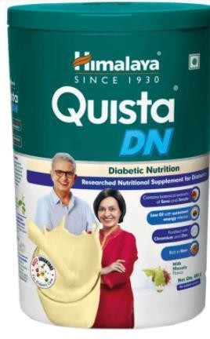
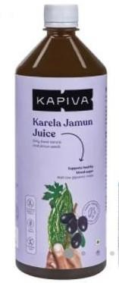
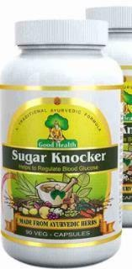
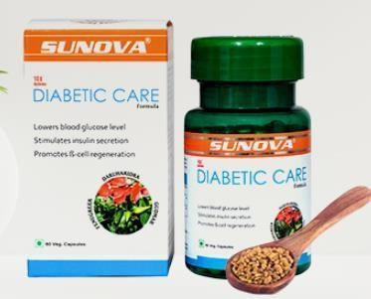
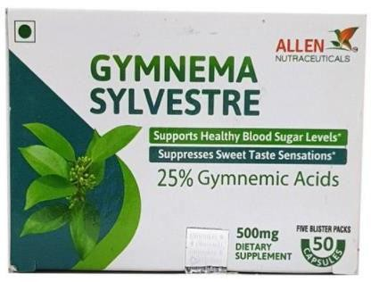

2. Health benefits and role of Nutraceuticals in ailments like CVS diseases
- Cardio vascular diseases:
  - Abnormal heart rhythms, or arrhythmias.
  - Aorta disease and Marfan syndrome.
  - Congenital heart disease.
  - Coronary artery disease (narrowing of the arteries)
  - Deep vein thrombosis and pulmonary embolism.
  - Heart attack.
  - Heart failure.
  - Heart muscle disease (cardiomyopathy)
Risk factors leading to cardiovascular diseases
- Smoking. ...
- High cholesterol. ...
- Diabetes. ...

- Being overweight or obese. ...
- Family history of CVD. ...
- Stress …..
- Unhealthy and improper diet…..

Nutraceuticals in ailments like cardio vascular diseases:
- Poly phenols:
Phenols have been shown to reduce cholesterol levels and LDL oxidation. Polyphenolic cathechin which is present in Green tea (Camellia sinensis) reduces the CVD by enhancing antioxidant activity by improving endothelial dysfunction, preventing cardiac hypertrophy and protects mitochondria.
  - Oxyphyte is now a days available products of polyphenolic extracts of green tea, apple, pomegranate and red grape (reveratrol)

Spirulina
  - Spirulina is a blue-green microalga (Cyanobacterium). Spirulina is a rich source of protein, vitamins, minerals, carotenoids, and phycocyanins. It prevents the deposition of LDL and total cholesterol.

Phytosterols:
Consumption of plant sterols/stanols has been shown to be associated with lower circulating concentrations of TC in humans and LDL-C reduction.
- Super Fibers: Dietary fiber found in plant foods (fruits,vegetables and whole grains) and is essential to maintain healthy digestive system.
  - Two types of fiber i.e. soluble fiber (gums & pectins) which can dissolve in water which helps to lower blood fat and maintain blood sugar. E.g. beans, fruit such as strawberry & banana and oat products, barley.
  - Insoluble fibers cant dissolve in water, so directly passes through the digestive tract and helps to trap cholesterol, toxins etc. that are then expelled through feces. E.g. cellulose, hemicelluloses in bran, leafy vegetables.

Fats for Vascular Health
  - The cardiovascular benefits of omega 3 oils are no secret.
  - Sources : Marine plants, algal sources such as Alpha linolenic acid (ALA), Eicosapentaenoic acid (EPA) and Docosahexaenoic acid (DHA) Vegetable oil such as soyabean, sunflower and nut like Peanuts and Almonds
  - Omega 3 consumption appears to reduce the risk of LDL-c oxidation.

Tocotrienols:
Tocotrienols are members of a subgroup of the vitamin E family, which includes tocopherols. Both tocotrienols and tocopherols are antioxidants, but only tocotrienols have been shown to reduce cholesterol, inhibit certain cancers and manage diabetes.
- Vitamin D (Calciferol): Vitamin D acts as a hormone, regulating more than 200 genes throughout the body.
  - It helps regulate blood pressure in the kidney
  - Vitamin D: Its direct effects on the arterial wall may protect against atherosclerosis through the inhibition of macrophage cholesterol uptake as and foam cell formation, reduced vascular smooth muscle cell proliferation, and reduced expression of adhesion molecules in endothelial cells.

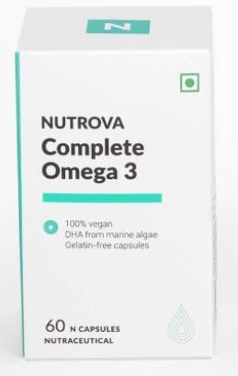
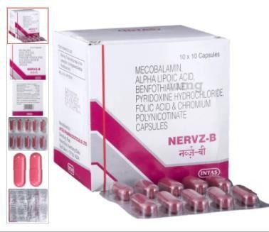
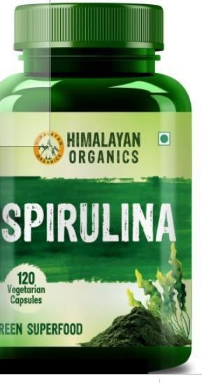
Raghu college of
pharmacy page no-5

    - Sources : sunlight, Fish oils, Egg yolk, Butter, Liver and in fortified foods
- Pantethine It is a dimeric form of pantothenic acid (vitamin B5 )
  - The biologically active co-enzyme similar to vitamin B5 is the precursor for coenzyme A.
  - Pantethine further reduces cardiovascular risk by inhibiting platelet clumping and the production of the inflammation producing chemical, thromboxane A2 (CVR).
  - Sources: milk, egg, peas, starchy veg.
- Cocoa beans: It lowers LDL
  - (dark chocolate: 37 gm/day) dec. hypertension
- Garlic: allicin (potent antiplatelet activity, enhance vaso dilation, block angiotension II, and lowers LDL.

Marketed nutraceutical

