UNIT-2 MAJOR EXTRA AND INTRA CELLULAR ELECTROLYTES
TOPIC- ELECTROLYTE USED IN REPLACEMENT THERAPY

ELECTROLYTES USED IN REPLACEMENT THERAPY: →
In normal conditions, the body is able to adjust the electrolyte balance.
while in some conditions like fever, severe Vomiting / diarrhoea there occurs a heavy loss of water & electrolytes.
So, need to administration of lost electrolytes. Electrolyte used in replacement therapy are →

1. Sodium chloride, 2. Potassium chloride,

- Calcium Gluconate*. 4. ORS

Sodium Chloride *

CF-Nacl

(MoW - 58.44)

General method of Preparation -
In laboratory - Prepared from common salt (Nacl) in water by passing Hcl acid gas. Industrially- prepared by
Evaporation of sea-water in shallow pans.
Impurity are removed by dissolving common salt in water in cemented tanks. Some alum & lime are added. The suspended impurities get settle down easily.

Physical properties- colorless, saline taste white, crystalline powder.

Chemical Properties-
(1) Nacl easily oxidised to liberate free chloride.
E.g Nacl heating with manganese dioxide and conc. sulfuric acid produce chlorine. 2Nacl + Mno2 + 2 H₂SO4 MnSO4 + Na2 SO4 + 2H2O + Cl2

2) Nacl + AgNo3 AgCl + NaNO3

Uses →
Used at fluid & electrolyte resplenisher. Used in homeopathetic medicine.
Solution of sodium chloride, used as an eye-drop, nasal drop & mouthwash.

Assay

Accurately weigh the Nacl (0.1gm) Dissolve in 50ml water.
Add 50ml OF 0.1N AgN03, 3 ml HNO3, 5ml nitro benzene, 2ml Ferric ammonium sulphate
Mix. Thoroughly

solution is titrated with ammonium thiocyanate until the color becomes brick red.

Potasium Chloride

(M-W- 74.55)

CF – KCl

Properties

Colourless, odourless & crystalline powder, saline.
  - soluble in water, glycerol, insoluble in alcohol, ether.

Uses
  - used as electrolyte, replenisher

  - Treatment of • potassium deficiency, myasthenia gravis Antidote For digitalis toxicity

3 Calcium Gluconate

Chemical Formula → [HOCH₂ (CHOH)4 C00]₂ Ca Molecular Formula- C12 H22 Ca O14
M.W 430.37

Method of preparation - Prepared by boiling solution of gluconic acid and with excess of calcium

carbonate. Filtering & crystalizing the substance from Filtrate.

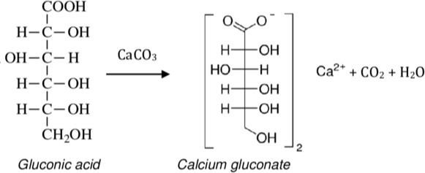
2 CH₂(OH) [(CHOH)]4 COOH + CaCO3
[HOCH2 (CHOH)4 COO]2 Ca + CO2 + H2O
Gluconic acid
Calcium
Carbonate
Calcium Gluconate

Properties
0dourless, White crystalline powder, tasteless.

freely soluble in - boiling water Sparingly soluble in-water
Insoluble in- alcohol, ether & chloroform.

Uses-
used as source of calcium ion in the treatment of calcium deficiency (hypocalcemic tetany).

