HERBAL DRUG TECHNOLOGY BP603T
UNIT: II
TOPIC: General aspects, Market, growth, scope and types of products available in the market of nutraceuticals
CLASS: 1
General aspects nutraceuticals
- Nearly two thirds of the world’s 6.1 billion people rely on the healing power of plant based materials for many reasons -availability, affordability, safety or their belief in traditional cures
- Medical benefits of food have been explored for thousands of years
- Modern nutraceutical industry began to develop in Japan during the 1980s.

Nutraceuticals:
- Nutraceuticals is derived from two words: Nutrition + Pharmaceuticals
- Term commonly used in marketing but has no regulatory definition
- Term commonly used synonymously for designer foods, health foods, fortified foods, medifoods, vita foods, pharma foods, functional foods and dietary supplements.
- Definition of nutraceuticals: The term “nutraceutical” was coined from “nutrition” and “pharmaceutical” by Stephen De Felice, founder and chairman of the Foundation for Innovation in Medicine, Cranford, NJ, in 1989.
- According to De Felice, nutraceutical can be defined as “A food (or a part of food) that provides medical or health benefits, including the prevention and or treatment of a disease” Eg: lycopene, beta carotene
- Classification of Nutraceuticals:
The food sources used as nutraceuticals are all natural and can be categorized as
- Dietary Fiber: ex: starches, oligosaccharides
- Probiotics: ex: Lactobacillus
- Prebiotics: ex: gut microbiome.
- Polyunsaturated fatty acids: omega-3 & omega-6 FA

- Antioxidant vitamin: ex: ascorbic acid (vitamin C), tocopherols and tocotrienols (vitamin E), carotenoids
- Polyphenols: Resveratrol, rutins, isoflavones
- Spices: turmeric, cinnamon, clove etc.
Global Market and growth of nutraceuticals:
  - It is the Constantly growing market
  - Nearly 2/3rd of Americans& 47% of Japanese consume atleast one type of nutraceutical annually
  - Industry worth 86 billion$ annually in USA Slightly higher in Europe
  - Industry amounting to 60 billion$ annual food sales in Japan

Nutraceuticals Scenario in India:
  - The Indian nutraceuticals industry has great prospects.
  - Over the last decade a wide range of products have been available, giving an insight into the tremendous growth.
  - On one hand a booming economy has resulted in overall increase in disposable income
of population.
  - There is a growing awareness on the importance of nutrition and diet for long term good health.
  - India has a lot of advantages like qualified human resources, world class R & D facilities and varied raw material-aspects that give our country a leading edge.
  - The Indian Nutritional market is estimated to be USD 1 Billion. While the global market is growing at a CAGR (Compound Annual Growth Rate) of 7%, the Indian market has been growing much faster at a CAGR of 18% for the last three years, driven by Functional food and beverages categories.
  - However the latent market in India is two to four times the current market size and is between USD 2 to USD 4 billion with almost 148 million potential customers. In USD 1 billion market size functional food having 54% market share followed by 32% market share of Dietary supplement and 14% share of Functional beverages.

  - The Indian nutraceutical market is dominated primarily by pharmaceuticals and FMCG (Fast-Moving Consumer Goods) companies with very few pure play nutraceutical companies.
  - Some major companies Marketing Nutraceuticals in India are GlaxoSmithKline consumer healthcare, Dabur India, Cadila Health care, EID Parry’s, Zandu Pharmaceuticals, Himalaya herbal Healthcare, Amway, Sami labs, Elder pharmaceuticals and Ranbaxy
  - The Indian nutraceutical market is dominated primarily by pharmaceuticals and FMCG (Fast-Moving Consumer Goods) companies with very few pure play nutraceutical companies.
  - Some major companies Marketing Nutraceuticals in India are GlaxoSmithKline consumer healthcare, Dabur India, Cadila Health care, EID Parry’s, Zandu Pharmaceuticals, Himalaya herbal Healthcare, Amway, Sami labs, Elder pharmaceuticals and Ranbaxy
  - Indian market growing at the rate of 21% per year AMWAY- highest market share - over 15% Dabur, Ranbaxy, Pfizer Other major companies
  - Scope of nutraceuticals:
  - 90 % of people are living with cancer which will be diagnosed at the end of second or third stage.
  - 35%of population have various undiagnosed chronic diseases.
  - 50% of people are with heart problems.
  - More than 1,96,000 people die and 2.2 million are injured each year by adverse reactions to prescription drug.
  - The use of prescription drugs is the 3rd leading cause of death.
  - 65% of adult Americans are over weight and 30% are obese according to National centre for health statistics.

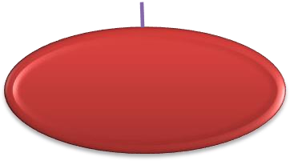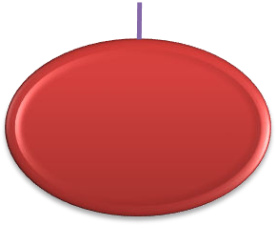
PROBIOTICS & PREBIOTICS
PUFA
PHENOLS
VITAMINS
NUTRACEUTICALS
MAJOR
CONSTITUENTS
FLAVONOIDS
MINERALS
CATECHINS
ANTIOXIDANTS
ANTIDIABETIC
INFLAMMATION
Nutraceuticals
ARTHRITIS
benefits
PREVENTS CARDIAC DISEASES
PREVENTS
OBESITY
PREVENTS CANCER

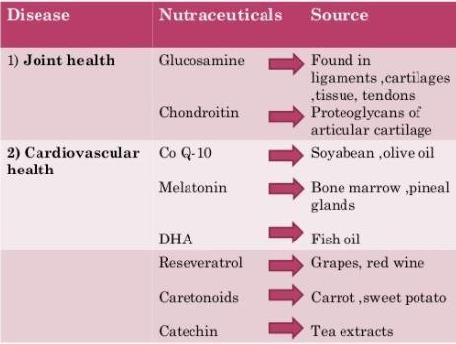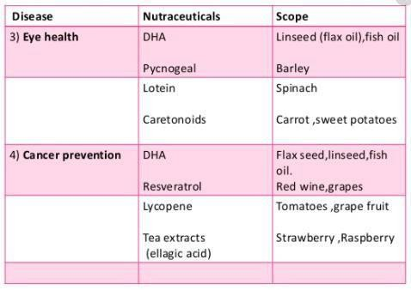

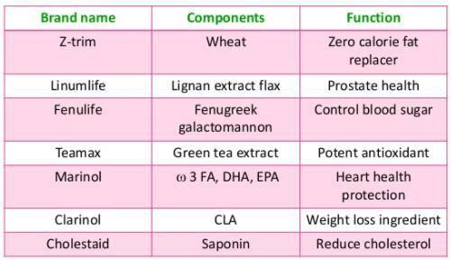
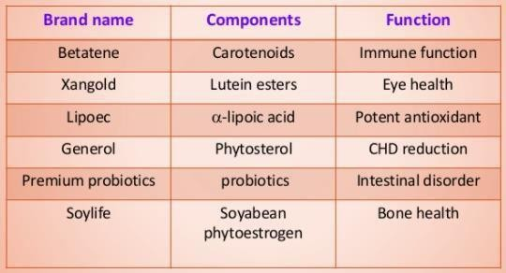
Types of products available in the market of nutraceuticals:

