SUBJECT NAME & CODE: PHARMACEUTICAL ENGINEERING(BP304T)
UNIT: 1 (FLOW OF FLUIDS)

CLASS:1

TOPIC: TYPES OF MANOMETERS, REYNOLDS NUMBER AND ITS SIGNIFICANCE

FLOW OF FLUIDS
Fluid flow may be defined as the flow of substances that do not permanently resist distortion.
This definition covers the flow of liquids and gases. Fluid is considered to be a mass of a substance formed by a series of layers. When an attempt is made to change its shape, the layers of fluid slide over one another, until a new shape is attained. At the end, the fluid is relieved off the stresses that it encountered during the flow. Flow of fluids is observed while handling materials.
- Handling of liquids: Transportation of materials such as solvents, solutions and suspensions is simpler, cheaper and less troublesome than handling of solids in industrial operations.
- Handling of solids: Solids are handled in a finely divided state in the form of suspension of fluids, so that transportation becomes easy. This two-phase mixture is known as 'fluidised solids'.
During the handling process, the behaviour of liquids changes transiently. Such changes have profound influence on heat transfer process, energy losses during pumping, energy changes in pumping etc. Therefore, ‘fluid flow’ is treated independently.
Flow of fluids is involved in a number of areas of pharmaceutical industries. Some of them are:
  - Passing of reactants (liquids and gases) into the reaction system.
  - Transferring of air, nutrients, broth into fermenter.
  - Bottling of liquid (dosage forms) medicaments into suitable containers.
  - Transporting of sterile air and sterile water in the production of parenterals.
  - Mixing of solids and liquids in case of suspensions.
  - Packing of semisolids in containers.
The nature of flow influences the type of equipment used for handling. Flow characteristics through pipes and channels are relevant.
At the same time, the measurement of rate of flow is necessary for the quantification of additives (reactants) into a process. The subject of fluid flow can be divided into fluid statics and fluid dynamics.
Fluid statics deals with fluids at rest in equilibrium. Fluid dynamics deals with fluids in motion.

FLUID STATICS
Fluid statics deals with the fluids at rest in equilibrium. The behaviour of a liquid at rest, the nature of pressure it exerts and the variation of pressure at different layers in the liquid are some of the relevant aspects in the pharmaceutical engineering.

The study of fluids at rest is based on two principles.
- Pressure at a point is the same in all directions.
- Pressure is the same at all points in a given horizontal line in a continuous fluid.

Pressure Difference Between Layers of Liquids
Consider a column of liquid as shown in Figure (a). Two openings are provided to the wall of the vessel at different heights. The rate of flow from these openings is different (Figure a). This is due to the differences in the pressures exerted at different heights. This behaviour can be quantitatively expressed as follows.
Consider a stationary column of fluid as shown in Figure (b). The pressure ps, pascals is acting on the surface of the fluid. The stationary column is maintained at constant pressure by applying pressure. P pascals at point A.
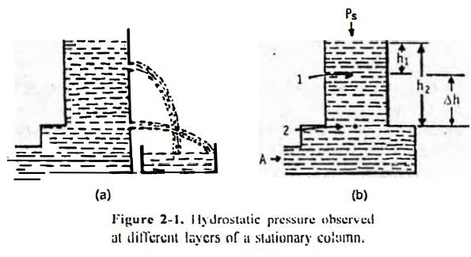
Let the cross-section of the column be S metre square and is uniform from top to bottom. The force (further pressure) acting on the liquid at different levels of the liquid column can be determined. The forces (newton) acting on each side (horizontal components) of the point 1 are mutually nullified. The forces in newtons acting below and above the point l are evaluated.
Force acting on the liquid at = Force on the surface + Force exerted by the liquid above the point 1 point 1 (1)
Substituting the force with pressure × area of cross section (S) in equation (1) gives:
Pressure at point 1 × surface area = (Pressure on the surface surface area) + (mass × acceleration) (2) P1 S = PsS + volume x density x acceleration due to gravity
=PsS+ height x area x density x acceleration due to gravity P1S = PsS + h1Sρg (3)
Since cross sectional surface area is same, equation (3) may be written as:
P1 = Ps + h1ρg (4)
Similarly, the pressure acting on the liquid at point 2 may be written as:
P2 =Ps + h2ρg (5)

The difference in the pressure may be obtained by subtracting equation (4) from equation (5) as: P2 – P1 = Ps + h2ρg – Ps – h1ρg
ΔP = h2ρg – h1ρg ΔP = (h2 – h1) ρg
=Δhρg (6)
Therefore, the pressure difference (ΔP pascals) between any two points can be measured by the distance between those points in a fluid. If the density of fluid (ρ kilogram per metre cube) varies with variation of pressure, an average density could be used. The variation in densities is quite negligible for liquids and gases. Since the difference in the heights (metre) is necessary for the measurement, height can be measured from the bottom of the stationary column.
Pressure difference ∝ height difference
Applications: The principle of fluid statics is employed in the working of manometers. In such cases, the pressure difference (AP) is measured in terms of difference in the heights of the liquid column. It is also applied for quantification of fluid flow as in Bernoulli's theorem.

Manometers
Manometers are the devices used for measuring the pressure difference. Three different manometers are available. These are:
- Simple
- Differential
- Inclined
The principles and applications of these manometers are discussed in the following sections.
Simple manometer: This manometer is the most commonly used! The construction of a simple manometer is shown in Figure It consists of a glass U tube filled with a liquid (A) of density, ρA. kilogram per metre cube. Above liquid A, the arms are filled with liquid B of density ρB kilogram per metre cube. The liquids A and B are immiscible and the interface can be seen clearly.
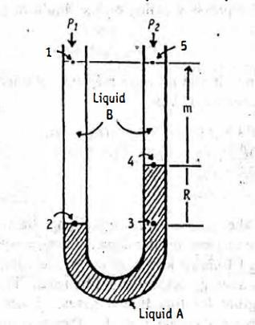

The construction of simple manometer
If two different pressures are applied on the two arms, the meniscus of liquid A will be higher in one arm than the other (Figure ). Let the pressure at point I is P1 pascals in left hand-side of the limb. Let the pressure at point 5 is P2 pascals in the right hand-side of the limb. From the principles of fluid statics, the pressure at point 2 can be written as:
Pressure at point 2 = P₁ + (m+R) ρBg (7) where (m+ R) = distance from points 3 to 4 + distance from points 4 to 5.
Since, points 2 and 3 are at the same level, the pressure at point 3 may be written as: Pressure at point 3 = P₁ + (m+R) ρBg (8)
The pressure at point 4 can be written from the right hand-side of the limb (from P2) as: Pressure at point 4 = P₂ + gmρB (9)
In another manner, the pressure at point 4 can be written from point 3 (i.c.. from left hand-side) as: Pressure at point 4 = P1 + ρB (m+R) g – ρARg (10)
Equations (9) and (10) represent the pressure at point 4 only. Hence, these equations should be equal. This relationship may be written as:
P1 + gρB (m+R) – ρARg = P2 + gm ρb P1 – P2 = gmρB – ρB (m+R)g + ρARg ΔP = mρBg – mρBg - RρBg + RρAg
ΔP = R (ρA – ρB) g (11)
The important conclusions drawn from equation (11) are:
- It is easy to measure R value (metres), i.e., the difference in the levels of liquid A in the two limbs.
- The value ΔP pascals is independent of the value of m and also the dimensions of the U tube.
When wide ranges of pressure are applied, the sensitivity of liquids employed in the measurement is important. If the pressure differences are large, mercury (high density, liquid A) can be used as manometric liquid. If the pressure differences are small, liquids such as alcohol, water (for gases) and carbon tetrachloride are used.
Applications: (1) Simple manometer helps in measuring the consumption of gases in the chemical reactions. (2) Manometers are used in conjunction with flow meters for the measurement of flow of fluids. For example. venturi meter and orifice meter are used for the measurement of pressure head using a manometer. Pitot tube measures the velocity head using a manometer.
Differential manometers: Differential manometers find occasional applications. This manometer is suitable for measurement of small pressure differences. It is a sensitive device and useful for measuring even small gas pressures (heads).
The construction of a differential manometer is given in Figure. The differential manometer is also known as two-fluid U-tube manometer. It contains two immiscible liquids A and B having nearly same

densities. The U tube consists of enlarged chambers on both limbs. Hence, the meniscus of the liquid in these enlarged chambers does not change appreciably with changes in the reading R.
Using the principle of simple manometers, the pressure difference (ΔP pascals) can be written as: ΔP = P1 – P2 = R(ρC – ρA) g (12)
Equation (12) indicates that the smaller the difference (ρC – ρA), the larger will be reading on the manometer (R metres) for a given value of ΔΡ.
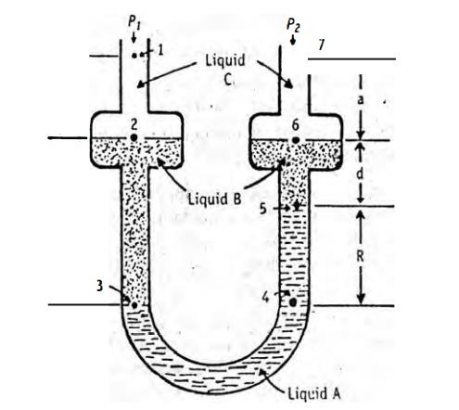
Construction of differential manometer
Applications: Micromanometers based on the liquid column principle are available commercially. They measure the reading with extreme precision and sensitivity. These are free from errors due to capillarity and require no calibration, apart from checking the micrometer scale.
Inclined manometers: Inclined manometer measures the minute pressure difference between any two points in a fluid contained in a pipe or vessel. It is a modification of differential manometer. This type of manometer increases the accuracy of the pressure determination particularly for small head.
Construction: In this type, the vertical leg is enlarged so that the movement of meniscus in the enlargement is negligible within the range of guaze.

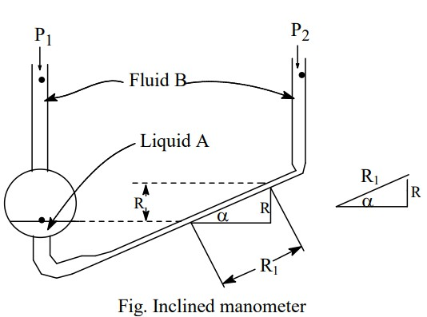
But, the leg containing one meniscus is inclined in such a manner that for a small value of reading, ”R” meniscus moves a considerable distance along the tube . The distance is equal to 'R' (vertical) divided by the sine of angle of inclination α (sin α). By making 'α' small, the value of inclined reading (R) is increased.
The principles of manometers also apply to fluids in motion.

FLUID DYNAMICS
Fluid dynamics deals with the study of fluids in motion.
Study of flow properties of liquids is important for pharmacists working in the manufacture of dosage forms, such as simple liquids, gels. ointments. creams and pastes. These systems change their flow behaviour. when exposed to different stress conditions in the following situations.
- Manufacture of dosage forms: Materials undergo processes such as mixing, flowing through pipes and getting filled in the containers. Flow related changes influence the selection of mixing equipment.
- Handling of drugs for administration: The syringeability of the medicines, pouring of the liquids, extrusion of ointment from tubes etc., depend on the changes in flow behaviour of dosage forms.
Flow properties are used as important quality control tools to maintain the superiority of the product and to reduce the batch-to-batch variations.

Nature of Fluid Flow-Reynolds Experiment
The flow of fluid through a closed channel (pipeline) can be either viscous or turbulent. These can be observed in the classical Reynolds experiment.
The assembly of the apparatus for the Reynolds experiment is shown

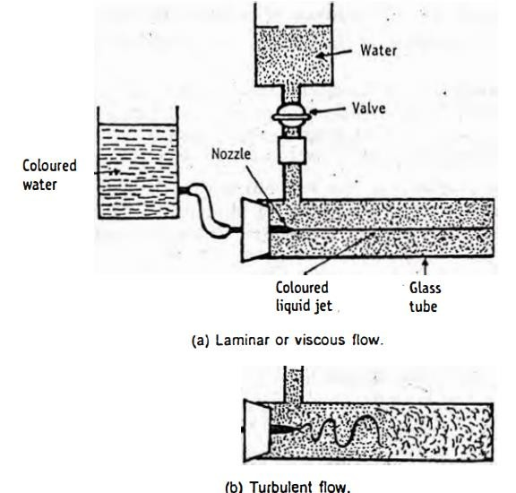
A glass tube is connected to a reservoir of water as shown in Figure. The rate of flow of water through the tube can be increased or decreased at will through a valve. A reservoir of coloured solution is connected to one end of the glass tube with the help of nozzle(s). Therefore. coloured solution can be introduced into the glass tube as a fine stream. From this experimental setup, the following observations may be made and conclusions can be drawn.
- When the velocity of water is low, the thread of coloured water maintains its identity throughout the tube. By introducing similar jets of coloured water at different points in the cross section of the glass tube, it can be noted that no part of the tube exhibits the signs of mixing. In other words, the colour streams are seen as parallel lines. The flow of water is considered to be viscous or streamline or laminar.
A laminar flow is one in which the fluid particles move in layers or laminar with one layer sliding over the other. Therefore, there is no exchange of fluid particles from one layer to the other. Hence, transfer of lateral momentum to the adjacent layers is not observed.
- When the velocity of water is increased (by increasing the flow rate), the threads of coloured water disappear and the entire mass of water gets uniformly coloured. It indicates complete mixing of solution. Then, the flow of water is considered to be turbulent. When the flow attains a certain velocity, it no longer remains steady and eddy currents appear. All the fluid particles are disturbed and get mixed up with each other. Thus, there is a continuous transfer of momentum to adjacent layers. Such a diffused flow is called turbulent flow.
- The change over of the flow from viscous to turbulent is a critical factor.
Critical velocity is defined as average velocity of any fluid at which viscous flow changes into turbulent flow.
Reynolds number: In Reynolds experiment, the flow conditions are affected by four factors.
Diameter of pipe, m (D)

Average velocity, m/s (u) Density of liquid, kg/m³ (ρ) Viscosity of the fluid, Pa's (ɳ)
These factors are grouped into a particular expression as given below. Reynolds number (13)
Re | = | Duρ
 |  | ƞ

Reynolds number is obtained by the following equation.

𝐼𝑛𝑒𝑟𝑡𝑖𝑎𝑙 𝑓𝑜𝑟𝑐𝑒𝑠
Reynolds number ,Re =
𝑉𝑖𝑠𝑐𝑜𝑢𝑠 𝑓𝑜𝑟𝑐𝑒𝑠
𝑀𝑎𝑠𝑠 ×𝐴𝑐𝑐𝑒𝑙𝑒𝑟𝑎𝑡𝑖𝑜𝑛 𝑜𝑓 𝑙𝑖𝑞𝑢𝑖𝑑 𝑓𝑙𝑜𝑤𝑖𝑛𝑔
=
𝑆ℎ𝑒𝑎𝑟 𝑠𝑡𝑟𝑒𝑠𝑠×𝐴𝑟𝑒𝑎

Inertial forces are due to mass and the velocity of the fluid particles trying to diffuse the fluid particles. The viscous force is the frictional force due to the viscosity of fluid, which makes the motion of fluid in parallel layers.
Therefore, at low velocities, the inertial forces are less when compared to the frictional forces caused by the viscosity. The resulting flow will be viscous in nature, i.e., the particles move in parallel layers. For this reason, laminar flow is sometimes known as viscous. On the other hand, when inertial forces are predominant, the fluid layers break up due to the increase in velocity, hence, turbulent flow takes place.
It is a dimensionless group, because the units of factors mutually get cancelled. If Re< 2100, the flow is said to be laminar and if Re> 4000, the flow is said to be turbulent. If Re lies between 2100 to 4000, the flow changes from laminar to turbulent.
Applications: (1) Reynolds number is used to predict the nature of flow (viscous or turbulent) in a particular set of experimental conditions. (2) The physical stability of suspensions (or emulsions) depends on the rate of settling of particles (or globules). For the study of sedimentation of particles, Stokes' law is used. In this study, rate of sedimentation of particles must not be too rapid to create turbulence. Therefore, type of flow (whether laminar or turbulent) is important. Accordingly, Stoke’s equation is modified to include Reynolds number. (3) The rate of heat transfer in liquids also depends on the flow, whether viscous or turbulent.

Variation in the Velocity of Flow Across the Cross-Section
When the local velocity of the fluid is plotted against distance from the wall (Figure), the following conclusions can be drawn.
- The flow of fluid in the middle of the pipe is faster than the fluid nearer to the wall.
- The velocity of fluid approaches zero as the pipe-wall is approached.
- At the actual surface of the pipe-wall, the velocity of the fluid is zero.
Since variations are observed in velocity of flow across the cross section, there should be some means of estimating average velocity.
- In viscous conditions, the average velocity over the whole cross section is 0.5 times the maximum.
- In turbulent flow, the average velocity over the whole cross section is 0.8 times, the maximum.

- Since the velocity of the fluid is zero at the wall surface, there should be some layers in viscous. flow near the pipe-wall, which acts as a stagnant layer.
- Even if the flow is turbulent at the centre (of the pipe) and viscous at the surface of the wall, a buffer layer exists.
- A gradual transition from one region to another, there exists a boundary layer which is known as buffer layer. This buffer layer oscillates between viscous flow and turbulent flow.
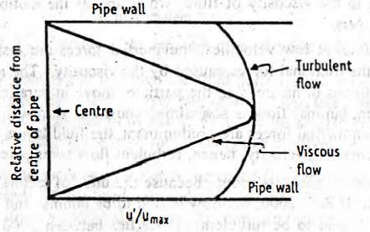
Distribution of fluid velocities across the cross section of a pipe
It must be emphasized that boundary layer can never be eliminated. Increasing the velocity of the fluid over the surface will reduce the thickness of the layer, but it will be never eliminated entirely.
Applications: (1) Though the general principles are mentioned above, considerable variation in velocity distribution may be possible with changes in roughness, direction, temperature or cross section of the pipe. Due to these reasons, the shape of curves may be changed. (2) The nature of flow of liquids in pipes determines the rate of heat transfer. The buffer layer in turbulent flow and stagnant layer in viscous flow offer resistance to heat transfer.

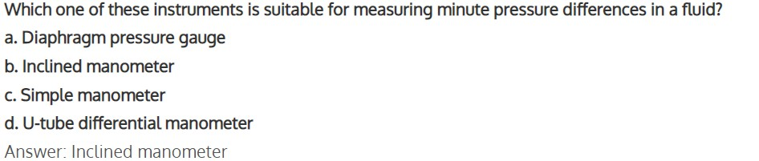
MCQ each carry 1 mark

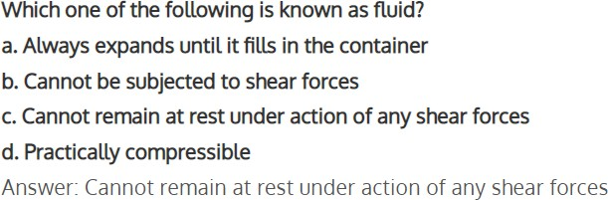

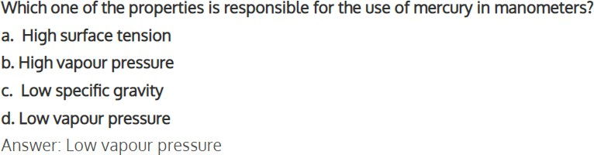
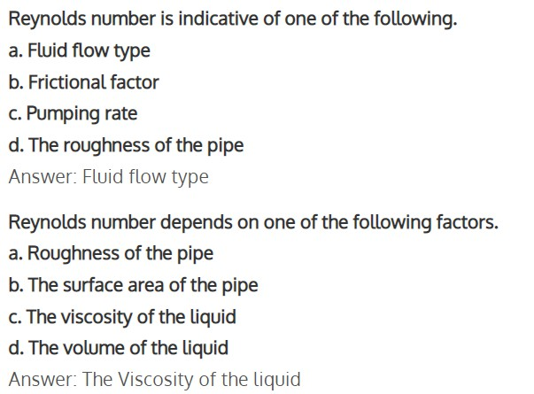

Each question carries 2 marks
  - Give Reynolds number and explain the symbols used therein.
  - What is Reynolds number? Describe its importance
  - What is a pressure head? How is it calculated
  - Differentiate between constant pressure and constant area meters
  - What are the types of fluid flow
  - What are the different flow meters.
  - Why is mercury used as a liquid in manometer?
  - Explain construction and working of differential monometer.

Each question carries 5 marks
- Describe the types of flow patterns exhibited by liquids in motion
- Differentiate between fluid statics and fluid dynamics. Name the fluid flow meter, which gives point velocity
- Describe Reynolds classic experiment elucidating different types of low patterns, when a liquid flows through a closed channel.
- Explain the characteristics of different types of flow. Add a note on Reynolds number,

Each question carries 10 marks
- Explain construction and working of differential monometer.
- Give a neat sketch of two fluid manometers and explain its working principle.

