PHARMACEUTICAL ENGINEERING (BP304T)
UNIT: 4 (FILTRATION, CENTRIFUGATION)
CLASS: 35
TOPIC: SUPERCENTRIFUGE
Sharples supercentrifuge is a continuous centrifuge used for separating two immiscible liquid phases.
Principle: Supercentrifuge is a sedimentation centrifuge. The separation is based on the difference in the densities between two immiscible liquids. Centrifugation is done in the bowl of small centrifuge. During centrifugation, the heavier liquid is thrown against the wall, while the lighter liquid remains as an inner layer. The two layers are simultaneously separated using modified weirs.
Construction: The construction of a supercentrifuge is shown in diameter. It is suspended from a flexible spindle at the top and guided Figure It consists of a long hollow cylindrical bowl of small at the bottom by loose-fit bushing. It can be rotated on its longitudinal axis. Provision is made at the bottom for the feed inlet using pressure system. Two liquid outlets are provided at different heights at the top of the bowl, and modified weirs, are attached.
Working: The centrifuge is allowed to rotate on its longitudinal axis at a high speed, usually about 2000 revolutions per minute with the help of drive-assembly. The feed is introduced from the bottom of the centrifuge using a pressure system. During centrifugation, two liquid phases separate based on the difference in their densities. The heavier liquid is thrown against the wall, while the lighter liquid forms an inner layer. Both liquids rise to the top of the vertical bowl.
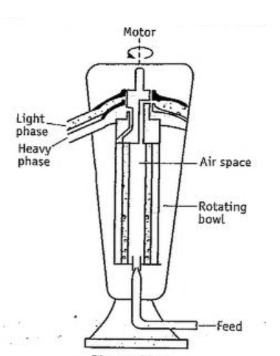
Construction of supercentrifuge
The liquid-liquid interface (the so-called neutral zone) is maintained by an hydraulic balance. These two layers are simultaneously removed as two liquids separately from different heights through modified weirs (as shown in Figure). Thus, the supercentrifuge can work for continuous separation of immiscible liquid phases.
Use: Supercentrifuge is used for separating liquid phases of emulsions in foods and pharmaceuticals.
Variants: Tubular bowl centrifuge: It is used to separate solids and liquids, when the solid content is low. It is a cylindrical bowl and other facilities remain the same. During centrifugation, clear liquid overflows from the weir at the top, solids are deposited on the wall and are removed at intervals, if necessary. Capacity of this centrifuge is limited.
MCQ Each carry 1 mark
Tubular bowl centrifuge is a variant of
A. Conical disc centrifuge
B. Continuous horizontal centrifuge
C. Perforated basket centrifuge
D. Super-centrifuge
The velocity of centrifuge is commonly expressed in terms of the following units.
A. Diameter of the rotation
B. Meter per second square
C. Metre square per second
D. Revolutions per minute
centrifuge used for separating two immiscible liquid phases
A. Conical disc centrifuge
B. Horizontal centrifuge
C. Perforated basket centrifuge
D. Supercentrifuge
Each carry 5 marks
- Describe the construction and working of a Sharpies supercentrifuge.
Each carry 10 marks
- Describe the construction and working of a centrifuge used for the separation of two liquid phases as in case of emulsions.

