PHARMACEUTICAL ENGINEERING (BP304T)
UNIT: 4 (FILTRATION, CENTRIFUGATION)
CLASS: 34
TOPIC: NON-PERFORATED BASKET CENTRIFUGE
Principle: This is a sedimentation centrifuge. The separation is based on the difference in the densities of solid and liquid phases without a porous barrier. The bowl contains a non-perforated side-wall. During centrifugation, solid phase is retained on the sides of the basket, while the liquid remains at the top, which is removed by a skimming
Construction: The construction of under-driven non-perforated basket centrifuge is shown in Figure It consists of a basket, which may be made of steel or any other suitable metal. The basket is suspended on vertical shaft and is driven by a motor using a suitable power system.
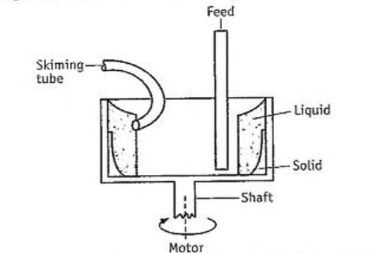
Construction of non-perforated basket centrifuge
Working: The suspension is fed continuously into the basket. During centrifugation, solid phase is retained on the sides of the basket. while liquid remains on the top. The liquid is removed over a weir or through a skimming tube (Figure). When a suitable depth of solids has been deposited on the walls of the basket, the operation is stopped. The solids are then scraped off by hand or using a scraper blade.
Uses: Non-perforated basket centrifuge is useful when the deposited solids offer high resistance to the flow of liquid.
Variants: When a mixture of liquids is to be separated, the denser liquid is collected near the walls and the lighter liquid forms an inner layer. Overflow weirs are arranged so that the two constituents are continuously removed.
Semi-continuous Centrifuge or Short Cycle Automatic Batch Centrifuge
Principle: Semi-continuous centrifuge is a filtration centrifuge. The separation is through a perforated wall based on the difference in the densities of solid and liquid phases. The bowl contains a perforated side-wall. During centrifugation, the liquid phase passes through the perforated wall. while solid phase retains in the bowl. The solid is washed and removed by cutting the sediment using a blade. It is a short cycle automatic batch centrifuge.
Construction: The construction of a semi-continuous centrifuge is shown in Figure. It consists of a vertical perforated basket, which is supported from a horizontal shaft driven by a motor. From the open side of the basket, provisions are made at the centre to introduce feed and wash pipe through horizontal tubes. A feeler (not shown) rides over the feed, which is connected to diaphragm valve through air supply. The feeler controls the thickness of the feed. Hydraulic cylinder attachment is made in such a manner that the discharge chute enters from the sides of basket, when discharge of crystals is desirable.
Working: The perforated basket is allowed to rotate and slurry is introduced from the side pipe. During centrifugation, the slurry passes through the perforated wall. The solids are retained in the basket, while filtrate leaves the basket, which is collected at outlet. Further, the cake is washed with water. The wash escapes from the basket through the filtrate outlet.
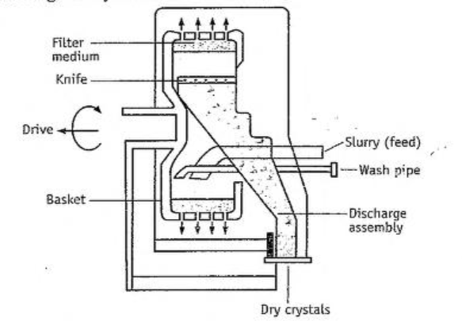
Construction of semi-continuous centrifuge
After achieving the desired thickness (50 to 70 millimetres), the feeler cuts off the air supply to a diaphragm valve that automatically shuts off the entry of slurry. The hydraulic cylinder is actuated, which lifts the knife along with the discharge chute. The knife does not cut the cake completely down to the screen, but leaves a layer of crystals that acts as a filter medium for further separation in the next cycle. The residual crystals may be given a brief wash before starting the next cycle.
Through a timer and air supply mechanisms, diaphragm valve controls all steps. Therefore, the entire cycle is semiautomatic. The discharged crystals may contain 2 to 4% of moisture.
Advantages: Short-cycle automatic batch centrifuge is used when solids can be drained fast from the bowl.
Disadvantage: During discharge, considerable breakage of crystals is possible. Many moving parts are involved making the construction and functioning more complicated.
MCQ Each carry 1 mark
- For a sedimentation type, the centrifuge has one of the following conditions.
  - Basket is non-perforated
  - Basket is perforated
  - Containing filter aid
  - Containing filter medium
- Washing of solids is NOT possible in one of the following centrifuges.
  - Non-perforated basket centrifuge
  - Perforated basket centrifuge
  - Semi-continuous centrifuge
  - Super-centrifuge
- During discharge, breaking of crystals is possible in one of the following centrifuges.
  - Horizontal continuous centrifuge
  - Non-perforated basket centrifuge
  - Semi-continuous centrifuge
  - Super-centrifuge
- Which factor does NOT affect the separation process of a centrifuge?
  - Centrifugation time
  - Nature of slurry
  - Speed of centrifuge
  - Temperature
Each carry 2 marks
- What are basket centrifuges? Describe their applications.
Each carry 5 marks
1. Write construction and working of a non-perforated basket centrifuge.
2. Write construction and working of a semi continuous centrifuge.

