PHARMACEUTICAL ENGINEERING (BP304T)
UNIT: 5 (MATERIALS OF CONSTRUCTION)
CLASS: 46
TOPIC: SELECTION OF PROPER MATERIAL
Corrosion should not be permitted in fine mesh wire-screens, orifices and other items in which dimensions are critical and changes are not per¬ mitted. In many cases, non-metal lie materials will be useful and attractive from the point of view of economics and performance. These should be considered if their strength, temperature and design specifications are satisfactory.
The corrosion characteristics of chemicals and limitations of construction materials must be considered from the literature before selecting equipment. In addition, processing conditions to which the material is exposed should also be considered. For this purpose, relevant literature. should be consulted. Permissible corrosion rates are important factors and differ with equipment. Appreciable corrosion can be permitted for tanks and lines, if anticipated and allowed for thickness in its design.
Proper Design of Equipment
In the design of equipment, a number of fittings such as baffles, stiffeners, drain nozzles, location of valves and pumps should be considered. Corrosion can be minimised, if the equipment design facilitates:
- Elimination of crevices.
- Complete drainage of liquids.
- Ease of cleaning.
- Ease of inspection and maintenance.
On the basis of these general principles, some poor and good engineering designs are given in Figure A direct contact between two metals should be avoided, if they are separated widely in the electrochemical series. Otherwise, they should be insulated. Equipment should be supported in such a way that it will not rest in pools of liquid or on damp insulating material.

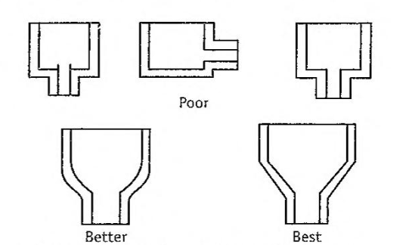
Drainage affects the corrosion.
Coatings and Linings
Non-metallic coatings and linings can be applied on steel and other materials of construction in order to combat corrosion. Appropriate methods such as electroplating, cladding, organic coatings should be considered. The thickness of the linings is important (100 mils). Effective linings can be obtained by bonding directly to substrate metal of building multiple layers or lamination.
Organic coatings are used as linings in equipment such as tanks. piping, pumping lines and shipping containers. Some examples of the linings are:
Ceramic Carbon brick Plastic
Elastic Glass-coated Organic
A thin non-reinforced paint-like coating of less than 0.75 mm thick- ness should not be used in services for which full protection is required from corrosion. Some examples of linings and uses are:
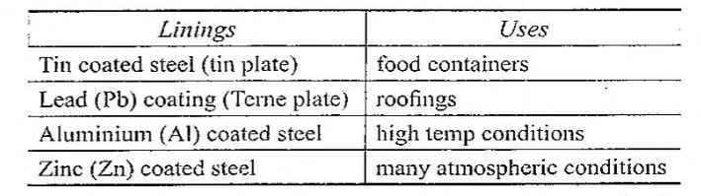
The cladding (i.e., mechanical bonding) of steel with an alloy is another approach to this problem. For instance, special glasses can be bonded to steel so that the liner is of 1.5 mm thick which is impervious. Equipment and pipings are lined in this manner and routinely used in severely corrosive acid services. The only limitation of this method is service behaviour of the protective coatings.
Altering Environment
Corrosion can be combated or reduced by employing the following environmental conditions.
- Removing air from boiler feed water prevents the influence of water on steel.
- Reducing aeration prevents the formation of passive oxide film in stainless steel alloys by acidic media.
- Pumping of inert gas into solutions prevents the contact of air or oxygen as in case of nickel-based alloys.
- Reducing the temperature.
- Eliminating the moisture.
- Reducing the velocity or turbulence.
- Shortening the time of exposure.
Addition of acid media should be done as a last step, so that maximum dilution can be obtained.
Inhibitors
The corrosion inhibitors are added to the environment for effectively decreasing corrosion of These form protective film
Adsorption type, for example, adsorbed on the metal.
Scavenger type, for example, remove corrosion agents.
Vapour phase type, for example, sublime and condense on metal surface.
Examples of inhibitors are given below.
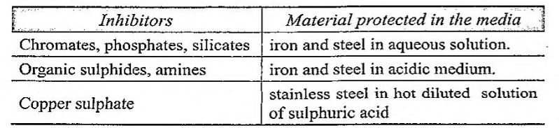
Inhibitors also interfere with the process of corrosion, namely scavenging of oxygen, hydrogen, and reducing the diffusion of the constituents.
- The diffusion of H+ ions is considerably decreased by organic inhibitors. Examples are amines, mercaptanes, substituted ureas and thioureas. These are cathodic inhibitors.
- Reducing agents eliminate oxygen from the corroding medium. Example is sodium sulphite.
- Inhibitors retard the diffusion to the cathodic areas. Examples are magnesium, zinc and nickel salts.
Inhibitors are generally used in quantities less than 0.1% by weight. In some cases, the amount of inhibitor used is critical.
Cathodic Protection
The cathodic protection is based on the galvanic action between the metal(s) of the plant (cathode) and anode suspended in the solution. The metal to be protected is made a cathode, i.e., electrons are supplied, there by dissolution of metal is suppressed. This can be achieved by two methods.
(1) Sacrificial anode method (2) Impressed emf method
Sacrificial anode method: In this method, anodes are kept in electrical contact with the metal to be protected (cathode). The anodes are sacrificed, since it goes into solution (Figure). For example, for the protection of iron and steel tanks, the metals such as zinc, aluminium, magnesium and their alloys are used as sacrificial anodes. These are used in limited pH range when high solution rate is accept- able, since these are amphoteric.
Anode metal is selected from the electrochemical series amongst the metals present above the tank metal. The anode should not be poisonous and not detrimental to the product.
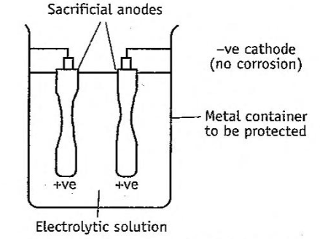
Simple sacrificial anodes.
Impressed emf method: This is also known as applied current system, i.e., external voltage is impressed between tank and electrodes. The negative terminal of power supply is connected to the material to be protected. Therefore, the natural galvanic effect is avoided and the anode is maintained positive (Figure).

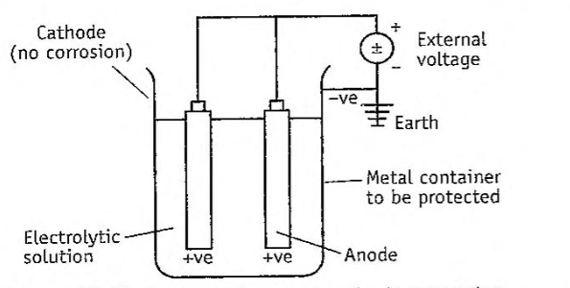
Impressed current cathode protection.
The term impressed emf (or current) means the current which is greater than the corrosion current. When such an impressed current is applied in opposite direction, the corrosion effect is nullified. Under Since anode is not consumed, any conducting material, metal or non- such conditions, anode is converted to cathode in the corroding metal. corrodible alloys can be used. For example, in case of sulphuric acid and deionised water, graphite and high silicon steel are impressed. The anodes can be buried in the ground or suspended in the aqueous solution of electrolyte.
Advantages:
- This method is used for large tanks to store mild corrosive liquors. In these cases, mild steel is used with negligible corrosion.
- Cathodic protection method is simple and the most effective.
- It is inexpensive. It enables the use of cheaper material for plant construction.
Disadvantage: Corrosion cannot be reduced to zero.
Anodic Protection
In the method, a predetermined potential is applied to the metal specimen and the corresponding current changes are observed. During the initial stage, the current increases indicating the dissolution (corrosion) of the metal. When the current reaches a critical point, passivation occurs, i.e., the oxide layer sets in a suitable oxidising environment. The potential at critical point is called passivating potential. Above this passivating potential, the current flow decreases to a very small value called passivating current.
The passivating current is defined as the minimum protective current density required to maintain passivation.
Passivity is a phenomenon in which a metal or alloy exhibits much higher corrosion resistance than expected from its position in the galvanic cell. At this stage, an increase in potential will not corrode the metal since the latter is in a highly passive state. For example, in case of stainless steel, titanium becomes easily passive and cannot offer cathodic protection. In such cases, the corrosion rate may be slowed down by the use of anodic current.
Advantage: Anodic protection requires a small current. The anodic protection method is utilised in the transportation of concentrated sulphuric acid.
Disadvantages:
- Corrosion cannot be reduced to zero.
- This method cannot be applied for metals, which do not passivate.
A proper material should be selected for a specific process based on the literature and by personal experience. The factors influencing corrosion will not only help in selecting the right kind of material, but also suggest the processing conditions. It is equally essential to identify the type of corrosion, if it occurs. Since the theories of corrosion are known, it is possible to adopt appropriate preventive measures.
MCQ Each carry 1 mark
- Increase in temperature does NOT enhance the extent of corrosion by one of the following conditions.
  - Diffusivity of the corroding medium
  - Solubility of the constituents of the metal in the corroding media
  - Thickness of the oxide film.
  - Volatility of the constituents of the metal
- The corrosion of aluminium metal is prevented, due to one of the follow¬ ing film characteristics.
  - Thick and nonporous film
  - Thick and porous film
  - Thin and nonporous film
  - Thin and porous film
- In cathodic protection, one of the following effects is suppressed.
  - Dissolution of anode
  - Dissolution of cathode
  - Dissolution of oxide film
  - Electric current
- Which one of the following conditions is NOT responsible for preventing the corrosion?
  - Inhibiting the flow of current
  - Decreasing the temperature
  - Removing air and oxygen
  - Removing inhibitor
- Anodic protection controls the corrosion based on one of the following mechanisms
  - Adding inhibitors
  - Decreasing the current flow
  - Drainage of liquid
  - Promoting oxide layer
- Which one of the following metals can retard the corrosion of metals?
  - Carbon steel
  - Chromium
  - Iron
  - Zinc
Each carry 2 marks
- In a structure, two dissimilar metals should not be allowed to come in contact with each other. Why?
- Which type of oxide film is more protective against corrosion? Give one example of a metal, which produces such an oxide film.
- How does the addition of amines protect against corrosion of iron
- Describe the effect of grain size of the metal on corrosion.
- Describe the term ‘passivity’. How is it combat corrosion?
- Why is brass a preferred alloy for the construction of equipment?
- A piece of pure zinc and impure zinc are placed in a salt solution, which will corrode faster. Why?
- Highlight two non-metal linings on the material for the construction of equipment
Each carry 5 marks
- Explain measures you suggest to check the problems of corrosion.
- Describe the biological corrosion and suggest the preventive measures
Each carry 10 marks
- Describe various types of corrosion and suggest the methods to tackle the same in pharmaceutical industries

