PHARMACEUTICAL ENGINEERING (BP304T)
UNIT: 5 (MATERIALS OF CONSTRUCTION)
CLASS: 45
TOPIC: CLASSIFICATION OF MATERIALS FOR PLANT CONSTRUCTION
Materials of pharmaceutical plant construction can be classified as shown in Figure Different materials and their properties are discussed so that right kind of materials can be selected for the desired purpose and function.
FERROUS METALS
Iron metal is one of the widely used materials for the construction of plants because of its mechanical strength, abundant availability and lower cost.
Cast Iron
Cast iron consists of iron with a proportion of carbon (beyond 1.5%). The properties of iron depend on the amount of carbon present in it. Cast iron is abundantly available, inexpensive and therefore widely used. A number of types of cast iron are available (Table).
Materials of construction

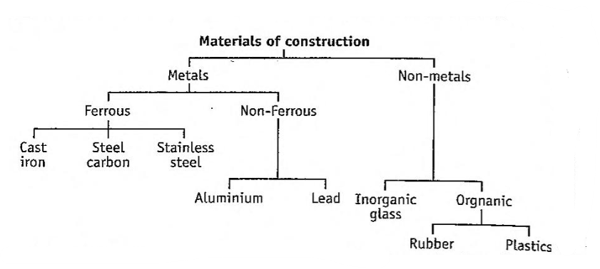
Classification of materials used for the construction of plant.
Advantages:
- Cast iron is cheap. Therefore, it is used in place of expensive plant material with coatings or linings of enamel or plastic.
- It is resistant to concentrated sulphuric acid, nitric acid and dilute alkalis.
- Since cast iron has low thermal conductivity, it is used for the construction of outer surface of jackets of steam pans.
Disadvantages:
- Cast iron is very hard and brittle. Therefore, it is difficult to machine. This disadvantage can be overcome by the addition of different materials to improve its performance.
- Cast iron is attacked by dilute sulphuric acid, dilute nitric acid and dilute as well as concentrated hydrochloric acid.
- Since cast iron has low thermal conductivity, it cannot be used for heat transfer in stills,
Uses: It is commonly used for the construction of:
- Supports for plant
- Jackets of steam pans
- Linings with enamel, plastic or suitable protective material
Modifications of cast iron: Cast iron is not considered corrosion The characteristics of cast iron can be altered by alloying with resistant. other elements such as silicon, nickel and chromium.
Commercial Types: Duriron and Durichlor.
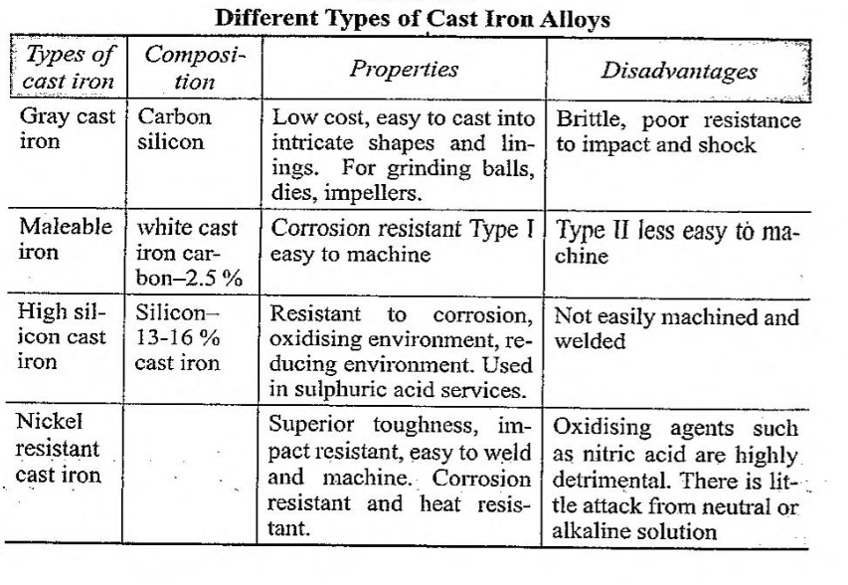Carbon steel or Mild steel
Carbon steel is an iron alloy, which contains only a small percentage of carbon.
Advantages of carbon steel are:
  - Carbon steel is cheapest. Therefore, it is preferred.
  - It is easily weldable and is frequently used in fabrication.
Disadvantages of carbon steel are:
- Carbon steel has limited resistance to corrosion. This property can be improved by preparing alloys.
- It reacts with caustic soda, brine and sea-water. Alloying it can reduce this reactivity.
Uses: Carbon steel is used for the construction of bars, pipes and plates. It is used to fabricate large storage tanks for water, sulphuric acid, organic solvents etc. It is used for supporting structures such as grinders and bases for plant vessels.
Variants of carbon steel: The properties of carbon steel can be altered by alloying it with other metals. Some of the metals and their properties are:
Nickel (Ni) improves toughness, corrosion resistance and low temperature properties.
Chromium (Cr) increases hardness, more abrasive resistance and resistance to oxidation.
Silicon (Si) increases hardness, more abrasive resistance and resistance to oxidation.
Molybdenum (Mb) provides strength at elevated temperatures
The of alloys of carbon steel are given in Table
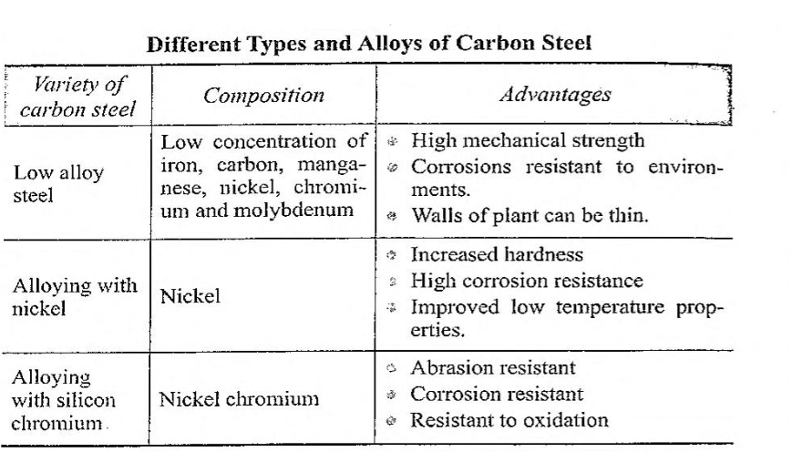
Stainless Steel
Stainless steel is an alloy of iron. Usually, it contains chromium and nickel, which make the steel corrosion resistant. Stainless steel is stabilised by the addition of titanium, niobium or tantalum. Minor amounts of other elements such as copper, molybdenum and selenium are added. Stainless steel also has the advantage of ease in fabrication
The abundant use of stainless steel is due to the properties such as
▸heat resistance
▸corrosion resistance
▸ease of fabrication
▸ tensile strength
▸cleaning and sterilisation
Depending on the composition, stainless steel alloys are available in three groups, viz., martensitic, ferritic and austenitic. These are given in Table
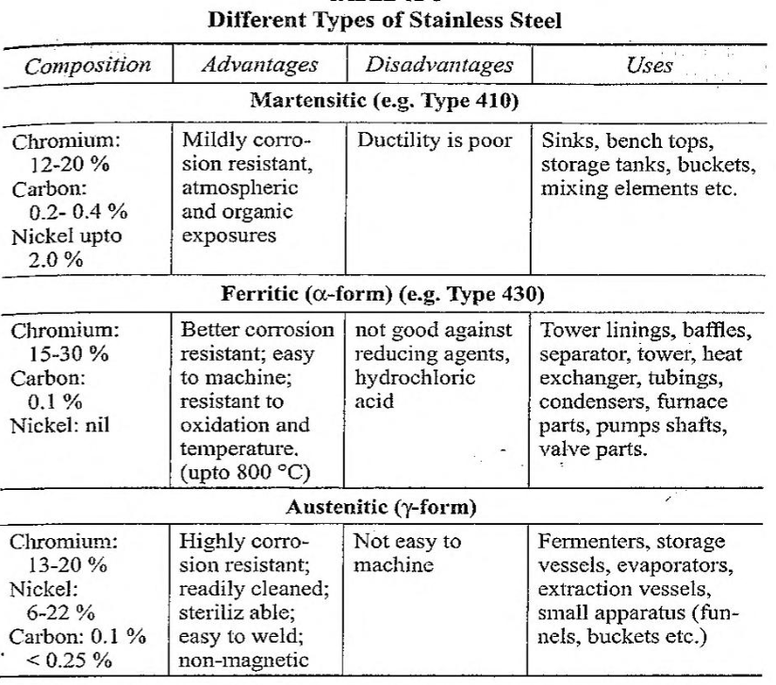
NON-FERROUS METALS
Aluminium
A number of aluminium items are used in regular day to day life. Aluminium is cheap, light in weight and offers adequate mechanical strength. In addition, aluminium equipment can be easily fabricated.
Further, aluminium can be strengthened by cold working. Their maintenance and cleaning is also easy. Hence, its utility is mostly recommended. However, the use of aluminium in the construction of plant and equipment is limited.
Advantages:
- High resistance to atmospheric conditions, industrial fumes, vapour and fresh or salt waters. Aluminium can be used with concentrated nitric acid (above 82%) and acetic acid.
- Thermal conductivity of aluminium is 60% that of pure copper.
Disadvantages:
- The mechanical strength decreases greatly above 150 °C.
- Aluminium cannot be used with strong caustic solution.
- Many mineral acids attack aluminium.
- Oxide and hydro-oxide films are formed rapidly, when its surface is exposed. Normally this film is thickened by chemical and electrolytic means. These provide so called anodised finishes.
Uses: A super grade is preferred for food and pharmaceutical use. It is used in many heat transfer applications. These are used as meat storage containers.
Aluminium alloys and modifications: A number of aluminium alloys are available with improved qualities and mechanical properties. Aluminium alloys are used in the construction of equipment producing medicinal substances, since aluminium does not affect the salts.
Aluminium is non-toxic to microorganisms. It has considerable use in biosynthetic processes such as the production of citric acid gluconic acid and streptomycin by deep culture methods. It is most useful for the construction of containers namely drums, barrels, rail tankers etc.
Lead
Lead has the lowest cost and is used as collapsible tube material particularly for non-food products such as adhesives, inks, paints and lubricants. Lead tubes with internal linings are sometimes used for fluoride tooth-paste. Lead chamber process is used in the manufacture of sulphuric acid.
Disadvantages:
- Lead has low melting point and hence possesses poor structural qualities.
- It has high coefficient of expansion. Therefore, temperature strain results in permanent deformation.
In pharmaceutical practice, lead has little use, because of the risk of contamination even in traces produces toxicity and of cumulative nature.
It is used for the construction of cold water pipes, waste pipes dilution tanks for laboratories.
Lead alloys and modifications: Lead alloys with superior performance qualities have been established. For example, acid lead and copper lead are used in chemical industries. Some metals are added to lead for altering properties.
Silver and copper improves corrosion resistance.
improves creep and fatigue resistance.
Antimony, tin, arsenic hardens, still melting point is low.
Lead-lined steel structures are used for the construction of pipes, valves, vessels designed for operations at high temperatures, fluctuating temperatures or vacuum.
Copper and its Alloys
Copper is preferred when good thermal and electrical conductivity is required. It is relatively inexpensive and possesses fair mechanical strength. It can be fabricated easily into a wide variety of shapes. Copper is resistant to atmospheric moisture and oxygen, because a protective coating (copper oxide) is formed on the surface. Copper exhibits good corrosion resistance to strong alkalis, with the exception of ammonium hydroxide. It resists most organic solvents and aqueous solutions of organic acids. However, copper oxide is soluble in most acids and hence not a suitable material of construction, when it must contact any acid in the presence of oxygen or oxidizing agents.
Many components of formulation react with copper. Hence, copper is usually protected by a lining of tin, when used for in pharmaceutical plant. Copper is used for evaporators, pans (for sugar coating), stills and fractionating columns. However, for the reasons of corrosion, it is largely replaced by stainless steel. Copper piping is used extensively for services such as cold water, gas, vacuum and flow pressure steam. Copper alloys, such as brass (copper-zinc alloy) and bronze (copper-tin alloy), can exhibit better corrosion resistance and better mechanical properties than pure copper.
- Brass is used for tube plates and condensers, for tubes and valves and in making nuts, bolts, rods etc.
- Bronze is used for filter gauges, stirrers, pipes, autoclaves and special tablet punches and dies.
Most of the low-zinc alloys are resistant to hot dilute acids. High zinc alloys should not be used with acids and alkalis owing to the possibility of dezincification.
Tin
Tin has high resistance to a variety of substances and its salts are nontoxic. Tin is widely used in the food industry. Foods are packed in 'tin cans. Steel sheet coated with tin is used for containers and condenser tubes. Similarly, brass and copper are also coated with tin.
Nickel and Its Alloys
Nickel-clad steel is used extensively for equipment in the production of caustic soda and alkalis. It is useful for such plants, as pans, vats, tanks, mixers, valves and pumps. Nickel exhibits high corrosion resistance and good mechanical strength. It has hardness as great as that of carbon steel. The metal can be fabricated easily. Oxidising conditions promote the corrosion of nickel, while reducing conditions retard it. Nickel is resistant to weak organic acids, such as citric acid, tartaric acid and stearic acid, which are used in the pharmaceutical preparations.
Monel alloy (67% nickel and 30% copper) is often used in food industry. In Inconel (77% nickel and 15% chromium), the chromium increases the resistance of nickel to oxidizing conditions.
Chromium
Chromium is used as plating. Chromium is not normally used even though it is hard and resistant to corrosion. It is mainly used in the manufacture of stainless steel, in combination with nickel.
Silver
Silver shows fair resistance to aqueous solutions of the halogen acids. Silver is generally used only in the form of linings because of its low mechanical strength and high costs. It is resistant to organic acids, but not to concentrated acids, such as hydrochloric acid, sulphuric acid and nitric acid. Silver has a higher thermal conductivity than all other metals. Silver is specially used in the manufacture of salicylates and acetic acid. A silver-plated basket is used for a hydroextractor utilized in vitamin crystallization. Solid silver vessel in a cast-iron jacket is used for bromination.
Platinum
Platinum is used when all other metals fail, because it is expensive. It is as strong as steel and is stable to hydrofluoric acids.
MCQ Each carry 1 mark
- In pharmaceutical packing, collapsible tubes made from lead are not used as such, for one of the following reasons.
  - Costly metal
  - Difficulty in packing
  - Risk of poisoning
  - Soft in strength
- Hermetic sealed containers are also known as:
  - Air-tight containers
  - Multi-dose containers
  - Single-dose containers-
  - Well-closed containers
- Which one of the following materials is used for the construction of outer surface of jacket of steam pans, because of its low thermal conductivity?
  - Carbon steel
  - Cast iron
  - Copper
  - Stainless steel
- Which metal makes the steel corrosion resistant?
  - Chromium and nickel
  - Copper and selenium
  - Tantalum and molybdenum
  - Titanium and niobium
- Which metals improve creep and fatigue resistance properties of lead?
  - Chromium
  - Copper
  - Silicon
  - Tin
Each carry 2 marks
- Arrange the following materials of construction in descending order of their reactivity: copper, iron, zinc, aluminium, magnesium, tin and lead
- Why is stainless steel used instead of steel (iron) for the fabrication of equipment?
- Austenitic steel is frequently used for the fabrication the equipment. Why?
- High coefficient of thermal expansion of metal is not necessary for the metal used in designing the equipment. True or false. Justify.
- Why are noble metals not used for the construction of equipment?
Each carry 5 marks
- Explain the importance of stainless steel in pharmaceutical industry
- Describe steel as a material of plant construction
- Describe the steel alloys used in pharmacy practice.
- escribe various types of iron as materials of construction.

