PHARMACEUTICAL ENGINEERING (BP304T)
UNIT: 5 (MATERIALS OF CONSTRUCTION)
CLASS: 44
TOPIC: NONMETALS-INORGANIC
Glass
A number of glass articles are used in daily life. Glass has the advantages of superior protective qualities, attractiveness and low cost It is chemically inert to a large extent and available in a variety of sizes, shapes and colours. Glass containers practically offer excellent barrier against every element except light. UV rays and sunlight are harmful to certain ingredients and bring about chemical deterioration. Protective action against light can be achieved by amber-coloured glass. Protection against IR rays can be obtained by using green glass. The disadvantages are its fragility and weight.
Some Varieties of Glasses
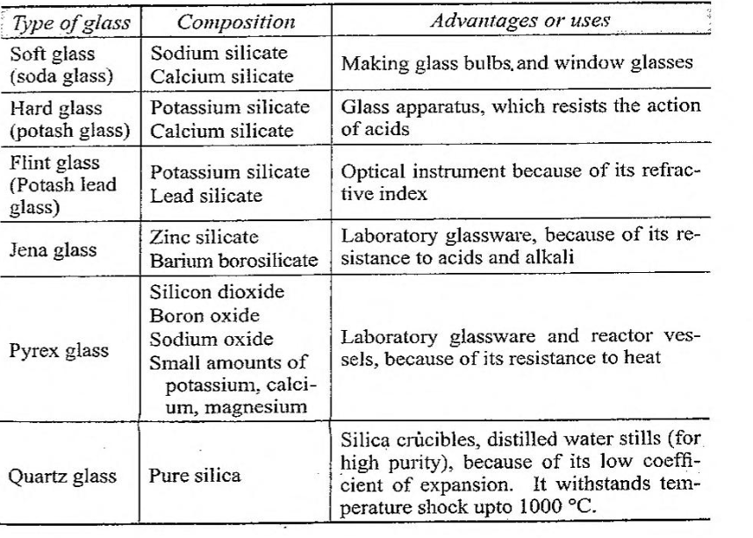
Glass is considered as a super-cooled liquid, though it is seen in solid state. The constituents are present in amorphous state. Glass is com- posed of the following constituents.
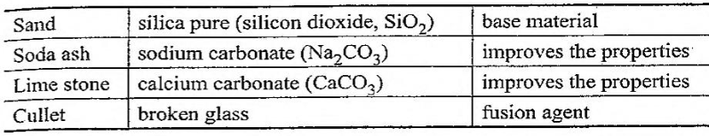
Silicon dioxide is having a tetrahedron structure. The glass that is prepared by silicon dioxide alone is the most resistant, but relatively brittle. It can be melted and moulded at high temperatures. Therefore, cations such as sodium, potassium, calcium, magnesium, aluminium, boron, iron etc., are added. These cations (available as oxides) modify the physicochemical properties of glass, so that it is suitable for the manufacture of glass with desired characteristics. However, this glass has low chemical resistance. Some varieties of glasses are given in Table. Glass containers used for pharmaceutical purposes are given in Table These types are classified into four groups. These have varied degree of chemical resistance. The reasons for the low chemical resistance are as follows. Most of the alkali oxides such as Na₂O, K₂O, MgO and CaO enter the spaces within the structures and reduce the strength of inter-atomic forces between silicon and oxygen. The oxides decrease the melting point of glass and are comparatively free to migrate. This behaviour creates a number of problems in their use.
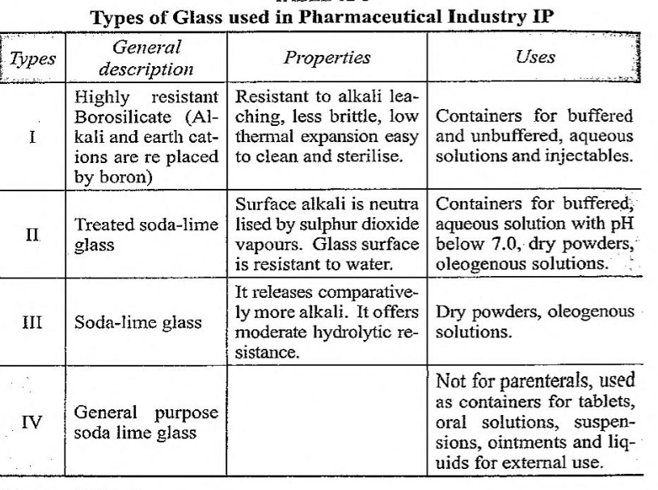
These are
- Oxides leach into the solution, raises the pH. hydrolyse or catalyse chemical reactions.
- Sometimes, glass flakes are formed in the solution.
However, boron oxide enters into the structural configuration of glass and does not leach out and hence is used in parenteral packings.
Glassed Steel
Glassed steel is an inorganic product of fusion, which is cooled to a rigid condition without crystallising. It requires special considerations in its design and use. These surfaces are applied to heavy vessels. Normally, several coatings are fused in a furnace. Glassed steel combines the corrosion resistance of glass with the working strength of steel.

Advantages of glassed steel are:
- It has excellent resistance to all acids except hydrofluoric and hot concentrated sulphuric acid.
- It can be attacked by hot alkaline solution. Particularly suitable for piping when transparency is desirable.
- It is brittle and gets damaged by thermal shock. Hence it is protected using glass lined with epoxy polyester fibre glass.
- A nucleated crystallised ceramic metal composite form of glass has superior mechanical properties compared with conventional glassed steel.
- Glass linings are resistant to:
  - All concentrations of hydrochloric acids upto 120°C.
  - Dilute concentrations of sulphuric acid up to the boiling point.
  - All concentrations of nitric acid upto boiling point.
  - Acid resistant glass with improved alkali resistance (up to pH 12)
Uses: Glass lined steel is used for handling of strong acids, alkalis and saline solutions. For small-scale manufacture and pilot plant work, glassed steel vessels are used.
Brick, Concrete and Clay
If corrosive conditions are severe and other high alloys fail, brick- lined construction is the only alternative. These bricks are made from carbon, acid-proof refractory materials. Phenolic resins, silicates and epoxy-based materials are good against non-oxidizing acids, salts and solvents. Each type of cement has its own limitations. For example, sodium silicate-based cement is good against acids up to 400 °C. Vitrified acid-resistant bricks are used for tanks, drains, culvets etc. Granite is used in certain types of mills;
Concrete is an amorphous matrix of hardened cement paste in which the particles are reinforced. These have limited resistance to acids and bases and fail mechanically following absorption of crystal forming solutions (example is brine). It is used for tanks and special purpose structures.
Clay is used as a material of construction for settling basins and waste treatment evaporation ponds.
Porcelain and Stoneware
Porcelain enamels are used to coat steel, but enamels have slightly inferior chemical resistance. Stoneware avoids mechanical fragility of glass, but heat transfer is a problem. Acid-proof stoneware is highly resistant to acids, but has low strength, Porcelain and stoneware have the advantage of greater strength and resistant to acids and chemicals. These have poor thermal conductivity and hence can be damaged by thermal shock. Ceramics are widely used on a small-scale plant. Pipeline, tanks, vessels and filters are a few items of ceramics.
Enamelled and Silica Ware
Enamelled ware may be used successfully only under moderate process temperatures and relatively mild conditions of mechanical and temperature shock. Glass coated on iron and steel is useful. Silica ware possesses the corrosion resistance.

Asbestos
Asbestos pads are used for sterile filtration, as it is fibrous and can be woven into cloth. It is a poor conductor of heat and hence used for heat insulation for pipe lining and for pipe jointing.
NONMETALS-ORGANIC
Rubber
Rubber is used as such or as lining materials for the construction of plants. Both natural and synthetic rubbers are used.
Natural rubber: Rubber is a naturally occurring polymer, which is obtained as latex from rubber trees. It is a common example of an elastomer. Elastomer is a substance that can be stretched readily and when released, rapidly regains its original form.
Soft rubber: The naturally occurring polymer is known as soft rubber. It is a polymer of monomeric isoprene (CH). Thus, rubber is a polyisoprene with a formula (CsH8) Soft rubber has the advantages of being resistant to dilute mineral acids, dilute alkalis and salts. The disadvantage is that soft rubber can be attacked by oxidising media, oils and organic solvents. Soft rubber is used as lining materials for plants, as it can bond easily to the steel. Addition of carbon black to the soft rubber gives hardened rubber. It is used for making tyres, tubes and conveyor belts.
Some Varieties of Rubber
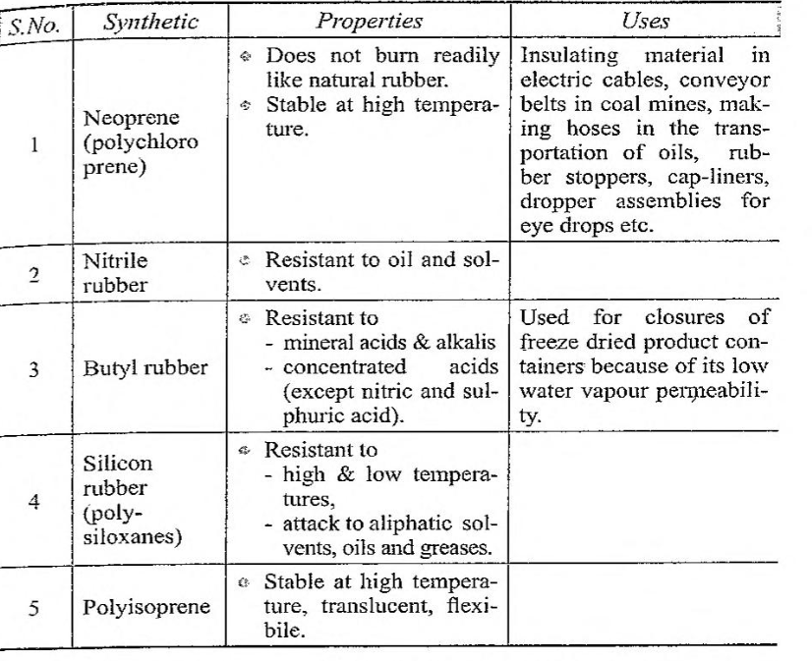
Hard rubber: When soft rubber is mixed with sulphur, warmed and set into a given shape, it retains its form. The sulphur combines with the polymeric chains of rubber and cross-links between them. This process is called vulcanisation. Soft rubber with 25% or more sulphur is known as hard rubber. Hard rubber has the advantages of hardness and strength. So, it is used for making gloves, bands, tubes and stoppers, Rubber is a soft material, but can be hardened by adding carbon black. Hardened rubber is used for making tubes, tyres and belts.
Synthetic rubber: Synthetic rubber has taken greater importance over natural rubber due to its superiority in properties such as resistance to oxidation, solvents, oils and other chemicals. Some synthetic rubber materials with their properties are reported in Table
Synthetic rubber thermoplastic, but when mixed with sulphur, warmed and set into a given shape, it retains its form. Vulcanisation of rubber is possible. It is used for making gloves, bands and tubes, caps for vials.
Plastics
Plastic materials have been in common use in various ways in our daily life. These are light in weight so that transportation is easy and cheap. These are available in a variety of shapes implying that it can be easily fabricated. Plastic containers are used for storing a number of substances such as inorganic salts and weak mineral acid. In machines. plastic materials are preferred wherever moving parts are present indicating that it offers less friction. These have better resistance to environmental factors. In a similar manner, plastic materials also used in the construction of plants.
Plastics are synthetic resins containing long chains of atoms linked to form giant or macromolecules (polymers). They have high molecular weight (10³ to 10⁷ ).
Plastics have several advantages. These are:
- Low thermal and electrical resistance.
- Excellent resistance to weak mineral acids.
- Unaffected by inorganic salts.
- Resistance to slight changes in pH.
Plastics have disadvantages also. These are:
- Low mechanical strength
- High expansion rates
Basically, two types of plastics are used in pharmaceutical industry.
Thermosetting plastics: Thermosetting plastics can be formed un- der heat and pressure. But these cannot be softened or remoulded, once hardened. Some thermosetting plastics are made of phenolic and urea resins.
Thermoplastic plastics: Thermoplastic plastics are formed by the application of heat and pressure and can be softened and remoulded. This is a specific advantage. Scrap and rejected articles can be worked again to get new materials.

Some thermoplastic materials and their uses are given below:
Polyethylene cables, buckets, pipes
Polypropylene milk cartons, ropes
Polyvinyl chloride gloves, water proof garments
Teflon gaskets, coatings
Based on the utility of plastics in plant construction, these can be categorised as:
- Rigid materials
- Flexible materials
- Metallic surfaces.
- Plastic cements
- Special case plastics
1. Rigid materials: These are phenolic resins with various inert fillers. These are used in the fabrication of a number of items. For example, Keebush is a rigid material (phenolic plastic) and is used for gears, bearing etc. It is light in weight. Some of its applications are
▸ Gears ▸Pipes ▸ Bearing
▸ Fittings ▸Vessels ▸ Valves
▸ Pumps ▸Ducts ▸ Filter presses
Disadvantages: These are resistant to corrosion except oxidising substances and strong alkalis.
2. Flexible materials: These are thermoplastic materials. These materials can be rigid or flexible depending upon the amount of plasticizer added. These are used in the fabrication of:
▸ Tanks ▸ Pipes ▸ Ducts
▸ Funnels ▸ Buckets
3. Metallic surfaces: Plastics of polyethylene or polyvinyl chloride types are used along with plasticizers for the coating of metallic surfaces. These are used to protect the metal from corrosion. These linings are applied on:
▸Tanks ▸ Stirrers
▸Vessels ▸Fans
4. Plastic cements: These are used for spaces between acid resistant tiles and bricks.
5. Special cases: Plastics are used as guards for moving parts of machinery. Nylon and PVC fibres are woven into filter cloths and are used for aseptic screening.
Wood
Wood is impregnated to resist acids or alkalis. Impregnated wood is not affected at high temperature. Wood is fairly inert chemically, but hydrolysed by the use of strong solutions, acids, alkalis, especially when these are hot. Wood is dehydrated and badly shrinks in concentrated solutions. Wood is used for tanks and vats. Its light weight is advantageous and occasionally used in filter presses, because metal filter press becomes heavy.
MCQ Each carry 1 mark
Water attack test is performed on glass in order to find the limits of one of the following.
A. Acid liberated
B. Alkali liberated
C. Conductivity
D. Metal ions
One of the following glass containers is used for the storage of light sensitive pharmaceuticals.
A. Air-tight
B. Amber coloured
C. Unit dose
D. Well closed
Containers meant for storage of injections (buffered and un-buffered aqueous solutions) are made from one of the following type of glasses.
A. Borosilicate
B. General purpose
C. Lime soda
D. Neutral
One of the containers is currently used for bulk packaging of tablets, capsules, powders and food materials.
A. Cardboard
B. Glass
C. Metal
D. Plastic
Protection against IR rays can be achieved using one of the following glass containers.
A. Amber coloured
B. Green coloured
C. Transparent
D. Yellow coloured
Rubber contains one of the following chemical units?
A. Amino acid
B. Glucosidal
C. Isoprene
D. Sugar
Vulcanisation of rubber involves the addition of one of the following substances to the soft rubber.
A. Magnesium
B. Phosphorus
C. Potassium
D. Sulphur
Phenolic plastics are one of the following types
A. Cement
B. Flexible
C. Metallic
D. Rigid material
Which glass is used for the preparation of optical instruments because of its refractive index?
A. Flint glass
B. Hard glass
C. Pyrex glass
D. Soft glass
Which type of glass is used for the preparation of distilled water stills?
A. Hard glass
B. Jena glass
C. Quartz glass
D. Soft glass
Which type of rubber is used for making of gloves, bands, tubes, caps and stoppers?
A. Hard rubber
B. Neutral rubber
C. Soft rubber
D. Vulcanised rubber

Each carry 2 marks
- Write the usefulness of glass lined equipment in the pharmaceutical plant.
- List important types of glass containers. Mention an example of formulation that is stored in each type of container
- Plastic containers are used to store aerosol. True or false. Justify.
- Why is hardening of rubber necessary?
- What is the material used for the preparation of dropper assemblies of eye drops and why?
- What is the desirable property for the stoppers used for freeze dried products?
- Differentiate thermo plastics and thermosetting plastics
Each carry 5 marks
- Write a note on the utility of glass and stainless steel in pharmaceutical industry.
- Name five important classes of plastics. Mention their applications in pharmaceutical industry.
- What are the properties of glass? What are its applications as a material of construction?

