PHARMACEUTICAL ENGINEERING (BP304T)
UNIT: 4 (MATERIALS OF CONSTRUCTION)
CLASS: 42
TOPIC: TYPES OF CORROSION

Pure metals and their alloys tend to enter into chemical union with the components of a corrosive medium to form stable compounds Corrosion can be broadly classified as follows.
- Fluid corrosion, General
- Fluid corrosion, Localised
- Fluid corrosion, Structural
- Fluid corrosion, Biological
Fluid Corrosion: General
When corrosion is generally confined to a metal surface, it is known as general corrosion. This type occurs in a uniform fashion over the entire exposed surface area at a wide range of temperatures. General corrosion is of two types.
Physicochemical corrosion: The effects of this type are swelling crazing, cracking, softening etc. Examples are plastics and non-metallic material.
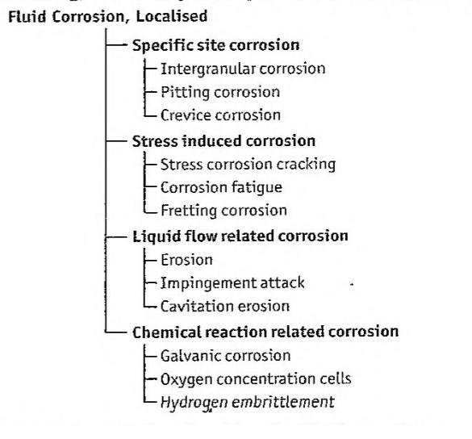
Classification of localised fluid corrosion.
Electrochemical corrosion: This type of corrosion occurs at discrete points of metallic surfaces when electricity flows from cathodic area to anodic area. Metallic surface gets divided into anodic portion or cathodic portion.
Fluid Corrosion: Localised
Fluid corrosion is the most frequently observed on different locations in a material. It occurs in numerous ways. It is further classified as given in Figure
Specific site corrosion: Mechanically weak spots or dead spots in a reaction vessel cause specific site corrosion.
Inter-granular corrosion: Selective corrosion that occurs in the grain boundaries in a metal/alloy is called as intergranular corrosion. In this type of corrosion, the grain boundaries contain material, which shows electrode potential more anodic than that of the grain centre in the particular corroding medium. This may be due to the precipitation of certain compounds at the grain boundaries, thereby leaving the solid metal solution (just adjacent to that grain boundary) (or depleted or poor) on one constituent. The impoverished solid solution is anodic with respect to the grain centers and the precipitated compound, so that it will be attacked preferentially by the corrosive environment (Fig.).
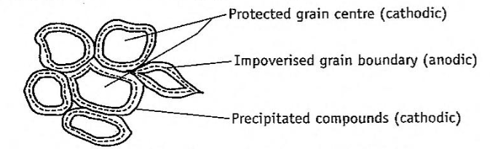
General inter-granular corrosion.
Microscopic examination can reveal clearly the intergranular corrosion. When severe, this attack causes a loss of strength and ductility out of proportion to the amount of metal actually destroyed by corrosion, Crystalline grain structure as such is not attacked appreciably. One example is:
Hot condition
Austenitic stainless steel + Nitric acid ---------------------→ Grain boundary precipitation
Stainless steel is stabilized by incorporation of niobium/titanium or carbon (less than 0.03%).
Pitting corrosion: This type of corrosion results in development of pits and cavities. They range from deep cavities of small diameter to shallow depressions. Example is:
chlorides
Alloy of aluminium or stainless steel + Aqueous solution -------------------→ Cavities
Pitting of a metal occurs when there is a break in the protective oxide layer and imperfections on the underlying metal. This gives rise to the formation of small anodic and large cathodic areas. The presence of the extraneous impurities (examples are sand, dust, scale etc.) embedded on the surfaces of metals and are also responsible for pitting. Owing to the differential amount of oxygen in contact with the metal (Figure), the small part (underneath the impurity) becomes the anodic area and the surrounding large part becomes the cathodic areas. Once a small pit is formed, the rate of corrosion will be increased. Inhibitors are sometimes helpful in preventing pitting corrosion.
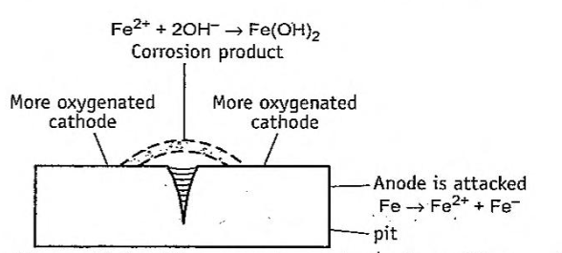
Pitting corrosion at the surface of iron.
Crevice corrosion: In this type, corrosion occurs in crevices because solutions are retained at such places, which takes longer time to dry out. When this occurs, the intensity of attack is usually more severe than surrounding areas of the same surface. Crevices are formed because of the metal contact with another piece of the same or other metal or with a non-metallic material. Corrosion in the crevices is due to a number of reasons as given below:
- Deficiency of oxygen
- Acidity changes
- Build-up of ions
- Depletion of inhibitor
Stress induced corrosion: Residual internal stress in the metal or external applied stress accelerates the corrosion. Residual internal stress is produced by:
- Deformation during fabrication.
- Unequal rate of cooling from high temperatures.
- Internal stress rearrangements involving volume changes.
- Stress induced by rivets, bolts and shrink fits.
Stress corrosion occurs along narrow paths, forming anodic areas with respect to the more cathodic areas at the metallic surface (Fig.). Presence of stress produces strains, which result in localized zones of higher electrode potentials. These become so chemically active that these are attacked, even by a mild corrosive environment.
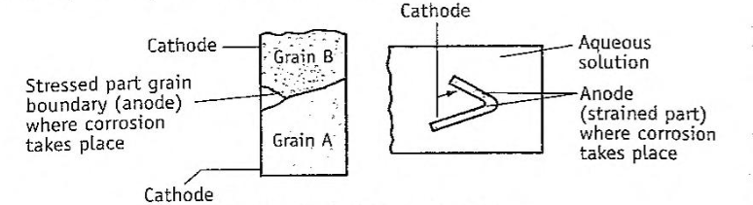
Stress corrosion.
Eliminating high stress areas prevents this type of corrosion. The external stress can be kept at minimum by employing suitable experimental conditions.
Stress corrosion cracking: At the surface, if the tensile stress is equal to or more than the yield stress, the surface develops cracks. This is known as stress corrosion cracking. Examples are:
- Cold-formed brass develops crack in the environment of ammonia.
- Embrittlement cracking of steel is observed in caustic solution.
Corrosion fatigue: Corrosion fatigue is the ability of a metal surface to withstand repeated cycles of corrosion. The metal surface is stressed and simultaneously attacked by the corrosive media. Pits (concentration points) indicating corrosion are formed initially, which further develop into cracks. As this process continues, the surface loses its fatigue resistance and ultimate failure of equipment.
The protective surface oxide film reduces corrosion. Under cyclic or repeated stress conditions, rupture of protective oxide films takes place at a higher rate than at which new protective films can be formed. Therefore, the rate of corrosion is enhanced.
Fretting corrosion: Fretting corrosion occurs when metals slide over each other and cause mechanical damage to one or both. During relative movement of metals, two processes may occur. (i) frictional heat is generated, which oxidizes the metal to form oxide films (ii) removal of the protective films resulting in exposure of fresh surface to corrosion attack
This can be avoided by using harder materials, minimising friction by lubrication or by proper designing of the equipment, so that no relative movement of parts takes place.
Flow related corrosion: Liquid metals can cause corrosion. Usually the driving force is the tendency of the liquid to dissolve solids or penetrating the metal along the grain boundaries at places of wetting. Corrosion rate is enhanced at high temperatures. A few examples are:
- Mercury attack on aluminium alloys.
- Molten zinc on stainless steel.
Impingement corrosion: This is also referred to as erosion-corrosion or velocity accelerated corrosion. It is accelerated by removal of corrosive products (such as oxide films), which would otherwise tend to stifle the corrosion reaction.
Erosion: Erosion is the destruction of a metal by abrasion and attrition caused by the flow of liquid/gas (with or without suspended solids). The factors that can influence erosion include:
- Alloy contents of the steel (for example, chromium, copper, manganese etc.).
- Pipe system design and component geometry.
- Water and steam composition (especially pH and oxygen content).
The use of harder metals and changes in velocity or environment are used to prevent erosion.
Cavitation erosion: Formation of transient voids or vacuum bubbles in a liquid stream passing over a surface is known as cavitation. The bubbles may collapse on the metal surface thereby causing severe impact or explosive effect. Therefore, considerable damage and corrosion is observed. The protective films also get destroyed due to impact.
Cavitation erosion is observed around propellers, rudders in pumps etc. Redesign, use of a more resistant metal and protective coatings are required to avoid this type of corrosion.
Chemical reaction related corrosion: Corrosion involves chemical reactions such as oxidation and reduction at anode and cathode, respectively.
Galvanic corrosion: Galvanic corrosion is associated with the flow of current to a less-active metal (copper cathode) from a more-active metal (zinc anode) in the same environment. Coupling of two metals. which are widely separated in the electrochemical series, generally produces an accelerated attack on the more active metal, zinc, i.e., anodic corrosion. Therefore, a combination of metals which are as close as possible in the electrochemical series should be chosen.
In galvanic corrosion, the effect of area is very important. For example, steel rivets on copper (Cu) plates will corrode much more rapidly than a steel plate with copper rivets. Corrosion at the anode may be 100 to 1000 times higher, if the two areas are same.
Protective oxide films tend to reduce galvanic corrosion. Insulating materials can be placed between two metal faces to prevent corrosion. For example, plates when bolted together, specially designed plastic washers can be used.
Oxygen concentration cell: This type of corrosion is due to the presence of oxygen electrolytic cell, i.e., a difference in the amount of oxygen in solution at one point exists when compared to another. Corrosion is accelerated where oxygen concentration is least, for example, under gaskets, stuffing boxes etc., because formation of an oxide film is not possible. This also occurs under solid substances that may be deposited on a metal surface as ready access to oxygen is shielded. Redesign/change in mechanical conditions must be used to overcome this situation.
Hydrogen embrittlement: Hydrogen can penetrate carbon steel and reacts with carbon to form methane. The removal of carbon results in decreased strength. Corrosion is possible at elevated temperatures as significant hydrogen partial pressure is generated. This causes a loss of ductility. (Hydrogen embrittlement) and failure by cracking or blistering of the steel. Resistance to this type of attack is improved by alloying with chromium/molybdenum.
Hydrogen damage can also result from hydrogen generated by electrochemical corrosion reaction. The atomic hydrogen formed on the metal surface diffuses into the metal and forms molecular hydrogen at micro-voids. The result is failure by embrittlement, cracking and blistering. This phenomenon is observed in solution of specific weak acids such as hydrogen sulphide and hydrocyanic acid.
Fluid Corrosion: Structural
In structural fluid corrosion type, the structural (mechanical) strength is reduced on account of corrosion. This may occur when one component of the alloy is removed or released into the solution. The corrosion products may remain in the plant. Two examples are presented here.
Graphite corrosion: Graphite is an allotropy of carbon. Graphite corrosion occurs in gray cast iron. The metallic iron is converted corrosive products leaving a residue of intact graphite mixed with iron corrosive products and other insoluble constituents of cast iron. When the layer of graphite and corrosive products is impervious, corrosion will cease or slow down. If the layer is porous, the corrosion will progress by galvanic behaviour between graphite and iron.
When carbon steel is heated for prolonged periods at temperatures higher than 455°C, carbon may get segregated, which is then trans- formed into graphite. Hence, the structural strength of steel is affected. Employing killed steel or low alloyed steels of chromium and molybdenum or chromium and nickel can prevent this type of corrosion.
Dezincification: This type of corrosion is seen in brass that contains more than 15% zinc. In brass, the principal product of corrosion is metallic copper, which may redeposit on the plant. Another mechanism involves the formation of zinc corrosion products leaving the copper residue.
Corrosion may occur as plug filling pits (plug type) or as continuous layers surrounding the unaffected core of brass (general type). It can be reduced by the addition of small amount of arsenic, antimony or phosphorus to the alloy.
Fluid Corrosion: Biological
The metabolic action of microorganisms can either directly or indirectly cause deterioration of a metal. Such a process is called biological corrosion. Microorganisms associated with corrosion are either aerobic or anaerobic. The causes for biological corrosion are:
Producing corrosive environment or altering environmental com- position.
Creating electrolyte-concentration cells on the metal surface.
Altering resistance to surface films.
Influencing the rate of anodic/cathodic reaction.
Sporovobrio desulphuricous organism is responsible for the anaerobic corrosion of iron and steel. The sequence of reactions associated with anaerobic sulphate reducing bacteria is as follows.
Anodic solution of iron:
8H₂ O ↔ 8 H⁺ + 8 (OH) ⁻
4Fe + 8 H⁺ ↔ 4Fe²⁺ + 8 H
Depolarization, due to activity of bacteria:
H₂ SO₄ +8 H ↔ H₂ S+ 4 H₂ O
Corrosion products:
Fe²⁺ + H₂ S ↔ FeS + 2 H⁺
3Fe²⁺ + 6 (OH)⁻ ↔ 3Fe(OH)₂
The principal corrosion products are black iron sulphide and ferrous hydroxide. The corrosion is intense and localized.
The role of biological corrosion may be explained using anaerobic sulphate reducing bacteria in slightly acidic or alkaline soils. The optimum conditions for their growth are 25 to 30 °C and the pH is from 5 to 9 (Figure).
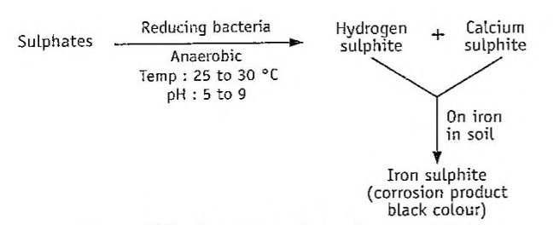
Sequence of events associated with the anaerobic sulphite reducing bacteria.
As these bacteria thrive under these conditions, they will continue to promote this reaction until failure of the pipe occurs. Aerobic bacteria (sulphur bacteria) oxidize sulphur (present in their cells) to yield sulphuric acid, which attacks the iron. These grow best under acidic conditions (pH Oto 1).
MCQ Each carry 1 mark
- A severe form of corrosion that develops in highly localized areas of metal surface is called as:
  - erosion
  - galvanic corrosion
  - pitting corrosion
  - stress corrosion
- One of the following types of corrosion is NOT related to liquid flow related corrosion. .
  - Cavitation erosion
  - Erosion
  - Fretting corrosion
  - Impingement corrosion
- Which one of the following types of corrosion of metals is flow related?
    - Biological corrosion
  - Crevice corrosion
  - Erosion
  - Inter-granular corrosion
- For explaining dry corrosion of iron metal, which one of the following is necessary?
  - Chlorine
  - Hydrogen
  - Oxygen
  - Sulphur
- For chemical (dry) corrosion of iron, which one of the following conditions is necessary?
  - Connecting the metal through external wire
  - Hydrochloric acid solution
  - Sulphur dioxide gas
  - Sulphur dioxide solution
- Galvanic corrosion is observed, when external electric current in solution is passed between one of the following combinations.
  - Gold and platinum
  - Iron and hydrogen
  - Iron and iron
  - Zinc and copper
Each carry 2 marks
- Explain the terms ‘pitting corrosion’ and ‘galvanic corrosion’.
- Differentiate between chemical corrosion and electrochemical corrosion.
- Explain the term ‘rusting of iron’. What is its chemical formula?
- Describe the term ‘passivity’. How is it combat corrosion?
- What is the role of plastic washers in the corrosion of metals?
- Describe the effect of grain size of the metal on corrosion.
- In a structure, two dissimilar metals should not be allowed to come in contact with each other. Why?
Each carry 5 marks
- Write the electrochemical theory of corrosion.
- Describe the biological corrosion and suggest the preventive measures.
- Describe the mechanism of corrosion of iron.
Each carry 10 marks
- What is meant by corrosion? Name (he various types of corrosion. How can corrosion be prevented?

