Lession-6

TOPIC- Physiological Antidotes (Sodium Nitrite)

SODIUM NITRITE-
Molecular Weight- 69.00 Chemical Formula- NaNO2 Synonym- Nitrous acid sodium salt
Preparations-
NaNO₃ + Pb → NaNO₂ + PbO
Properties
It is odourless, colourless
Saline taste, soluble in water, sparingly soluble in alchol
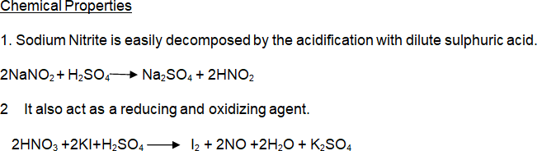

Uses-
It is used as a treatment of cyanide poisoning in conjugation with sodium thiosulphate.
Used as a rust inhibitor preservative in foods such as cured meals for manufacturing dyes.
Used as a vasodilator.

