UNIT: 1 (SIZE SEPARATION)
CLASS:9
TOPIC: OFFICIAL STANDARDS FOR POWDERS, SIEVES, SIEVE SHAKER MACHINE
OFFICIAL STANDARDS FOR POWDERS
In general, powders are vaguely described as coarse and fine powders. However, it is essential to identify with some guiding specifications. Indian Pharmacopoeia has prescribed standards for powders for pharmaceutical purposes. Accordingly, degree of coarseness or fineness is expressed with reference to the nominal aperture size of sieve through which powder is able to pass. The relevant grades of powders and sieve number along with nominal aperture size are shown in Table. The IP 1996 specifies five grades of powder.
Grades of Powders and Sieve Number along with Nominal Aperture Size as per IP
Sl No | Grade of  powder | Sieve through  which all  particles  must pass | Nominal  mesh  aperture  size | Sieve through  which 40%  particles  pass | Nominal  mesh  aperture  size
1 | Coarse powder | 10 | 1.7mm | 44 | 355μm
2 | Moderately coarse  powder | 22 | 710μm | 60 | 250μm
3 | Moderately fine  powder | 44 | 355μm | 85 | 180μm
4 | Fine powder | 85 | 180μm | - | -
5 | Very fine powder | 120 | 125μm | - | -

Coarse powder: A powder, all the particles of which pass through a sieve with nominal mesh aperture of 1.70 mm (No. 10 sieve) and not more than 40,0 per cent through a sieve with nominal mesh aperture of 355 um (No. 44 sieve) is called coarse powder.
When fineness of a powder is described by means of a number, it is an indication that all the particles of the powder shall pass through the sieve of which the nominal mesh aperture in µm, is equal to that number. Normally, for compound powders, fine powders are preferred, while moderately coarse powder is used for the preparation of tinctures. Coarse powder without fines is employed in percolation process.
The above mentioned terminology has applications in the production of galanicals. A few examples are given in the Table.
Some Examples of Crude Drugs and Nature of Powder Required
Liquid extracts | Useful parts | Grade of powder
Ashoka | Stem bark | Coarse
Nux vomica | Seeds | Moderately coarse
Rauwolfia | Roots | Moderately coarse
Ergot | Sclerotia | Moderately fine
Ipecac | Root | Fine
Ephedra | stem | fine

The pharmacopoeia has prescribed upper and lower limits for the three coarse grades of powder. For two fine grades, the pharmacopoeia has prescribed only the upper limit.
SIEVES
Sieves are the simplest and sieving is the most frequently used method for size separation.
Construction
Sieves for pharmaceutical testing are constructed from wire cloth with square meshes, woven from wire of brass, bronze, stainless steel or any suitable materials. Sieves should not be coated or plated. There must be no reaction between the material of the sieve and the substance to be sieved.
Types of Sieves
The primary considerations for sieves are given to the size and shape of aperture opening. Square meshes are arranged as per the specifications. Sieves commonly used in pharmaceutical processing include:
Woven wire sieves
Bolting cloth sieves
Closely spaced bars (screens)
Punched plates
Standards of Sieves, Dimensions and Notations
Common standards used for sieves are:
(a) Tyler standard sieve series (in USA)
(b) US standard sieve series (in USA)
(c) British standard sieve series (in UK)
(d) German DIN (Deutsche Industrienormein) (in Germany and Europe)
(e) IP standard sieve series (in India)
(f) International test sieve series (ISO) (World wide)
Tyler and US standards can be interchangeable, since the difference between the two standards is less than the allowable tolerance in weaving of the screens. These are also known as test sieves. Sieves used for pharmacopoeial testing must match with the following specifications:
1. Number of sieve: Sieve number indicates the number of meshes per linear length of 25.4 millimetres.
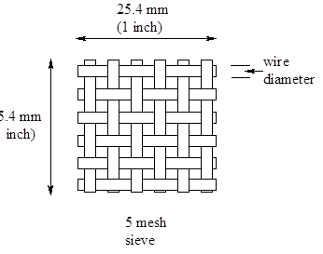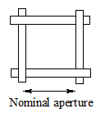
2. Nominal size of aperture: Nominal size of aperture indicates the distance between the two adjacent wires. It represents the side of a square aperture. IP 1996 gives the nominal mesh aperture size for majority of sieves in mm or in µm.
3. Nominal diameter of the wire: Wire mesh sieves are made from the wire having the specified diameter in order to give a suitable aperture size and sufficient strength to avoid distortion of the sieve.
4. Approximate percentage sieving area : This standard expresses the area of the mesh as a percentage of the total area of the sieve. It depends on the size of the wire used for any particular sieve. Generally, the sieving area is kept within the range of 35 to 40 per cent in order to give suitable strength to the sieve.
5. Aperture tolerance average size: Some variation in the aperture size is unavoidable. This variation is expressed as a percentage and is known as the aperture tolerance average. In fact, it is a limit given by pharmacopeia within which a particular dimension or average aperture size can be allowed to vary and still be acceptable for the purpose for which it is used. Fine meshes cannot be woven with the same accuracy as coarse meshes. Hence, the aperture tolerance average is lower for coarse sieves than the fine sieves.
SIEVE ANALYSIS TESTING OF POWDER
The milled material is subjected to size separation in order to obtain the powder of desired size or size distribution. Size distribution analysis is important in different areas as mentioned below.
- Quality control tool for the analysis of raw materials.
- Testing the efficiency of a size reduction equipment or process.
- Optimising the process conditions such as method of agitation, time of screening, etc.
- Selecting the sieve system for commercial equipment.
Errors can arise if the sieves are overloaded or if insufficient time is allowed for the particles to pass through.
Sieve Shaker Machine
Principle: The powdered drug is separated according to its particle size using a number of sieves in a nest. These are subjected to different types of agitation, so that size separation is rapid.
Construction: Standard sieves of different mesh numbers are avail- able commercially as per the specifications of IP and USP. These sieves are fixed in a mechanical shaker apparatus (Figure)
Working: Sieves are arranged in a nest with the coarsest at the top. A sample (50 g) of the powder is placed on the top sieve (Figure). This sieve set is fixed to the mechanical shaker apparatus and shaken for a certain period of time (20 minutes). The powder retained on each sieve is weighed.
Practical considerations: Care should be taken in order to get reproducible results. The type of motion influences sieving; vibratory motion is most efficient, followed by side-tap motion, bottom-pat motion, rotary motion with tap and finally rotary motion. The type of motion and intensity of the shaker are fixed and standardized. Shakers are commercially available.
Other factors are weight of the sample and duration of shaking. Sieves produced by photo-etching and electro-forming techniques are used to get a better estimate of the size distribution analysis with a lower limit of estimation of particle diameter 50 μm.

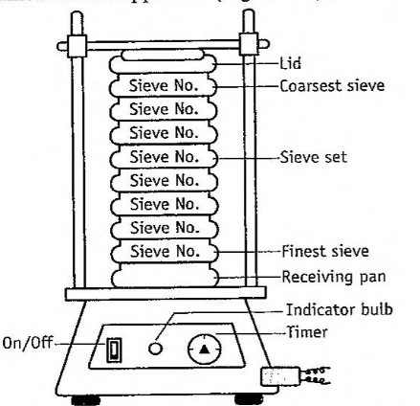
Laboratory sieve shaker machine
Advantages: It is inexpensive, simple and rapid with reproducible results.
Disadvantages: (1) Lower limit of particle size is 50 µm.
(2) If powder is not dry. apertures get clogged with particles, leading to improper sieving,
(3) During shaking, attrition (particles colliding with each other) occurs causing size reduction of particles. This leads to error in estimation.
Variants: Electromagnetic sieve shaker, Sonic sifter.
MCQ Each carry 1 mark
1. For two _____ grades of powder, Indian Pharmacopoeia has prescribed only the upper limit.
- Fine
- Coarse
- Both Fine and Coarse
- None of the above
2. "Number of sieve" indicates-
- Distance between the wires
- Specific diameter of the wire
- Number of meshes
- Area of the meshes
3. Mechanical sieving devices works on the basis of
- Agitation
- Brushing
- Centrifugal
- All of the above
4. The Indian Pharmacopoeia has prescribed upper and lower limits for three __________ grades of powder.
- Fine
- Coarse
- Both Fine and Coarse
- None of the above
5. Which of the following standards are given for sieves mean for pharmaceutical testing-
- Number of sieve
- Nominal diameter of wire
- Tolerance average aperture size
- All of the above
6. The degree of particle size of a powder is expressed in the pharmacopoeia in the form of-
- Sieve number
- Nominal mesh aperture size of sieve
- Amount of powder pass through sieve
- Approx. percentage sieving area
Each carry 2 marks
- Name the standards of screens used in pharmaceutical practice.
- What are standard sieves?
- Differentiate ideal and actual screens.
- List the specifications and standards for sieves
- Explain the term blinding of screen. How is it prevented?
- What are various grades of coarse powders? Define them.
- Give the classification of fine powders with definitions.
- What are the advantages of expressing sieves by sieve number over the nominal size of aperture?
- Differentiate the terminology, nominal size of aperture and nominal diameter of the wire.
- What are the uses of screen analysis? How is it expressed?
- List the methods of sieve analysis used for testing the powders. Give their relative advantages
Each carry 5 marks
- Explain various grades of powders official in pharmacopoeia.
- Give details about the various standards fixed by the pharmacopoeia lor sieves.
- Describe the specifications of standard sieves as per 1P.
Each question carries 10 marks
I. Describe one industrial method for size separation of a powder and its applications

